**Impact of Various Independent Variables: Graphs**

Elementary Schools

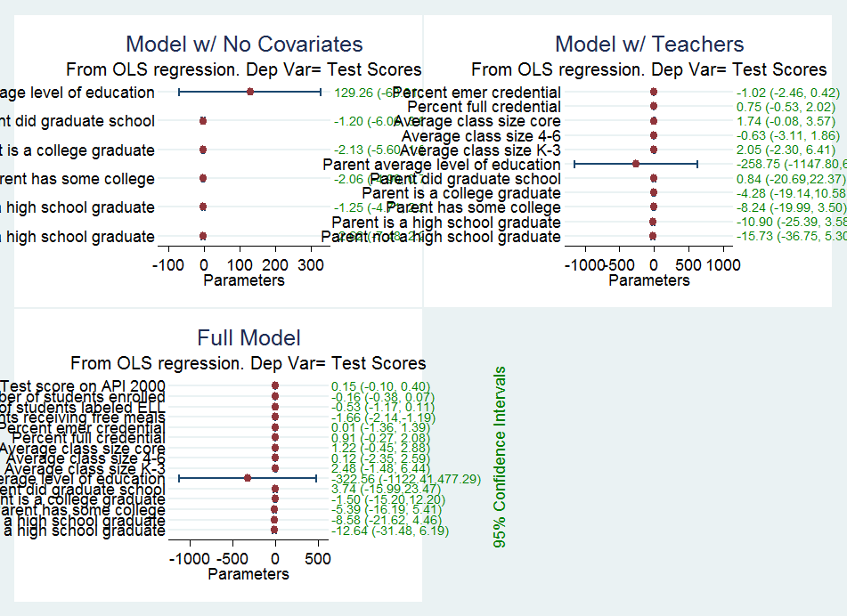

Middle Schools



High Schools

