**Scatterplots**

**Elementary Schools**

Parents are high school graduates and API score

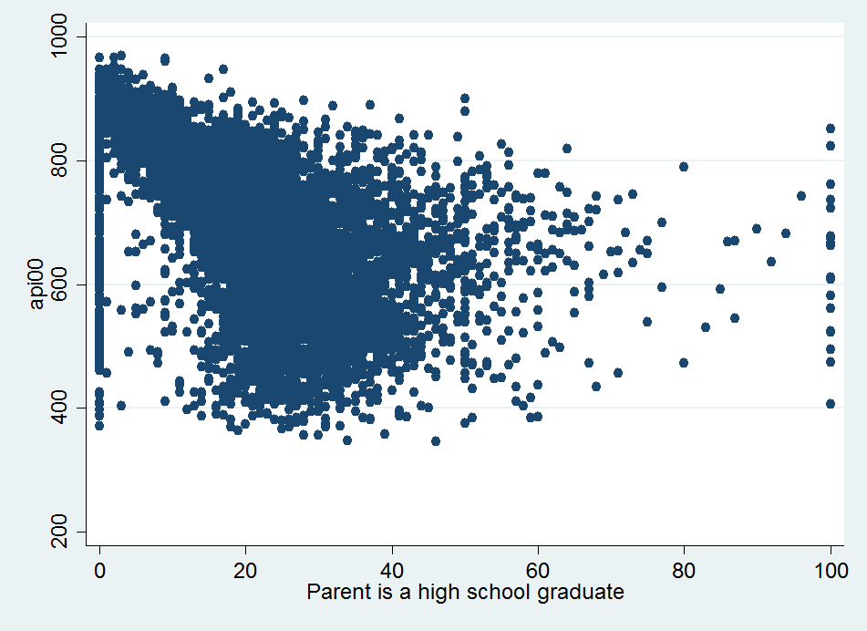

Parents have some college and API score

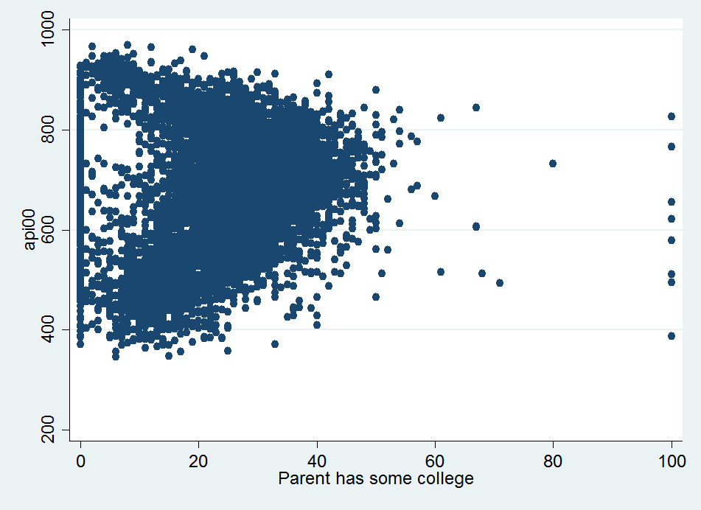

Parents are college graduates and API score

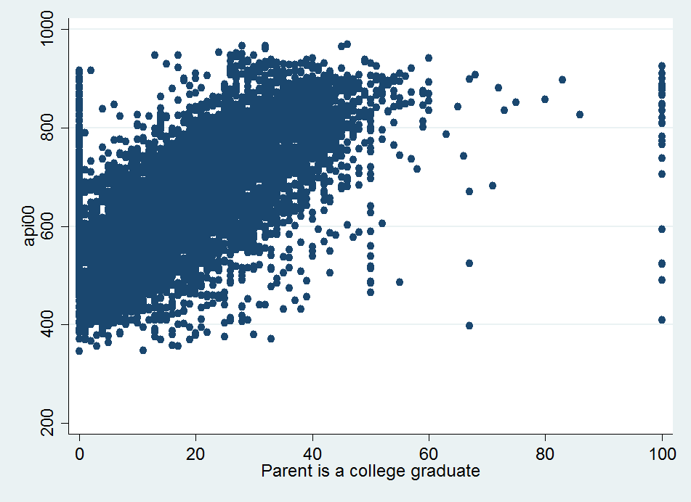

Parents have graduate school degree and API score

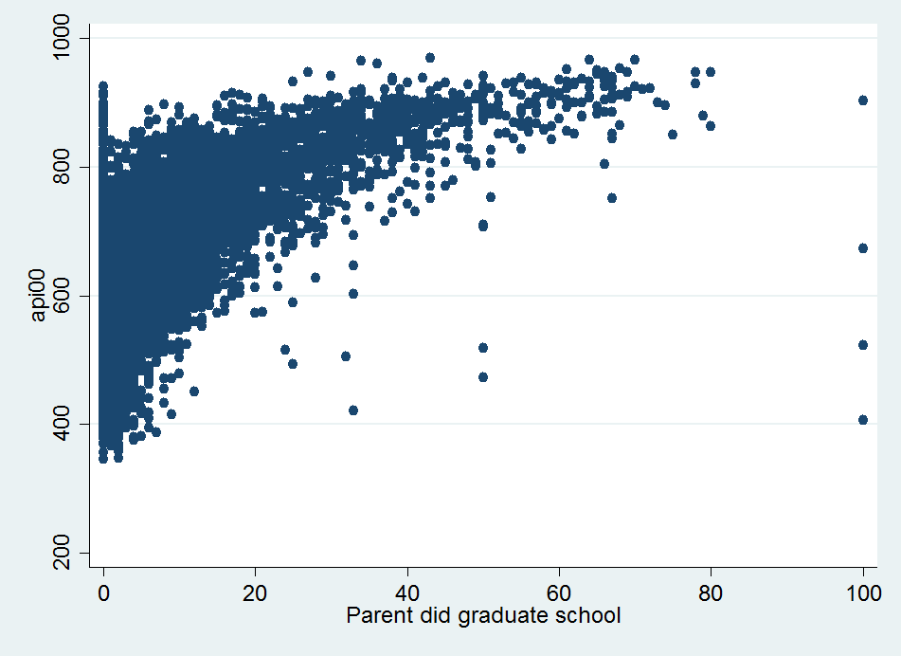

**Middle Schools**

Parents are high school graduates and API score



Parents have some college and API score



Parents are college graduates and API score



Parents have graduate school degree and API score



**High Schools**

Parents are high school graduates and API score



Parents have some college and API score



Parents are college graduates and API score



Parents have graduate school degree and API score

