TECHNICAL REPORT
World Crisis project

University of Texas at Austin
Computer Science 373
Summer 2012

All the Single Ladies
Ian Buitrago, Jake Wilke, George Ross Shwarts, Fayz Rahman, Robert Reed

EXECUTIVE SUMMARY

Every year the lives of millions of people across the globe are significantly affected by various widespread crises. The effects of these tragedies are almost always long term, and there are usually organizations that continue to provide aid for as long as it is needed. Yet, the media will cover a crisis extensively for only a few weeks before another topic comes into vogue and the crisis is no longer mentioned. Unfortunately, the public consciousness in the developed parts of the world has a short attention span and the people affected by these crises are quickly forgotten by the individuals most capable of providing the resources needed. As a consequence, these organizations begin to lose funding once news sources move on to the next “hip” topic, while the effects of the crisis continue without the support needed.
The goal of this project is to build a website to track and aggregate information about recent and ongoing crises, the people affected, along with information about the organizations involved. This is an effort to keep these events and the people affected in the peripheral vision of the public consciousness. Accordingly, the site does not only contain a compilation of data on the events that occurred, but also provides research on the current status of the people, places, and organizations involved. More importantly, it provides links and contact information for those organizations involved in providing aid. In this way, the site goes beyond just raising awareness and is extended to providing concrete information that every visitor to the website can use to get involved. We have also provided information on key public figures that are involved. This is to provide role-model-like examples that users are already familiar with (chiefly for motivation) or, in the case of militant and terrorist crises, to give information on the people behind the atrocities that have been committed.
In keeping with our aims, the site emulates the IMDB website design in that each page has information about a single crisis, organization, or person including statistics, summarized data, pictures, videos, and links to external sites that can assist users in getting involved. Every page also links to related pages on our website. So, if a user is looking at data on a particular crisis, say the earthquakes near Christchurch, Haiti, the page contains a link to every organization contained in the database that is involved in the rebuilding of these communities and, accordingly, each of these pages contains information on the work that organization does and its contact information and, of course, a link leading back to the earthquakes.
To import data into the site, we used an XML instance, which must conform to a precisely defined XSD schema. This includes support for updating and merging data for entities already stored in the data base.XML. After being imported, the new data is then parsed using the ElementTree interface, and then stored into Google App Engine (via Datastore models). The export feature displays an XML instance in the browser that allows the user to get access to all of the data and links stored in our website. The data in any instance file that does not conform to our schema will not be imported into the website. There is currently no device to insure the correctness of imported data.
Of course, the site needs to be both attractive and easy to use. Navigation must be intuitive and each page should be compact and free of clutter. We did not want any part of our presentation to become a barrier to the information we are providing. To do this we used page templates to conform the information contained in the database to be displayed in a consistent fashion. This allowed us to make the site update itself dynamically as data is imported, but it also made things cleaner, which is allows for a more attractive website. We implemented a search feature, which is an essential component of any website, but it is especially important for our goals. What good is a database of crises if a user cannot easily find the particular crisis in which they are interested? Additionally, we provide browsing tools for each of the page types.
To implement this website in the most efficient and economic manner possible, we used a number of free tools, chief of which is the Google App Engine, which served as the host for our site. The majority of the code is written in python (via GAE’s Python API). Schema validation was accomplished using Minixsv. Python’s ElementTree was used to parse and write XML files, allowing for relatively easy import/export of the data into the GAE Datastore, which in turn provides the website with easy access to our data. The data models we used and the relationships between them were carefully designed in UML with the help of Gliffy to display a readable class diagram for quick reference throughout production. To put the information on the website, Django templates were used to dynamically generate the HTML pages from the data in the Datastore, which can then be displayed by the Google App Engine. GAE also provides a search API for implementing our in-site search. Finally, we used GitHub to coordinate our efforts and keep track of all project issues.
Finally, we needed to guarantee that our site worked as intended. The import/export feature was the primary target of our automated unit tests. For these we used snippets of an XML document that we could paste together in different combinations that would pick out the various corner cases involved in importing schema-verified data. These tests were then embedded into the GAEUnit framework. Acceptance tests, mostly done by hand were used for almost every other part of the site. The most difficult part of the project to test have been the Django templates, which have required us to walk through the various pages generated to make sure that all links and videos display correctly and that photos are being embedded and resized correctly, which did not always display similarly on different browsers. Also, we had to make sure all design decisions were implemented.

As for the effectiveness of our solution, that is difficult to measure. We hope that our users will get involved. Yet, even if we add visitor counters, it would not inform us as to how many of these visitors went on to contribute to organizations or in what fashion. All we can do is verify that our site works correctly and identify ways to improve it.

TABLE OF CONTENTS

Executive Summary | 2
Table of Contents | 4
Introduction | 5
Design | 7
Implementation | 11
Evaluation | 16

Example 1 | Splash Page picture | 7
Example 2 | Examples of error messages | 7
Diagram 1 | Gliffy Diagram | 9
Example 3 | Schema Example | 10
Example 4 | Pydoc access | 13
Example 5 | GAE local server | 16

INTRODUCTION

Problem
There are many recent and ongoing crises that have fallen out of the awareness of the developed world. A tsunami might hit vast areas in numerous countries, even more than one continent all at the same time, killing thousands and causing billions of dollars in damages to infrastructure. Information about the disaster and its immediate effects will be in the media continuously for weeks on end. During this time millions of people from around the world will recognize the dire need for aid and send aid in the form of food and water and/or monetary donations to organizations working on site. But shortly after, as quickly as changing the channel on a television, the media switches attention to the next big story or crisis, leaving the tsunami and its victims to fade from global consciousness.

Importance
Clearly, the fallout from these world crises far outlasts the media coverage afforded them in almost every case. Yet, the support and funding to the organizations providing relief and aid to those most affected by these disasters often reduces dramatically once public attention shifts to another topic, and these organizations become severely crippled in their capacity to help. Thus, the effects of a particular crisis last longer than necessary, people groups remain displaced or without food and medicine, and infrastructures remain desolate. There must be away to keep those affected by the various disasters every year in the hearts and mind of the people of the developed world, those who are most able to help.

Our Solution
We are unable to stop disasters from happening, change the nature of the media, or force individuals to get involved. What we can do is make it easy for these individuals to become or remain involved by providing easily accessible information on these disasters, including updated statuses on the after-effects and the resource requirements of those organizations that are providing aid. The most obvious way to do this, within the confines of our particular skills and available funds, is to build a website that can scale indefinitely and remain stable and navigable while accepting a constant stream of new data and updates. This type of site can help to bring more awareness for those forgotten after these disasters cease to appear in the media, while providing concrete ways for visitors to get involved and make a difference in the lives of the survivors.

Difficulty and Key Components
At the beginning of this process we knew that we would need to acquire and use a number of existing technologies, without which our project would be infeasible. Unfortunately, only one or two people from our group had experience with building and/or designing websites or databases and this little bit of experience was isolated to only a small section of the overall project. Fortunately, though, there are many tools that would be suitable for this type of project that are available free on the Internet, along with the necessary documentation and user blogs to point out special cases and idiosyncrasies regarding their use. Therefore, we were able to start off with a complete battery of free tools that would meet all of our needs and allow us to build the entire site without spending any money that could otherwise go to the aid of those in need.
Of course, this approach involved its own difficulties. First, there was quite a learning curve for everyone involved and much of our time was spent researching the how to use the chosen tools. One way that we tackled this issue was that we separated group members into pairs that would be assigned specific tasks that required only a subset of these tools. In that way, each member of the group became expert in only 1 or 2 of these tools, requiring only a limit working knowledge in the others. This reduced the time spent researching and allowed us to begin making tangible progress very quickly.
Another difficulty was that the majority of the website features that we wanted to implement were reliant on one or more others. Thus, any attempts to build the entire site at once would require us to leave testing until the very end, since so features would work correctly without the others. This was unacceptable, both because it left much uncertainty in the outcome of our product (especially with our team being so inexperienced) and because we use Extreme Programming (XP) methodology. So, we built the website over several iterations (in accordance with standard XP practices) with each iteration ending with a working, usable website that was hosted on line. In this manner, we were able to guarantee that dependent features were always built on top of completed features, allowing us to fully test every feature being worked on during any phase of development.
Ultimately, the most difficult task has been the gathering of information for our site. The manner that we have chosen for importing information to our site requires the compilation of specific information provided in a very specific format. These have largely been completed by hand, although the automation of this process is a future goal. This takes extensive amounts of time and research for every crisis included in the site. One way we have death with this is to make a public import feature that any user of the site has access to. This feature automatically updates previously stored data with the current information via a “merge” setting. This gives other people the opportunity to contribute to our site and for those involved in the crises to provide real-time updates.

Results
In the end, we were able to produce a functional site that displays all the imported information correctly in an attractive way. We are pleased with the look of the site, especially with the lack of clutter and advertising that plagues so many free sites. Also, finding and navigating through to a particular page is very simple. A user can go to a list of just the crises, organizations, or people, from which they can choose a particular entity of that type. Additionally, we have implemented a simple search tool that is sufficient for the purposes of our site. Finally, there is a system in place for adding information that is accessible to users around the world, so the site has the capacity to grow and continually be updated over time. Thus, we feel that the site we have produced thus far is an important start toward achieving our goal of maintaining communication and resource flow between the victims of major crises and the world at large.

Limitations
Unfortunately, the current amount of data that has been added to the site is rather small and not at all in keeping with our ideals. Thus, the site’s effectiveness is mostly limited by how much properly formatted information that has been submitted to the site. Another limitation is the amount of updated information readily available on the Internet. While the Internet is full of freely available information from a seemingly unlimited amount of sources, we have found it quite difficult, sometimes impossible, to find all the desired information on a particular entity. Often this is a direct result of the problem that we are trying to solve: the media, and thus the general population, has ceased to talk about a crisis that has occurred more than a month past. This is why acquiring connections with and contributions from the organizations and people involved with in world crises is so critical. Our current model for adding and updating data requires technical knowledge before it can be used. Future development iterations of the website should add other methods of adding information that any layman can use to contribute to the information contained in our site.
This leads to another problem: reliability of information. We are very limited in our capacity to verify the information being added by users, which can significantly mar the usefulness and reputation of our website. We do, however, want to provide users with concrete ways to help, so any future efforts to address this issue will first be concentrated on contact information for the organizations involved, followed by verifying that the correct organizations are linked to each crisis.

Additionally, there are some technical limitations to our project, mostly resulting from our lack of funding and experience. For example, our entire website is hosted on the Google App Engine which puts a limit to how much data can be stored for a particular app before charging money. Likewise, we use GitHub extensively for source control and communication with each other about our code. GitHub will eventually charge us for use of private repositories on their site. Similarly, we lack the funds to buy tools for our website, which is, therefore, limited by the capabilities of the free tools that we have used. As for experience, we have very little, but we are finding that our knowledge of how to build and improve the website is continuously growing and that each iteration seems to be progressing more smoothly and effectively. We expect that this will continue to be the case over time as our expertise in the tools becomes more developed and our team finds a rhythm and workflow that we all our comfortable with.

DESIGN

Design Decisions
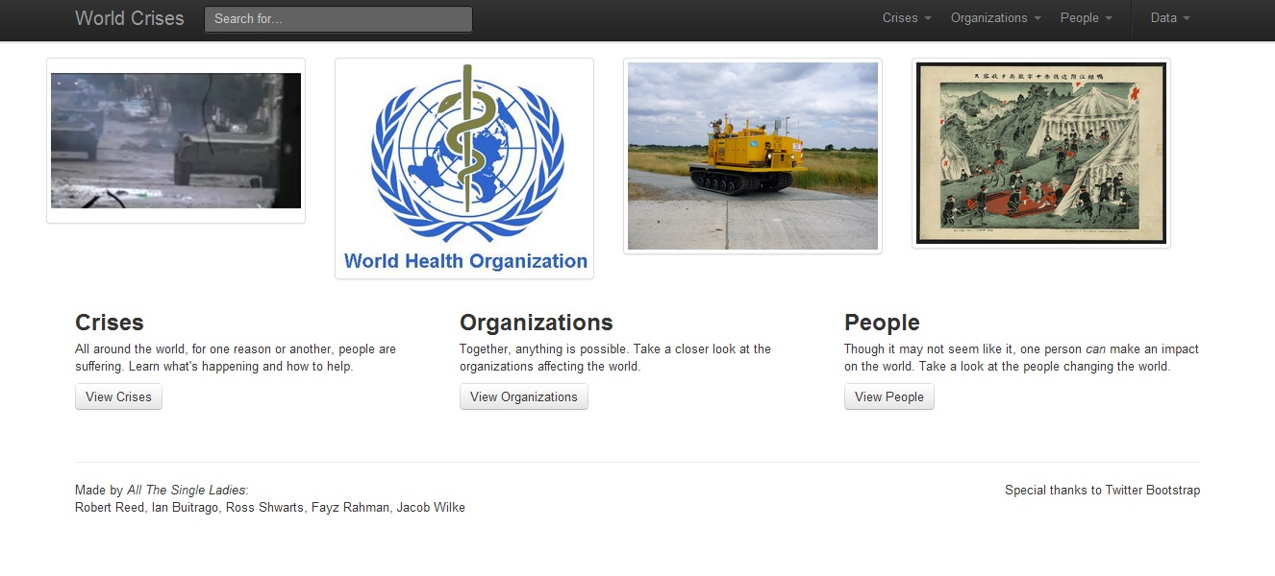
Example 1: Front page of the current Phase II iteration of the site’s home page. Note how all of the color is in the pictures, and none of it is in the user interface.

The idea was to design the site with a clean, focused look. By eliminating unnecessary site flourishes, we are able to focus on what is important--the data. The site’s usage of typography emphasizes the text. The site’s color scheme is mostly white and black, and uses color sparingly. This way, any usage of color has more impact and meaning. Links are blue, greens mean “Success!”, red means “Warning!”, etc. With a general lack of color on the site, viewer’s eyes will be drawn to the most dominating elements of color--the pictures of crises, organizations, and people.

Example 2: Examples of when color is used in the user interface. Here, we’re coloring status messages on the site’s import page, to give users visual feedback.

Special Features
One feature is the “Recent Entries” section in each of the drop-down menus in the navigation bar. Our datastore models for each page contain a property that keeps track of when the page’s data was last modified. This property is updated automatically whenever we call a .put() method on a page’s datastore entity in our code. The drop-down menu on the front page will then display the four most recently for each kind of entry.
Another special feature is the searchbar’s auto-complete functionality. If the user starts typing, it will display closely spelled crises, organizations, or people. Although search functionality is not required until Phase III, very basic functionality has been added (essentially, it queries the datastore for a name exactly equal to the search term).

User Interface
The User Interface, adhering to our design principle, is clean and focused. We decided to use Twitter Bootstrap as the front-end framework for our site. It has a good amount of functionality, was fairly easy to implement, and had the advantage of including a default style that fits in with our stated design principle.
For ease of use, there is a navigation bar at the top all pages, that stays at the top of the view, even when the user scrolls up and down. On that bar, there is a search bar, and four drop-down menus. The search bar has auto-complete functionality, though a true search experience has yet to be implemented--at the moment, it only searches for the names of crises, organizations, or people. The first three drop-down menus display data on Crises, People, and Organizations. They all display links to the four most recent entries, and a link to a page which displays all entries. The last drop-down menu displays links to the site’s import and export pages, and an “About” page for the site and group.
There are three pages that display all entries of each type--a Crises Page that displays all crises, an Organization Page that displays all organizations, and a People Page that displays all people. All these pages have the same format: four images at the top, and the list of entries below it. At the moment, there are four entries of every type in our XML, so the images at the top of each page correspond to each entry. However, when the ability to merge data into our datastore is added in Phase III of the project, we plan to display the list of entries four at a time, with links at the bottom to navigate back and forth through the various “pages” of entries. The four images at the top will then just show images from the corresponding four entries on the page.

UML

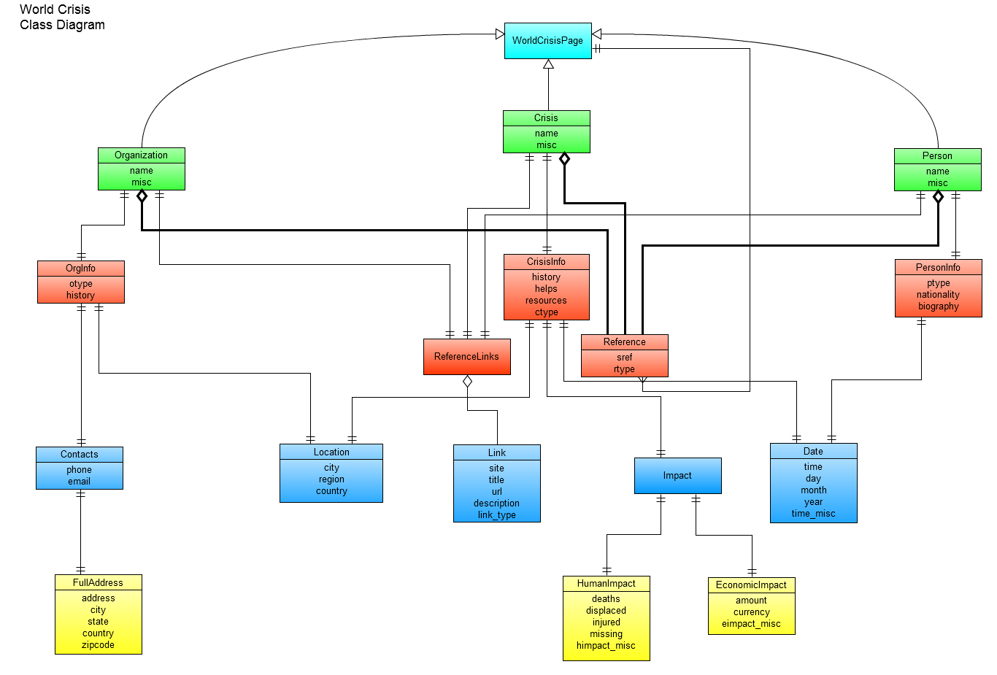
Diagram 1: This UML diagram illustrates the relationship between classes in Models.py
The UML diagram is modeled directly from the models we used to put information into the data store. Each model has its own box along with all its members that provide information is posted on the page just below it. All the one to one relationships are required in order for the whole page to be considered correct. If a model is an aggregation of another model, then that model has a list of references to that model.
The top of the diagram, the teal model, is the most general model: WorldCrisisPage. WorldCrisisPage is a type that has only one piece of information about the last time the particular model was updated. Under that in green are the types of pages which inherit from WorldCrisisPage. Each green model contains a name of the page and miscellaneous information about the page. They also have references to the red models. Each of these relationships is one to one with the exception of the references to other pages. The pages are aggregations of those references. One of the one to one relationships is with a model called ReferenceLinks. A ReferenceLinks model is simply an aggregation of Link models, a blue model.
The red models are defined further with blue models along with their member variables. The blue models are all one to one relationships with the red models. If the blue models need to be defined further, then the yellow models come in. These are also one to one relationships.
UML diagram was done with the Gliffy website gliffy.com. This link has the latest version of the diagram: http://www.gliffy.com/pubdoc/3716424/L.png.

XML
We adjusted our XML instance to conform and validate with the chosen schema. We had some issues regarding the schema. Some elements are required when they should be optional. For example, the exact time of day and date including month, day and year may not be relevant of a crisis as some of the other crises. World Hunger is an ongoing crisis that should not have a specific date whereas a tsunami could even have a specific hour. The chosen schema uses a sequence which requires the tags to be in that particular order and have at least one of each tag. However, an empty string in the tag will be validated. The schema has a tag that needs in it an extType. Shown in the example below, extType is a sequence of elements in the order of site, title, URL, and description. Each of these tags needs to be in the XML file; however the tags can be empty. This poses a problem seeing how it would not make sense to have a external link with a site and title but no URL This is more a weakness of the schema that we have to take care of in the code.
<xsd:complexType name="extType">
<xsd:sequence>
<xsd:element name="site" type="xsd:normalizedString"/>
<xsd:element name="title" type="xsd:normalizedString"/>
<xsd:element name="URL" type="xsd:token"/>
<xsd:element name="description" type="xsd:string" minOccurs="0" maxOccurs="1" />
</xsd:sequence>
</xsd:complexType>
Example 3: This is a snippet of code from the schema of an extType which is used for links

IMPLEMENTATION

Solution
We designed and implemented a website to organize and spread awareness of current and past crises, the organizations that are involved with assisting the victims of these crises, and notable public figures that are involved with these events. IMDB(Internet Movie Data Base) was our primary influence on how this information was organized and made accessible to users. In particular, we borrowed the concept of having pages of different types and having a common template for each of those types. This facilitates ease and predictability in the formatting and location of the information provided on each topic.
We chose to have 3 page types, corresponding with the three types of information that we would like to provide: crises, organizations, and people. Accordingly, the information that we provide for each crisis, organization, and person is primarily contained on one page, each with links to related pages of all types. Among the information provided are figures that convey the significance of the damage caused by each crisis, a sample of the resources needed for continued relief and aid being provided, and links to the organizations that are currently involved with providing that aid. We hope that this website and the information it contains will significantly contribute to the aiding these just causes and make the world a better place.

Execution
In order to build our website, we knew that we would need to utilize a number of different technologies to accomplish the various task that we would need to complete. We needed a database to store our information, a way to easily import data into the database, a standard way to communicate with the website, a way to dynamically build separate pages for each of the entities in our database, and a way to display these pages to the screen in an attractive and easily navigable manner. We also didn’t want to reinvent the wheel in accomplishing any of these tasks. This led to our choosing to use a variety of tools and frameworks available for free on the Internet

Framework and Tools
We had to familiarize ourselves with a number of tools, as no one in the group had ever worked on any projects of this nature. Research and training in using these tools took up a large portion of the time that we spent working on this project. However, the amount of time and work saved on designing ways to implement all of the features that we desired from scratch would have made the project prohibitive. Because the work of the project was divided up between various pairs from within the group, only 2 or 3 people needed to be trained for most of the tools. We found this was a great way to divide up our resources. Furthermore, while each person did not get to become “expert” in more than 1 or 2 parts, we traded partners and positions enough that we were all exposed to the various pieces involved. This knowledge and experience is ripe to be expanded on in future assignments.
The tools that we used are as follows:
- Google App Engine
- Django web framework (GAE version)
- GitHub/git
- Minixsv
- CoreFiling XML Schema Validator
- Twitter Bootstrap
- Pydoc
- Gliffy
- GAEUnit
- XML
What follows is a description of how we used each of these tools, in order, how we used them, and how these tools impacted our project.
We chose to use the Google App Engine to build and host our website. Google App Engine provides a free and relatively simple way of running this site and was highly suitable for our needs. It provides a database(datastore) that is easy to manage and that doesn’t require the use of any complicate query language, while being remarkably scalable. It also provides us with a domain that we can reliably use indefinitely. GAE also provides a python SDK so that everything can be written in a language that we were already familiar with. Additionally, the Python SDK allowed us to simulate the site locally without having to update or change the live site every time we needed to locate a bug or add a new feature. In short, we found GAE to be the perfect development environment for the needs of our project.
The template system of the Django web framework was used for the generation of our web pages. We are able to dynamically generate web pages by using python-like syntax within our HTML files. For example, say we want a page with all of our crises. Statically, we’d have an unordered list, and specify each list item. Dynamically, we’d still have a unordered list, but now we can use Django to insert a for loop to iterate through a list of crises, and “write” list items out to the HTML page. Then in our python code, we can query the datastore for crises, and pass it into the template. The Django templates were essential in making our site dynamic.
We used GitHub to host our remote repositories and track our issues. Emulating the developers of GitHub we used the fork and pull request model. We use a single main repository that we tried to keep in a stable compiling state and multiple forks of the repository, one for each person. Each team member is then free to push changes to their independent fork without affecting the main repository. Then when that fork reaches a significant milestone, the owner can submit a pull request to the main repository. The pull request creates an issue with broadcasts to all the collaborators(team members) through email. Then that code can be reviewed, discussed and then merged with the main repository. Using git was a huge asset in keeping track of changes.
The CoreFiling XML Schema Validator was used at first to make sure our revised XML instance validates with the new schema. Towards the end of phase 2 development it was mostly used as a sanity check whenever a new XML file wouldn’t import into our site. This validator was used as the standard for any validation.
Twitter bootstrap is the user interface framework used for our front-end. It includes many built-in components that can be easily combined to create a good looking site. Plus, the default styling fits in with our design principles. These factors made Twitter Bootstrap an excellent foundation for our web site's design.
Pydoc was used to generate HTML files of documentation as dictated by the project specifications. To be able to run Pydoc without errors in a GAE app, these paths should be added to PYTHONPATH variable in Linux.
export PYTHONPATH=~/Documents/cs373/google_appengine/: \
~/Documents/cs373/google_appengine/lib/webob_1_1_1/
Example 4: Shows a useful command that can be explicitly executed or added to your .bashrc file.

The flash website Gliffy was used to design the UML. It allows shared files between registered users and also provides different URLs to the file. It can also export the file to many formats but not PDF. SVG files have infinitely better resolution though.
Validation of imported XML instance files was accomplished using minixsv. Minixsv is a python library that depends on another pure python parser named genxmlif. Together, these libraries ensure that our given XML schema is well formed and that the XML file instances conform to the ground rules laid out by the schema. The interface into minixsv has a few ways to accomplish validation including file and string representations of the given schema and instances. The path we chose was to use strings. The schema is hard coded into one of our functions and the XML instance is provided at the time the user hits the “submit” button. Then minixsv and genxmlif does their magic and has 3 possible outcomes. The first is an error message that occurs if the schema and/or the XML instance is not able to be parsed. This error occurs whenever the user forgets to use a close tag or something syntactically incorrect. The second is another error that occurs if the schema and the instance are not well-formed. This is more of forcing that XML instance has all of the required content that is needed by the schema. Finally, the third outcome is that they are both able to be parsed and well-formed. Then the validation is complete! The handler will then pass the information into import.
Google docs was immensely helpful in completing the report by enabling us to type in the report simultaneously. The document was easily shared between all the group members and had almost every feature of a traditional word processor including exporting the document in PDF format.
We used an XML instance to compile all of the data that we wanted to store in the Database in an organized way that is completely readable to a human, syntactically specific enough to allow for automated parsing by a machine. The XML language is remarkably flexible and accommodates this quite well. Unfortunately, the XML is actually a little too flexible and only places a minimum of restrictions on the content of such files and no restrictions on the layout or order of the information. Therefore we needed to provide a schema for what information would be expected and could be used to enforce these expectations, making them, in fact, requirements. To this end, we used the XSD language and imported minixsv to be used as a lightweight schema validator.

Datastore
The datastore offers persistent storage for our crisis data. Without it, the data would be lost every time the browser window closes. It uses our models from Models.py to build tables and references to those tables. An issue we have run into is running a local instance of the app in the CS machines will create an datastore file on that particular machine. This file gives permissions only to the last person who used it. So any other team member or other team cannot simulate an app on that machine that uses the datastore. This issue is still being worked on.

Import/Export
Our import page has a file submit box that will accept a valid XML file and put that data into a presentable view on our website. Whenever the user hits the “submit” button, our handler extracts the contents of the file into a string and passes it through the minixsv and genxmlif validator. The validator ensures that the XML instance is well formed (all open tags have closing tags etc.) and also makes sure that the instance conforms to our XML schema. This validation check makes certain that we can parse the file later and that we have all the data necessary to display the given pages. After validation, our handler that runs deletes all the models in our datastore and then proceeds to pass the XML instance file to our import function. The import function parses the file and builds an ElementTree of the XML and builds all the parts required for our models and stores all of the new models into the datastore. At the moment, our import function requires all tags to be completely filled out otherwise there will be an import error and our website will delete all existing models.
Our export page has a button that displays the current XML instance that our website has stored in our datastore. It displays the information attractively by being appropriately colored and correctly indented. Behind the curtain, we use the models stored in our datastore to rebuild and re-parse the ElementTree. This XML instance can be significantly different than the actual XML instance that was imported and this is okay. For instance, if the original imported XML file has an empty tag that is optional, it will be excluded from the output of the export XML instance. Also, order of the entities within the files will also vary because of the way they are stored inside the datastore.
In the future, we will change the way the import utility works. Specifically, the import page will have two possible settings, a replace import and a merge import. The replace import is currently implemented but we will make sure that the data is backed up prior to trying to build the models so the website isn’t empty with an invalid XML file. With the addition of the merge import, we will be able to add new models to coincide with our current models without the need to delete them. This will allow our database to expand and grow for future crises to come that need awareness.

Files and Directory Structure
All the py files are in the top level, only TestWC2.py is in a folder, test/. Models.py contains the data models. RunExport.py calls Export.py. RunImport.py calls Import.py. Bootstrap framework is in the static/ folder. The Pydoc HTML files are in the Pydoc/ folder. All the template HTML files with Django are in templates/.

Team Member Responsibilities
Jake Wilke worked on updating and reforming the XML and uploading the app the the Google App Engine. Jake also researched and implemented the XML validator. Fayz Rahman figured out bootstrap and the front end of the dynamic pages. Ian Buitrago and George Shwarts did the UML diagram and wrote introductory sections of report. George did much of the research compilation in phase 1. Ian figured out how to make Pydoc play nice with the help of notes on Piazza. Robert Reed wrote the import and export python code with the assistance of Jake Wilke. However all of us on the team had something to do with every part of the project in some way.

EVALUATION

Testing
We tested the app in many ways. Unit tests were run with GAEUnit locally and live on the web. Besides the unit tests, we thoroughly tested our import and export facility with other XML instances of other groups. Corefiling XML schema validator we used as a last resort when we could not get an XML instance to validate with our app.

Unit Tests
As specified in the project requirements, the unit tests use GAEUnit. All the tests are contained in a single py file: TestWC2.py which is in the folder test/. Most of the time as we developed the app was run locally with the GAE SDK. The bash command to run the local version from the project folder is:
dev_appserver.py .

If that SDK file is not your PATH variable, you can add it with something like this:
export PATH=$PATH:~/Documents/cs373/google_appengine
Example 5: the commands for running the app locally for purposes of testing.
Once the app is running on the local host, enter localhost:8080 into the browser to view the site. With the site running we can easily run the unit tests by appending/test to the URL.
The unit tests thoroughly check the whole import and export process. From import to export. The process includes inputting the XML file, parsing with ElementTree, building the data models, storing the models in the datastore, querying the datastore, rebuilding the models from stored information, recreating the XML file and outputting it to the screen.

Performance Tests
All the unit tests were performed using GAEUnit. To run the GAEUnit tests navigate to the test page from the splash page navigation bar located at the top through Data > Unit Tests or simply append/test to the end of the main page URL. We plan on writing some more systematic performance tests with time output for import/export and searches.

