SP-GQE: Empirical evaluation on HotpotQA (distractor)

Abstract. We report a multi-seed aggregate of SP-GQE and baselines (V-RAG, GQE-RAG, GR-RAG, GF-RAG) on 562 HotpotQA distractor dev instances, 23 random seeds. Paired 95% bootstrap CIs for (SP-GQE−V-RAG) token F1 include zero on bridge and comparison subsets. Graph-query validity ablations show complementary two-branch pools and a precision–recall trade-off under cosine pruning.

1. Introduction and motivation
Open-domain multi-hop question answering (Yang et al., 2018) and retrieval-augmented generation (Lewis et al., 2020) are standard frameworks. This work evaluates a query-time, training-free design (SPARQL on a per-question co-occurrence graph + semantic pruning + dense retrieval + Groq reader) with pipeline controls held fixed as far as the protocol allows (config/EXPERIMENT_PROTOCOL.md). Motivation: test whether graph-conditioned queries improve token F1 vs classical dense RAG, especially on bridge questions (pre-registered H1).

2. Methods (summary)
Pipelines: V-RAG; GQE-RAG(n=2); SP-GQE(n=2,τ=0.5); SP-GQE-i; GR-RAG; GF-RAG. Reader: llama-3.1-8b-instant (T=0) under --stack plan. Aggregation: mean ± 95% CI on seed means; paired ΔF1 with bootstrap 95% CI. Re-run: python scripts/aggregate_daily_runs.py

3. Results - tables
Table 1. Per-pipeline (mean of seed means, 23 seeds; 95% CI on F1):
Pipeline | Mean F1 | 95% CI F1 | Mean EM | Sup. recall@k | P@k
GQE-RAG(n=2) | 0.5760 | [0.5381, 0.6139] | 0.4636 | 0.8021 | 0.6654
GR-RAG | 0.5727 | [0.5361, 0.6092] | 0.4607 | 0.7908 | 0.6738
V-RAG | 0.5633 | [0.5276, 0.5991] | 0.4520 | 0.7908 | 0.6738
SP-GQE-i | 0.5520 | [0.5212, 0.5828] | 0.4560 | 0.7781 | 0.6610
GF-RAG | 0.5512 | [0.5213, 0.5811] | 0.4403 | 0.7445 | 0.6382
SP-GQE(n=2,τ=0.5) | 0.5489 | [0.5149, 0.5828] | 0.4463 | 0.7704 | 0.6360
Table 2. Paired ΔF1: SP-GQE(n=2,τ=0.5) − V-RAG (pooled):
Subset | Mean Δ | Bootstrap 95% CI | n pairs
bridge | -0.0185 | [-0.0473, 0.0093] | 270
comparison | -0.0096 | [-0.0448, 0.0253] | 292
Table 3. Graph-query validity (pooled, n=562):
Stage | Mean P | Mean R | n Q
Branch 1 n-hop | 0.3460 | 0.5959 | 562
Branch 2 keyword | 0.3793 | 0.1698 | 562
Union | 0.3155 | 0.6343 | 562
Kept @τ=0.5 | 0.4545 | 0.2192 | 562

4. Figures
Figure: pipelines_bar_f1.png
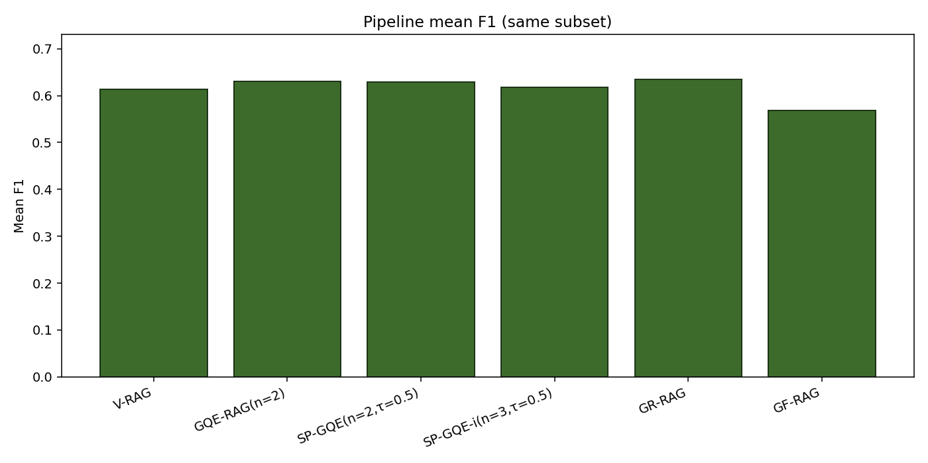
Bar chart: mean F1 by pipeline (last local run; tables above are full aggregate).

Figure: heatmap_fungi_n_tau.png
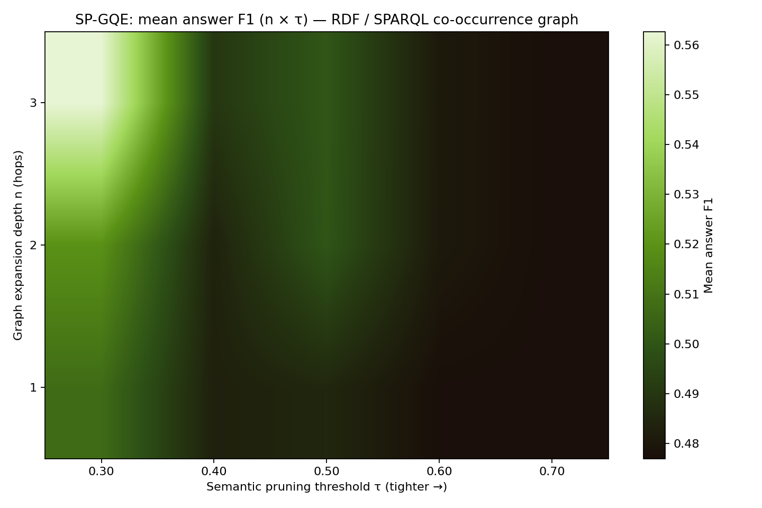
n×τ heatmap (mean F1) — single-seed sensitivity run; illustrative.

Figure: heatmap_fungi_n_tau_retrieval_p_at_k.png
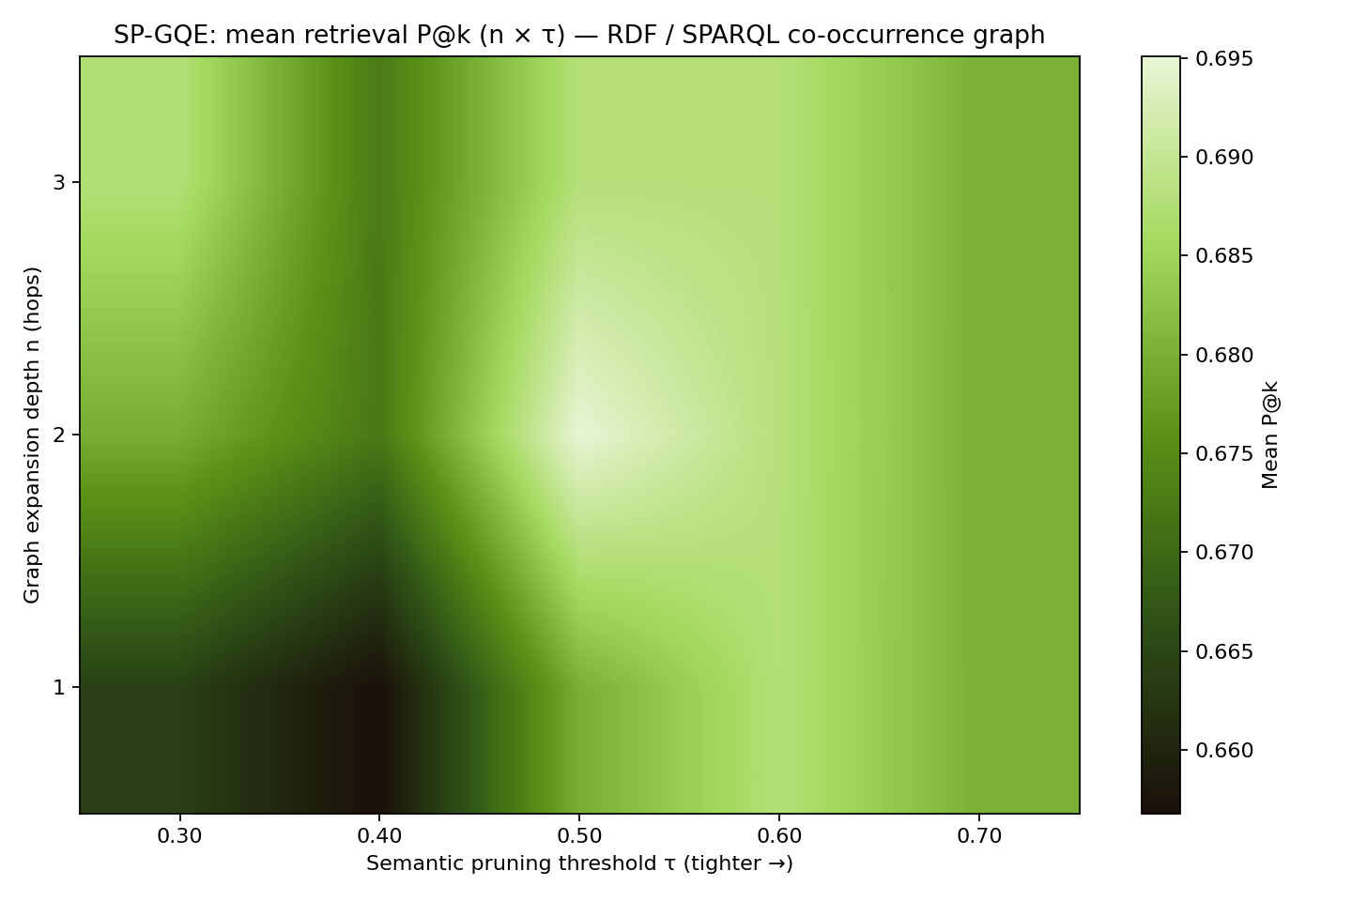
n×τ heatmap (mean P@k) — same.

5. References (selection)
- Lewis, P., et al. (2020). Retrieval-augmented generation for knowledge-intensive NLP. NeurIPS.
- Yang, Z., et al. (2018). HotpotQA: diverse, explainable multi-hop QA. EMNLP.
- Edge, D., et al. (2024). From local to global: graph RAG for query-focused summarization. (Microsoft / GraphRAG, technical).

