**UNIVERSITY OF DAR ES SALAAM**

**COLLEGE OF INFORMATI ON AND COMMUNICATION TECHNOLOGIES (CoICT)**

**DEPARTMENT OF COMPUTER SCIENCE AND ENGENEERING**



**Final year project for B.Sc. Computer Science**

**Project Title: Development of Immigration Permit System**

**BY:**

**NAME REG#**

1. **TEMAELI**, Daudi: **2009-04-05113**
2. **ANDREA**, Robert: **2009-04-00299**
3. **MARCEL**, Joseph: **2009-04-02676**
4. **MDEGELA**, Jaqlini : **2009-04-02957**
5. **CHAHE**, Karington: **2009-04-00595**

**University of Dar es Salaam**

**February, 2012**

**UNIVERSITY OF DAR ES SALAAM**

**COLLEGE OF INFORMATI ON AND COMMUNICATION TECHNOLOGIES (CoICT)**

**DEPARTMENT OF COMPUTER SCIENCE AND ENGENEERING**

**Final year project proposal for B.Sc. Computer Science**

1. **Project Title: Development of Immigration Permit System**
2. **Project Group Member**
3. ***TEMAELI, Daudi: 2009-04-05113 B.Sc. In Computer Science***
4. ***ANDREA, Robert: 2009-04-00299 B.Sc. In Computer Science***
5. ***MARCEL, Joseph: 2009-04-02676 B.Sc. In Computer Science***
6. ***MDEGELA, Jaqlini: 2009-04-02957 B.Sc. In Computer Science***
7. ***CHAHE, Karington: 2009-04-00595 B.Sc. In Computer Science***
8. **Project Core Supervisor**

*Mr Wilfred Senyoni*

**University of Dar es Salaam**

**June, 2012**

# ABSTRACT

Immigration Permit system (IPS) is an information system for processing and issuing residence permits. The use of the system is dedicated to the department of Immigration under the Ministry of Home Affairs. However, the department has encountered many problems with the use of current manual system which involves much working with hard copies and physical file handling of information. With the objective of simplifying the whole residence permit processing and granting activity, Immigration Permit System (IPS) also tries to overcome the following major technical problems in the current system.

* Provision of secure visitor information handling and storage.
* Connecting remote permit centers, system, the existing system has no link between permits centers.
* The lack of scientific immigrant’s information processing system.
* Periodic statistical report generation.
* Human errors on mathematical computations

To solve the addressed problems, the development of Immigration Permit System started with an initial stage that involved data collection which was done through open ended interview between our project team and the training staff members at the department of Immigration, Dar es Salaam Head Quarters.

In implementing the Immigration Permit System, we described the system into about six modules according to the requirement specifications namely: Users, Settings, Backups, Applications, Permit and Report. The division of the system into modules was very useful especially during the task division and distribution among the project team members, correction of errors and we expect it to play an important role during the system life time operation for troubleshooting and system updates.

Finally, the collections of component modules forms the “Immigration Permit System” which we believe rather than only decreasing the time unit for permit processing and simplify the whole work on permit processing it is also going to overcome some technical problems encountering the permit processing and granting activity.

God bless UDSM, God Bless the department of Computer Science and God bless our Project Team! Amen!

# ACKNOWLEDGEMENT

We would like to acknowledge the following people without their help; this work would never have come to completion.

Most valuable is the contribution of our supervisor Mr. Wilfred Senyoni for his time and technical guidance throughout the study. Thank you for always being there whenever we needed you and for your love and support.

Also, nothing to offer but our infinity thanks to the immigration department administration for their maximum cooperation during the system’s requirement gathering and collection, our appreciation to the training staff members Mr. James, Mr. Ikomba Mathew and Miss. Hoja Mahiba the permit officers at the department of Immigration, Dar es Salaam Head Quarters.

Our parents and benefactors who have ensured that we have whatever is necessary to complete our course successfully cannot go unmentioned. This project report shows that their financial assistance and guidance has surely not been in vain.

We would like to acknowledge each group member for making the experience of doing the project in a group worthwhile. The individual input of each member of this group cannot be underestimated and our combined effort in realizing this project report gives us satisfaction in ourselves despite the challenges faced.

Saving the best for the last, we thank the Almighty God on whose guidance and love we have always relied and thus enabled us reach this far.

# LIST OF ACRONYMS AND ABBREVIATION

1. HTML Hypertext Markup Language

2. SQL Structured Query Language

3. PHP Hypertext Preprocessor

4. CSS Cascading Style Sheet

5. IDE Integrated Development Environment

6. DBMS Database Management System

7. CoICT College of Informatics and Communication Technologies

8. IPS Immigration Permit System.

9. RDBMS Relational Database Management System

# TABLE OF CONTENTS

ABSTRACT i

ACKNOWLEDGEMENT ii

LIST OF ACRONYMS AND ABBREVIATION iii

TABLE OF CONTENTS iv

1 INTRODUCTION 1

1.1 General introduction 1

1.2 Problem definition 1

2 PROPOSED SOLUTION 3

3 PROJECT OBJECTIVES 4

3.1 Main objective 4

3.2 Specific objectives 4

4 EXPECTED APPLICATION DOMAIN AND PROSPECTED USERS OF THE SYSTEM 5

5 LITERATURE REVIEW 6

5.1 Issues related to the problem 6

6 METHODOLOGY 7

6.1 Software project model (Process framework) 7

6.2 SRS-requirements and how they were gathered 7

6.3 Analysis of requirements. 7

6.4 User requirements: 8

6.5 Functional Requirement. 8

6.6 Non Functional Requirements. 8

6.7 Tools used for development 9

7 SYSTEM DESIGN 10

7.1 System interface 10

7.2 User interfaces 10

7.3 Hardware and Software Interfaces 10

7.4 Use case diagram for immigration permit system 11

7.5 Actors description 12

7.6 Use case description 13

8 DEVELOPMENT 22

8.1 Main modules of system; 22

8.2 Database Structure 24

9 SYSTEM CAPABILITY 25

10 FURTHER DEVELOPMENT 26

10.1 Possible further development that the system can accommodate; 26

10.2 Addition modules that can be developed; 26

10.3 How does the system embrace different technology 26

11 CONCLUSION 27

11.1 System limitations 27

11.2 Recommendation 27

12 REFFERENCES 28

# INTRODUCTION

## General introduction

Handling visitor’s information in a country is the one of the most challenging process in most countries, (Kristen McCabe and Doris Meissner , January 2010) statedthat “For the country, how to manage the flow of immigrants has always been a difficult issue”, the complexity on managing the process is on how to simplify the whole permit granting activities and tracking information on already permitted visitors such as permit expire date and whether the user is doing what is stated on the permission statement document. Furthermore the whole process involves various categories of information to be managed before granting a permit, for instance all people intending to reside in the United Republic of Tanzania for business or work or for any other acceptable purpose are issued residence permits based on the following three types described by (Tanzania government, 2010):

* Class A: for self-employed foreigners (investors)
* Class B: for foreigners with jobs
* Class C: other classes of foreigner such as missionaries, students, volunteers.

The Immigration Permit System Project is the project aims to develop an information system that will be used to manage the permission granting process under the department of immigration, the system is expected to store the provided visitor particulars and to notify the immigration department staff about the visitors running whose permissions are running out of time.

## Problem definition

The immigration department has encountered many problems on the use of manual system some which are more technical that has led to recommendations on having other alternative way of handling the immigration permit providing process; the following are major technical problems facing the current system.

Provision of secure visitor information handling and storage. Visitor information are the most of very confidential information in the country that not need to be accessed without clear authorization to any one at any time so need for way to provide security mechanism on keeping and access such information.

Connecting remote permit centers, the existing system has no link between permits centers. This brings hardships to immigration officers as sometimes some caught foreigners reject to provide their particulars thus for approval they must be sent up to the centers where they were registered during their time of entrance. This brings physical tiresome it is also cost full and is time consuming.

The lack of scientific immigrant information processing system. As we are moving with the world of science and technology there is an increase in the need for speed, accuracy and highly working performance nearly in every aspect of life in both governmental and non-governmental institutions, private and public sectors. Scientific systems are more reliable, that is well organized, easy to access and improved accurate.

The generation of technical report for a certain given period on applications and permit is the other technical problem facing the current system. Since the information is poorly handled and not easily accessible generating reports such as annually class A permit granted report or application is the most challenging process the need for more simplified approach to the problem.

Regardless of the major technical problems the existing manual system has been leading to time wastage as it may take a number of days to issue a permit of just a single customer. Different stages that the application must pass through for approval is associated with several delays due to different complications that arise because of the hardship of running the manual system as a result the overall completion of the whole process until the customer gets his or her permit takes longer.

However, human errors on mathematical computation are the other major problem on the current system that may be eliminated through implementation of the stated technical problems. All mathematical computations are done manually especially financial transactions which need high handling accuracy.

# PROPOSED SOLUTION

The following are the proposed solutions will achieve the above stated problems

For the problem of security and storage, the system is encrypted with user name and password thus only the authorized users with correct user account will be illegible in accessing the system. It has a secure database that stores permit information in a software manner thus can’t be deteriorated easy. The administrator of the system can make a backup of the system at remote external source for more security and reliability incase it crashes.

The system is running on line hence any centre countrywide can log in to it provided that is given the account, with the use of the system recourses will be shared between centers therefore the problem in communication between centers is combated by the system.

The system is integrated with high skills of science and technology as has deployed variety of technologies in its development for the aim of ensuring that it works at high speed, accuracy and ensures data integrity. In copes with the current development of science and technology as it runs in cross browsers and can support variety of hardware platforms.

The system also generates report that gives the detailed information about the number of permits that are granted; those which are still in process and rejected permits in a given interval of time. This simplifies analysis process and quantifies the process time to time.

The solutions provided above are relevant since have solved the addressed problem to some extent. They have also involved the modern technology and hence the system cops with the current evolution of science and technology.

# PROJECT OBJECTIVES

## Main objective

* To create information system for residence permit processing activity. Developing a secure and user friendly system that will help the simplification of residence permit issuing process.

## Specific objectives

* Automation on how the residence permits are processed.
* Connecting remote permit centers by the use of one system to simplify inter-communication among them.
* Provide means for automatic mathematical computation on permit application fees.

# EXPECTED APPLICATION DOMAIN AND PROSPECTED USERS OF THE SYSTEM

The Immigration Permit System is a system specifically designed for processing residence permits and delivery. The system consists of the following users:

1. Administrator
2. Officers
3. Permit officer
4. Commissioner officer
5. Principal commissioner
6. Writers
7. Immigration officer

**Administrator** will be able to perform administrative tasks in the system such as creating accounts of users, block user, activate user, create backups, restore backups, view system logs, settings, to search, to change and reset passwords.

**Officers** will be able to deal with applicant information entry, to deal with attachments, having minute talk, to search, view profile, edit profile reset password and change password.

**Permit officer** will be able to view application, having minute talk, to search, view profile, edit profile reset password and change password.

**Commissioner Officer** will be able to filter information, having minute talk, to search, view profile, edit profile reset password and change password.

**Principal Commissioner** will be able to approve the permit, to search, view profile, edit profile reset password and change password.

**Writers** will be able to write permits, print permits, to search, view profile, edit profile reset password and change password.

**Immigration officer** will be able to view permits, to search, view profile, edit profile reset password and change password.

This new system will increase accuracy and safety of the stored records, improve reports since data are being stored in a computer so they will be manipulated well and ultimately in higher profitability.

# LITERATURE REVIEW

## Issues related to the problem

In most developed countries the process of issuing residence permit has been automated, people can apply for residence in remoteness and application get processed in definite amount of time, for instance can apply for residence in Miami America online through using the website by (Revilla Law Firm, 2011), this has improved the way of handling immigrant information, reduced permit processing time and simplified the way through which are processed.

As for most developing countries immigration permit issuing is still a very challenging process, both the immigrants and governments still facing complexities in managing the activity. As (Rileys, 2011) in Uganda claims “I thought I’d update readers on our work permit application (yes it’s a long one!). As you may have previously read you can’t formally start work in Uganda until you have a work permit. You can however obtain a ‘special pass’ which usually lasts 3 months, while your work permit is being processed.

Firstly to check a work permit application you must check the ‘red’ folder which is usually kept outside room 2. Room 2 is only identified and accessed from within another room so you really have to ask someone where it is if you don’t already know. The ‘red’ folder occasionally goes ‘walk about’ – either someone will be updating it or someone will just wander off with it. When you eventually get hold of the ‘red’ folder you have to check your file number to see if your application has been accepted, rejected or is awaiting further information. There is no quick way of doing this I’m afraid so it is just a case of going through each page checking hundreds of file numbers to see if yours is included. If your file number is not listed, like ours, then you have to ask an official to investigate the situation. I was told to speak with one of the Directors of Immigration, a Mr. Beynon. He’s a very busy guy but knows what is going on with applications and is more than happy to sit and look at your particular application. I was told that our application was still in the pipeline so I would need to obtain further ‘special passes’ for Keren and myself until our application has been processed.  This cost us an extra $100 each and you can't query it even if the delay in your work visas being issues has been caused by them.”

This shows how complicated it is, time consuming and how costly is to process the residence permit in developing countries.

In Tanzania, application and handling visitor information is also still an undefeated challenge, the system is still done manually which has made the whole process unreliable, difficult to manage and control hence need for alternative solution.

# METHODOLOGY

## Software project model (Process framework)

Waterfall model is an approach we are going to use in developing Immigration Permit System. This takes the fundamental process activities of specification, development, validation and evolution and represents them as separate process phases such as requirements specification, software design, implementation, testing and so on. We will use it because of the need for parallel development of different parts of the system.

***WATERFALL MODEL***

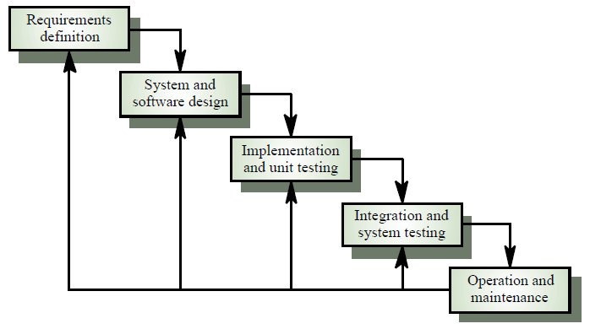

## SRS-requirements and how they were gathered

Most of the information on the project requirements was collected from the Tanzania immigration department through open interview and more about information system manual and guidelines from the computer science department at university of Dar es salaam.

## Analysis of requirements.

This section outlines all the main feature of Immigration Permit System basing on their categories as outlined below:-

## User requirements:

* One that is user friendly and intuitive
* One that is fast in producing results
* One that is user friendly and intuitive
* A system that would make it easy to retrieve information concerning the visitors
* A system that has an element of consistency especially on the interfaces
* A system that is easy to learn, adapt, use and memorize.

## Functional Requirement.

These are statements of services the system should provide, these include how the system should behave in particular situation and how the system should react to particular inputs. The system allows different users to do the following;

* Administrator is able to create users accounts, block user, activate user, create backups, restore backups, view system logs, settings, to search, to change and reset passwords.
* Officers are able to deal with applicant information entry, to deal with attachments, having minute talk, to search, view profile, edit profile reset password and change password.
* Permit officer can view application, having minute talk, to search, view profile, edit profile reset password and change password.
* Commissioner Officer is able to filter information, having minute talk, to search, view profile, edit profile reset password and change password.
* Principal Commissioner is able to approve the permit, to search, view profile, edit profile reset password and change password.
* Writers write permits, print permits, to search, view profile, edit profile reset password and change password.
* Immigration officer views permits, to search, view profile, edit profile reset password and change password.

## Non Functional Requirements.

These are constraints on the services or functions offered by the system such as timing constraints, constraints on the development process, standards etc. The following are non-functional requirements:

* The system platform is web based.
* The user is informed any error and inapplicable input data
* The interface is simple and easy to use
* The user is informed on whether a task is completed
* It generates reports and queries at a very fast rate.
* The software is easy to download and install given the correct hardware support
* It is reliable, the system can be installed on hardware that is of reasonable purchase, easy to repair, maintain and replace.
* The results generated are easy to interpret.

## Tools used for development

The following tools were used in developing the system;

HTML stands for HyperText Markup Language used for web page development; it is the central language that can read web pages, well understood by web browsers, ability in linking, validating pages and suitable for displaying images and forms.

PHP for Web Scripting, it is also a powerful tool for making dynamic and interactive web pages. It is popular technology for developing complex web application with amazing features. It also has the ability to interact with database.

MySQL database management system, (Janet Valade, 2004), is a fast and easy-to-use RDBMS used for databases on many Web sites. Made of fewer features to improve speed, even though MySQL is less full featured than its commercial competitors, it has all the features needed by the large majority of database developers.

Web browser is a piece of software that runs of personal computer and enables to view web pages. Web browsers, often simply called “browsers”, interpret the HTML code and provide a visual layout displayed on the screen.

IDEs, an integrated development environment is a software application that provides comprehensive facilities to computer programmers for software development.

(Wikipedia, March 2012)

Apache Web server, (Janet Valade, 2004) states that although PHP works with several Web servers, it works best with Apache. If you can select or influence the selection of the Web server used in your organization, select Apache. By itself, Apache is a good choice.

# SYSTEM DESIGN

## System interface

The IPS is the web-based project unit management system. It is intended to implement all IPS's features for processing permits. All components follow Model-View-Controller pattern.IPS import packages that can either connect to an Oracle database or MySQL database through the Database Utility components. The possible extension is to inter-connect to the Link System which provides users with many functions.

## User interfaces

All pages of the system are following a consistent theme and clear structure. The occurrence of errors are minimized through the use of checkboxes, radio buttons and scroll down in order to reduce the amount of text input from user. JavaScript is implemented in HTML in order to provide a Data Check before submission. HTML Tables to display information to give a clear structure that is easy to understand by user. Error message are located beside the error input which clearly highlight and tell user how to solve it. If system error, it provides the contact method. Each level of user will have its own interface and privilege to manage and modify her/his profile information

## Hardware and Software Interfaces

The system is a web based application; clients are requiring using a modern web browser such as Mozilla Firebox 1.5, Google chrome, Internet Explorer 8 or more and Enable Cookies. The computer must have an Internet connection in order to be able to access the system.

An OS is capable of running a modern web browser which supports HTML version 3.2 or higher.

## Use case diagram for immigration permit system

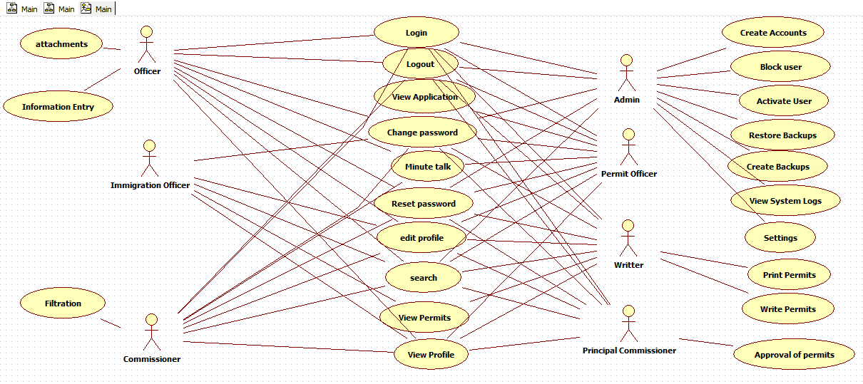

## Actors description

|  |  |  |
| --- | --- | --- |
| LABEL | ACTOR | DESCRIPTION |
| 1 | Administrator | He/she is a person who manages a system. Administrator can   * Create user accounts * Block/Activate user * Create backups * Restore backups * View system logs * System settings * Search * Manage profile |
| 2 | Officers | They deal with receiving applications and applicants information entry, also they can   * Search * Having minute talk * Manage their profiles |
| 3 | Permit Officer | He/she validates applicants information and their attachments and forward to the commissioner, also she/he can   * View application * Having minute talk * Search * Manage profile |
| 4 | Commissioner Officer | Receives the information from permit officer, conversation is held by having minute talk then information is filtered. He/she can   * Search * Manage profile * View applications |
| 5 | Principal Commissioner | A person who has a final say, he/she approves for provision of permits. He/she can   * Search * Manage profile |
| 6 | Writers | They write permits after completion of applicant’s payments, they can also   * Print permit * Search * Manage profile |
| 7 | Permit Officers | Their role is to track visitors whose permits expired. They are able to;   * View permits * Search * Manage user |

## Use case description

**USECASE 1**

|  |  |
| --- | --- |
| NAME | LOGIN |
| ACTOR | Administrator, officer, permit officer, commissioner, principal commissioner, writers and permit officer |
| PRE CONDITION | User of the system must have an account which was created by the administrator  The user should supply username and password in order to login |
| POST CONDITION | When the user logs in successfully, he/she can be able to perform anything according to his/her privilege |
| DESCRIPTION | This is the use case where by the user should provide username and password to login into the system  Enables users to have access to the system |
| EVENT | User click on the login button then he/she will be directed to her/his home page which contains functionalities according to the user privilege. |

**USECASE 2**

|  |  |
| --- | --- |
| NAME | CREATE ACCOUNT |
| ACTOR | Administrator |
| PRE CONDITION | A valid user must login as Administrator |
| POST CONDITION | Distinct accounts for different users of the system are created |
| DESCRIPTION | Enables the administrator to create accounts for new users of the system  The use case begins when the administrator selects Add new user, then he/she fill user details and account details  The administrator confirms the username and password for the user |
| EVENT | The Administrator has to click a manage user link that takes him to where he/she can creates new accounts. |

**USE CASE 3**

|  |  |
| --- | --- |
| NAME | EDIT PROFILE |
| ACTOR | Administrator, officer, permit officer, commissioner, principal commissioner, writers and permit officer |
| PRE CONDITION | A valid user must be logged into the system |
| POST CONDITION | The system contains new records of user if any changes were made and the system keeps history of the changes made |
| DESCRIPTION | User can change his first name, last name and email incase of any incorrectness but she/he can’t change username and role in the system |
| EVENT | The user has to click on the edit my profile link and the system requests information for that user from the database and is presented in a form, in which now the user can change the details, after editing then he/she can click update profile link for changes to be saved in a database. |

**USECASE 4**

|  |  |
| --- | --- |
| NAME | VIEW PROFILE |
| ACTOR | Administrator, officer, permit officer, commissioner, principal commissioner, writers and permit officer |
| PRE CONDITION | A valid user must be logged into the system |
| POST CONDITION | User’s profile information is displayed showing his/her first name, last name, email, username and role. |
| DESCRIPTION | User can view profile whenever he/she is in any page of his/her privilege. |
| EVENT | The user has to click on the word Hello and some optional functionalities are displayed including view profile, by clicking it user can view his/her profile |

**USECASE 5**

|  |  |
| --- | --- |
| NAME | SEARCH |
| ACTOR | Administrator, officer, permit officer, commissioner, principal commissioner, writers and permit officer |
| PRE CONDITION | A valid user must be logged into the system |
| POST CONDITION | Details of a searched user are displayed |
| DESCRIPTION | Use case enable a user to get specific information |
| EVENT | User has to type the required information on a search box at the top in the right side of the page and then click enter to get a specific information |

**USECASE 6**

|  |  |
| --- | --- |
| NAME | LOGOUT |
| ACTOR | Administrator, officer, permit officer, commissioner, principal commissioner, writers and permit officer |
| PRE CONDITION | A valid user must be logged into the system |
| POST CONDITION | The user exit from the page she/he was to the index page |
| DESCRIPTION | The use case begins when user click on the link Hello where there is ‘log off’ option the system then takes the user away from the page to the index page of the system |
| EVENT | The user will have to click on the log off link, the database connection is terminated and user is taken way to the index page |

**USECASE 7**

|  |  |
| --- | --- |
| NAME | CHANGE PASSWORD |
| ACTOR | Administrator, officer, permit officer, commissioner, principal commissioner, writers and permit officer |
| PRE CONDITION | A valid user must be logged into the system |
| POST CONDITION | The user’s password is changed |
| DESCRIPTION | The use case begins when user hover the icon Hello where there is ‘change my password’ option the system then takes the user to the page of changing password where there will be options of filling the old and new password. |
| EVENT | The user will have to click on the change my password link after clicking to the icon Hello, the link will direct him/her to the page where old and new password will be filled and after confirming the new password and then clicking the change password button, password will be changed in the database. |

**USECASE 8**

|  |  |
| --- | --- |
| NAME | RESET PASSWORD |
| ACTOR | Administrator, officer, permit officer, commissioner, principal commissioner, writers and permit officer |
| PRE CONDITION | A valid user must be logged into the system |
| POST CONDITION | New password is reset |
| DESCRIPTION | The use case start when user has forgotten his/her password during login process, by clicking the link “forgot password”, user must write username and email which were used during account creation and the new password will be sent to his/her e-mail |
| EVENT | The user has to click on the link “forgot password” then after filling the required information he/she has to click “reset password ” to get new password from his/her e-mail. |

**USECASE 9**

|  |  |
| --- | --- |
| NAME | VIEW APPLICATION |
| ACTOR | Permit officer and Administrator |
| PRE CONDITION | A valid user must be logged into the system |
| POST CONDITION | Applicants information are displayed |
| DESCRIPTION | The use case begins when user click on application link he/she is directed to the page containing applicants information |
| EVENT | The user will have to click on the “application” link then applicants information will be retrieved from the database |

**USECASE 10**

|  |  |
| --- | --- |
| NAME | VIEW PERMITS |
| ACTOR | Immigration officer and writers |
| PRE CONDITION | A valid user must be logged into the system |
| POST CONDITION | Processed permits are displayed |
| DESCRIPTION | The use case begins when user click on “permit” link to the left where there are information concerning the permits and they can be viewed well when the link “more” is clicked |
| EVENT | The user will have to click on the “permit” he/she is directed to the page of permits information and when the word “more” is clicked the full permit of selected applicant will be displayed |

**USECASE 11**

|  |  |
| --- | --- |
| NAME | BLOCK USER |
| ACTOR | Administrator |
| PRE CONDITION | A valid user must login as Administrator |
| POST CONDITION | Users with blocked accounts will be unable to access the system |
| DESCRIPTION | Used to make an account inactive for a certain period of time. The administrator selects the account to be blocked, “Block user” option is then selected, and the administrator confirms to block selected user. When confirmed, the account is blocked. |
| EVENT | The Administrator has to click a manage user link that takes him/her to where he/she can bock a user account |

**USECASE 12**

|  |  |
| --- | --- |
| NAME | CREATE BACKUP |
| ACTOR | Administrator |
| PRE CONDITION | A valid user must login as Administrator |
| POST CONDITION | Backup is created |
| DESCRIPTION | The use case helps to keep the current information of the database. This information is useful when the system crush |
| EVENT | Administrator has to click on the “Backups” and he, she will be directed to the page where backup can be created by clicking the link backup system |

**USECASE 13**

|  |  |
| --- | --- |
| NAME | RESTOR BACKUP |
| ACTOR | Administrator |
| PRE CONDITION | A valid user must login as Administrator |
| POST CONDITION | Backup is restored |
| DESCRIPTION | The use case helps to retrieve the current information of the database. This information is useful for the crushed system |
| EVENT | Administrator has to click on the “Backups” and he, she will be directed to the page where backup can be restored by clicking the icon indicating “restore backup” at the right side of the backup page |

**USECASE 14**

|  |  |
| --- | --- |
| NAME | WRITE PERMITS |
| ACTOR | Writers |
| PRE CONDITION | A valid user must login as writer |
| POST CONDITION | Permit is written |
| DESCRIPTION | Here the writer has to fill some blanks concerning applicant information |
| EVENT | Writer has to click on the “application” link and he/she will be directed to the page where permit can be written by clicking the icon indicating “write permit” |

**USECASE 15**

|  |  |
| --- | --- |
| NAME | PRINT PERMITS |
| ACTOR | Writers |
| PRE CONDITION | A valid user must login as writer |
| POST CONDITION | Permit is printed |
| DESCRIPTION | The use case helps to get a permit in a form of hardcopy which can be given to a qualified applicant |
| EVENT | Writer has to click on the “permit” link and he/she will be directed to the page where permit can be printed by clicking the icon indicating the printer at the top on the right side of page |

**USECASE 16**

|  |  |
| --- | --- |
| NAME | PERMITS APPROVAL |
| ACTOR | Principal Commissioner |
| PRE CONDITION | A valid user must login as principal commissioner |
| POST CONDITION | Approved Permit is ready for the provision |
| DESCRIPTION | In this use case Principal commissioner conclude whether the permit should be given to the applicant or not. |
| EVENT | Principal commissioner has to click on the “application” link and he/she will be directed to the page where permit can be approved by clicking the icon indicating “approve permit” |

**USECASE 17**

|  |  |
| --- | --- |
| NAME | ACTIVATE USER |
| ACTOR | Administrator |
| PRE CONDITION | A valid user must login as Administrator |
| POST CONDITION | Users with activated accounts will be able to access the system |
| DESCRIPTION | Used to make an account inactive for a certain period of time. The administrator selects the account to be blocked, “Block user” option is then selected, and the administrator confirms to block selected user. When confirmed, the account is blocked. |
| EVENT | The Administrator has to click a manage user link that takes him/her to where he/she can activate a blocked user |

# DEVELOPMENT

## Main modules of system;

The IPS has six main modules integrated together. These modules are;

* Managing users

This module enables users of the system to perform several operations. The users of the system are Admin, Permit Officer, Writer, and Principal Commissioner. These are managed in the way that each user can perform a certain operation to the system depending on the privilege. Some operations are related thus require synchronization on how to schedule them. The principal user of the system is the admin who has the privilege of managing other users. He manages other users in different ways like deleting other users and adding new users.

* Settings

This module enables the user of the system to perform system settings, some of the settings that the user does is the cost setting in which the Changes of the cost is done.

* Backups

In this module the backup of the system is done. There are three actions that are done in this module namely, downloads backup, Delete backup and Restore backup. In downloading the backup, a user retrieves a selected backup individually and saves it to the local source thus can be used even when the user is logged out.

In deleting the backup, the action involves permanent removing of the entire backup from the list of backup. The backup and its associated information are erased. In restoring the backup the system restores the database permanent.

* Permits

This module contains the core functions of the system. This is where the permit is issued, and all information concerning the permit is viewed. It contains digestible information for the beholder of the permit. These information include Holder’s name, Date at which the permit was issued, Number of years through which the permit is valid and the expire date. For a given selected permit the system provides a shortcut to the user the status of the permit whether expired or still valid. It also gives the status of the officer who has issued a given permit and the option to view more information at which the whole issued permit will be seen.

* Application

Here is where the new application is launched. In this module, the user applies for the permit by filling the form that will need all particulars to identify him/her .The application is then minted through a number of ranks and finally once is approved positively, it is sent to the specified officers to notify the customer for payment to be done. After the payment is done, the application is finished and the system keeps records for further reference. The issued permit can also be viewed, edited and attachments associated with the permit are viewed in this module.

* Report

It is from this module where the report is generated, This gives a straight forward means on identifying what the system has done in the given time interval. The reports that are generated by the system includes, Number of granted, in process and rejected permits .It further linked to the individual specifications to which one of the specified operation is done.

## Database Structure

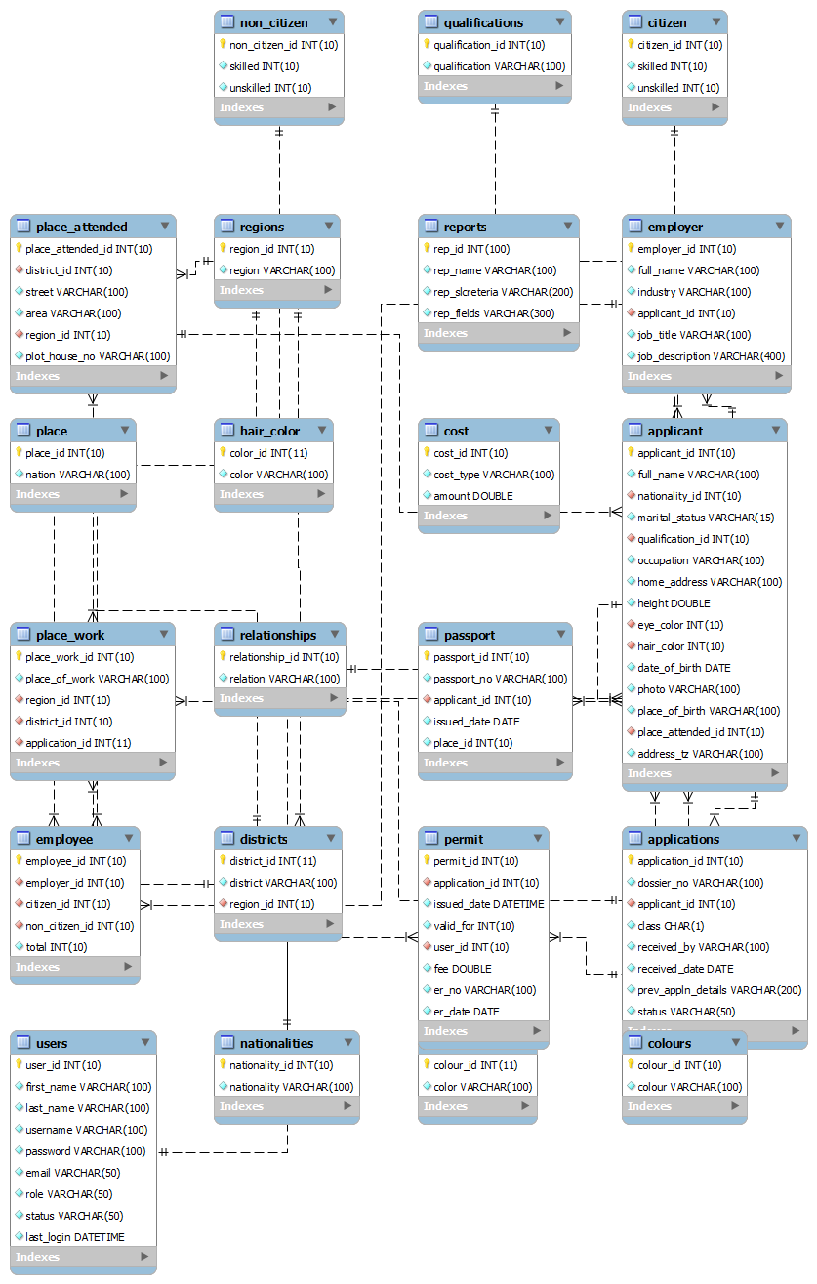

# SYSTEM CAPABILITY

The system is capable of doing the following operations;

* Keeping records of all in process issued and rejected permits.
* Providing the status of the permit whether valid or expired
* It is integrated with the webcam for security issues.
* Providing a report according to the user request

The system can run on any machine with memory of at least 128MB RAM. Also the machine must have the processor speed of at least 256MHz for it to run.

# FURTHER DEVELOPMENT

## Possible further development that the system can accommodate;

There are functionalities performed in Immigration department which we were not able to implement due to a limited time of project, some includes the following:

* Other types of permits like Exemption certificate, Dependant pass, special pass, CTA were not implemented
* Functionality like minute talk was not implemented
* Application file attachments was also not implemented

## Addition modules that can be developed;

* Developing means of associating application with mobile platformlike Blackberry, iOS, Simbian Operating Systems
* On line application from the scratch, the initial data should be entered by the remote client who is the customer unlike to this system in which there is a dedicated officer for entering prior data.

## How does the system embrace different technology

Our system supports several technologies as it can run on different hardware platforms, runs on different operating systems like WINDOW and LINUX. In the development phase it has also tested using different technologies as it runs on both WAMPP and XAMPP servers on the local host. On top of that the system has developed with browser compatibility hence supports several browsers like Internet Explorer, Mozilla Firefox and Google Chrome.

# CONCLUSION

The project identified the problems that exist in the current manual system. Through interviewing staff members, various problems were identified and modeled the resultant system requirements based on solution required to solve those problems. This led to the system that somehow answers the question posed.

## System limitations

The implementation of IPS faced numerous challenges among which include the following;

* Cold welcome from clients in a department during requirements collection believing that the information is confidential
* Limited time space given the technologies involved in the implementation
* Limited facilities like printers
* Appointment delays thus requirements were not obtained in appropriate time

## Recommendation

This part concludes on the ideas that were thought to be better for efficiency of the system but were not implemented for some reason. These recommendations are;

* Clients should appreciate the changes in technology, especially the need of automated residence permit system.
* The time schedule for the system development is not enough as it starts from the second semester; it could rather start right from the first semester.
* The department should encourage students to centre to other fields of IT like security issues rather than always developing systems.

# REFFERENCES

Janet Valade (2004). ***PHP & MySQL for DUMMIES Second edition,*** Canada: Wiley Publishing, Inc.

Jon Docket (2009). ***Beginning Web Programming with HTML, XHTML, and CSS.*** Canada***:*** Wiley Publishing, Inc.

Joseph S. Valacich, Joey F. George, Jeffrey A. Hoffer (2010). ***Essentials of Systems Analysis and Design.*** USA: Pearson Education, Inc.

Kristen McCabe and Doris Meissner (January 2010), www.immigratin.about.com retrieved on Thursday, 1st January, 2012

Open Source Initiative (2011), www.opensource.org/docs/definition.php retrieved on Thursday, 1st January, 2012

Rileys (2011), www.rileysinuganda.blogspot.com retrieved on Tuesday, 20th March, 2012

Tanzania government (2010), www.**tanzania**.go.tz retrieved on Thursday, 1st January, 2012

NETCRAFT LTD (2012) www.netcraft.com retrieved on Thursday, 1st January, 2012

Wendy Willard (2003). ***HTML a Beginner’s Guide Second edition***. USA: McGraw-Hill Companies, Inc.

Wikipedia (March 2012), en.wikipedia.org/wiki/integrated_development_environment retrieved on Wednesday, 21st March 2012