Barredo, Felix Simon BSIT-3B

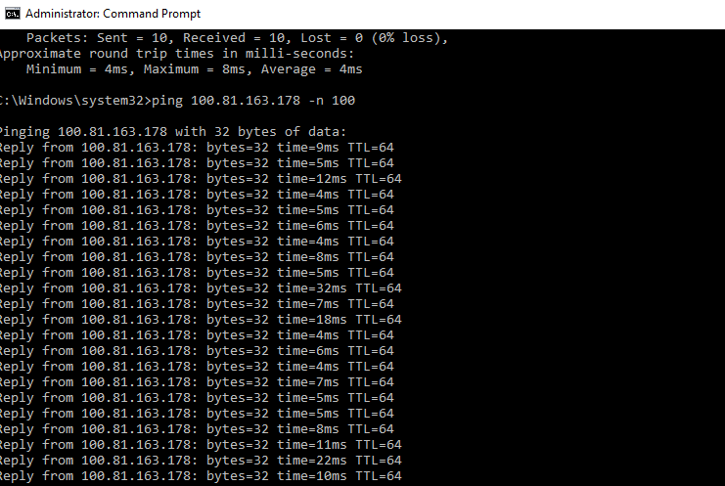Task 1

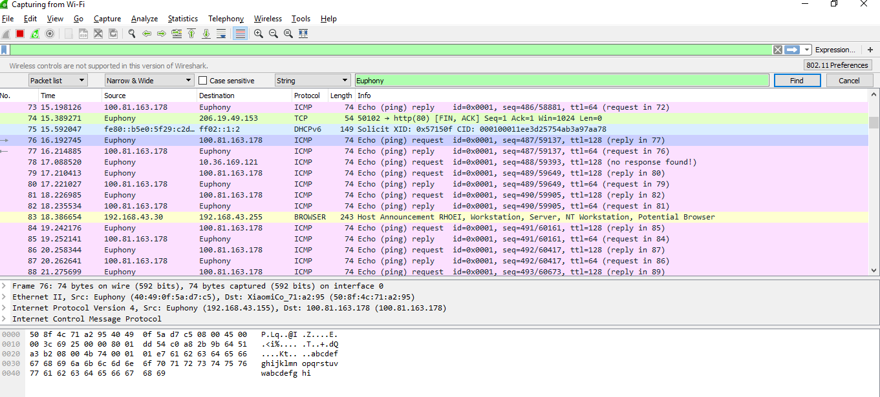

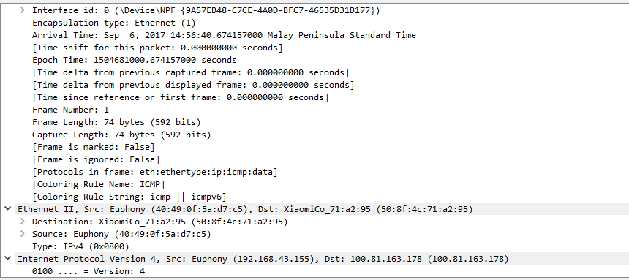

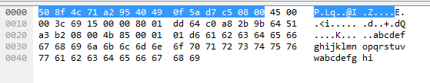

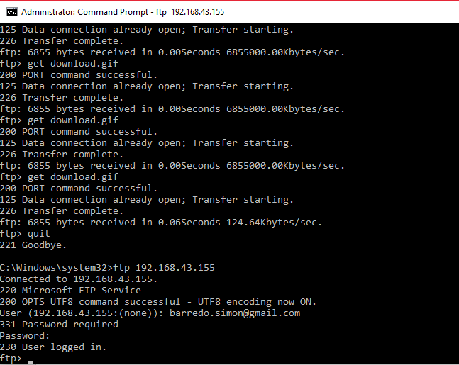Task 2

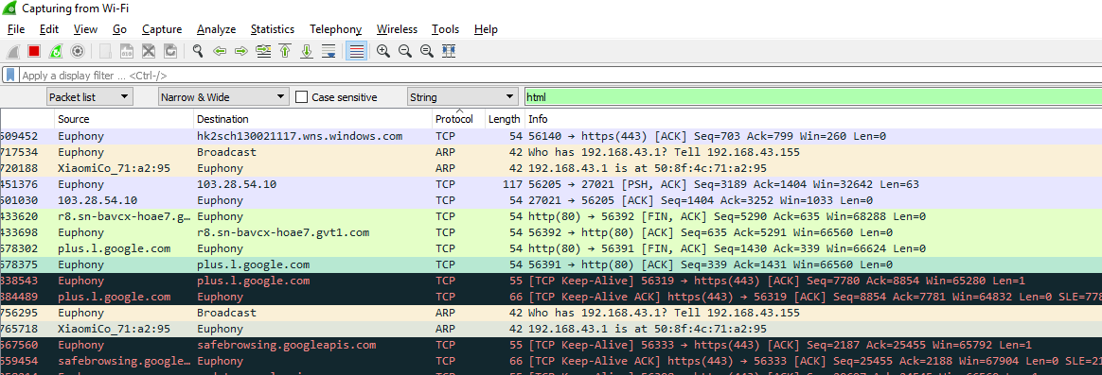

Task 3

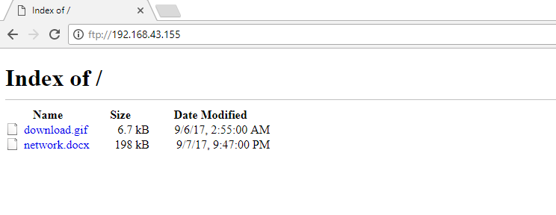

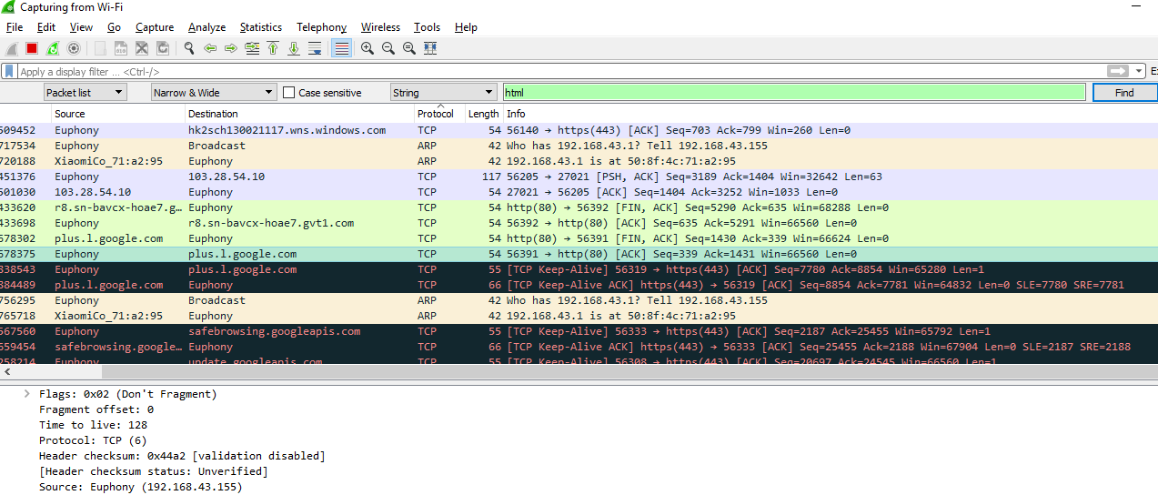

Task 4

The TCP/IP, Transmission Control Protocol/Internet Protocol, is a suite of communications protocols used to interconnect network devices on the Internet. TCP/IP implements layers of protocol stacks, and each layer provides a well-defined network services to the upper layer protocol.

The Open Systems Interconnection model (OSI model) is a [conceptual model](https://en.wikipedia.org/wiki/Conceptual_model) that characterizes and standardizes the communication functions of a [telecommunication](https://en.wikipedia.org/wiki/Telecommunication) or computing system without regard to their underlying internal structure and technology. Its goal is the interoperability of diverse communication systems with standard protocols. The model partitions a communication system into [abstraction layers](https://en.wikipedia.org/wiki/Abstraction_layer).

The Wireshark is used for network troubleshooting, analysis and communication protocol development. With Wireshark you can capture protocol to differ model.