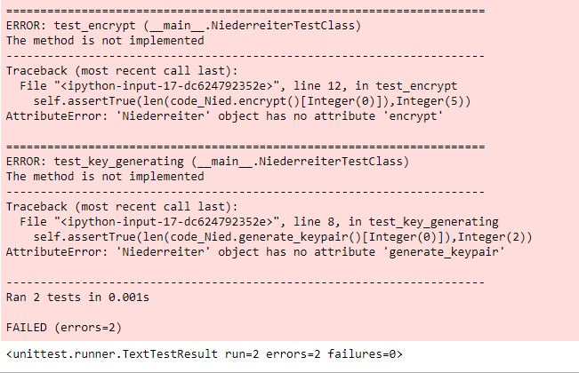

1. Print screen that shows that the methods are missing so the tests fail

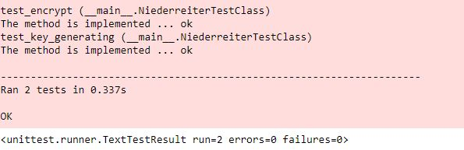

1. Print screen that shows the tests are passing