Nowcasting Australian GDP Growth
A point-in-time evaluation of bridge equations and a dynamic factor model
Independent research project · generated 2026-07-25

Abstract
This project builds a point-in-time nowcasting system for Australian quarterly real GDP growth using monthly indicators published by the ABS and RBA. Because official GDP is released roughly nine weeks after a quarter ends, the current quarter is systematically unmeasured; the system estimates it from labour-market, trade, construction and financial data that arrive earlier. The central methodological commitment is a strictly point-in-time backtest: every observation carries the date it was actually published, so no forecast can use information unavailable at the time. Across a 1993–2019 out-of-sample evaluation, a rolling-window average of bridge equations was the most accurate model, improving on a rolling-mean benchmark by 2.5%, with accuracy rising as monthly data accrued through the quarter. The improvement was not statistically significant (Diebold–Mariano test), and a mixed-frequency dynamic factor model did not outperform the simpler combination. The result is a credible negative finding: standard indicators provide limited, non-significant uplift for Australian GDP at a one-quarter horizon, and model complexity is not rewarded on a short sample.

1. Introduction and motivation
Gross domestic product is the headline measure of economic activity, but it is published with a long delay and at quarterly frequency only. In Australia the ABS releases the national accounts approximately 65 days after the reference quarter closes, so at any given moment the most recent completed quarter has no official GDP figure. Policymakers, markets and forecasters therefore rely on "nowcasting": inferring current activity from higher-frequency indicators that are published sooner — employment, hours worked, retail and household spending, building approvals, trade flows and financial variables.
This project implements and rigorously evaluates such a system for Australia. The emphasis is not on a single model but on an honest evaluation framework: the central question is whether monthly indicators genuinely improve on naive benchmarks once look-ahead bias is eliminated. The distinction matters because nowcasting results are unusually easy to inflate — a one-line timing error that lets a model see data from the future can produce large but entirely spurious accuracy gains.

2. Data
The target is quarter-on-quarter growth in real GDP (chain volume measures, seasonally adjusted; ABS 5206.0). Predictors are drawn from monthly ABS and RBA series. All data is publicly available and retrieved programmatically via the readabs package. Table 1 lists the series, their native frequency, the stationarity transform applied, and — critically — the publication lag used to determine when each observation became known.
Series | ABS ID | Cat. | Freq | Lag (d) | Transform
gdp growth | A2304402X | 5206.0 | Q | 65 | pct
employment | A84423043C | 6202.0 | M | 26 | mean_then_pct
unemployment rate | A84423050A | 6202.0 | M | 26 | mean_then_diff
hours worked | A84426277X | 6202.0 | M | 26 | mean_then_pct
building approvals | A422070J | 8731.0 | M | 38 | mean_then_pct
household spending | A130200584T | 5682.0 | M | 40 | mean_then_pct
goods exports | A2718577A | 5368.0 | M | 40 | mean_then_pct
Table 1. Series registry. Publication lags are conservative upper bounds verified against the ABS release calendar.
Publication lags were verified against the ABS release calendar and set to conservative upper bounds: where a release date varied month to month, the longest recent delay plus a small buffer was used. This biases the system against itself — it occasionally discards data it could legitimately have used — so measured accuracy is a lower bound on what a real-time forecaster could achieve. The balanced-panel sample begins 1983Q3, constrained by the shortest long-history series; the Monthly Household Spending Indicator (from 2012) is used only by the factor model, which handles a ragged left edge.

3. Methodology

3.1 Point-in-time data and the ragged edge
Every observation is stored in a long panel stamped with an availability date equal to the end of its reference period plus its publication lag. A "snapshot" as of any date is formed by keeping only rows whose availability date precedes it. Because series publish at different speeds, the most recent months form a staircase pattern — the ragged edge — in which faster indicators (labour force) extend further than slower ones (trade, construction). This construction makes look-ahead bias structurally impossible rather than a matter of discipline, and is enforced by an assertion in the backtest and by unit tests that deliberately inject leakage and confirm it is caught.

3.2 Stationarity
Level series were transformed to stationary form — percentage changes for volume/value series, first differences for rates. Augmented Dickey–Fuller tests confirm stationarity of the resulting regressors (Table 2).
Series | ADF stat | p-value | Stationary (5%)
building approvals | -9.71 | 0.0000 | yes
employment | -11.06 | 0.0000 | yes
gdp growth | -17.30 | 0.0000 | yes
goods exports | -6.67 | 0.0000 | yes
hours worked | -13.28 | 0.0000 | yes
household spending | -7.80 | 0.0000 | yes
unemployment rate | -6.20 | 0.0000 | yes
Table 2. Augmented Dickey–Fuller tests. The null of a unit root is rejected for every regressor.

3.3 Bridge equations
A bridge equation regresses quarterly GDP growth on the quarterly reading of a monthly indicator, using whatever months of the target quarter have been published. Two construction choices matter. First, monthly indicators enter as levels and the regressor is the change in the quarterly average level — the same quantity GDP is measured on — rather than an average of monthly growth rates; a controlled test showed this recovers true quarterly growth with roughly 60% lower error when only one month is available. Second, estimation uses a 40-quarter rolling window, because Australian trend growth has declined over the sample and an expanding window anchors the intercept on a stale, higher average — the same mechanism that makes a rolling mean outperform an expanding mean here.

3.4 Dynamic factor model
The bridge equations read each indicator in isolation. A mixed-frequency dynamic factor model instead treats all indicators as noisy signals of a common latent factor — the business cycle — estimated by the Kalman filter and EM algorithm (statsmodels DynamicFactorMQ). It ingests monthly and quarterly series at their native frequencies, handles the ragged edge natively, and can incorporate the short-history spending series. This is the architecture underlying the New York Fed Staff Nowcast.

3.5 Evaluation
Models are evaluated by expanding-window pseudo-out-of-sample forecasting: one nowcast per GDP release, the model refit from scratch on exactly the data visible at that vintage. To trace how accuracy improves within a quarter, the backtest is run at 0, 30, 60 and 80 days after each release. Accuracy is summarised by RMSE and MAE, and differences are tested with the Diebold–Mariano test rather than read off raw RMSE, since with roughly one hundred forecasts small gaps are not statistically meaningful.

4. Results

4.1 Model comparison
Table 3 ranks all models at the richest information set (80 days after the prior release), on the 1993–2019 sample that excludes both the volatile 1970s–80s and the COVID shock. bridge average achieved the lowest RMSE.
Model | RMSE | MAE | Bias | vs benchmark
bridge average | 0.5233 | 0.3957 | +0.026 | 2.5% better
bridge employment | 0.5358 | 0.3985 | +0.024 | 0.2% better
rolling mean | 0.5369 | 0.4009 | +0.019 | baseline
bridge hours worked | 0.5373 | 0.4073 | +0.027 | 0.1% worse
bridge avg expanding | 0.5392 | 0.4129 | +0.037 | 0.4% worse
bridge unemployment rate | 0.5394 | 0.4142 | +0.051 | 0.5% worse
bridge building approvals | 0.5403 | 0.4069 | +0.015 | 0.6% worse
ar1 | 0.5449 | 0.4184 | +0.114 | 1.5% worse
mean | 0.5457 | 0.4213 | +0.108 | 1.6% worse
bridge goods exports | 0.5518 | 0.4215 | +0.013 | 2.8% worse
ar aic | 0.5570 | 0.4382 | +0.108 | 3.7% worse
ridge | 0.5669 | 0.4397 | +0.028 | 5.6% worse
Table 3. Out-of-sample accuracy, 1993–2019, 80 days after the prior GDP release. RMSE and MAE in percentage points of quarterly growth.
The ranking carries the project's main message. The simple forecast combination leads; the dynamic factor model does not improve on it; and the flexible ridge regression is among the worst. This is the expected outcome on a short macroeconomic sample, where richly-parameterised models pay an estimation-variance cost that their flexibility does not recoup.

4.2 Accuracy improves as data arrives
Figure 1 plots RMSE against how many days into the forecasting cycle the nowcast is formed. The headline model's error falls as more monthly data accrues — the signature of a nowcast that is extracting genuine signal, not merely fitting the unconditional mean. Models that ignore the monthly indicators appear as flat lines.
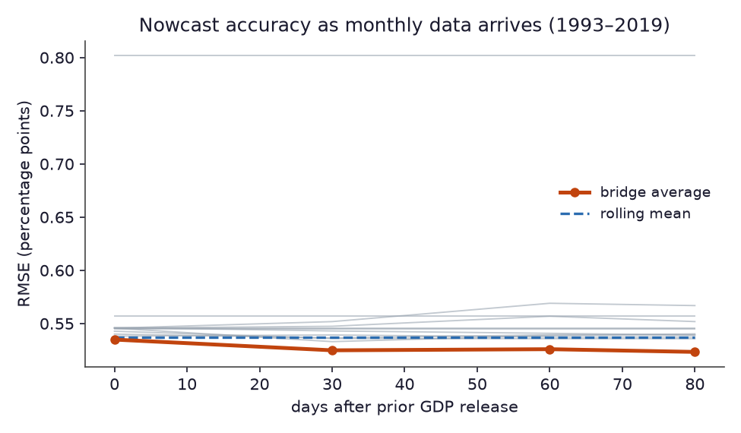
Figure 1. Nowcast RMSE by days after the prior GDP release (1993–2019). The bridge combination improves monotonically as data arrives.

4.3 Nowcast versus outcome
Figure 2 overlays the headline nowcast on realised GDP growth across the full evaluation period. The model tracks the broad path of activity but, as the statistics indicate, adds only modest information beyond a slowly-moving mean — and no model anticipates the COVID collapse of 2020Q2, an approximately ten-sigma event that no indicator-based system could have foreseen.
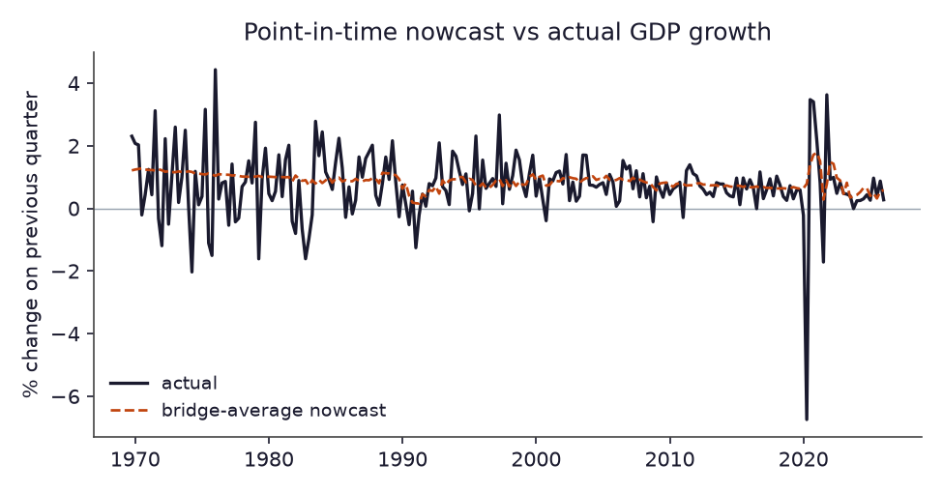
Figure 2. Point-in-time nowcast versus actual quarterly GDP growth.

5. Current nowcast
As of 2026-07-25, the system's nowcast for 2026Q2 — a quarter not yet published by the ABS — is +0.39% quarter-on-quarter, from the rolling-window bridge combination. The most recently published figure was +0.27% for 2026Q1. Because the target quarter has no official outcome yet, this is a genuine forward statement whose accuracy will be revealed at the next ABS release — the honest test of any nowcasting system.

6. Limitations
- Final-vintage data. The system uses the latest revised figures rather than the first prints a real-time forecaster would have seen. GDP revisions in Australia can reach several tenths of a percentage point, so measured accuracy is optimistic relative to a true real-time system. Incorporating genuine data vintages is the single most valuable extension.
- Constant publication lags. Lags are held fixed across the sample, though ABS releases were slower historically; the assumption is mildly favourable to the model on older data.
- Short sample. With roughly 130 usable quarters, flexible models are structurally disadvantaged, and the failure of the factor model to win should be read in that light.
- Narrow indicator set. The system omits business and consumer surveys, financial conditions indices and commodity-price detail that richer nowcasting systems exploit; these are plausible sources of the uplift the current indicators do not provide.

7. Conclusion
A rigorous point-in-time framework shows that standard monthly indicators offer only limited, statistically insignificant improvement over a rolling-mean benchmark for one-quarter-ahead Australian GDP growth, and that a mixed-frequency dynamic factor model does not beat a simple combination of bridge equations. Far from a disappointment, this is the credible outcome the framework was built to detect: the value of the project lies in the honesty of the evaluation, not in an inflated accuracy figure. The most promising directions — real-time data vintages and a broader indicator set including survey and financial data — follow directly from the limitations above.
Code, tests and an interactive dashboard accompany this report. Data: ABS and RBA, retrieved via the readabs package. This is a personal research project and not investment advice.

