GROUP - Assignment #4

Web Application

Roberta Meneghelo Apezzatto Martins

8558660

Chinmay Thoriya

8604944

Huynh Thi Phuong Thao

8312506

Dmytro Salenko

8298028

**Aug, 8th, 2019**

Contents

Requirements 3

High-level system design 4

Detailed system design 4

Activity Diagram 5

Search for cars activity diagram 5

Enter new information activity diagram 5

Use Cases 6

Tasks 6

Git repository 6

# Requirements

The application allows you to enter new information, or search for saved information. The application's basic idea is to permit people to place their used vehicles up for sale by submitting their contact information and vehicle details into a standard HTML form on a Web page. Some validation of the input is necessary, which must be done using JavaScript or HTML5 (Note: You may find it easier to use Selenium to test for an error message created in JavaScript, rather than testing for HTML5 validation. Though the latter can be done). Once the information is validated, the contact information and vehicle make, model and year will be saved. Aftersaving, the saved information will be displayed, along with the vehicle's make, model and year as a hyperlink; clicking on the hyperlink will cause the application to redirect the user to the correct JD Power and Associates page that contains information about that specific vehicle.

If the search option is selected from the home page, a list of all the previously entered cars is displayed.

# High-level system design

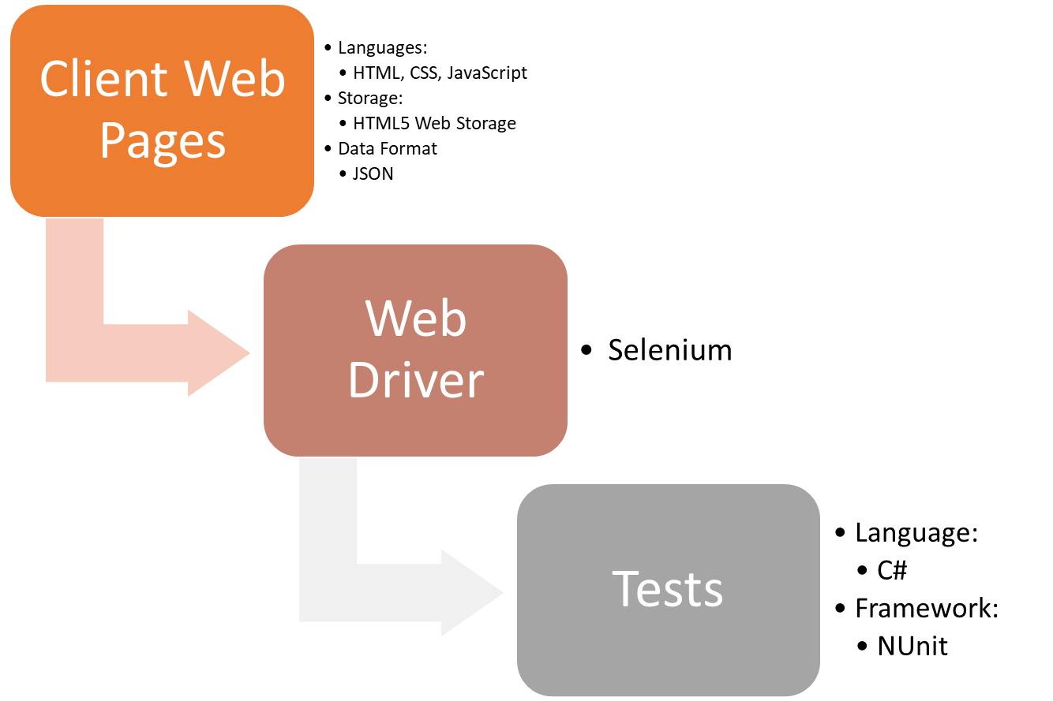

# Detailed system design

# Activity Diagram

## Search for cars activity diagram

## Enter new information activity diagram

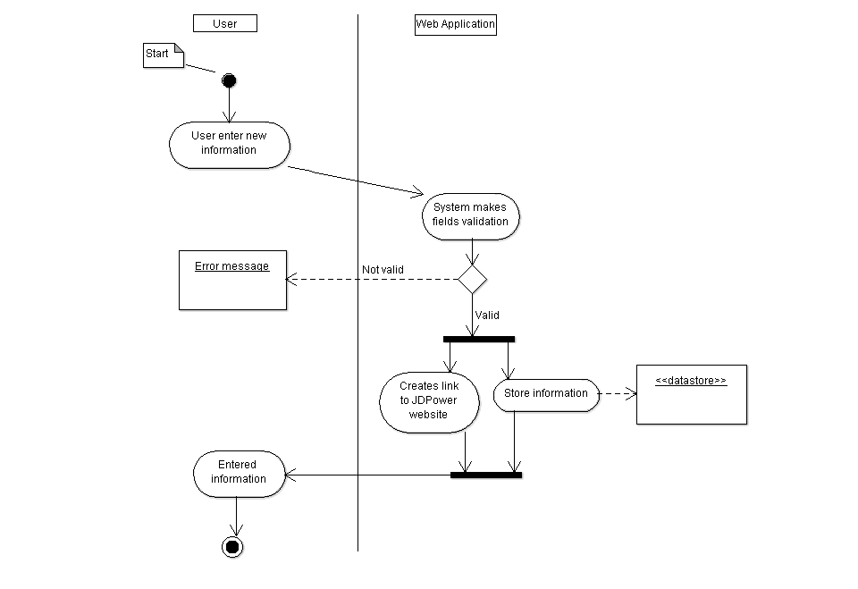

# Use Cases

* View Cars: User views all saved car’s and user’s information. Includes: *Display car’s comparison*.
* Create Vehicle Information: User inputs name, city, phone, car make, car model and car year.
* View Car: User views previously saved information about the car and his/her information. Includes: Display car’s comparison.
* Display car’s comparison: User clicks on JDPower website hyperlink created for a specific car. The system redirects the user to JDPower website’s page showing cars that match with make, model and year of the selected car. Extends: *View Car*. Extends: *View Cars*.

# Tasks

# Git repository