**US Computer and Mathematical Employment Analysis**

**1. Which states have the fastest growing job market for computer and mathematical occupations?**

When looking at YOY growth for 2017 vs 2016 for “Computer and Mathematical Occupations”, top 3 fastest states/territories are Guam, Montana, and Utah. The three bottom states are Louisiana, New Mexico, and Minnesota. Overall US grew in 2017, but not as fast as it did in 2016 and 2015

Both Guam and Montana show a volatile job market from at least 2015-2017. Utah did not grow as much as it did in 2016, like the total US, but continued to experience a strong job market

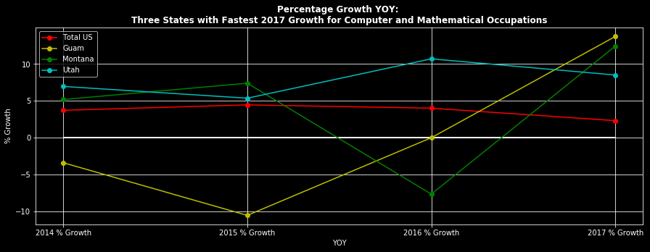



Louisiana, New Mexico, and Minnesota did experience growth in 2016. Out of the three, New Mexico experienced the largest % decline from 2016 to 2017. All three of these state outgrew total US in 2014, but did not exceed overall US growth in 2015, 2016, or 2017

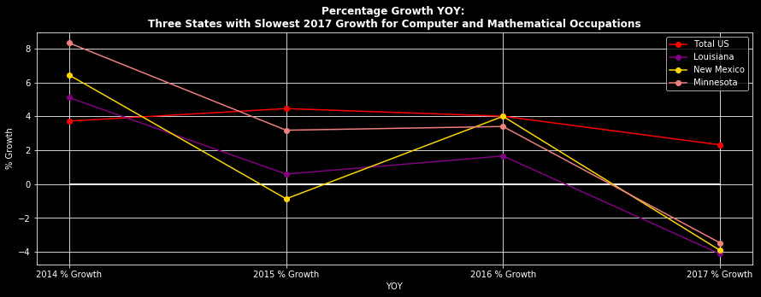



**2. Does a larger state population translate to higher job growth?**

When looking at YOY growth rate (2017 vs 2016) for Computer and Mathematical Occupations, a larger population did not necessarily translate to higher job growth in this case. In the two charts below, one can see that California, the most populous state, did not grow as fast as states a fraction of its size. The second chart includes the top 3 most populous states (California, Texas, and Florida) and the three least populated states (DC, Vermont, and Wyoming) and compared the 2017 % growth

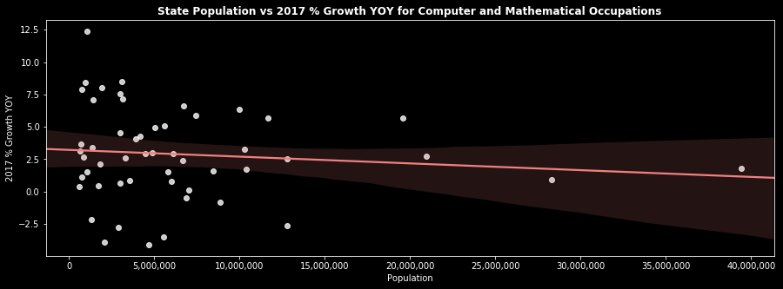



Additionally, the highest growth rates are seen for states with less than 5MM people (Guam not included, as it was not in the US Census file used). Included in the top 5 are Utah, Nebraska, Montana, Delaware and Alaska



**3. Which specific occupations are the most and least in demand?**

Occupations with high growth in 2017 also had higher average yearly growth over the four preceding years. Occupations with low growth in 2017 also had lower average yearly growth over the four preceding years

Both Computer and Mathematical Occupations and All Occupations showed steady growth. However, Computer and Mathematical Occupations had consistently higher growth than All Occupations

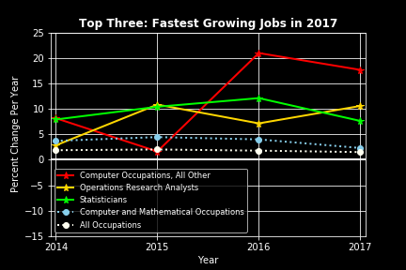

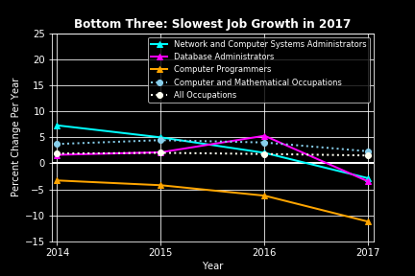

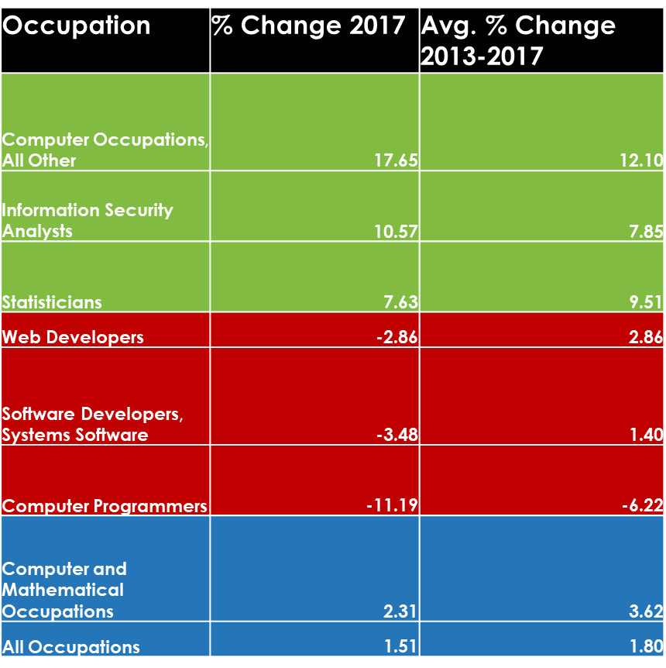

**4. How do computer and mathematical occupations stack up against other occupation types?**

At the national level in 2017, office and administrative support, sales, and food preparation and serving were the top three major occupations in terms of employment. Computer and Mathematical Occupations ranked No. 14 among the 22 major occupation categories

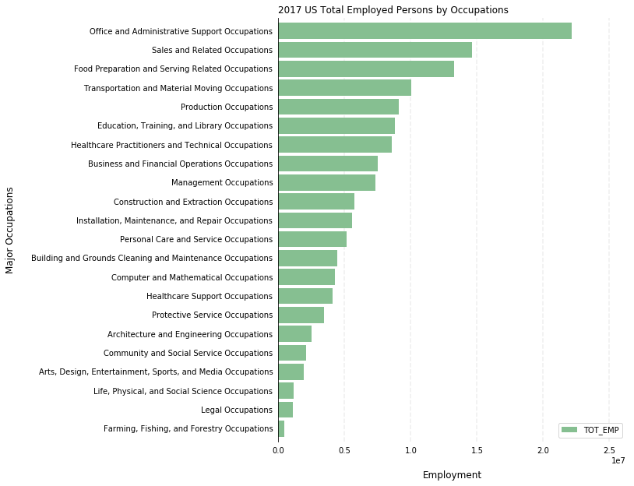

**5. Which specific occupations had the highest number of employees in 2017?**

Regarding jobs that fell under Computer and Mathematical Occupations, the software developers (applications), computer user support specialists and computer system analysts categories had the highest number of employees

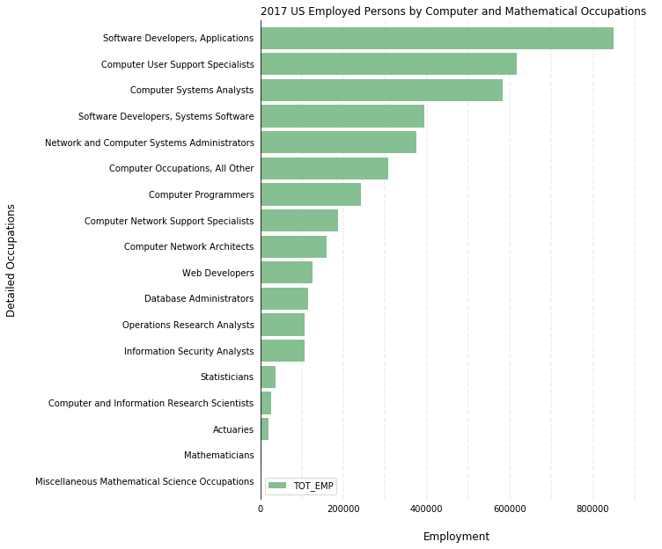

**6. Which state had the most people working in computer and mathematical related occupations in 2017?**

At the state level in 2017, California, Texas, and New York were the top 3 states that had the most people working in computer and mathematical occupations.

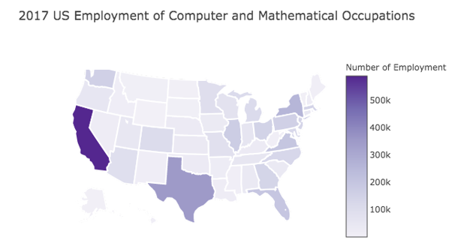

**Results**

* Fastest YOY growth (‘17 vs ‘16) for Comp & Math occupations: **Guam**
* Slowest YOY growth (‘17 vs ‘16) for Comp & Math occupations : **Louisiana**
* Larger population size does not necessarily mean higher job growth
* Occupation with fastest YOY growth for 2017 vs 2016 : **Computer Occupations, All Other**
* Occupation with slowest YOY growth for 2017 vs 2016 : **Computer Programmers**
* Computer and Mathematical Occupations is **14th** out of 22 occupation types in the US
* Within Computer and Mathematical Occupations, **Software Developers (Applications)** had the highest number of employees in 2017
* **California** had the most people working in computer and mathematical related occupations in 2017