**Experiment No**: X

**Title**: Configuration & Implementation of Multiple LAN Network.

**Problem Statement:**

To learn how to configure multiple router for packet transmission in Cisco packet tracer simulation software.

**Hypothesis:**

At first we made a proper connection by setting up IP address of each PC and provide a Next hope IP address for packet transmission between two or more LAN.

**Materials:**

Cisco Packet Tracer Software

**Procedure:**

* Design the connection using Cisco Packet Tracer Software like figure 1

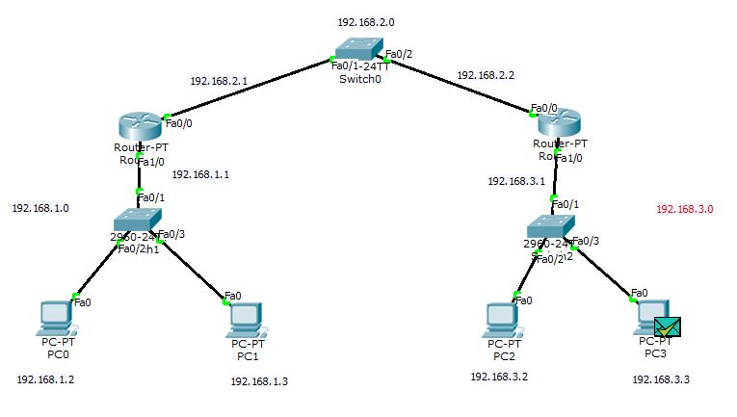

Figure: 01

* Connect 2 router(router0 and router1) with switch0 (2960)
* Each router connect with a switch

-Router0 connect with switch1

-Router1 connect with switch2

* And then each switch connect with 2 pc(2960)

-PC0 and PC1 with switch1

-PC2 and PC3 with switch1

* Set IP address for each pc

-PC0 IP address = 192.168.1.2, Default Gateway =192.168.1.1

-PC1 IP address = 192.168.1.3, Default Gateway =192.168.1.1

-PC2 IP address =192.168.3.2, Default Gateway =192.168.3.1

-PC3 IP address =192.168.3.3, Default Gateway =192.168.3.1

* Configure Router

-Router0

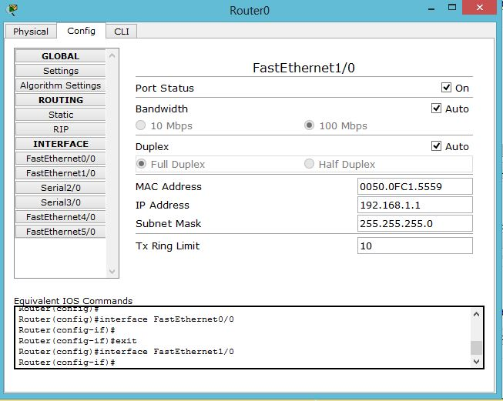

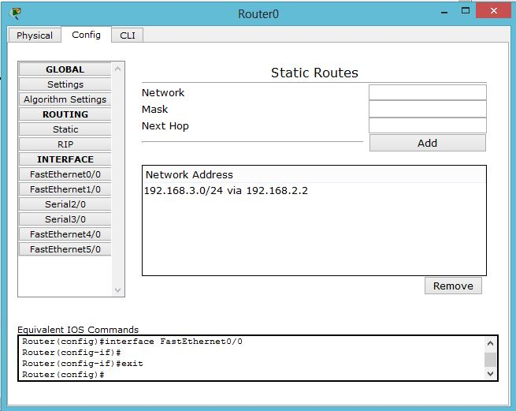

-Router1

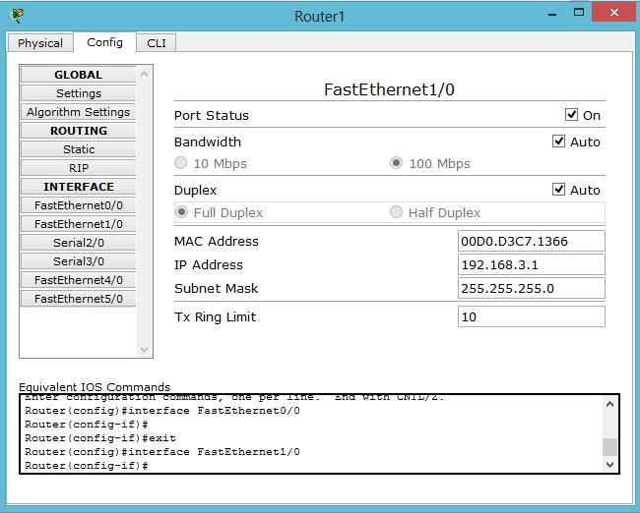

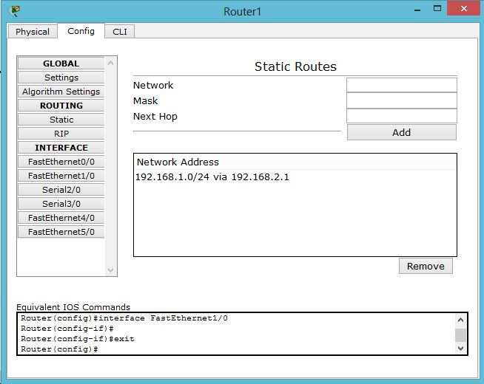

* Here all the PCs are connected to the different networks and routers connect them. All the configurations are properly done that’s why the connections are green.
* Select message option and select the sender and receiver
* If the connections are properly made and networks are properly set then we can send packet from one network to another.

**Discussions:**

* We must check all the connections and IP addresses to ensure successful data transfer.
* If the number of computer increases then the communication will become more complex.
* Switching speed is an important factor here.

**Experiment No**: X

**Title:** *Set up a wireless connection using password.*

**Statement of the Problem:**here we will make a wired and wireless network. Then we will set password to it.

**Hypothesis:**

We design wired and wireless network in cisco packet tracer and simulate .We will use password protection for wireless LAN with the built in options in wireless router**.**

**Materials:**

* Personal computer.
* Cisco Packet Tracer(software)

**Procedure:**

1. We design the following wired LAN with the help of packet tracer.

* We take 2 generic PC and a switch

* We connect those 2 pc with the help of copper straight wire to the switch

2. For the wireless connection we take a wireless router and tow wireless

device (tablet) like the figure.

*From the wireless router configuration tab we click in to wireless option

and set authentication to WEP

* We set a new password.

* In the device settings, from the configuration tab we click to on the wireless

option then we select the WEP option and set key.

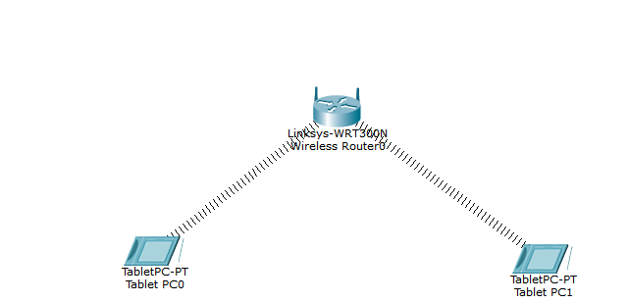

**Fig: wireless LAN with WEP security.**

**Results:**

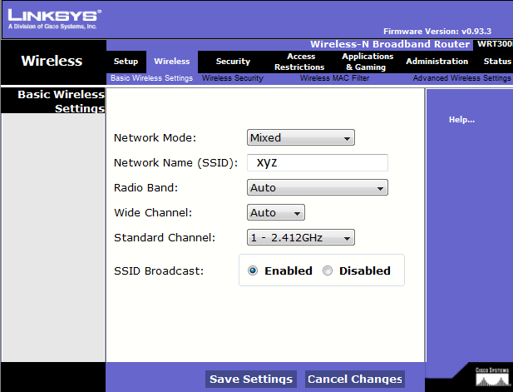

**Figure 2: Set the network name.**

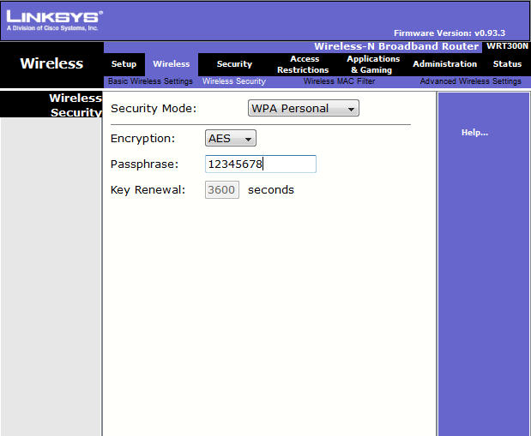

**Figure 3: Protect the network with a password.**

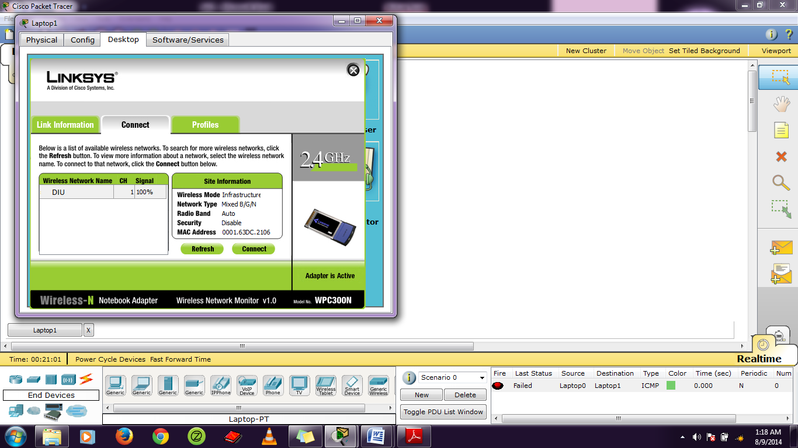

**Figure 4: Connection scheme**.

**We simulate data by sending packets for the wireless LAN in figure,**

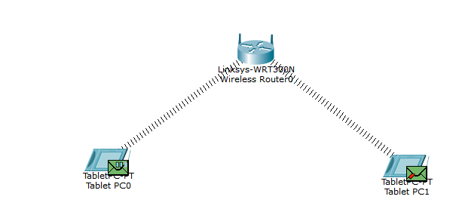

**Discussion:**

1. We can ping the IP address in the command prompt to check whether the packet is sent from one pc to other or not.
2. If the packet is sent successfully we can continue our experiment successfully.