**Experiment No:** 06

**Title:** Configuration of VLAN and a simple network creation.

**Problem Statement:**

To learns how to configure VLAN for packet transmission in Cisco packet tracer simulation software.

**Objective:**

In this lab task we created a network by configuring 2 Virtual Local Area Network (VLAN). In this task we know how to configure and maintain VLAN. Assign Switch ports to a VLAN also management of VLAN. Configure the trunk ports and verify that switches can communicate to each other.

**Topology:**

In this task we use Star Topology. Here every PC is connected with a Switch through straight wire and every Switch is connected with Router. We know in its simplest form, a star network consists of one central switch, hub or computer, which acts as a conduit to transmit messages. This consists of a central node, to which all other nodes are connected; here are two nodes which provide a common connection point for all nodes through a hub or switch.



**Materials:**

Cisco Packet Tracer Software

**Devices:**

1. 2 Switches

2. 5 PC

3. Copper straight cable

4. Copper Cross-Over cable

5. Serial DCE

**Procedure:**

• Design the connection using Cisco Packet Tracer Software like figure 1.

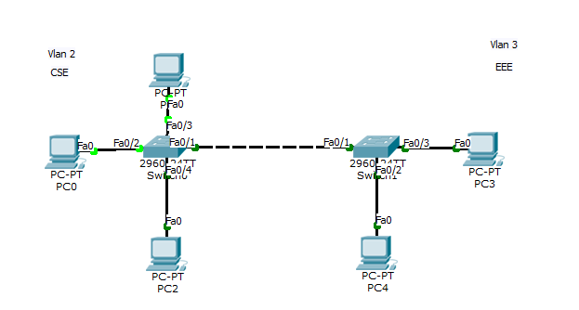

Figure: 01

• Connect 3 switches (switch0, switch1).

• And then each switch connect with pc

-PC0, PC1 and PC2 with switch0

-PC3 and PC4 with switch1

**IP Configuration:**

**PC0:** **PC1:**

IP: 192.168.1.1 IP: 192.168.1.2

Subnet mask: 255.255.255.0 Subnet mask: 255.255.255.0

Gateway: 192.168.1.254 Gateway: 192.168.1.254

**PC2: PC4:**

IP: 192.168.1.3 IP: 192.168.2.1

Subnet mask: 255.255.255.0 Subnet mask: 255.255.255.0

Gateway: 192.168.1.254 Gateway: 192.168.2.254

**PC5:**

IP: 192.168.2.2

Subnet mask: 255.255.255.0

Gateway: 192.168.2.254

**Switching command:**

//Creating VLAN for switch0

>>en

>>conf t

>>Vlan 2

>>name CSE

>>exit

///Assigning Ports

>>int fa0/1

>>int range fa0/1-3

>>switchport mode access

>>switchport access vlan 2

>>exit

////showing VLAN table

>>do show vlan

///Assigning Trunk port

>>int fa0/1

>>switchport mode trunk

>>exit

//// showing trunk port interface

>>show int trunk

//Creating VLAN for switch1

>>en

>>conf t

>>Vlan 3

>>name EEE

>>exit

///Assigning Ports

>>int fa0/1

>>int range fa0/4-5

>>switchport mode access

>>switchport access vlan 3

>>exit

////showing VLAN table

>>do show vlan

///Assigning Trunk port

>>int fa0/1

>>switchport mode trunk

>>exit

//// showing trunk port interface

>>show int trunk