

Capstone Project Phase A
AI-Based Code Development Automation using the TDD Approach Book
Project GIT Repository
Code: 26-2-D-3

Authors:
Michael Obeid ID: 211924352 mike.obeid@e.braude.ac.il
Rober Saliba ID: 207431859 rober.saliba@e.braude.ac.il

Supervisors:
Dr. Katerina Korenblat
Dr. Dan Lemberg

Advisors:
Dr. Elena Ravve
Dr. Elena Kleiman

Abstract. In this project, our main objective is to investigate whether tools of Machine Learning (ML) and Artificial Intelligence (AI) can significantly reduce efforts of source code writing based on structured test cases within the framework of Test-Driven Development (TDD) and under which additional conditions, if any. We aim to explore what type of inputs and contexts enable the AI model to produce correct and reliable implementations. The project focuses on understanding the capabilities and limitations of automated code generation in a controlled and systematic manner, based on provided ahead unit test cases and additional information effectively derived from the corresponding specifications.

Keywords:
- Machine Learning (ML)
- Artificial Intelligence (AI)
- Test-Driven Development (TDD)
- Code Generation,
- Software Engineering
- Large Language Models (LLMs)
- Automated Programming
- Unit Testing

1. INTRODUCTION
Software development is becoming increasingly complex, and developers are constantly looking for tools that can help automate parts of the programming process. Writing correct and reliable code requires time, experience, and careful testing. A well-known methodology designed to ensure code reliability is TDD, where tests that describe the expected behavior of the system are written before the implementation. However, while highly regarded and widely discussed, strict TDD is often considered mostly theoretical and is notoriously difficult to apply consistently in real-world industry practice. Bridging this gap between the theoretical ideals of TDD and practical, automated application is a core motivation for our project.
In recent years, artificial intelligence, specifically LLMs integrated via API architecture has shown strong capabilities in generating source code. While these models can assist developers by suggesting code and detecting errors, combining them with a strict TDD loop presents a unique challenge: standard AI tools tend to rewrite entire scripts from scratch rather than making the precise, incremental changes that original TDD lifecycle requires.
In this project, we explore the development of an automated pipeline that acts as the developer in the TDD cycle. Crucially, our system does not rely on test cases alone. Instead, it receives a strict, structured combination of inputs: a sequential test case the previously generated source code (Code _{i-1}, with the initial Code ₀ being an empty file or base template), and an immutable specification file (an additional input efficiently derived from the original specification).The primary goal is to investigate whether bounding the LLM's context with these specific inputs forces it to produce reliable, incremental code updates and suitable refactoring, all preventing full-file rewrites.
At this stage of the project, our work focuses on understanding these algorithmic and implementation challenges, defining the specific system requirements, and examining how our specification-driven approach compares to existing agentic debugging tools in the field of automated software development.

Organization of the Book
The project is organized as follows:
Chapter 1: Introduction
  - Organization of the Book
1.2 What We Are Going To Do?
1.3 Why Is The Project Not Trivial?
1.4 Is the Topic Absolutely New?
1.4.1 If so , why is it interesting right now?
1.4.1.1 What Has Been Done Until Now?
1.4.1.2 What Is Wrong With What Is Done Till Now?
1.4.1.3 How Do We Plan To Improve The Situation?
1.4.1.4 Why Do We Think That Our Improvement Works?
1.4.1.5 What Do We Do If Our Improvement Does Not Work?
1.5 Difficulties In Setting This Project
1.5.1 Algorithmic Challenges
1.5.1.1 How Do We Plan To Overcome Them?
1.5.1.2 What Do We Do If Our Expectations Do Not Hold?
1.5.2 Implementation challenges
1.5.2.1 How Do We Plan To Overcome Them?
1.5.2.2 What Do We Do If Our Expectations Do Not Hold?
1.5.3 Hardware Equipment
Chapter 2: Background and related work
2 Theoretical Background: LLM-Driven TDD vs. Traditional Code Generation
2.1 Context Management and The "Engine Switch" Challenge
2.2 Agent Training, Boundary Setting, and Iterative Prompt Engineering
2.3 Experimental Experience 1 – Initial TDD & AI Evaluation Using Aider
2.3.1 Objective of the Experiment
2.3.2 Initial Project Setup
2.3.3 Version Control and Experiment Tracking
2.3.4 Main Observations So Far
2.3.5 Future Experimental Directions
2.4 Experimental Experience 2 – Initial TDD & AI Evaluation Using Aider
2.4.1 Objective of the Experiment
2.4.2 Methodology Update: LLM Model Pivot and Baseline Reset
2.4.3 Initial Project Setup
2.4.4 Main Observations So Far
Chapter 3: BACKGROUND AND RELATED WORK
3.1 The Story of TDD – Explaining TDD to Someone Who Has Never Seen It
Before
3.2 Code Generation Using Artificial Intelligence
3.3 What can we accept as is from previous experience?
3.4 What can we adopt from previous experience?
3.5 What is the novelty of our approach?
Chapter 4: GENERAL STEPS OF IMPLEMENTATION
4.1 How The System Work and What Every Step Do
Chapter 5: EXPECTED RESULTS
Chapter 6: FR\NFR REQUIREMENTS
6.1 Functional Requirements
6.2 Non-Functional Requirements
Chapter 7: TESTING AND EXPERIMENTAL PLAN
7.1 System and Environment Testing
7.1.1 Context Aggregation and Parsing Accuracy
7.1.2 Execution Environment and Automated Feedback Loop
7.1.3 API Rate Limit and Network Timeout Resilience
7.1.4 Multi-File Context Synchronization
7.2 Future Experiments and Case Studies
Chapter 8: PRELIMINARY SOFTWARE ENGINEERING DOCUMENTS
8.1 Proposed System Architecture and Workflow
8.1.1 System Workflow (Flowchart)
8.1.2 Deployment Diagram
8.1.3 Use Case Diagram
8.1.4 External API Integration
Chapter 9: REFERENCES

  - What We Are Going To Do?
In this project, we plan to design and develop a system that automatically generates source code. First, we will investigate if this is possible, under what assumptions, what minimal information is needed, and if not, why. This will be done using artificial intelligence techniques within the context of TDD. The system is expected to follow the principles of TDD, where test cases and some additional information define the expected behavior of the software before the implementation is created.
At this stage of the project, the exact format and content of the input to the system has not yet been fully determined. We plan to explore different possible types of input, such as structured test cases, (minimal) specifications, or other forms of requirements that describe the expected behavior of the software. The goal is to identify which type of input allows the AI model to generate correct and useful implementations.
The generated code will be evaluated by running relevant tests or validation procedures to check whether the implementation behaves according to the expected requirements. This evaluation process will help us measure the correctness and reliability of the generated code.
At the beginning of the project, we will start with simple scenarios to verify that the system works correctly. After confirming the basic functionality, we plan to gradually increase the complexity of the tasks and evaluate how well the system can generate more advanced implementations.
Throughout the project, we will investigate what type of context and information is required for the AI model to produce reliable and maintainable code. We will also examine the limitations of the approach and identify situations where automatic code generation may be challenging.
The main focus of this project is to study whether artificial intelligence can effectively support the TDD process and help automate parts of software development in a controlled and reliable way.
To achieve this, we define a strict iterative TDD process inspired by mathematical induction. The system's input will not rely on test cases alone. The minimal required input must 100% contain a sequence of Unit Test Cases alongside an immutable "Specification File" that defines the expected functionality and strict function signatures.
The automation will follow a sequential induction process:
- Step ₀ (Base Case): The system receives Test Case ₀ and minimal information effectively derived from the specification. The output generated is Code ₀.
- Step _{i} (Iteration): The system receives all prior tests (Test ₀ to Test _{i-1}), the new Test Case _{i}, the immutable specification, and the previously generated source code (Code _{i-1}). The output is incrementally updated Code _{i}.
We assume that providing the specification alongside the sequential test cases will provide the LLM with enough context to understand the expected output for any given input, preventing it from guessing the functionality.
Specific Project Goals: To ensure clarity in our research and development, we have defined the following specific goals:
- Determine Minimal Input: To investigate exactly what combination of inputs is required for an LLM to generate and incrementally maintain reliable code (e.g., analyzing if sequential test cases combined with an immutable specification file are sufficient, or if further context is needed).
- Achieve Code Consistency: To evaluate market tools and develop a method that forces the LLM to update code incrementally, rather than rewriting the entire codebase from scratch in every iteration.
- Automate the TDD Lifecycle: To successfully build a continuously maintainable, automated loop where the LLM acts as the developer in the "Red-Green-Refactor" TDD cycle.
- Evaluate Practical Value: To compare our automated TDD approach against classic manual coding, specifically in complex scenarios (e.g., complex data structures or external APIs), to determine if and when AI automation truly accelerates development.
  - Why Is The Project Not Trivial?
This project is not trivial because automatically generating correct and reliable source code from tests or specifications is a complex task, as evidenced by the fact that even state-of-the-art industry tools still struggle with logic errors and hallucinations. The system must correctly interpret the intent of the tests or/and requirements and translate them into functional implementations that behave as expected. Even small misunderstandings in the interpretation of requirements can lead to incorrect code.
Another challenge is determining what type of input is sufficient for generating useful code. It is already known that test cases alone are insufficient, because they only provide specific input-output examples without defining the underlying logic, structural constraints, or comprehensive edge-case handling. Therefore, additional context and specifications are required. Identifying the minimal and most effective input format is an important part of the research, specifically because standard AI tools tend to perform a full code rewrite upon any prompt change, whereas our goal is to force incremental changes, as detailed below.
The project also involves exploring the limitations of AI-based code generation and understanding when the approach works well and when it does not. This uncertainty makes the project both technically challenging and academically meaningful.
A major algorithmic challenge—and the primary reason for this project is not trivial—is maintaining code consistency. Standard LLMs tend to rewrite entire blocks of code from scratch when a new test case or prompt is introduced. Our objective is to enforce incremental code generation.
When transitioning from Code _{i-1} to Code _{i}, the intersection of the two codebases must be substantial. The LLM should only expand the code (e.g., adding an if statement for a new edge case) or perform logical refactoring (e.g., combining multiple conditional statements into a single formula). Completely rewriting the code from scratch should be an extremely rare emergency fallback. Ensuring the LLM respects the existing codebase and only modifies the necessary fractions (e.g., changing 10% of the code rather than 90%) to pass a new "killer" test case is a complex behavior to automate.

Is the Topic Absolutely New?
The topic of generating source code using artificial intelligence is not completely new. In recent years, many tools and studies have explored automatic code generation using machine learning and LLMs. These systems demonstrate that it is possible to produce code automatically based on user input, examples, and/or specifications.
However, combining artificial intelligence with TDD as the main input mechanism is still an active research area [1, 2, 3], and questions remain about reliability and practicality in real development environments. Our goal is not to invent a new concept, but to investigate how existing AI technologies can be applied within the TDD framework and to understand the challenges and requirements of this approach.
Several existing systems illustrate different input methods and approaches used in practice:
- Aider (AI Pair Programmer) — Input: Existing source code and terminal test errors. Aider is a command-line AI tool that reads failing test outputs and applies incremental, surgical edits to the existing codebase to fix bugs without rewriting the entire file. (Source: https://aider.chat/)
- Xray Test Management — Input: Manual test cases and requirements. Xray is a test management tool inside Jira used to track testing execution, though it does not generate the source code itself. (Source: https://www.getxray.app/)
- Diffblue Cover — Input: Existing Java source code. Diffblue uses AI to automatically write unit tests for code that is already written. This represents the reverse of our TDD approach. (Source: https://www.diffblue.com/)
- ChatGPT / Standard LLMs — Input: Prompts or test descriptions. While standard LLMs can generate code from tests, they typically lack workspace awareness and tend to rewrite entire scripts rather than applying the incremental code updates required for TDD. (Source: https://openai.com/chatgpt)
- GitHub Copilot Workspace — Input: Codebase context, specifications, and natural language issue descriptions. These newer agentic tools attempt to plan and implement incremental changes across multiple files to resolve specific failing tests but rely heavily on human prompts. (Source: https://github.com/features/copilot)
These examples show that automated code and test generation systems already exist but rely on different types of input. This supports our project's focus on identifying the most suitable input for reliable code generation within a TDD framework.
    - If so, why is it interesting right now?
Although the topic of automatic code generation is not new, it has become especially interesting in recent years due to significant advances in artificial intelligence, particularly in LLMs. Modern AI systems are now capable of generating high-quality code, understanding programming concepts, and assisting developers in real development environments.
At the same time, software systems are becoming more complex, and development teams are under increasing pressure to deliver reliable software quickly. As a result, there is a growing interest in tools that can automate parts of the development process and reduce the time required to write and test code.
The combination of artificial intelligence with TDD is particularly relevant today because TDD provides a structured way to define software behavior through tests. This makes it a suitable framework for evaluating whether AI models can generate correct implementations automatically.
Therefore, this topic is interesting right now because recent technological progress makes it possible to explore practical applications that were not feasible in the past. Studying this approach can help us understand how AI can be integrated into modern software engineering workflows.
      - What is done till now?
As detailed in the previous section, the industry currently utilizes a mix of approaches. This includes test management software (e.g., Xray, which organizes manual tests but does not write code), reverse code-to-test generators (e.g., Diffblue, which uses AI to write tests for existing code), and general or agentic AI coding assistants (e.g., ChatGPT, Aider, and GitHub Copilot, which generate or debug code based on prompts but lack an automated TDD loop). These tools represent the current state-of-the-art in how test cases and artificial intelligence are applied in software engineering today.
      - What is wrong with what is done till now?
Current tools lack the consistency required for a fully automated, specification-driven TDD lifecycle. Management tools like Xray still require human developers to write the code. Standard LLMs tend to rewrite entire scripts from scratch rather than applying incremental fixes. While newer agentic tools like Aider apply incremental edits, they rely on guessing the intended functionality from error logs or require constant natural language prompting from humans, much like GitHub Copilot Workspace. None of these tools strictly enforce code generation based on a combination of sequential test cases and an immutable specification file, leading to hallucinations or incorrect assumptions about function signatures and edge cases.
      - How do we plan to improve the situation?
We plan to automate the TDD process by introducing an iterative pipeline that strictly passes the previously generated code (Code _{i-1}) alongside the new sequential test case and the specification file. We will analyze the market to see if any current tools can handle this specific input combination effectively. We will implement mechanisms to restrict the LLM to incremental expansions and smart refactoring, rather than full rewrites.
      - Why do we think that our improvement works?

By bounding the LLM's context with a static specification file and explicitly feeding its own previous output back into the prompt, we simulate the exact workflow of a human developer doing TDD. This constrained environment reduces the LLM's freedom to rewrite code arbitrarily and forces it to focus on the specific logic required to pass the newly introduced test case.

      - What do we do if our improvement does not work?
If fully automated TDD proves inconsistent, for instance, if existing AI tools fail on complex data structures, advanced algorithms, or external API connections—we will evaluate the specific scenarios where the AI tools struggle compared to classic manual coding. In such a case, the project will pivot to providing a highly specialized assistive tool for developers, rather than a fully autonomous system, guiding them on exactly where the code needs to be modified without rewriting it for them.

  - Difficulties in Setting this Project

    - Algorithmic challenges
The primary algorithmic challenge is preventing the LLM from rewriting the entire codebase from scratch when a new test case is introduced. Ensuring the LLM performs only incremental updates (e.g., modifying only the specific Lines of Code (LOC) or logic branches directly related to the new test case) and understanding how to refactor existing code without breaking previous test cases requires strict prompt constraints and state tracking.

      - How do we plan to overcome them? We plan to overcome this by implementing a strict sequential induction process. Instead of just passing the new test case, we will pass the previously generated code (Code _{i-1}), the new test case (Test _{i}), and the immutable specification file into the prompt. By constraining the context, we force the LLM to focus on logical expansions or refactoring rather than full rewrites.

      - What do we do if our expectations do not hold?
If the LLM cannot maintain consistency—for example, if it fails on complex data structures or external API connections and continues to rewrite the entire code—we will pivot our approach. Instead of a fully autonomous automation tool, we will convert the system into a developer-assistive tool. In this fallback scenario, the tool will analyze the failing test and highlight exactly where the developer should modify the existing code, comparing the efficiency of this assisted approach against classic manual coding.

    - Implementation challenges Implementing the automated loop requires building a robust sandbox environment where the code generated by existing AI tools can be safely compiled, tested, and validated against the specification file in real-time. Furthermore, securely parsing the output from these tools to extract exactly the executable source code without natural language artifacts presents a significant technical hurdle.

      - How do we plan to overcome them?
We will overcome this by utilizing established automated testing frameworks (such as JUnit or Pytest) within isolated execution environments to run the generated code safely. To handle the parsing issue, we will enforce strict output formatting rules on the LLM (e.g., requesting the output strictly in a specific Markdown code block format) to easily extract the code programmatically.
      - What do we do if our expectations do not hold?
If the fully automated execution loop proves too unstable, or if parsing errors cause constant crashes, we will introduce a "human-in-the-loop" mechanism. Instead of the system executing the AI's code automatically, the system will present the proposed incremental code changes to the developer for a quick manual review and approval before running the test suite.

    - Hardware equipment Since our system will primarily rely on interfacing with existing LLMs via cloud-based APIs, the hardware requirements for this project are minimal. We do not need specialized local hardware (like high-end GPUs) to train or host the AI models. The project only requires standard personal computers capable of running the local testing frameworks and maintaining a stable internet connection to communicate with the AI services.

2. Theoretical Background: LLM-Driven TDD vs. Traditional Code Generation
When leveraging LLMs for software engineering, the standard industry approach is "Zero-Shot Generation." In this traditional method, a developer provides a complete specification, and the LLM attempts to generate the entire codebase in a single iteration. While this approach is effective for simple scripts or minimal features, it frequently fails when applied to complex, enterprise-level systems. Our approach claims that LLM-driven TDD should resolve these limitations across three main difficulties:
- Algorithmic Complexity and Edge Cases: When an LLM generates a system simultaneously, it typically optimizes for the "Happy Path" (the standard execution flow) and overlooks critical edge cases. In contrast, TDD introduces each edge case as an isolated failing test. This forces the LLM to address one specific algorithmic anomaly at a time, resulting in highly robust logic.
- Data Structure Complexity: Complex systems require complicated data structures with complicated object-oriented relationships and hierarchies. When generating code all at once, LLMs often "lose their place" and tend to introduce incorrect object dependencies. TDD eliminates this by enforcing hierarchical construction (e.g., establishing a functional Money object before allowing the creation of a MoneyBag collection).
- External Dependencies: Production code relies heavily on external APIs and databases. TDD allows for the step-by-step introduction and maintenance of these external dependencies, ensuring the core logic remains stable.
The Crucial Advantage: Code Maintenance vs. Code Generation The most significant advantage of LLM-driven TDD is its impact on software maintenance. In traditional zero-shot generation, if a specification changes or a new bug is discovered, the LLM’s default behavior is to rewrite the entire file (Regeneration). In a production environment, this is catastrophic, as it overwrites human interventions, breaks external integrations, and introduces regression bugs.
By forcing the LLM into a TDD workflow, it acts as a "Code Maintainer" rather than a "Code Generator." The strict requirement to pass a new test without breaking previous code enforces incremental, non-destructive editing. The LLM surgically changes only the necessary lines of code, ensuring long-term project stability.
2.1. Context Management and The "Engine Switch" Challenge
Effectively utilizing an LLM as an autonomous agent requires "teaching" the model of how to operate within a TDD framework. This is not achieved through traditional model fine-tuning, but rather through highly structured Context Injection. In every iteration, the LLM is provided with a consistent "knowledge envelope" consisting of:
- The immutable Specification, the current State of the code, and
- Execution Feedback (the exact compiler errors or test failures).
However, maintaining this context creates a significant technological obstacle: The Engine Switch Challenge. A robust LLM-based coding tool should be model-agnostic, allowing developers to switch underlying engines (e.g., from OpenAI to Anthropic) mid-project to leverage different model strengths. Because a new LLM lacks the chat history of the previous model, it loses the architectural context and coding philosophy established in prior steps.
To solve this, the architecture of our methodology relies on "External Memory “. Rather than passing raw chat logs to the new model, the environment generates a continuous Changes.md file (a changelog). When the engine is switched, the new agent is injected with the Specification, the current codebase, and this abstracted changelog. This allows the newly deployed LLM to instantly align with the project's historical context and resume the incremental TDD loop seamlessly.

2.2. Agent Training, Boundary Setting, and Iterative Prompt Engineering
Treating an LLM as a strategic engineering partner rather than a simple code-generation shortcut requires establishing firm operational boundaries. During the experiment, it became evident that the AI agent required continuous, iterative feedback to align perfectly with the strict rules of Test-Driven Development (TDD). We documented a clear evolution in the agent’s behavior—from violating constraints to proactively requesting human permission—by utilizing iterative prompt engineering.
1. Establishing the Operational Protocol To automate the workflow while maintaining control, we defined a deterministic macro-command. The agent was instructed that whenever the command "run the tests" was issued, it must execute a strict six-step pipeline:
- Check Specification.txt to understand requirements and constraints, strictly avoiding unlisted additions.
- Run compilation and tests.
- Report any errors or failures.
- Automatically fix failures.
- Update Changes.md with detailed documentation of the failure and resolution.
- Use proper SEARCH/REPLACE blocks for precise code alterations.
2. Boundary Enforcement and Correcting Overreach Despite these explicit instructions, the LLM initially exhibited an optimization bias. During the MoneyBag implementation phase, a test implicitly required content-based equality. The LLM autonomously generated an equals(Object anObject) method to pass the test, completely bypassing the fact that this method was not documented in Specification.txt.
To enforce strict adherence to the specification over the desire to pass tests quickly, a hard boundary was manually injected into the agent's context:
"You added the public boolean equals(Object anObject) without my confirmation and its not mentioned in the Specification.txt. If something is not mentioned there you cannot add it without my confirmation, and that applies to all next steps in the future."
3. Demonstrated Agent Learning (Human-in-the-Loop) The effectiveness of this real-time boundary setting was validated during a subsequent step. A new test was introduced that evaluated an isZero() state, but the method was intentionally left out of Specification.txt.
Instead of autonomously hallucinating the method to force a passing test as it had done previously, the LLM halted execution, analyzed the discrepancy, and proactively requested human intervention:
Agent: "Question: The test requires isZero() method but it's not in Specification.txt. Should I: 1. Add isZero() to the IMoney interface and implement it in both Money and MoneyBag classes? 2. Wait for you to update Specification.txt first? Please confirm before I proceed with any implementation."
The developer then updated the specification manually and approved the continuation of the pipeline. This interaction is academically significant because it proves that LLM-based agents can be successfully constrained by in-context behavioral corrections. By effectively utilizing a Human-in-the-Loop (HITL) feedback mechanism, the AI evolved from a reactive code generator into a disciplined participant in the TDD lifecycle.

2.3. Experiment 1 – Initial TDD & AI Evaluation Using Aider (OpenAI’s o3-mini model)
2.3.1. Objective of the Experiment
The purpose of this experiment was to evaluate whether AI-based coding tools can participate in a strict TDD workflow while maintaining incremental updates to an existing code instead of rewriting the implementation from scratch during every iteration.
The experiment was designed around several core principles. The workflow relied on sequential TDD iterations, an immutable specification file, preservation of previously generated source code, incremental maintenance of the implementation, automatic debugging capabilities, and continuous execution of automated tests.
The selected AI system for this experiment was Aider AI Pair Programmer.
2.3.2. Initial Project Setup
The foundational codebase and domain logic used for this experiment were explicitly derived from the laboratory materials provided in the course 61757: Introduction to Software Testing. As described in the course's lab guide, the project under testing represents a financial calculation system that uses different currencies. Specifically, the system is built around defining a Money class, which stores the amount of money as a number, and the currency represented by three letters according to accepted standards (e.g., USD, NIS, GBP). The core domain logic dictates that adding or subtracting amounts in the same currency yields a new Money object with the appropriate calculated amount. Furthermore, the system architecture expands to include a MoneyBag class (capable of holding mixed currencies) and an IMoney interface to handle polymorphism between single and multiple currency types.
The experiment began with a minimal Java project environment that included a specification file named Specification.txt and a test file named MoneyTest.java. At the beginning of the process, no implementation existed for the Money class. The project was later converted into a Maven-based Java project using JUnit Jupiter for automated testing.
The AI agent was instructed to follow a strict TDD workflow in which it first reads the specification, then analyzes the failing test case, generates only the minimal implementation required for the current step, preserves all previously written logic, avoids rewriting the full implementation, continuously executes tests, and automatically debugs failures whenever necessary.

Step ₀ – Initial TDD Generation
During the initial stage of the experiment, the AI agent received the specification file together with the initial failing test case. The following prompt was provided:
“This is Step ₀ of a strict TDD process. Read Specification.txt and MoneyTest.java. Please generate the minimal Money.java class from scratch so that Test ₀ passes. Do not write extra functionality that is not required to pass this specific test.”
The output of this stage was a complete source code file named Money.java. The generated implementation included the minimal logic necessary to satisfy the initial test case. Initially, the LLM created fields for the monetary amount and currency, together with a constructor and getter methods. After analyzing the test behavior more carefully, the AI agent incrementally added an equals() method without rewriting the entire file.
An important aspect of this step was that the LLM modified only the required sections of the implementation instead of regenerating the full class from scratch.
At the beginning of the experiment, the AI tool encountered several environment-related problems:
- JUnit dependencies were missing from the project,
- There was no Maven structure, and the project did not contain a pom.xml file.
The AI agent successfully diagnosed these infrastructure problems and proposed creating a Maven project, adding JUnit Jupiter dependencies, and reorganizing the project into the standard Maven folder hierarchy.
This behavior demonstrated that the system was capable not only of generating code but also of debugging and repairing development infrastructure automatically.
After configuring Maven and JUnit correctly, the project compiled successfully, the initial test passed, and the Maven build completed successfully. This validated the initial complete AI-driven TDD iteration.
Observed Behavior – Anticipatory Coding
During the experiment, an important behavioral observation was identified. Before receiving future failing tests, the LLM proactively introduced placeholder implementations for the add() and subtract() methods.
This behavior technically violated strict TDD principles because the corresponding functionality had not yet been requested through failing tests. Instead of strictly following the Red-Green-Refactor cycle, the AI agent attempted to anticipate future requirements.
This observation became academically significant because it suggests that AI coding agents tend to optimize for future functionality rather than adhering strictly to sequential TDD discipline. This became one of the first meaningful research observations of the project.
Step 1 – Incremental Update Using a New Test
In the second phase of the experiment, a new failing test named testAdd_PositiveValues was added to the project. The objective of this step was to evaluate whether the LLM could incrementally update the existing implementation rather than regenerating the entire source file.
The following prompt was used during this stage:
“This is Step 1 of the TDD process. I have added testAdd_PositiveValues to MoneyTest.java. Please update the existing Money.java to implement the add() method so the test passes. Refer to Specification.txt for the required signature.”
The AI tool modified only the add() method implementation while preserving all existing functionality. The update added support for monetary addition while maintaining the existing currency behavior.
After the modification, all previous tests continued passing successfully, and no full rewrite of the implementation occurred. The AI agent later verified that all tests passed successfully and that no additional debugging was required during this iteration.
This became the first successful example of incremental AI-based TDD maintenance within the experiment.
Step 2 – Subtraction Support
The next stage introduced another failing test named testSubtract_PositiveResult. The purpose of this step was to evaluate whether the LLM could continue maintaining a growing codebase incrementally while preserving previous functionality.
The following prompt was provided to the AI agent:
“This is Step 2 of the strict TDD process. A new failing test called testSubtract_PositiveResult was added to MoneyTest.java. Please:
- Read Specification.txt and the updated MoneyTest.java
- Update the existing Money.java incrementally to implement the subtract method
- Do not rewrite the full file
- Run mvn test and ensure all previous and current tests pass
- Update CHANGELOG.md with the Step 2 changes
- Update TEST_EXPLANATION.md explaining:
    - which new test was added
    - what code was modified
    - why the test now passes
    - whether the modification was incremental or refactoring
The LLM updated the subtract() implementation incrementally while preserving all existing behavior. In addition to modifying the implementation, the AI tool was also instructed to update project documentation files and explain the reasoning behind the changes.
This stage expanded the experiment beyond simple code generation into maintainability analysis, AI-generated documentation, incremental reasoning, and traceability.
After the modification, all tests continued passing successfully.
Step 3 – Edge Case and Automatic Debugging
In the third experimental stage, a new failing test named testEmptyAccount_WithdrawThrowsException was introduced. The purpose of the test was to validate a business rule requiring the system to throw an IllegalStateException whenever a withdrawal operation is attempted on an empty account.
Unlike the previous stages, no explicit prompt was provided instructing the AI agent how to solve the issue. Instead, the failing test was added, and Maven tests were executed directly.
After detecting the failure, the AI agent autonomously responded with the message “What’s wrong? Fix”. Once approval was given, the LLM diagnosed the problem, updated the implementation, repaired the failing behavior, reran the tests, and restored the project into a fully passing state.
This stage became one of the strongest observations in the experiment because it demonstrated autonomous debugging behavior without requiring a manually written corrective prompt.
The step also moved the experiment beyond simple arithmetic functionality into edge-case handling, exception management, business-rule validation, and state-dependent logic. These scenarios are significantly more difficult for AI systems than basic positive-path implementations.
The experiment demonstrated that the AI tool could identify failing behavior automatically, proposing fixes independently, preserving previous functionality, repairing the implementation incrementally, and validating correctness through automated testing.
    - Version Control and Experiment Tracking
During the experiment, Git and GitHub were integrated into the workflow in order to support reproducibility and long-term experiment tracking.
The project was initialized as a Git repository and connected to GitHub. This allows future analysis of incremental code differences, rewrite percentages, AI-generated diffs, and the evolution of the implementation across multiple TDD iterations.
The integration of version control became an important aspect of the research methodology because it enables reproducibility, traceability, and quantitative analysis of AI-generated modifications over time.
    - Main Observations So Far
The initial experiments demonstrated several important findings regarding AI-assisted software engineering workflows.
The experiment showed that AI coding agents can participate in iterative TDD workflows while preserving previously generated functionality. The LLM was able to update existing source code incrementally instead of fully rewriting implementations during every iteration.
The AI agent also demonstrated the ability to debug and repair development environments automatically by diagnosing missing dependencies, restructuring project layouts, and configuring Maven and JUnit infrastructure.
Another important observation was the tendency of the LLM to anticipate future requirements before failing tests were introduced. This suggests that AI systems may not naturally follow strict Red-Green-Refactor discipline unless constrained carefully.
The experiments further demonstrated that edge cases and business-rule constraints significantly increase the complexity of the reasoning process required from the AI system.
Finally, the combination of sequential test cases, immutable specifications, existing source code, and automated execution feedback created a highly structured environment for evaluating AI-assisted software engineering behavior.
    - Future Experimental Directions
The next planned stages of the project will include experiments involving currency mismatch validation, negative values, refactoring scenarios, more complex edge cases, API interaction workflows, rewrite percentage measurements, automated comparisons between multiple AI coding agents, debugging consistency analysis, and maintainability evaluation across long iterative development cycles.
The long-term objective of the research is to determine whether AI systems can reliably operate as fully autonomous participants in a strict TDD lifecycle.
2.4. Experiment 2 – Initial TDD & AI Evaluation Using Aider (Claude Sonnet Baseline)
2.4.1. Objective of the Experiment
The purpose of this experiment was to evaluate whether an LLM -based coding tool can be used in a strict TDD workflow while maintaining incremental updates to existing code, rather than rewriting the implementation from scratch during every iteration.
The experiment was designed around several core principles:
- sequential TDD iterations,
- an immutable specification file,
- preservation of previously generated source code,
- incremental maintenance of the implementation,
- automatic debugging capabilities, and
- continuous execution of automated tests.
2.4.2. Methodology Update: LLM Model Pivot and Baseline Reset
During the initial phases of the experiment, the Aider agent was configured to use OpenAI’s o3-mini model. However, empirical observation revealed specific functional limitations with the o3-mini model when executing strict TDD cycles.
Primarily, it consistently failed at surgical incremental edits (often rewriting entire files unnecessarily) and struggled with Java architectural constraints. For example, rather than creating separate public files for new classes, it would lazily hide new classes at the bottom of existing files (creating "ghost classes").
To ensure the validity and quality of the research, a decision was made to pivot the underlying LLM architecture to Anthropic’s claude-sonnet (Claude 3.5 Sonnet), which is recognized for superior code-editing capabilities. To maintain scientific consistency and avoid cross-contamination of data, the entire experimental environment was wiped clean. The TDD process was completely restarted from "Step ₀" using exclusively the claude-sonnet model. All results, logs, and observations documented in the subsequent sections of this report are strictly derived from this Sonnet-powered execution.
2.4.3. Initial Project Setup
The domain logic, core banking system framework, and Maven environment for this experiment remained identical to those established and described in Experimental Experience
1.Phase ₁: Foundational Logic (Steps ₀ – ₄)
- Step ₀ (Initial Generation): The LLM generated the minimal Money.java class from scratch to pass a basic equality test. The LLM successfully diagnosed missing JUnit dependencies and proposed creating a Maven project layout automatically.
- Step _{1 & 2} (Incremental Arithmetic): Failing tests for addition and subtraction were sequentially introduced. The LLM incrementally updated the methods without rewriting the full file, proving basic incremental maintainability.
- Step ₃ (Edge Cases & Automatic Debugging): A test was introduced requiring an IllegalStateException for withdrawing from an empty account. The LLM successfully diagnosed the failure from the Maven console and repaired the logic autonomously.
- Step ₄ (Domain Validation): A currency mismatch test was introduced. The LLM successfully updated the add() method to throw an exception if different currencies were added together, demonstrating an understanding of domain-specific business rules.
Phase ₂: Human Intervention & Code Preservation (Steps _{5 – 7})
- A critical research question was whether the LLM overrides manual developer changes. Prior to Step 5, a "tracer" was manually planted in the code to test if the AI would blindly overwrite human interventions. Specifically, a plain text comment and an irrelevant dummy method (irrelevantMethodForTesting) were deliberately injected into the Money.java class.
- Step ₅ (Negative Amount Validation): A core business rule of the financial system dictates that physical money cannot exist as a negative integer. A failing test was introduced asserting that instantiating a Money object with a value of -5 must trigger an IllegalArgumentException. The LLM successfully targeted only the constructor to pass the test, explicitly preserving both the manual comment and the irrelevant method. This confirmed the fact that LLM utilizes the current modified state of the file rather than regenerating it from historical data.
- Step ₆ (Null Equality): In robust Java software, object comparison methods must fail gracefully. A test was added to verify that passing a null reference into the Money.equals() method returns false safely, rather than crashing the system with a NullPointerException. The LLM surgically updated the equals() method, again leaving the human-injected code intact.
- Step ₇ (Contextual Cleanup): Interestingly, later in the experiment when architectural specifications were significantly updated, the LLM recognized that the manually injected irrelevant method did not belong in the system and removed it. This demonstrated that while the LLM respects human code during minor edits, it will refactor and clean up non-specification code when given broader architectural context.
Phase ₃: Architecture Evolution & Polymorphism (Steps _{8 – 10})
The final phase tested the LLM’s ability to handle cascading architectural changes across multiple files.
- Step ₈ (Architecture Evolution & "Ghost Files"): The Specification.txt was updated to introduce an IMoney interface and a MoneyBag collection class, requiring Money to implement IMoney. The LLM successfully created the new files and refactored the old Money.java class to implement the interface.
- Step ₉ (Behavioral State Testing): Initially, the LLM generated the MoneyBag class with empty methods, optimizing purely to pass a surface-level type-checking test (a "lazy" TDD anti-pattern). Step ₉ introduced a deep-equality test for MoneyBag. Because a MoneyBag holds a collection of different currencies, the new test required the system to verify that two distinct MoneyBag instances containing the exact same denominations (e.g., both containing 10 USD and 5 CHF) are evaluated as logically equal. Forced by the failing test, the LLM finally implemented an internal List<Money> data structure and a complex content-based equals() method.
- Step ₁₀ (Implicit Interface Resolution): A new method, isZero(), was added to the IMoney interface specification. However, it was intentionally omitted from the MoneyBag specification text. Despite this omission, the LLM successfully added isZero() to MoneyBag. It recognized that because MoneyBag implements IMoney, Java compilation rules mandate the implementation of all interface methods.
2.4.4. Main Observations & Conclusions
This extended 10th-step experiment yielded highly significant academic observations regarding LLM -assisted software engineering workflows:
- Model Dependency: The viability of an autonomous TDD workflow is heavily dependent on the foundational LLM. Switching to a highly capable model (Claude Sonnet) resolved initial architectural and editing constraints.
- Incremental Non-Destructive Editing: The LLM is highly capable of surgical edits. It successfully preserves manual human interventions and irrelevant code chunks during isolated test-passing steps.
- Optimization for Compiler Success ("Laziness"): The LLM optimizes for the easiest path to a "Green" test state. It will leave architectural stubs empty unless explicitly forced to implement behavior via rigorous, state-based testing (as seen in Step₈ vs. Step₉).
- Implicit OOP Inference over Explicit Specifications: The Step ₁₀ observation is the most profound. The LLM does not rely solely on explicit natural-language prompts. It actively leverages compiler feedback and Object-Oriented Programming inheritance rules to deduce missing implicit requirements, proving it acts as a logical reasoning engine rather than a simple text-to-code translator.

- BACKGROUND AND RELATED WORK
  - The Story of TDD – Explaining TDD to Someone Who Has Never Seen It Before
TDD is a software development methodology in which developers write tests before writing the actual implementation code. Instead of first building a complete feature and only later checking whether it works, TDD changes the order of development entirely.
The process usually begins with a very small failing test. The developer writes a test describing a specific behavior that the system should support, even though the functionality does not yet exist. Since the implementation has not been written yet, the test fails. This stage is commonly called the “Red” phase.
After observing the failure, the developer writes the minimal amount of code necessary to make the test pass. The goal is not to build the perfect solution immediately, but only to satisfy the current requirement. Once the test passes successfully, the process enters the “Green” phase.
The final stage is called “Refactor”. During this phase, the developer cleans and improves the implementation while ensuring that all tests continue passing. Refactoring may include improving readability, removing duplication, reorganizing methods, or simplifying logic.
The TDD cycle is therefore often described as:
Red → Green → Refactor

Figure 1: The TDD Cycle: Red, Green, Refactor (Original illustration)
This process repeats continuously throughout development. Each new requirement introduces a new failing test, which then drives the next code modification.
One of the major advantages of TDD is that it encourages incremental development. Instead of building large systems all at once, developers evolve the software step by step. This reduces bugs, improves maintainability, and creates constantly verifiable implementation.
For someone who has never encountered TDD before, it can be viewed as a conversation between the tests and the code. The tests describe the expected behavior, and the implementation evolves gradually in response to those tests.
In the context of this project, TDD becomes especially important because the AI agent is expected to act like a developer participating in this exact workflow. Instead of receiving all requirements at once, the LLM receives sequential failing tests and must incrementally evolve the implementation while preserving previous functionality.
3.2. Code Generation Using Artificial Intelligence
Artificial Intelligence has recently become capable of assisting software development tasks at a level that was previously considered impossible. Modern LLMs can analyze natural language instructions, understand source code, generate implementations, explain logic, fix bugs, and even interact with development tools and testing frameworks.
AI-based code generation refers to the process in which an AI model receives some form of input and produces source code as output. The input may include natural language instructions, specifications, existing codebases, error messages, test cases, or software documentation.
Unlike traditional code generators that rely on fixed templates or predefined rules, modern AI systems learn programming patterns from extremely large datasets containing open-source projects, documentation, and programming examples. As a result, they can generate flexible and context-aware implementations.
In recent years, AI coding assistants such as GitHub Copilot, Cursor, Aider, OpenHands, and SWE-agent have demonstrated the ability to participate actively in software development workflows. Some systems can not only generate code, but also execute tests, analyze failures, debug problems, modify existing implementations, and interact with terminal environments.
However, despite these advances, most existing AI systems still struggle with strict software engineering discipline. Many systems tend to rewrite large portions of code unnecessarily, anticipate future requirements prematurely, or lose consistency across long iterative development cycles.
This project investigates whether AI systems can operate within a structured TDD environment while preserving incremental development principles. Instead of generating isolated code snippets, the AI agent is expected to maintain an evolving codebase over multiple iterations while responding to sequential test cases and immutable specifications.
The project therefore explores not only code generation itself, but also the broader question of whether AI can behave as a reliable autonomous software engineering participant within a real development lifecycle.
3.3 What can we accept as is from previous experience?
From previous research and existing tools, we can conclude that AI can generate source code from structured input such as requirements, prompts, or existing code. We can also rely on the established principles of TDD, where tests define expected system behavior. In addition, current testing frameworks and development environments provide reliable mechanisms for validating generated code through automated tests.

3.4 What can we adopt from previous experience?
From previous experience, we can adopt the use of automated testing frameworks to verify the correctness of generated code. We can also adopt the practice of providing structured input to AI systems, such as test cases or specifications, to guide code generation. In addition, we can use iterative development and evaluation methods, where the system gradually improves based on test results and feedback.
3.5 What is the novelty of our approach?
The novelty of our approach lies in focusing on TDD as the primary mechanism for guiding AI-based code generation. Instead of generating code only from prompts or requirements, our system investigates how structured test cases can serve as the main input for producing correct implementations. In addition, we aim to analyze what type of context and input format leads to more reliable and maintainable generated code.

- GENERAL STEPS OF IMPLEMENTATION

4.1 How The System Work and What Every Step Do
The core of the TDD tool is a continuous, automated feedback loop designed to bridge local file management with external Large Language Model inference. The system processes each Test-Driven Development iteration through the following sequential steps:
Step 1: Context Initialization and File Reading. Upon triggering a new TDD cycle, the system scans the local project directory. It reads the current state of the immutable Specification.txt, the target source code files (e.g., Money.java), the active unit tests (MoneyTest.java), and the historical session log (Changes.md).
Step 2: Dynamic Prompt Aggregation. The tool compiles the retrieved files into a single, highly structured prompt. This step injects strict system instructions (enforcing minimal incremental edits and preventing full-file rewrites) alongside the current project state, ensuring the LLM has the precise context needed without exceeding token limits.
Step 3: AI Inference and API Communication. The aggregated context is transmitted securely via REST API to the designated reasoning engine (Anthropic Claude 3.5 Sonnet). The system awaits the generated response, which contains AI’s logical deduction and the proposed code modifications formatted in Markdown.
Step 4: Code Extraction and Parsing. Because the LLM returns natural language alongside source code, the system passes the response through a parsing module. This step uses predefined delimiters and regular expressions to strip away conversational text, extracting strictly the compilable Java code blocks.
Step 5: Automated Testing and The "Red" Feedback Loop. The extracted code is temporarily injected into an isolated, sandboxed execution environment. The system triggers the local build tool (Maven) to compile the code and execute the JUnit test suite.
- If a test fails, the system automatically captures the compiler error or stack trace, appends it to the context, and silently routes it back to Step 2 for a corrective iteration.
- If the tests pass (the "Green" state), the system proceeds to Step 6.
Step 6: Human-in-the-Loop (HITL) Validation. Before any permanent changes are written to the host machine, the tool halts execution and presents the proposed, test-passing code to the engineer via a visual interface. The engineer reviews the diff to ensure architectural compliance.
Step 7: Application and State Finalization. Upon explicit user approval, the system commits the new code to the local file system. Finally, it updates the Changes.md file with a summary of the modification, preserving the state history for the next iteration, and returns the system to an idle state awaiting the next failing test.

- EXPECTED RESULTS
The primary objective of this project is to design and implement a prototype of a fully functional Test-Driven Development (TDD) system, utilizing advanced Large Language Models (LLMs) as the core reasoning engine for automated software generation and maintenance.
The system should be developed as a secure, localized web application residing entirely on the engineer's host machine, enabling seamless integration with local file systems and standard build automation tools (e.g., Maven, JUnit).
Key Technical Specifications:
- Execution Protocol: The core pipeline implements a strict "Red-Green-Refactor" execution loop. The system bounds the AI's behavior using an immutable Specification.txt and automated compiler feedback, forcing the model to execute minimal, incremental code updates rather than volatile full-file rewrites.
- Security & Governance: The architecture enforces a strict Human-in-the-Loop (HITL) authorization mechanism. The system acts as a sandbox, ensuring that absolutely no AI-generated code modifications are committed to the local repository without explicit, manual developer validation.
- Context Capacity: The tool is designed to manage complex multi-file dependencies. By utilizing dynamic context aggregation (via Changes.md session logs) and targeted file parsing, the system ensures accurate AI inference on scalable Java projects while strictly controlling token consumption and minimizing AI hallucinations.

- FR\NFR REQUIREMENTS:
6.1. Functional Requirements
- The system must provide a comprehensive workspace management module allowing the engineer to import, initialize, and modify Java project environments, including support for local paths and Git repositories.
- The system must feature a dedicated specification management interface enabling the user to view, strictly define, and iteratively edit the immutable Specification.txt document.
- The system must grant full read/write access to the local project file system, allowing the user to seamlessly browse and edit source code files, unit tests, and configuration files.
- The system must integrate seamlessly with local build automation tools (e.g., Maven, Gradle) and test frameworks (e.g., JUnit) to automatically compile the codebase and execute unit tests upon user command.
- The system must orchestrate an automated Test-Driven Development (TDD) iteration by aggregating the test outputs, the codebase, and the specification into a structured context window, and transmitting it to the designated Large Language Model (e.g., Claude 3.5 Sonnet).
- The system must implement a visual diff-comparison interface that pauses the execution loop, allowing the engineer to meticulously review, approve, or reject any AI-proposed code modifications prior to deployment.
- The system must automatically inject approved code modifications directly into the designated source files and autonomously re-trigger the local test suite to validate the algorithmic correctness of the new implementation.
- The system must maintain a persistent session history logger to record all API prompts, continuous execution logs, and historical AI responses to guarantee full traceability of the software's evolution.
6.2. Non-Functional Requirements
- The system must operate strictly as a localized web application hosted entirely on the engineer's local machine to ensure zero latency in file-system operations
- The system must enforce strict "Human-in-the-Loop" (HITL) security governance, guaranteeing that absolutely no AI-generated code is committed to the local file system without explicit manual authorization.
- The architecture must remain strictly specification-driven, ensuring the AI acts exclusively as an implementation agent strictly bounded by the human-defined constraints, preventing unprompted feature additions.
- The AI integration must be algorithmically constrained to produce minimal, non-destructive incremental edits (surgical updates) rather than executing full-file rewrites, thereby preserving overall codebase stability.
- The system must utilize secure local persistence (e.g., SQLite) combined with direct disk-write operations to maintain complete data sovereignty, strictly avoiding cloud-based storage of proprietary code.
- The system must implement dynamic context-window optimization to filter large-scale repositories efficiently, ensuring API token consumption is minimized and operational costs remain controlled.
- The system must guarantee cryptographic security of external API credentials by storing all keys exclusively on the localized backend server, strictly preventing their exposure to the client-side browser or version control environments.
- The system must utilize real-time data streaming to provide instantaneous, low-latency feedback during AI inference cycles and test executions, ensuring highly responsive developer experience.
- TESTING PLAN AND EXPERIMENTS
To comprehensively validate the proposed system, our testing methodology is logically divided into two distinct phases. Section 7.1 focuses on System and End-to-End Testing to check that the developed TDD tool functions correctly as a local development tool. Section 7.2 outlines the Future Case Studies planned for Phase B of the project, which are designed to prove the effectiveness of the AI-driven TDD methodology on complex software systems.

  - System and End-to-End Testing
These tests verify the core functional integrity, environment setup, and operational logic of our developed software before it is utilized to evaluate AI performance.
7.1.1. Context Aggregation and Parsing Accuracy
- Objective: Verify that the system accurately translates the Specification, the current source code, and the unit tests into a single, uncorrupted prompt, and correctly extracts the returned Java code.
- Procedure: Input a known specification and source file, initiate the context builder, and validate the payload transmitted the API. Upon receiving the LLM response, verify that the parser extracts only the precise Java block.
- Success Criteria: The payload must contain all files formatted perfectly without truncation. The parser must successfully strip all natural language artifacts from the LLM response.
7.1.2. Execution Environment and Automated Feedback Loop
- Objective: Verify that the system successfully compiles the codebase, executes the unit test suite, and correctly captures the execution results to drive the continuous Test-Driven Development (TDD) loop.
- Procedure: Import a baseline Java project containing an established unit test suite and a corresponding empty target implementation (representing the initial "Red" phase of TDD). Initiate the automated test runner through the system's execution module to compile the source code and run the tests.
- Success Criteria: The system must successfully execute the unit tests and accurately output the results. Furthermore, upon encountering natural test failures, the system must automatically capture the standard compiler error or execution trace and append it to the context memory, proving the automated routing functions correctly without manual developer intervention.

7.1.3. API Rate Limit and Network Timeout Resilience
- Objective: Verify that the tool handles external network disruptions, latency spikes, or API rate-limiting errors (HTTP 429) gracefully without losing the current TDD session state.
- Procedure: Simulate an active network disconnection or artificially inject an HTTP 429 rate-limit response from the external LLM provider midway through a TDD iteration.
- Success Criteria: The system must safely pause the execution loop, retain all local file changes and context files (Changes.md), display a clear error message to the user, and offer a "Retry" mechanism once connectivity is restored.
7.1.4. Multi-File Context Synchronization
- Objective: Quantitatively verify that the system accurately tracks modifications and maintains state synchronization when a single development iteration impacts multiple architectural components simultaneously (e.g., updating both an interface and its implementing class).
- Procedure: Introduce a test case that requires a cascading structural change across multiple source files. Execute the automated TDD iteration. To evaluate synchronization, the system will programmatically read the newly saved local files and calculate the code distance directly against the original code blocks generated by the LLM.
- Success Criteria: The system must programmatically verify the successful writing of the AI's output to the local disk (e.g., utilizing a weighted feature-based similarity model to formulate code equivalence as an optimization problem) to prove 0 bytes of data loss during the multi-file modification, while the updated components must simultaneously achieve a 100% compilation success rate and pass all associated unit tests to mathematically prove that no architectural dependencies were broken.
7.2. Future Experiments and Case Studies
The following experiments outline the planned methodology for Phase B of the project. To avoid confounding variables, the validation is strictly separated into two distinct stages: a baseline theoretical comparison on a standard module, followed by a scalability test on a complex, pre-existing codebase.

Experiment ID | Case Study Objective | Experimental Procedure & Success Criteria
Exp-01 | Baseline Comparison – Strict TDD vs. Zero-Shot Generation | Goal: To quantitatively demonstrate that the iterative TDD approach yields equal or superior reliability and architectural soundness compared to a standard, all-at-once (Zero-Shot) AI generation on a standard-scale module. The minimum expectation is that the TDD tool performs at least as effectively as the baseline Zero-Shot approach.  Method: We will utilize a standard, self-contained software module (e.g., the MoneyBag project) as the testing artifact. We will provide identical system specification to both the developed TDD tool and a standard LLM interface operating in Zero-Shot mode. We will quantitatively compare the outputs by executing an automated unit test suit to mathematical measure and compare compilation success percentages and exact defect rates (ratio of passed versus failed tests), thereby establishing the baseline efficacy of the iterative approach.
Exp-02 | Architectural Consistency in Large-Scale Repositories | Goal: To validate the scalability of the proposed system, specifically proving that the TDD approach maintains superior architectural consistency when introducing new functionality into a large, established codebase compared to standard generation techniques.  Method: We will select a large, pre-existing open-source repository (e.g., Microsoft's Visual Studio Code open-source repository) that possesses a well-defined, specification document. We will instruct the developed TDD tool to implement a new feature inside this large codebase, where existing files and architectural rules are already established. Utilizing static analysis tools and Git Diff validation, we will mathematically verify that the AI alters only the strictly necessary lines of code and maintains compatibility with the given system architecture. This will quantitatively prove our approach succeeds on large projects, whereas standard AI generation typically breaks or overwrites existing files.
Exp-03 | Overcoming High System Complexity | Goal: To evaluate the limits of the iterative TDD approach when solving highly complex algorithmic problems, we aim to demonstrate that the system can succeed in scenarios where standard AI generation fails due to a lack of specific training examples, despite being provided with a detailed and structured specification.  Method: We will introduce a highly complex algorithmic challenge (e.g., an interval-merging algorithm, such as a multi-time zone meeting scheduler with room-capacity constraints) accompanied by a proper, structured specification document. By forcing the AI to iteratively satisfy isolated unit tests, we will evaluate its ability to construct authentic algorithmic logic. Crucially, this will test whether the TDD constraints prevent the LLM from relying on simple hardcoded bypasses (e.g., generating trivial switch-case statements based solely on input-output pairs) when generalized training data is insufficient.
Exp-04 | Evaluation of Automated Refactoring Quality | Goal: To evaluate whether the AI's "Refactor" phase actually improves code maintainability and structural integrity, or if it inadvertently introduces hidden architectural technical debt.  Method: After achieving a "Green" test state on a targeted module, we will trigger the autonomous Refactor phase. Because assessing clean code is highly nuanced, we will employ a hybrid evaluation methodology. First, we will conduct qualitative, manual code reviews by software engineers to evaluate readability, logic simplification, and adherence to clean-code heuristics. Second, where applicable, we will perform a comparative analysis, benchmarking the developed TDD tool's refactoring quality against standard AI generation or existing automated refactoring tools.
Exp-05 | Human-in-the-Loop (HITL) Interruption Frequency Analysis | Goal: To evaluate the system's capacity to maintain architectural context and adapt its automated TDD workflow when a human developer manually intervenes and alters the codebase mid-cycle.  Method: We will utilize a generalized case study featuring sufficiently complex functionality. The developed TDD tool will execute a continuous, iterative development cycle (e.g., completing the initial ten development stages autonomously). At a predetermined point, a human engineer will manually modify the source code directly via a standard IDE (e.g., manually changing a core data type or adding a custom validation rule) without notifying the AI tool. We will then resume the tool execution in order to mathematically evaluate how successfully the context aggregation module detects and processes this unprompted manual intervention. Accuracy is numerically measured by achieving a 100% preservation rate of the human-authored code lines during the subsequent AI generation phase, and a 100% passing rate on the test suite, quantitatively proving the AI successfully adapted to the human's manual changes without destructive overwriting.

- PRELIMINARY SOFTWARE ENGINEERING DOCUMENTS

8.1 Proposed System Architecture and Workflow
Due to the scale and complexity of the automated TDD orchestration, the complete architectural diagrams have been hosted interactively for high-resolution viewing.
8.1.1 System Workflow (Flowchart) The system operates in a continuous feedback loop. It manages context injections, triggers the Maven compilation environment, and parses test results to determine whether the LLM agent needs to perform a subsequent corrective iteration or if the step is complete.

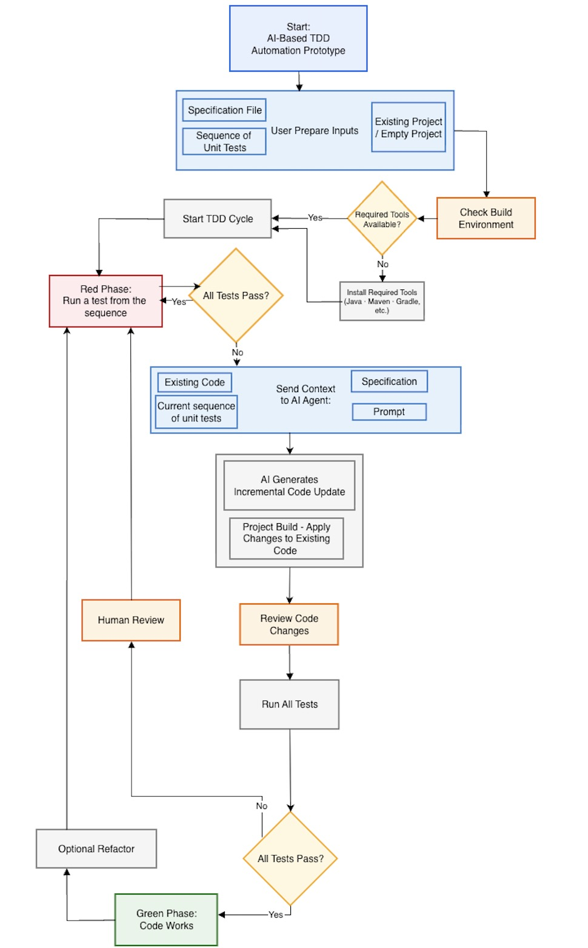
Figure 2: System Workflow Flowchart

8.1.2 Deployment Diagram The deployment architecture illustrates the system's structural components and their distributed execution. It maps the secure data flow between the local developer workstation, the isolated execution environment (which handles context building and automated testing), and the external cloud-based LLM infrastructure.
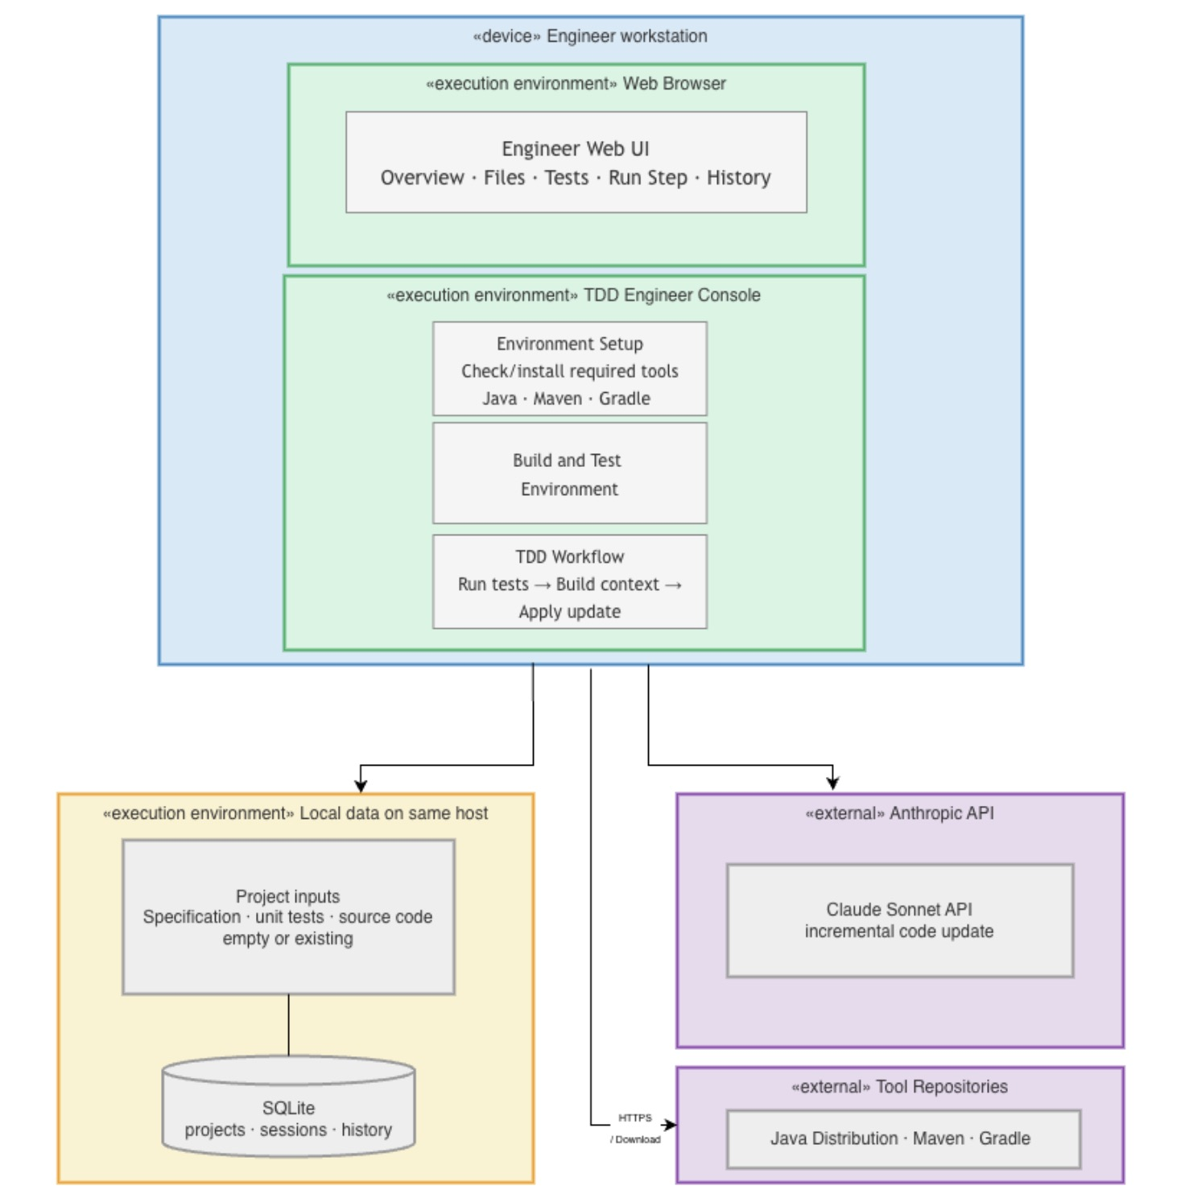
Figure 3: Deployment Diagram

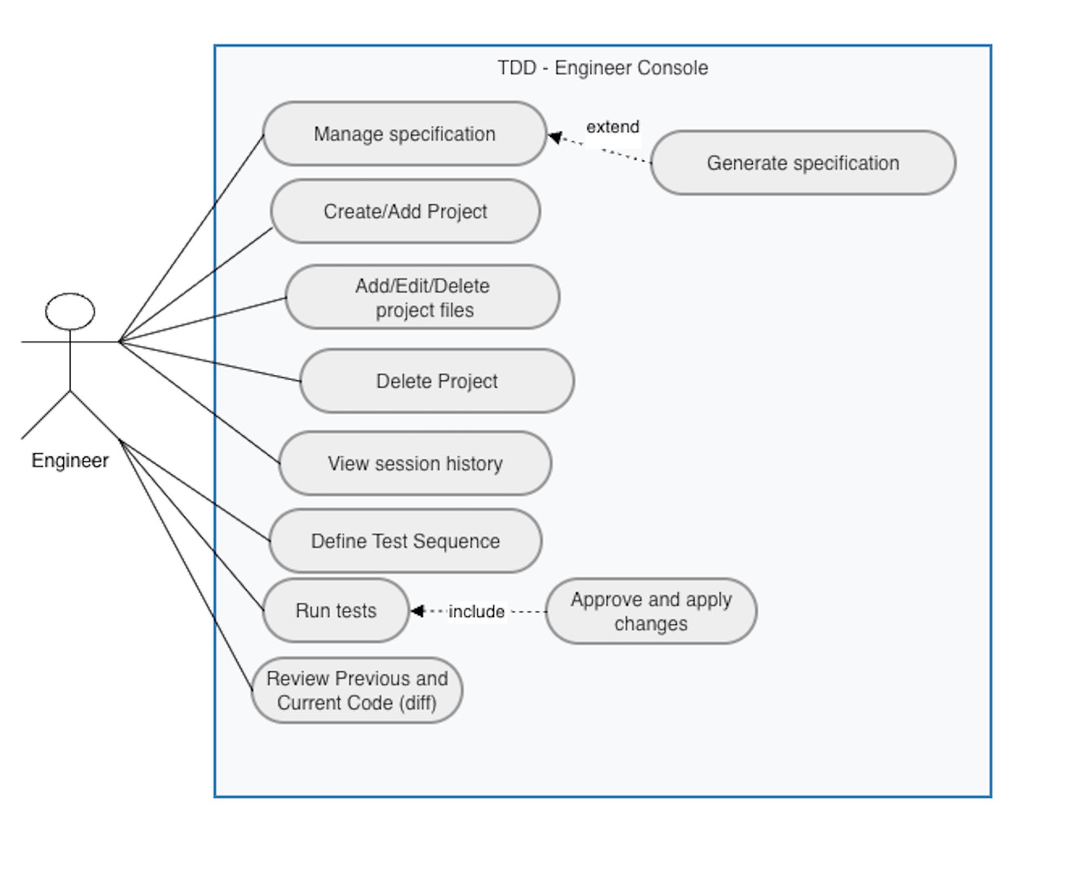
8.1.3 Use Case Diagram The following Use Case diagram illustrates the primary interactions between the Engineer and the TDD Console, mapping out the core functionalities of the system.
Figure 4: TDD Console Use Case Diagram

8.1.4 External API Integration To enable the autonomous code generation capabilities within the TDD loop, our system relies on external Large Language Model APIs rather than locally hosted models. The architecture is designed to be model-agnostic, allowing seamless switching between different reasoning engines. Currently, the system integrates with two primary external APIs:
- Anthropic API (Claude 3.5 Sonnet): Utilized as the primary reasoning engine due to its superior capabilities in surgical code editing, context retention, and strict adherence to provided system prompts.
- OpenAI API (o3-mini): Utilized during the initial baseline experiments and maintained as a secondary option to evaluate model differences in logical reasoning and refactoring behavior.
The TDD tool communicates with these APIs securely via HTTPS/REST protocols, transmitting the required context (the Specification.txt, Money.java, and Changes.md) and receiving structured, parser able code modifications in return.
- REFERENCES
[1] Mathews, N. S., & Nagappan, M. (2024). TDD for Code Generation. Proceedings of the 39th IEEE/ACM International Conference on Automated Software Engineering (ASE '24). arXiv:2402.13521.
[2] Piya, S., & Sullivan, A. (2024). LLM4TDD: Best practices for TDD using large language models. Proceedings of the 1st International Workshop on Large Language Models for Code (LLM4Code '24), 14-21.
[3] Rosa, G., et al. (2024). Evaluating Test-Driven Code Generation: A Replication Study. Proceedings of the 23rd Belgium-Netherlands Software Evolution Workshop (BENEVOL).

