Mckesson Databricks Column Masking Workflow

Databricks column masking uses a combination of Excel for the masking input parameters which is hosted in an Azure Dev Ops repository. There is an Azure Dev Ops (ADO) pipeline which starts and copies the Excel input parameters template into an Azure Storage Account container folder. Once the file lands there a Databricks workflow is triggered to update an ‘audit_rules’ managed Unity Catalog Delta table with new masking rules, and the masking rules will be applied to the appropriate tables and columns within a Domain Environment.

Masking Repo: https://dev.azure.com/mckessontech/mtdatamesh/_git/mtdatamesh_databricks?path=%2F&version=GBDatamasking_Upload

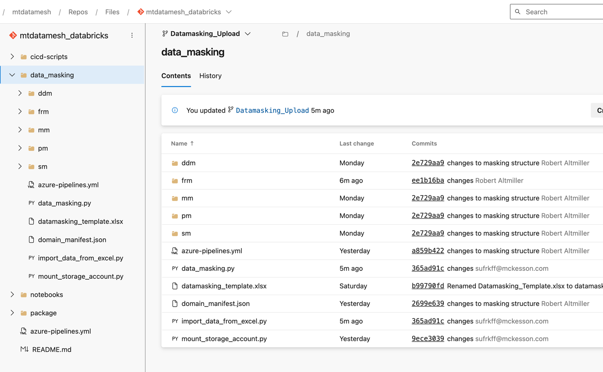
What are each of the following files / folders in the Repo for:

- ddm, frm, mm, pm, and sm folder represent each Domain, and within each of these folders you will find a dev, qa, uat, and prod folder. Within the environment folders you will find a separate Excel “datamasking_template.xlsx” which has masking rules for each Domain Environment.
- The data_masking.py is the main Databricks notebook is called from ADO by the datamasking_workflow in Databricks that orchestrates all the column masking. It also calls the import_data_from_excel.py” notebook.
- datamasking_template.xlsx is an example file to show an end user what user input is needed to use the datamasking workflow.
- The mount_storage_account.py is a notebook which is run in order to create a mount point to the storage account container where the datamasking_template.xlsx is copied into.
- The domain_manifest.json contains environment specific information (e.g. resource group name, region, subscription, etc) and it is read by the azure-pipelines.yml file. This manifest file is important to reduce or dependency on needing so many variable groups and allows us to us a single ADO pipeline to deploy column masking between Domain Environments.
- The azure-pipelines.yml file is called by an ADO Pipeline, and it copies the datamasking_template.xlsx and it copies the datamasking_template.xlsx into the appropriate Storage Account Container.
What Storage Account Containers and folders are used?

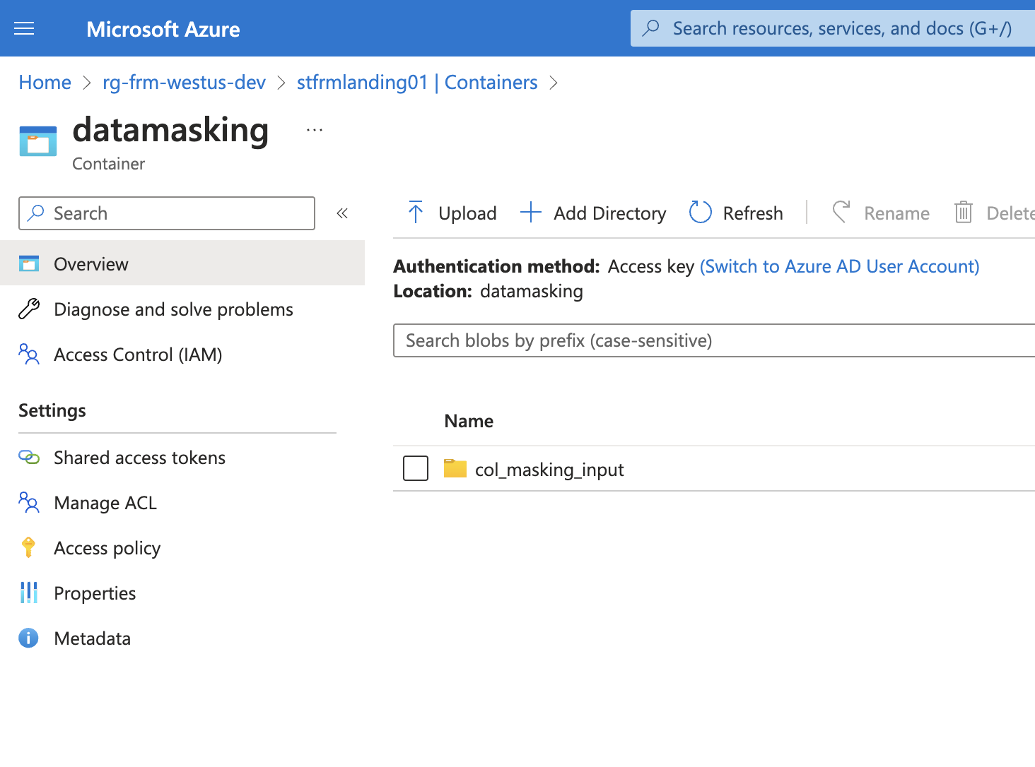

What Azure Dev Ops (ADO) Pipelines are used?

https://dev.azure.com/mckessontech/mtdatamesh/_build?definitionId=52

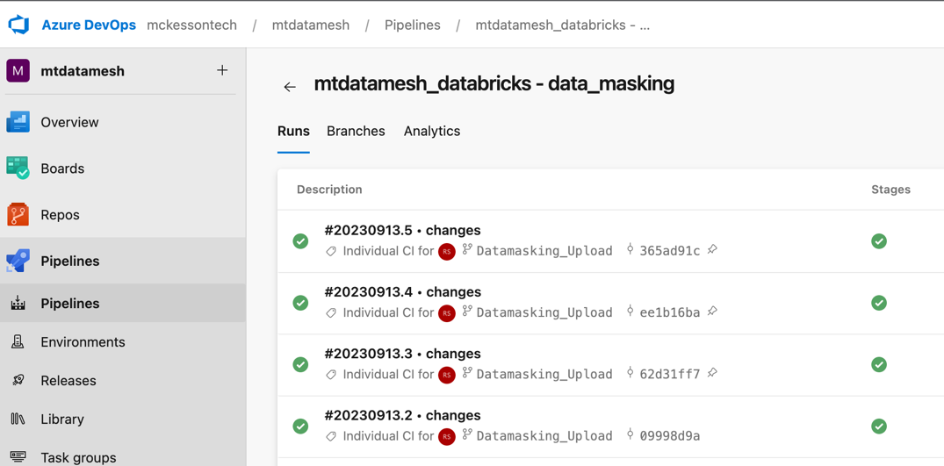

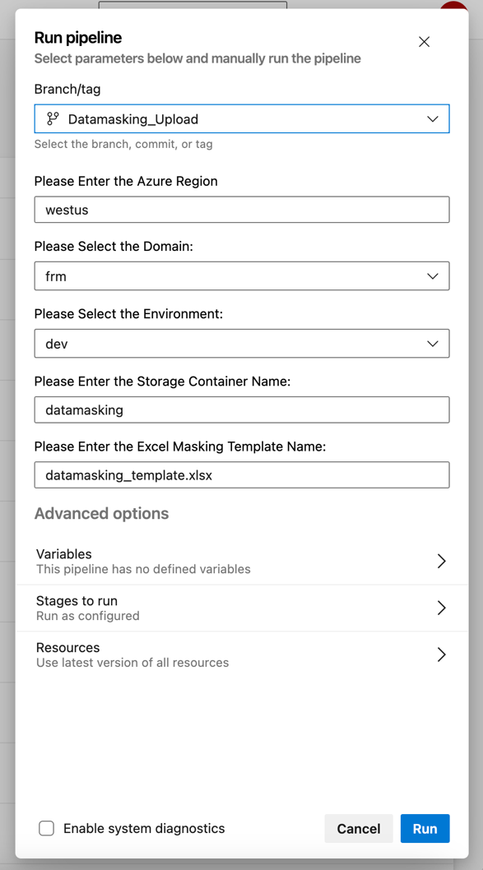
Where is the data masking workflow in Databricks?

https://adb-8619450367578475.15.azuredatabricks.net/?o=8619450367578475#job/666395697975975

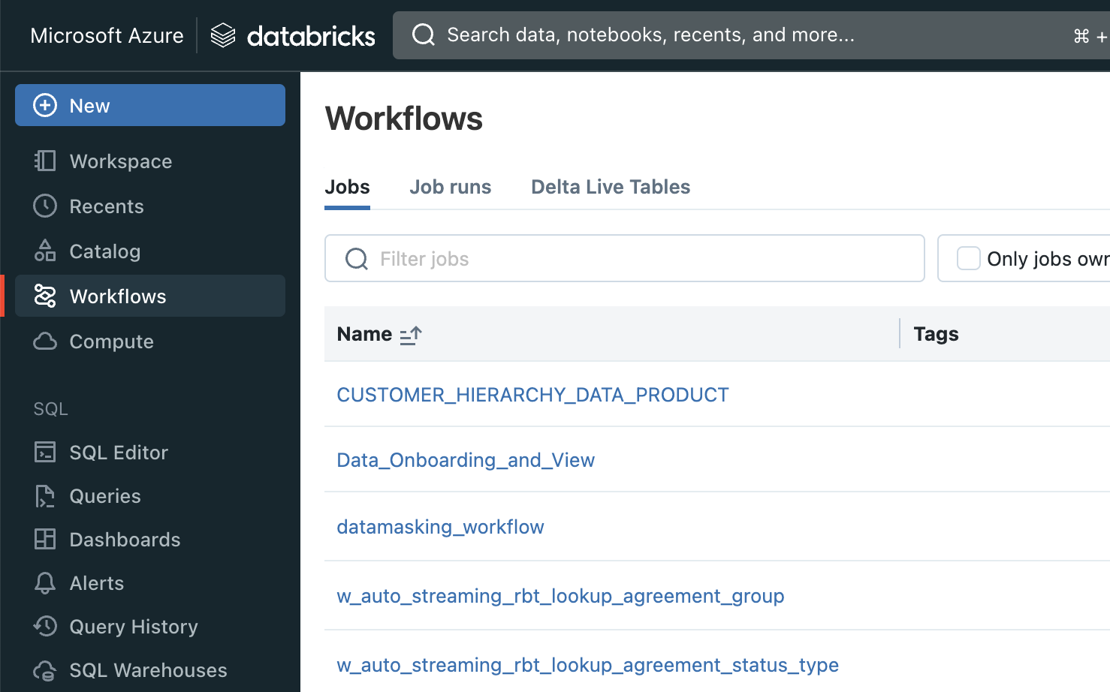

Update workflow parameters to reflect Domain Environment
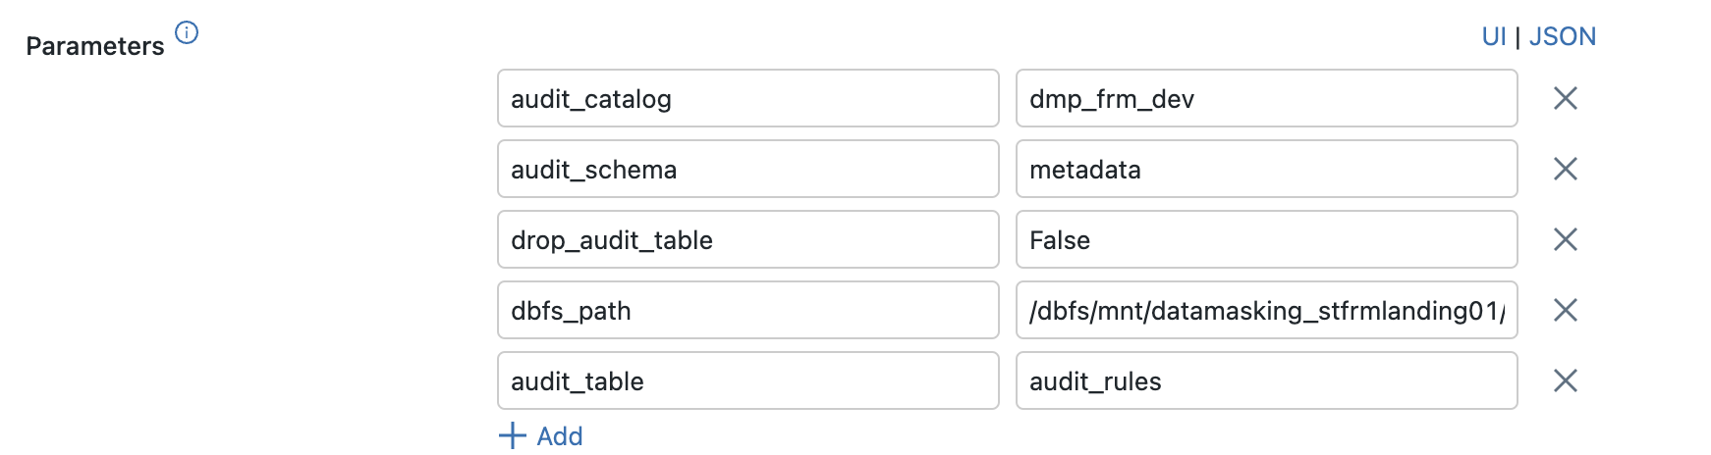

What improvements can be made?

A new file trigger should be setup on the data masking workflow using an external location so when the ADO pipeline copies the datamasking_template.xlsx in the storage account container the data masking workflow will automatically start.

Appendix

File Arrival Triggers Documentation:

https://learn.microsoft.com/en-us/azure/databricks/workflows/jobs/file-arrival-triggers

Row and Column Filters in Unity Catalog:

https://learn.microsoft.com/en-us/azure/databricks/data-governance/unity-catalog/row-and-column-filters

Unity Catalog Volumes (Replaces DBFS Mount Points):

https://learn.microsoft.com/en-us/azure/databricks/data-governance/unity-catalog/create-volumes

