DISSOLVE CATARACTS AND IMPROVE VISION

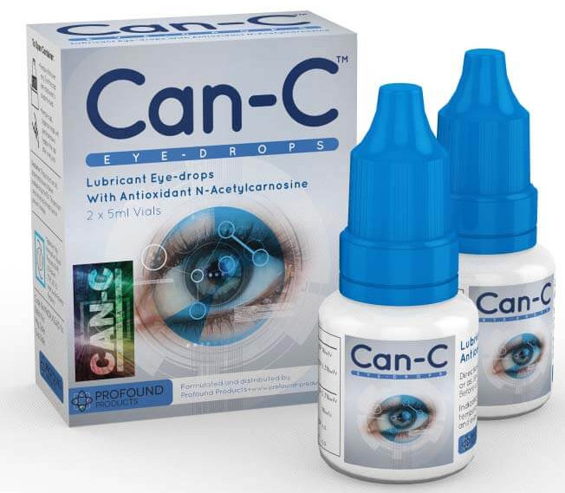


My story:
In 2023 I was diagnosed with cataracts and found Can-C eye drops on Amazon that were first approved for dogs and later for human use. Can-C claimed to dissolve senile cataracts. I noticed a significant improvement after 3 months. I have been using them once a day for about a year and can see better without my glasses than with them, I can drive at night without the annoying glare and the colors look so bright and vivid during the day. With age I became 20:40 with astigmatism but now I am back to 20:20 without astigmatism. These eye drops reverse the effects of aging. I still need progressive lenses for reading but my distance vision is great. For maintenance, now I use the drops once per week.
For purchase, located in Idaho: Can-C™ Original Eye Drops - Wise Choice Medicine
For information: https://www.can-c.me/ and https://www.can-c.net/
"Most People Know About Cataract Surgery… But Not Everyone Knows About Can-C™ Eye Drops."
"The word has been spreading about Can-C eye drops for cataracts over a decade. Why?
Reports from research studies tell us that Can-C™ eye drops can be a viable option to surgery."
NOTE: “We do not recommend that the Can-C™ eye-drops are combined with Lutein (unless a patient has a cataract associated with a retinal disorder), this is because Lutein appears to block the receptor sites and may lower the efficacy of the results.” The same appears to be true for Zeaxanthin.
https://pubmed.ncbi.nlm.nih.gov/16274259/ Not only CATARACTS but also FLOATERS:
CAN-C "NAC drug shows promise in the treatment of a range of ophthalmic disorders that have a component of oxidative stress in their pathogenesis (including cataract, glaucoma, dry eye, vitreous floaters, inflammatory disorders, and corneal, retinal and systemic diseases."
https://pubmed.ncbi.nlm.nih.gov/19503764/ CAN-C "NAC eye drops help the aging eye to recover by improving its clarity, glare sensitivity, color perception and overall vision."
https://pubmed.ncbi.nlm.nih.gov/11390029/
A clinical study was designed to document and quantify the changes in lens clarity over a 6 to 24 month period. The average age of the participants was 65. All subjects suffered from senile cataracts of a minimal to an advanced opacification. The patients received either a 1% solution of N-acetylcarnosine eye-drops or a placebo as 2-drops twice a day into each eye.
Results at 6 months were impressive; 88.9% of all eyes treated with N-acetylcarnosine eye drops had an improvement of glare sensitivity. Furthermore, 90% of the eyes treated showed an improvement in visual acuity. In contrast, there was little change in the eye quality of the placebo group at 6 months and the placebo group also experienced a gradual deterioration at 12 to 24 months. In summary, results thus showed that:
▶ 90% had an improvement in visual acuity.
▶ 88.9% had an improvement of glare sensitivity.
Drugs R D. 2002;3(2):87-103. Efficacy of N-acetylcarnosine in the treatment of cataracts. Babizhayev MA et al.
Also: https://www.can-c.me/current-research-on-cataracts

