Tools

GitHub:

Pwd

Cd Documents/

Dir

Cd Robert_Summer

dir

git add (file name; use Tab)

git commit –m “(Type a message)”

git push

Arduino:

Setup code: pinMode (13, OUTPUT);

Loop code (On and Off):

digitalWrite(13, HIGH); //set voltage to 5 volts

delay(remember “1000” is equal to one second);

digitalWrite(13, LOW);

delay(a number);

HIGH means circuit on

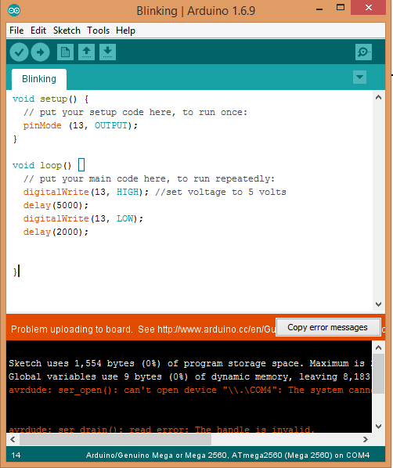LOW means circuit off