**CSC10008 – COMPUTER NETWORKING**

**PROJECT**

**PROJECT-03: NETWORK DESIGNATION AND CONFIGURATION USING CISCO PACKET TRACER**

1. **Information**

|  |  |
| --- | --- |
| ID: | PROJECT-03 |
| Estimated time: | 2 weeks |
| Deadline: |  |
| Type: | Group (maximum of 2 students) |
| Submission: | Via Moodle |
| Teacher assistant: |  |
| Contact: |  |

1. **Learning outcome**

The student will reach to:

* Understand how to connect two application via a network, specify at the transport layer
* Explore to socket programming: client – server architecture
* Deep understanding of HTTP protocol, a protocol at the application layer

1. **Description:**

# Lab 1: DHCP configuration on CISCO router

Please setup the network below using Packet Tracer with the following commands:

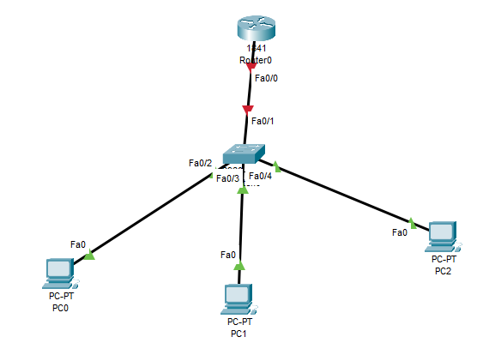



Then, please answer the following questions:

1. What is the IP addresses of PC0, PC1, PC2 which were acquired from DHCP?
2. What is the gateway addresses of PC0, PC1, PC2?
3. Which server is the DNS server for PC0, PC1, PC2?

# Lab 2: Static routing implementation

Consider the following diagram with IP address assignment, configure static routing:

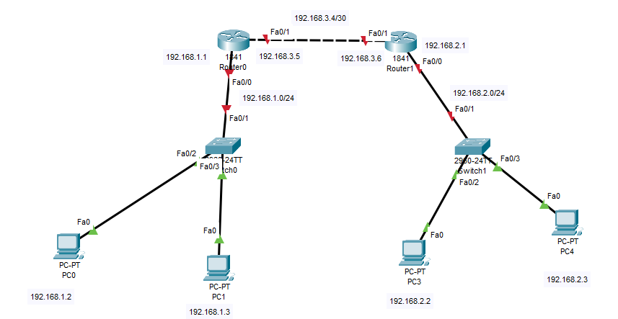

Please answer the following questions:

1. Execute ping commands and take screenshots the ping result between PC0 and PC2, PC3 and PC1
2. Show the routing table of the router R0 (can use command or GUI to get the routing table).
3. Which line in the routing table is configured by static route? What is the administrative distance (AD) and the metric of the static route?

# Lab 3: Implement the basic building network topology

Consider the following network topology,

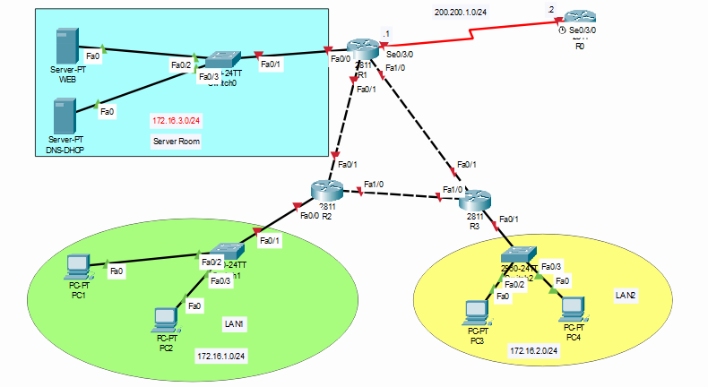

|  |  |  |  |
| --- | --- | --- | --- |
| **Device Name** | **Interface** | **IP address** | **Device Type** |
| R0 | S0/3/0 | 200.200.1.2/24 | Router |
| R1 | F0/0 | 172.16.3.1/24 | Router |
|  | F0/1 | 192.168.1.1/30 |  |
|  | F1/0 | 192.168.2.1/30 |  |
|  | S0/3/0 | 200.200.1.1/24 |  |
| R2 | F0/0 | 172.16.1.1/24 | Router |
|  | F0/1 | 192.168.1.2/30 |  |
|  | F1/0 | 192.168.3.1/30 |  |
| D2 | F0/1 |  | ??? |
|  | F0/0 | 172.16.2.1/24 |  |
|  | F1/0 |  |  |
| D1 |  |  | ??? |
| WEB server |  | 172.16.3.100 |  |
| DNS-DHCP server |  | 172.16.3.200 |  |
| PC1 |  |  |  |
| PC2 |  |  |  |
| PC3 |  |  |  |
| PC4 |  |  |  |

Please answer the following questions:

1. Determine the “Device Type” of devices D1 and D2 in the “Device Table” and in the diagram to finish the network topology.
2. Configure the DNS server and Web server for [www.network.com](http://www.network.com) and test to access it via a browser.
3. Configure the DHCP server to assign the IP addresses to PC1, PC2, PC3, PC4
4. Configure static routing for all routers so that all subnets can talk to each other.
5. Execute ping command and take screenshots about the ping result from PC1 to PC3, PC4 to PC2.
6. Access the web pages at http://www.network.com address via web browser of PC1, PC3
7. **Requirements:**

* Please submit your project via Moodle site with the following format: **Student-ID1_Student-ID2.zip** included:

Student-ID1_Student-ID2.pdf: the report file describes your answers, your main idea: how to implement the application, how to test your application, the refer link/ documents you used. Take the screenshots of test/ demo step.

Configure: a folder contents your configuration file: ***lab1.pkt, lab2.pkt, lab3.pkt***

Video.txt: contents your demo link (backup in the worst case)

Example:



1. **Assessment:**

Based on students’ report and configuration files.

1. **References**

The Packet Tracer‘s manuals and the documents provided on Moodle

1. **Another Rules:**

* No cheating please. Zero for all member if cheating.