# ITS320: Portfolio Project Screenshots

Vehicle Inventory Application: Robert T. Lancaster

Program start:

**<Application displays current inventory (empty on startup) and displays Main Menu>**

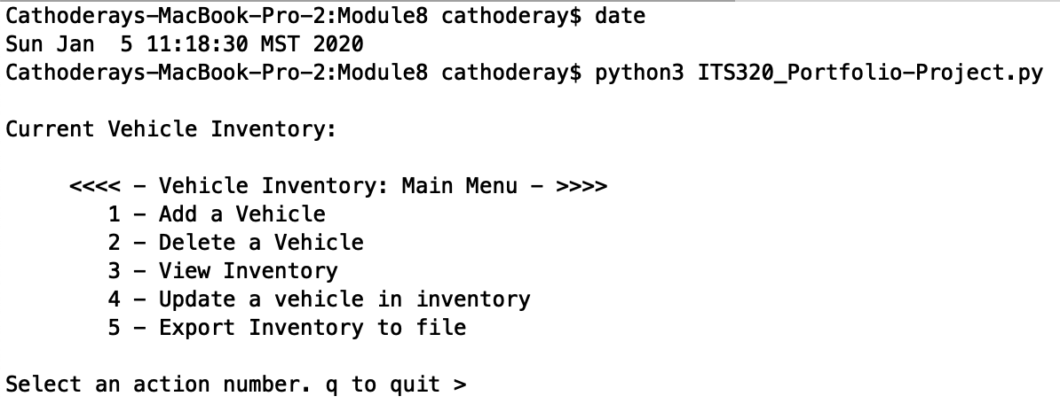

**<Selection action 1 enters Add dialog. Each field is prompted and complete vehicle is added to inventory list>**

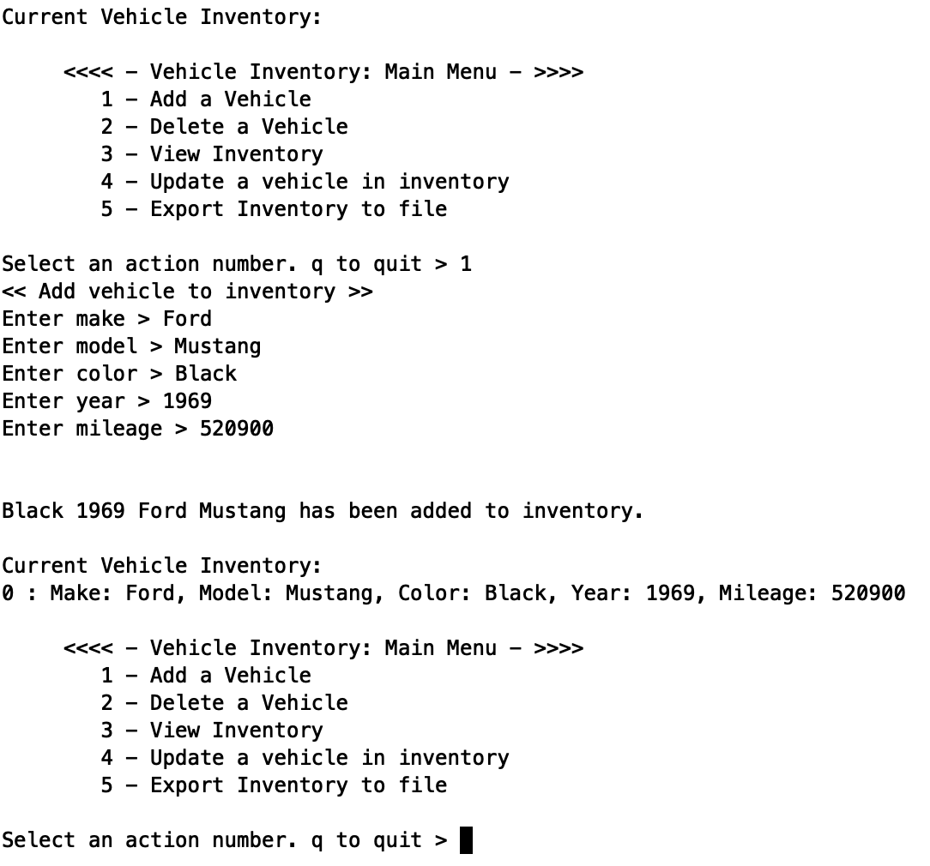

**< Main Menu always has current inventory. Adding a second vehicle>**

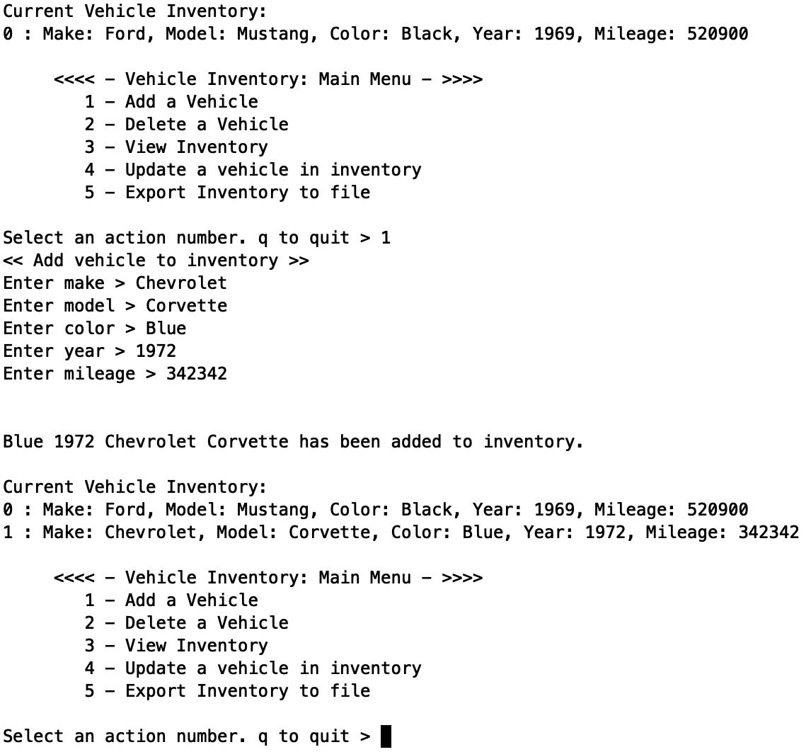

**<Third vehicle is added>**

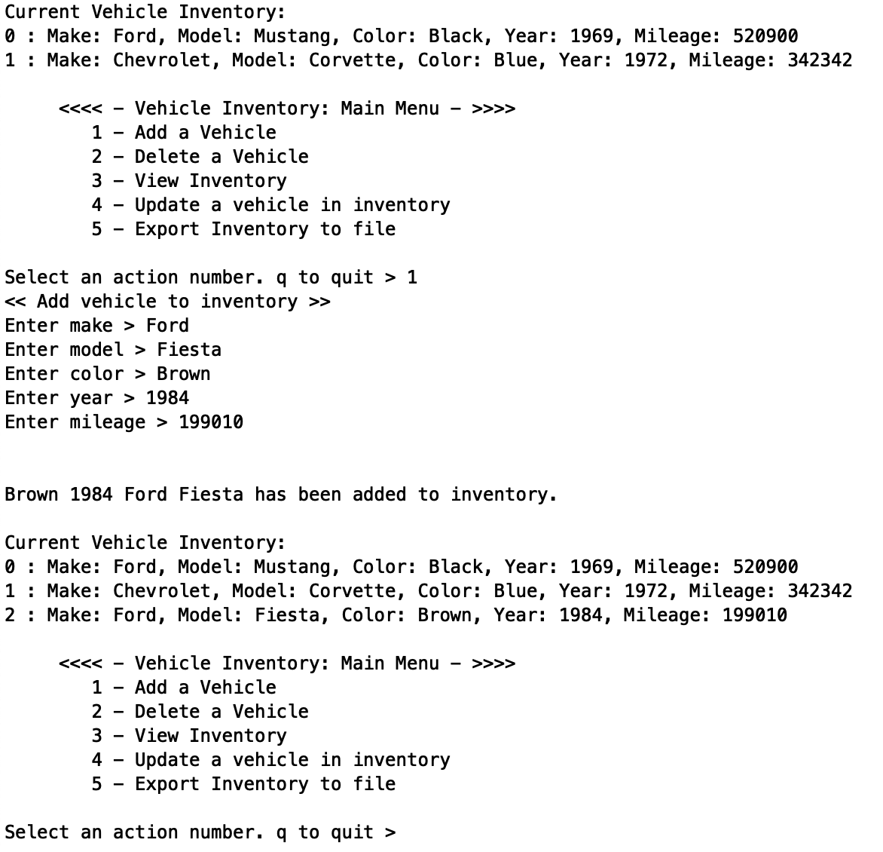

**<The Fiesta is such a great car, it is immediately purchased and removed from inventory. Note that inventory header reflects current program mode>**

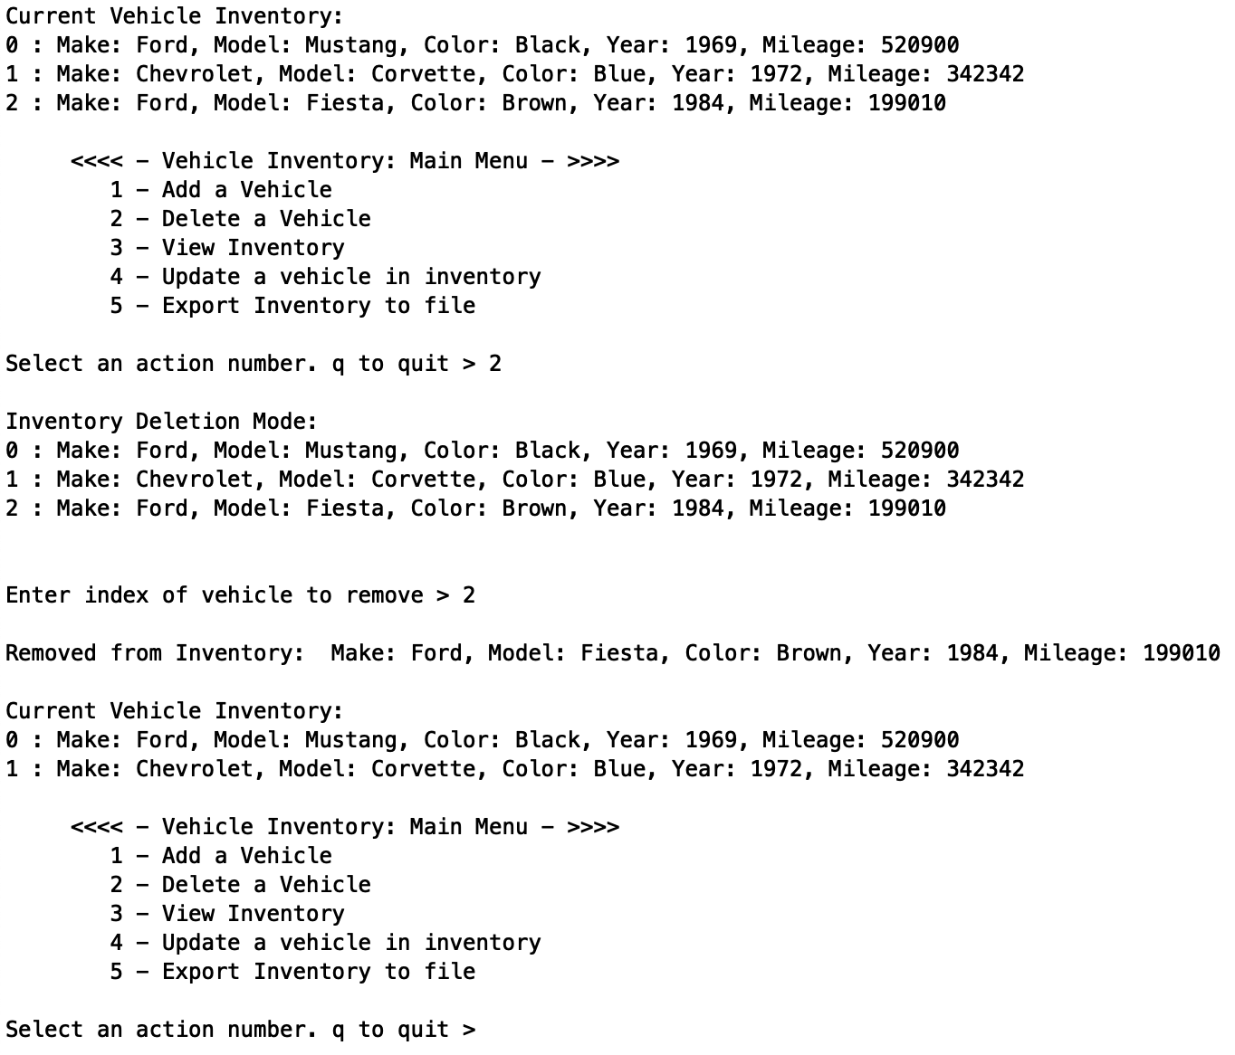

**<Main Menu always shows current inventory. Selecting action 3 displays inventory with new header to reflect selection result.>**

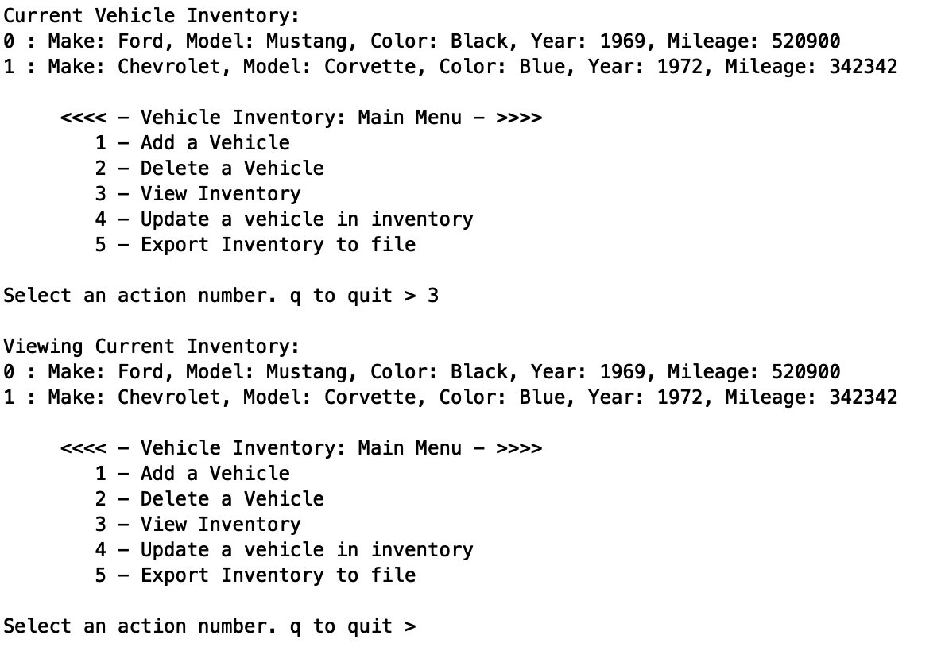

**<Perform vehicle attribute update (note that inventory list header reflects current mode and selected vehicle has all attributes displayed for user)>**

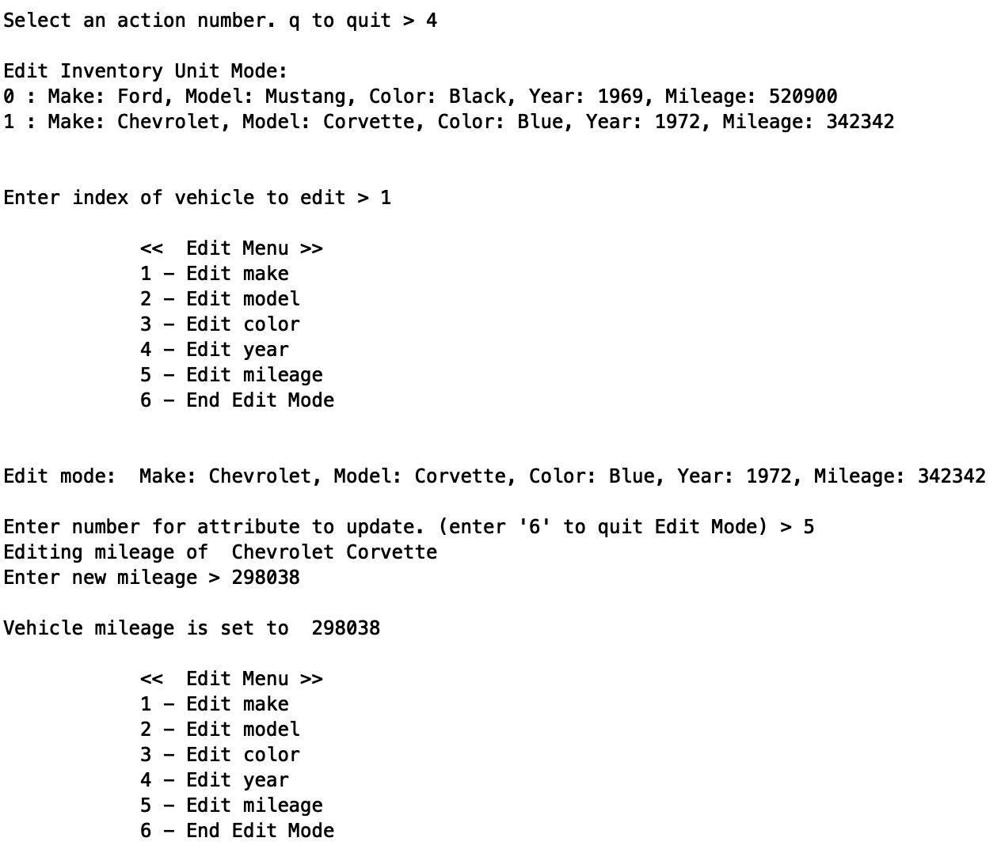

**< Mileage (5) was updated. Now the color attribute is edited for selected vehicle. Exit Edit mode and return to Main Menu>**

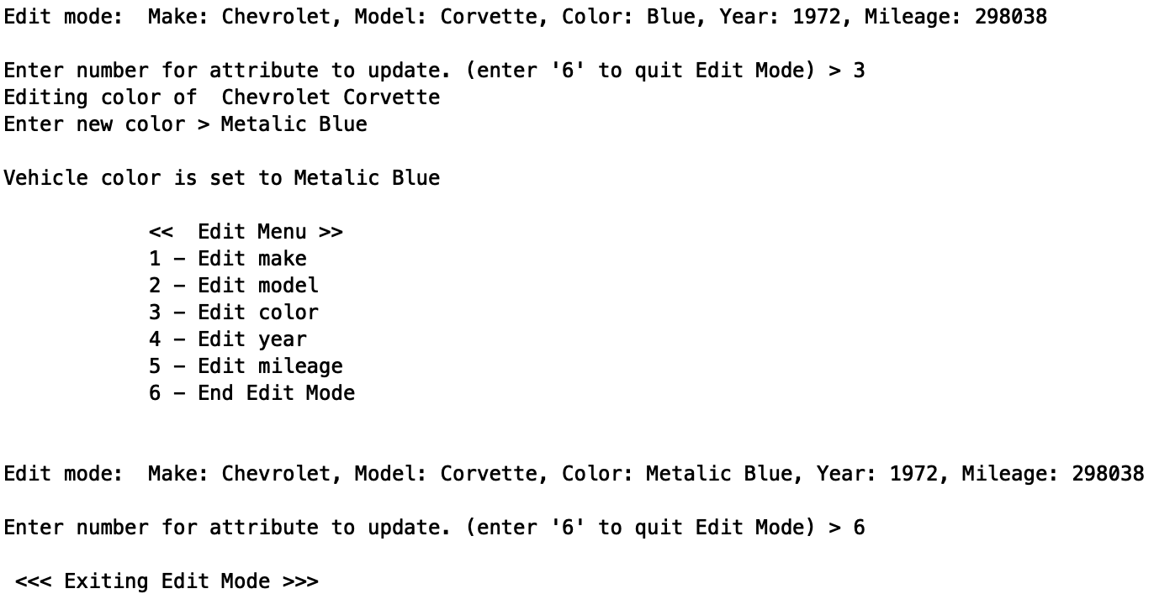

**<Main menu: Option 5 export data to file (name specified by user)>**

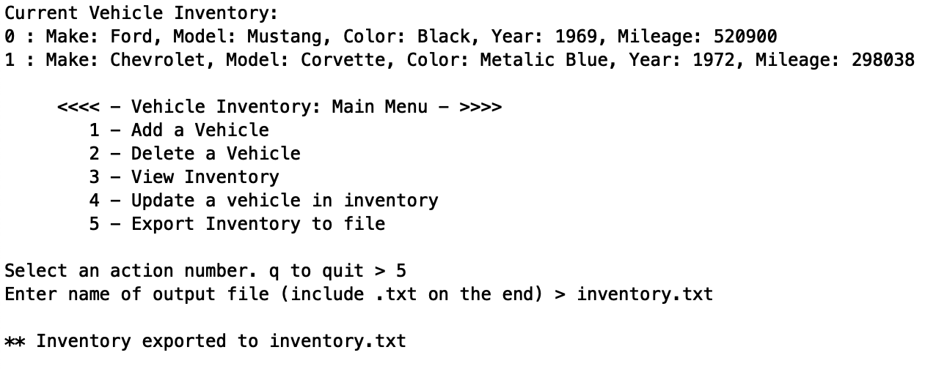

**<Quit program and verify file output.>**

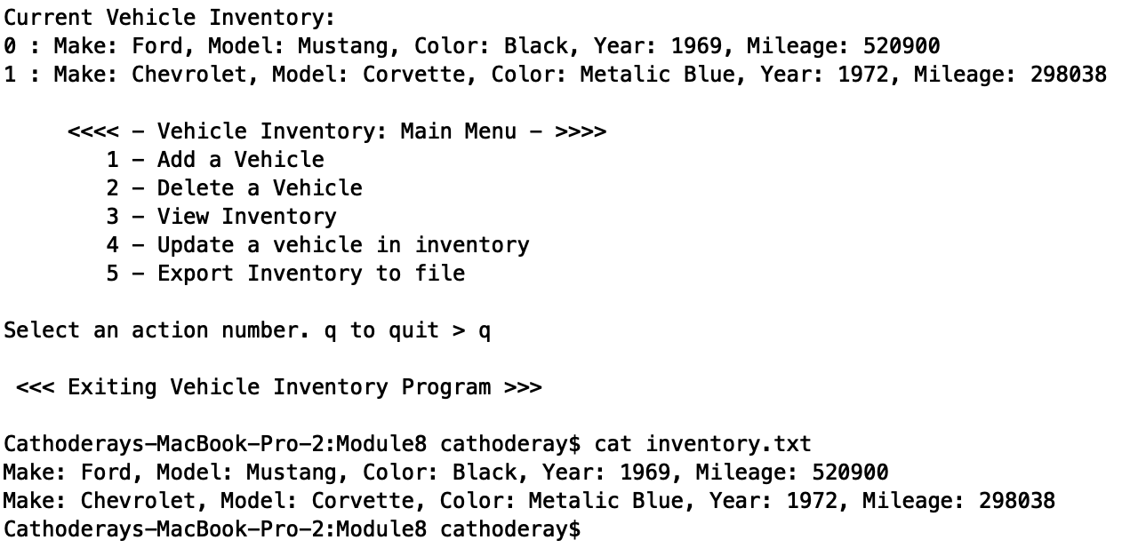

**< File shows inventory contents at time file written. >**