## Description: clip_image002MAKERERE UNIVERSITY

**COLLEGE OF ENGINEERING, DESIGN, ART AND TECHNOLOGY**

**MARGARET TROWELL SCHOOL OF INDUSTRIAL AND FINE ARTS**

DEPARTMENT OF FINE ARTS AND DESIGN

A REPORT ON FIELD RESEARCH AT MARGARET TROWELL SCHOOL OF INDUSTRIAL AND FINEARTSMAKERERE UNIVERSITY

**ARTISTIC VIEW ON ACCEPTABILITY ON TRENDS IN FASHION**

**KATUSHABE GLORIA**

13/U/6232/PS

213013441

A FIELD RESEARCH REPORT SUBMITTED TO COLLEGE OF ENGINEERING DESIGN, ART AND TECHNOLOGY IN PARTIAL FULFILMENT OF THE REQUIREMENTS OF A BACHELORS DEGREE

IN INDUSTRIAL AND FINE ARTS OF MAKERERE UNIVERSITY KAMPALA

JUNE 2017

# DECLARATION

I Katushabe Gloria declare that this research proposal is my original work and has never been submitted to any university or institute for an award or examination of any sort.

Name: Katushabe Gloria

Signature:…………………………………

Date:………………………………………..

# APPROVAL

This research proposal that was compiled by Katushabe Gloria was under my close supervision and guidance and it is now deemed necessary for submission into the university authority for examination with my due approval and signature.

SIGNATURE:……………………………………….

SUPERVISOR

PROF. PHILLIP KWESIGA

SIGNATURE………………………..

DATE:………………………………..

# DEDICATION

I dedicate this research report to my bellowed guardians and sisters for their endless love and financial support and counseling they accorded to me towards my academic journey.

# ACKNOWLEDGEMENTS

First and foremost I would like to thank the lord God almighty far this he has brought me because without his mercy I could have not reached this far.

I would like to express my gratitude to our devoted supervisor Prof. Philip Kwesiga for his time guidance, encouragement, constructive criticism and supervision at all the stages of research.

I am grateful to my dear brothers and sisters for their financial support, am proud of you.

MAY GOD BLESS YOU ALL.

TABLE OF CONTENTS

[DECLARATION i](#_Toc377298624)

[APPROVAL ii](#_Toc377298625)

[DEDICATION iii](#_Toc377298626)

[ACKNOWLEDGEMENTS iv](#_Toc377298627)

[1.0.Introduction and background 1](#_Toc377298628)

[1.1 Introduction 1](#_Toc377298629)

[1.6. Scope of the study 3](#_Toc377298630)

[1.7. Limitations 3](#_Toc377298631)

[CHAPTER TWO 4](#_Toc377298632)

[2.0 LITERATURE REVIEW OF THE STUDY 4](#_Toc377298633)

[2.1. Introductions 4](#_Toc377298634)

[2.2. Literature review 4](#_Toc377298635)

[CHAPTER THREE 12](#_Toc377298636)

[3.0. Study of Methodology 12](#_Toc377298637)

[3.1. Methodology 12](#_Toc377298638)

[3.2. Research designs 12](#_Toc377298639)

[3.3. Population sample 12](#_Toc377298640)

[3.4. Case study 12](#_Toc377298641)

[3.5. Data collection methods 13](#_Toc377298642)

[3.6. Data Analysis 13](#_Toc377298643)

[CHAPTER FOUR 14](#_Toc377298644)

[4.0. Findings and interpretations (from the field work) 14](#_Toc377298645)

[4.1introduction 14](#_Toc377298646)

[4.2. Interview Guided Questions 14](#_Toc377298647)

[CHAPTER FIVE 23](#_Toc377298648)

[5.0. Conclusion and Recommendation 23](#_Toc377298649)

[5.1. Conclusion 23](#_Toc377298650)

[5.2. Recommendation 23](#_Toc377298651)

[References 25](#_Toc377298652)

**CHAPTER ONE**

# 1.0.Introduction and background

# 1.1 Introduction

Throughout the early 20th century, practically all high fashion originated in Paris and to a less extent London. As this time in fashion history the division between haute culture and ready to wear was not sharply defined. Two separate modes of production were still; far from being competition and they often co-existed in houses of where they seamstresses moved freely between made to measure and ready -made.

A round the start of the 20th Century., fashion magazines begin to include table and photo graphs and become even more influential in the future. In the 1900s the outfits worn by fashionable women were strictly similar to those worn in the heyday of fashion pioneers Charles Worth who was the first designer to have his label sewn into the garments that he created. By the end of the 19th century, the horizons of fashion industry had broadened partly due to the more stable and independent life styles many well off women were beginning to adopt.

The changing on fashion was unthinkable so the use of different trimming was all at distinguished one season from another. The s-bend corset that was tightly laced at the waist which forced hips back changed to straight and slim. In the 1910’s the fashionable silhouette became much more in the fluid and soft. Some dresses changed in the World War 1 as women were forced to work. They demanded clothes that were suited for their new activities. By 1915 fashionable skirts had risen above ankle and then the mid-calf closets were abandoned and women borrowed their clothes from the male wearable and chose to dress like boys.

Due to different reasons for example social, economic and political changes fashion changed to where it is now and it’s still changing.

**1.2. Background**

Morality is the intentions, decisions and actions between those that are good and those that are bad. Morality can be a body of standard or principles derived from a particular philosophy religion, culture and so on or it can derive a standard that a person believes should be universal. Immorality question is not a new thing

Looking at this in the artistic point of view, many people have been misjudged due to what they wear. Each dressing code does not actually represent and reflect a person’s moral behavior. as long as a certain dress is put on at the right time, the right place, then it’s ok for example a mini skirt in the club that’s no immoral because it’s the right outfit worn in the right place or a person cannot be considered immorally it it’s their dress code for example the Karamajong.

although some people have dressed up in outfits in the wrong and at the wrong time which has led to fashion mishaps thus causing immoralities for example indecent dressing in fashion and because of this, laws against such immoralities have been passed in Uganda for example the law against women wearing miniskirts in public places.

**1.3. Problem statement**

The influential of fashion on morality in Uganda, the miss judgment of people’s moral behavior considering fashion. Since fashion is part of our social, economical and political life, it has influenced the moral behavior of the people in Uganda especially the youth who have taken it for granted and misused it for example most girls nowadays put on short skirts and dresses everywhere even in churches.

**1.4. Purpose of the study**

The purpose of the study, “artistic view on acceptable trends in fashion”, is to find the effects of fashion on people’s moral behavior.

To explore what is considered community’s acceptably allowed in fashion

To probe the advantages and disadvantages of fashion in the eyes of different communities in Uganda

To analyze the causes and determine decent in fashion dressing in selected communities in Uganda.

**1.5. Significance of the study**

The significance of the study is;

To share how fashion has affected the moral behavior o people in Uganda.

To reduce on the immoralities in fashion i.e. indecent dressing in Uganda.

To create awareness among the people in Uganda about the morals in fashion.

To reduce the miss judgment of people on what they put on.

# 1.6. Scope of the study

The study is Uganda’s investigation as a country on the area of morality and to achieve this scope, parts of Uganda were chosen i.e. in Kampala especially around clubs, bars and churches.

To get the results easily, the researcher used Nakulabye as part of Kampala, to carryout the study.

# 1.7. Limitations

During the study the researcher faced some limitations whereby some of the people that were chosen to be interviewed did not appear and other could not answer all the questions because of shortage of time.

Apart from the above limitations, the researcher was able to carry out the study to get enough and good results.

# CHAPTER TWO

# 2.0 LITERATURE REVIEW OF THE STUDY

# 2.1. Introductions

any research undertaken to understand the state of affairs and to propose practical solutions to the problems must be grounded on affirm methodology in order to achieve- the study objectives called for the selection of paradigms and development of tools which were applied in collecting data, analyzing the information and providing accurate interpretation of the study.

# 2.2. Literature review

Regarding morals, anthropologist Ruth Benedict (2014) argues that moral norms are nothing more than social norms. There are no demands on our behavior beyond those imposed by various human cultures. The truth of any moral claim or fashion claim is determined from within a particular culture.

Some differences in styles of dress for example don’t amount deviance, persons who wear a common style of clothing any still favour different colors without becoming deviant “Ruth Benedict’s Anthropology and the Abnormal.”

Beyond the idea of differences, deviance implies something evaluated or disvalued. Someone’s clothing may look different without qualifying as deviant, it may earn a label only if its difference seems in bad taste such as when colors clash violently or when the clothing is not suitable to the occasion, wearing a miniskirt in a club they would consider that as a deviant in contest to fashion. Ruth Benedict’s “Ethics are Relative.”

Some people may violate some group’s appearance norms by going too far as some older people might regard current or dress fad or dress code or tattooing among some young people. It depends upon some audience’s definition of something as deviant. These three differentness, judgment and relative standards support the understanding of the meaning of individual deviant conduct as well as connection of the conduct to a large social community.

Moral judgments generally don’t reflect the position of an individual alone, it reflects those of the group or the groups which the individual belongs .Ruth Benedict’s   
Ethics are Relative”

Fashion is a good thing because it makes an individual unique and classy but it has been abused by the way the youth especially the students by the way they choose to dress on campus, in public places. Thus has increased indecent dressing in Uganda. Breast shows, miniskirts are also clothes but they are supposed to be worn in the right place at the right time.

**Plate 1: Images showing women dressed indecently in public:**

 

**Figures courtesy of** [**www. Indecent**](http://www.indicent) **dressing .com.**

According to fashion expert Keturah Makugasa 2016, fashion in the 1970’s reflected of freedom, courage and liberalization whereby feminist movement had had an impact on the society. Women had more courage to expose ages of the legs and thighs.

People then had so much respect compared to people now whereby today the girl wearing a short skirt can be labeled as a slut.

In the late 1980’s and 1990’s a woman risked being undressed if she decided to go down town in mini. Today however, the perception changed and women freely wear mini attires.

**Plate 2: images showing women freely putting on mini attires in public**.

 

**Photos courtesy of mnyasatimes .com**

Indecent dressing in Uganda has increased especially among the youth who have taken some fashion trends for granted. The number of boys and girls showing off their underwear is not only fast becoming a trendy practice; it is becoming an acceptable norm in godly places, churches that are supposed to be teaching morals. This practice is contrary to the acceptable norms and values of the society. The battle against indecent dressing is an issue which generates controversy not only in Uganda but also worldwide.

**Plate 3: Images showing people’s dress code showing off their underwear:**

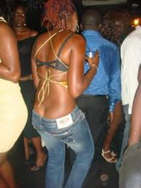 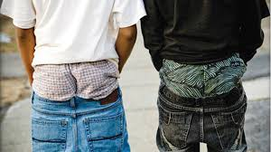

**Photos courtesy of** [**www.indecent**](http://www.indecent) **dressing .com**

In Uganda today, our leaders and even some individuals have tried to initiate bills and create laws that would regulate our public conduct, dressing and behavior in the public.

**Plate 4: Images showing women protesting against the mini skirt law:**

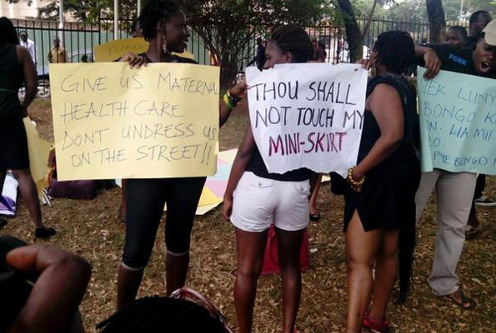

**Photo courtesy of new vision**

The questions asked are, what indecent dressing is, what are the criteria for indecent dressing and what should a boy or a girl dress?

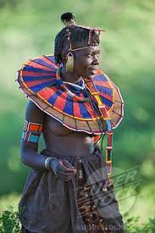At times in history fashionable dress has taken, very different forms. In modern times, nearly everyone follows fashion to some extent. There are different modes of dressing around the world reflecting the various available cultures. A particular mode of dressing can be used to identify a certain society as people. For example the Karamajongo’s dress code does not implement indecent or immorality, although in the present society people are expected to cover their bodies for privacy

**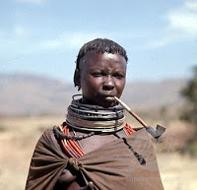Plate 5: Images showing the karamajongo’s dress code**

**Photos courtesy of** [**www.culture**](http://www.culture) **uganda.com**

**Plate6:Images showing the baganda’s dress code:**

**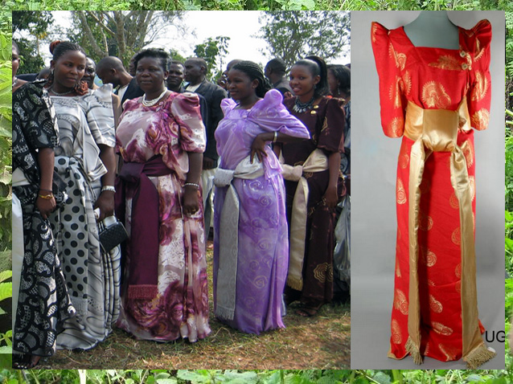 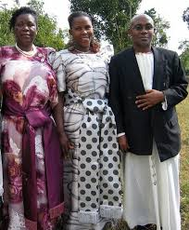**

**Photos courtesy of culture Uganda.com**

Fashion has also gone as far as interfering with a religious society whereby people now have no respect for God and put on skimpy clothes in churches and religious leaders have come out to condemn the act. On September 24th 1928 cardinal Vicar of Pope Pius made a statement that “we recall that a dress cannot be called decent which is cut deeper than two fingers under pit of the thread which does not cover the arms at least to the elbows and scarcely reaches a bit beyond knee. Furthermore dresses of transparent materials are improper.

Today women and men dress provocatively in churches. This is considered irresponsible since church is the one place where one should try to appear perfect in front of God.

This act is rather done by the women who come to church in mini attires. Years ago while in church, if a lady wears indecent of provocative closer to church she would be sent home to change unfortunately today, churches have failed to uphold righteousness, instead pastors fear to lose members of the church so they ignore the fact that the women are dressing indecently.

To the artistic view, as an artistic still respect church so its really indecent when I produce an attire that is indecent fro church for example in Uganda two girls were thrown out of church over indecent dressing. The embarrassed girls stood outside the church complaining that the pastor was a villager and old fashioned, “we put on similar attire and attend prayers in bigger churches around Kampala, but no pastor has ever embarrassed us like this one has done”

**Plate 7: Image showing girls dressed provocatively for church.**

**Photo courtesy of daily monitor**



Beauty and glamour is another reason why in Uganda or Kampala, some people are keen when it comes to fashion especially the youth. They like looking styled up and always want to have the latest fashion. Most youths clothing is a western domination in that most copy the way westerners dress, this has also affected Uganda’s moral status. The fact that the western clothing are allowed in the west and in Uganda not acceptable, makes them unpreferred because it has increasingly promoted immorality in Uganda.

**Plate 8: Images showing the indecent fashion that the people in Uganda have adapted from western fashion.**

**Sagging trousers (balance) and too much trousers:**

 

**Photos courtesy of** [**www.indecent**](http://www.indecent) **dressing.com**

Lillian Berenzi points that media is a source of style among youth. She writes that young generations express a lot of rebellion towards society. They have either own dressing-code and usually they emulate fashion of celebrities.

All girls follow the models seen in movies and television and each of them has constructed an idea where she will one lay broadcast her feminine charms for large audiences.

The truth is that a morally elevated fashion industry would bore the tailored pants off most people. Fashion industry should include Christian fashion week to promote and respect stylist modernization instead of sexuality and excess. Fashion is the only socialized elitist world I can think of where everybody belongs.

The clothing promoted by the heads of the fashion industry frequently goes beyond

standards of decency in most communities often more is revealed than concealed by the clothing which features high slits, plunging necklines and sheer fabrics. A large percentage of fashion designers are passionate about flaunting sexuality.

Fashion is facilitated by the present era, which has tremendous capacity for burning up in a short time all that is meant to satisfy the fantasy and the senses.

It is understandable that new generations intent upon their own future a different and better dream than that of the older people. They feel the need to detach themselves from those forms; not only of clothing but also of objects and ointments which most obviously recall a way of life that they wish to surpass thus they end up dressing indecently.

More basically, the immorality of some styles depends in great part of excesses either immediately or luxury. An excess of immodesty in fashion involves, in practice, the cut of the garment. The garment must not be evaluated according to the estimation of a decadent or already corrupt society which but according to the aspirations of the society which prices the dignity and seriousness of its public attire.

It is said almost with passive resignation that fashions reflect the customs of a people. But it would be more exact and much useful to say that they express the decision and moral direction that a person intends to take either to be immoral or to maintain him or herself at the level to which he or she has been raised by religion and civilization.

Lack of restraint in style is also another reason why there is indecency in Uganda. I don’t intend to suggest that the expansive force on the creative genius of fashion designers should be repressed, not that the fashion should reduce to unchanging forms, on the contrary I mean to indicate the right road that styles should follow, so that they may achieve their interpreters of civilized traditions.

All in all western civilization has been the main cause of immorality in different areas in Uganda. This has caused loss of respect, sexual crimes, cultural degradation and disrespect of religion cultures. Thus with the help of my research, fashion morality can be restored in Uganda. This will of course reduce the sexual crimes, prostitution and other immoralities in Uganda.

# CHAPTER THREE

# 3.0. Study of Methodology

# 3.1. Methodology

any research undertaken to understand a state of affairs and to propose solutions to problems must be grounded on affirm methodology in order to achieve the study objectives called for selection for paradigms and development of tolls which are applied in collecting data analyzing information and providing accurate interpretation of the study.

# 3.2. Research designs

In this study the researcher uses interviews, discussion and observation as instruments to find the results for the study. The researcher mainly uses a discussion guide to the different opinions of people bout the morals in fashion. This tool helped quite a lot to achieve the answers to the research questions.

# 3.3. Population sample

Using this type of research design, a number of people were interviewed through drafting questions. They were interviewed on what they though about the morals in fashion and each gave their own perspective.

# 3.4. Case study

Here the researcher interviews different persons from different places, like bartenders, students and the elderly, to get a general view of the acceptable trends in fashion. The researcher had the case study in Makerere resident where the researcher interviewed different students and residents of makerere. These people were interviewed to get the general views on the acceptable trends in fashion in Uganda.

# 3.5. Data collection methods

**Interviews**

The study employed this method more extensively with the elders in the different cadres and posts. This method was appropriate and it yielded more results about the morals in fashion. An interviewer guide that was used can be found as an appendix to this report.

**Observation**

According to my observation in the different places, there was still a problem of immorality in fashion. This was evidenced through the various codes among the people especially the youth, still dressing in skimpy clothes and see- through in public places without them feeling immoral. The visit to the church was undertaken to observe the key points to enlighten the study topic.

# 3.6. Data Analysis

The qualitative data that was obtained from the study was analyzed and presented in a form that captures the information more adequately that is presented in a descriptive form.

# CHAPTER FOUR

# 4.0. Findings and interpretations (from the field work)

# 4.1introduction

The study used a multiple of tools both qualitative and quantitative though the study is based on the former. The purpose of the study, “artistic view on acceptable trends in fashion” The purpose of the study, “artistic view on morality in fashion”

To find the effects of fashion on people’s moral behavior

To explore what is considered community’s acceptably allowed in fashion

To probe the disadvantages and advantages of fashion in the eyes of different communities in Uganda.

To analyze the causes and determine the decent trends in fashion dressing in selected communities in Uganda.

# 4.2. Interview Guided Questions

This study used interview a part of the probe in the dressing and morality in selected communities

1. What do our clothes say about?

a) Who we are?

b) Who we think we are?

2. What are different rights in fashion?

3. Does fashion reflect the custom of people?

a) Yes (explain why)

b) No (explain why)

4. How does the way we dress communicate massages about our identity?

5. Is it important to be critical in one’s own fashion?

1. Yes (explain why)
2. No (explain why)

6. What fashion trends are considered moral?

7. How has fashion affected people’s moral behavior?

8. How has fashion reflected the morals in society?

9. What are the causes of indecent dressing in the youth today?

**Findings**

1. **What do our clothes say about?**
2. who we are

One of the central findings was to be responsible. Some clothes communicate that

some people are responsible for example if a person is putting on a suit; he is sometimes looked at as being responsible.

Others have suggested that it is wrong for us to ignore the fact that clothing is a language. In fact, fashion has become a form of communication, a strong manipulating tool to stir the imagination, the curiosity and send a signal to the observing eyes

Respectable. Some people are considered respectable especially when putting on cultural wear. We should all be conscious of local sensibilities when choosing the clothes we wear.  It is also good to note that Africans are very neat dressers.  The villagers are more casual depending on what they can afford.

Since Ugandans consider it offensive for a woman to expose her knees and shoulders (although you may see less modest wear on the young adults and in the city), the most acceptable thing to wear is a dress/skirt covering the knees with a modest top - short tops that show your stomach or your back are not acceptable.  A tank or T-shirt which exposes your bra - or more - is definitely not acceptable.

Also the thigh and knee of a woman is considered very sensual so people are to keep them covered in public.  It is also absolutely necessary for ladies to wear an underskirt or lining underneath their dress/skirt, unless it is denim or of a similar heavy weight material.

1. **who we think we are**

Here the clothes people put on depict their age (old or young), gender (girl or boy), what color they like, if they are artistic or creative or whether they like dresses or not.

People must also be conscious of what they wear - or bare! The older generation will look upon you as still being a "boy" if you wear shorts in public. It is considered more respectable to wear trousers and have your legs covered. Walking around in a public place without a shirt is totally unacceptable.

The clothes we put on reflect what a person thinks he or she is whether classic, gothic or tomboy.

1. **What are the different rights in fashion?**

In fashion, the person has freedom to put on what he or she wants to put on as long s it does not offend him or her.

The person has a right to put on what is comfortable that is putting on what is free. For example some people argued against the law banning miniskirts in Kampala Uganda

Rita Achiro of the Uganda Women’s Network, a rights advocacy group, said such legislated control over women’s bodies sets a dangerous precedent for women’s rights.  
  
“Such laws actually take a country like Uganda backwards in regards to women’s empowerment. I do not want to look at it just as the miniskirt, but rather look at it from controlling women’s bodies, and eventually that will end up into actual total control of women,”shesaid.  
  
Achiro also argued strongly against the law’s implication that the way a woman dresses incites a man to rape, pointing out that in many Ugandan cultures Western-style dress is a comparatively new phenomenon. For centuries women in these cultures wore very little clothing at all, she said, and yet rape was neither common nor tolerated.

The person has a right to put on what he or she thinks will make him or her smart or look good. Right to choose the colour. A person has a right to put on clothes of his or her favorite color.

1. **Does fashion reflect the custom of people?**
2. **yes**

Because if someone sees you putting on gomesi they know you are traditionally a Muganda.in some societies people dress and cover up the whole body to reflect their religious custom so there are consequences if not followed. For example security at the Dubai Marina Mall in 2013 gave out blue cards to remind customers to wear 'respectful clothing' and outline what items were considered acceptable clothing and what are not.

Some people put on clothes that are from different cultures without caring what they represent. For example some people in Kampala put on Gomes just because they are in Buganda.

1. **How does the way we dress communicate massages about our identity?**

Different clothes communicate different massages like feelings for example feelings of sadness, sorrow, misery, happiness and so on. Also colors communicate massages of the different people in different cultures. For example the way white representatives unity and in others death. In Uganda black represents death so people put on black during burial.

1. **Is it important to be critical on one’s own fashion?**
2. **yes**

People have to be critical with what they put on to make sure they come out with their true identity.

They have to be critical with what they put on in order to come out with the right outfit for the right occasion at the right time.

They have to be critical with what they put on to make sure they don’t offend people or themselves. It is culturally inappropriate for ladies to wear trousers or shorts in many areas of Uganda, especially in the villages.  In such places longer skirts/dresses should be worn.  However, for beach holidays, school activities and trips, one may wear trousers.  For example a person can dress elegantly but still look sexy as seen in the image below.

**Plate 9: image showing a decent and sexy wear**

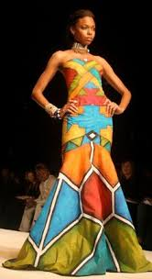

1. **What fashion trends are considered moral**?

Cultural trends because they are respectable that is people who usually put on cultural wear are respected fro example in Buganda people who put on Gomesi are respected by young people.

They are decent that is they are long enough to cover the private parts of the body and they can be anywhere.

They are valuable that is they can be worn anywhere that wedding parties, funerals and they represent culture in Buganda.

**Plate 10: images showing the different cultural wears in Uganda**

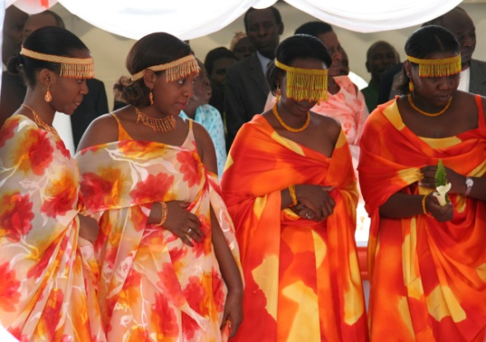 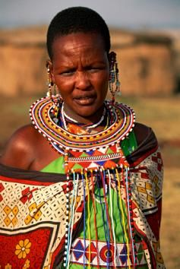

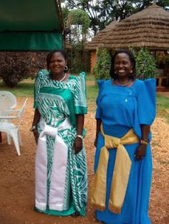 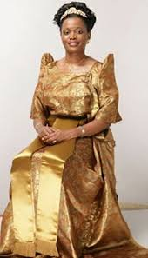

**Photos courtesy of culture Uganda**

Religion wears because they are decent and respectable. They show respect to God and they don’t offend anyone.

1. **How has fashion affected people’s behavior?**

Fashion has made people less generous. Here the example of sunglasses is used. The sun glasses have made a person less generous that is when people put on glasses they tend to look rude that people can’t approach them.

Fashion has made people less respectable for example some people because of the way they dress, they have lost respect like an old woman putting on a miniskirt she losses respect and have also lost respect for God

The provocative indecent dressing of Christian women in today churches is horrible and pathetic. Is not a fashion but irresponsible and demonic. God created women to be very attractive and beautiful more than anything in this world. Hence, such beauty comes with a condition. She must properly cover her body and secure her dignity; her beauty and outward appearance is only meant to be adored by her husband.

She must cover her body and shouldn’t expose or market it to the public because it abuses the glory of God upon them. Women are fearfully and wonderful created by God. They are weaker vessel, for this cause, the devil usually uses them in accomplishment and strategized his immoral enterprises against genuine great men of God

**Image showing women dressed provocatively in church**



Fashion has led to peer pressure in the youth that is the youth have copied the dress codes of the celebrities for example the youth have copied the dress code of the homosexuals which show their underwear thus causing indecent dressing.

People have also lost respect for culture in Uganda especially the youth today don’t care whether they put on indecently in front of their elders or on wrong occasions and thus are treated without respect by onlookers. For example a preacher in Kiyuni village, Nagojje Sub-county Mukono District threw out of church two girls for alleged indecent dressing. The girls, who were dressed in short, tight fitting clothes, were part of a sizable number of people who had gathered on Saturday for New Year prayers at the Church of Jesus Christ.

1. **How has fashion reflected the changes in the society?**

Fashion has reflected the different changes in society for example the changes in culture that is because of the changes in culture brought about by the western civilization have been shown through fashion. Because of the western civilization, fashion has changed that is people have adopted western way of dressing thus this has led to cultural degradation. For example some of the cultural wears have started to change that is the Buganda women wear, the gomesi has now changed to being sleeveless. Harold Martin, a commentator on the ACBS News (2004) said:

The last step in the degradation of a nation is immodesty. The wearing of suggestive dress leads to the ruin of a people (in the past ten years). The decade when the hemlines went up and the morals went down. Those who expose much of their bodies (both men and women) are debauching the nation, damning manhood, polluting society and breaking up the foundations of the home

It has reflected the change economically for example the technology that was used in the 18th century is not the one used in this century. The technology has developed thus this has led to different changes in fashion. There is the fashion of the rich and the poor. For example in the late centuries all people of Uganda used to put on backcloth but now the technology has changed fashion to more quality clothes made out of manmade materials which creates class between the poor and the rich since its expensive.

Political. Fashion has also reflected the political changes for example during war the fashion changes are seen where some people put on short things because of a lot of activities. Another example is the different colors representing different political groups like in Uganda yellow represent national resistance movement.

Social. Fashion has reflected the social change that is different fashion for work, parties and outings. People no longer have one outfit for every occasion.

1. **What are the causes of indecent dressing in the youth today?**

Peer pressure. Here because of some people are being pressured by their group mates, indecent dressing has increased. They do what others put on or tell them to put on. They discourage them saying that they are putting on is old fashion.

Poor parenting. Here some parents do not teach their children on what is decent or indecent because they are occupied by work, they don’t take time with their children.

Some parents dress indecently thus the children copy what their parents put on and they also put on.

Wrong use of the internet. Some youth have depicted such indecent dress codes from the internet where they copy such dressing from the photography on the internet so that they can attract the men. In many high institutions across then world indecent dressing among the youth has become the emblem of modernity in general and the university v-campuses in particular, it is clearly one of the effects of globalization. The leading opinion molders in the society today are models I the fashion, advertising, and entertainment industries

Need for recognition. Some of the youth especially the girls dress indecently to be recognized by the men. They dress indecently to show off their perfect bodies. Some girls dress indecently to entice men especially when looking for partners. For example in the adverts when women advertise themselves to get love partners.

# CHAPTER FIVE

# 5.0. Conclusion and Recommendation

# 5.1. Conclusion

This study focused on the artistic view on the acceptable trends in fashion and a lot of issues through observation interviews and investigations were made.

This book is an attempt to rationalize something known to most of us and something that has been and is still going on in order to encourage the present generation and generations to come towards the vision of immorality in fashion in Uganda. This is done in order to protect them against the increasing storm of western world influence of any kind of religion that intervenes in our cultures inclusive.

the researcher basing on the findings concluded that the man factors like modernization, technology growth has led to the rural urban migration of youth and other ages, the loss and death of an educated skilled man power that I men and women has led to the deterioration of morals in fashion.

# 5.2. Recommendation

Fashion in Uganda is facing a big threat from different cultures from different countries. These countries produce a fashion trends which influence people in Uganda. Some western countries produce provocative trends which are allowed in those countries though some people in Uganda tend to copy these trends for example most youth in Uganda are influenced by trends from western celebrities such as mini skirts yet these trends do not apply to cultures in Uganda.

Therefore according to the respondents views and observations made by the researcher the following are the recommendation

There is need to preserve the cultural values. This can be done through encouraging traditional seminars on the improvement of morals in fashion for example training about the cultural norms on what to wear and not to wear in fashion.

Due to the importance of fashion, there is need not only to improve but also to create trends fit for Uganda’s cultures. That is creating trends that are respectable. This will help to improve on the cultures and morals in fashion.

Since fashion is important, people should respect the different trends for different occasions for example people should respect Godly places by dressing in trends fit for the occasion.

All in all the colonial error with its related aspects of economic, political social ideologies have greatly contributed to the degradation of morals in fashion in the country.

# References

Alhassan Arnina (2013) indecency in the name of fashion

http//www.weeklytust.com.ng.indecent dressing

Trowell and wachsmas.kp (1953) tribal crafts Longman London

Wikipedia.com

Ask.com

http:/www.newvision.co.ug.com (Thursday, September 29, 2016)

http//www.wgmuganda.org

http://[www.ugandan](http://www.ugandan) culture guidelines.com

What to wear in Kampala Entebbe Uganda.

http:/[www.bbc.co.uk/world-africa.com](http://www.bbc.co.uk/world-africa.com)

http:/[www.telegraph](http://www.telegraph). Co. UK/ education news .com

http:/www.dailymail.co.uk/ travel/ articles.com

[www.voanews.com](http://www.voanews.com)

http:/ www.christian post.com

History of fashion designs files.com

Fashion Uganda-evolved files.com

World-africa-26351087.htm

http:/www.monitor.co.ug.com

http:/www.eternityrace.com

[www.world](http://www.world) gospel mission Uganda.com (dress guidelines)

**Artistic view on acceptable trends in fashion**

I am Katushabe Gloria the student of Mekerere University and these questions that I came up with to ask during the field work to get the appropriate information for the study.

Interview guide

1. what do our clothes say about
2. Who we are?

………………………………………………………………………………………………………………………………………………………………………………………………………………………………………………………………………………………………

1. Who we think we are?

………………………………………………………………………………………………………………………………………………………………………………………………………………………………………………………………………………………………

1. What are the moral rights in fashion?

………………………………………………………………………………………………………………………………………………………………………………………………………………………………………………………………………………………………

1. Does fashion reflect the custom of people?

a) Yes (explain why)

………………………………………………………………………………………………………………………………………………………………………………………………………………………………………………………………………………………………

b) No (explain why)

………………………………………………………………………………………………………………………………………………………………………………………………………………………………………………………………………………………………

1. How does the way we dress communicate massages about our identity?

………………………………………………………………………………………………………………………………………………………………………………………………………………………………………………………………………………………………

1. Is it important to be critical on one’s own fashion?
2. Yes (explain why)

……………………………………………………………………………………………………………………………………………………………………………………………………………………………………………………………………………………………..

1. No (explain why)

………………………………………………………………………………………………………………………………………………………………………………………………………………………………………………………………………………………………

1. What fashion trends are considered moral?

………………………………………………………………………………………………………………………………………………………………………………………………………………………………………………………………………………………………

1. How has fashion affected people’s moral behavior?

………………………………………………………………………………………………………………………………………………………………………………………………………………………………………………………………………………………………

1. How has fashion reflected the changes in society?

………………………………………………………………………………………………………………………………………………………………………………………………………………………………………………………………………………………………

1. What are causes the indecent dressing in the youth today?

………………………………………………………………………………………………………………………………………………………………………………………………………………………………………………………………………………………………