|  |  |
| --- | --- |
| RB0503 | Improve the Cleaning Process of Kitchen Sink Filters |

**Candidate Designs**

**Introduction**

With old food and drinks passing through and sitting in it regularly, the drain filter in a sink can be one of the least hygienic parts of a kitchen. Despite this, most household drain filters require that they be cleaned by hand, resulting in an unpleasant and potentially unhygienic user experience. To address this issue, this report presents a variety of candidates that could replace the conventional kitchen sink drain filter with something that addresses the problems associated with a conventional sink filter. This report can be used to first refine the objectives, metrics, criteria and constraints presented in the design brief provided, and eventually converge upon and develop one of the candidates into a recommended design.

**Candidate Design 1: Dropout Filter**

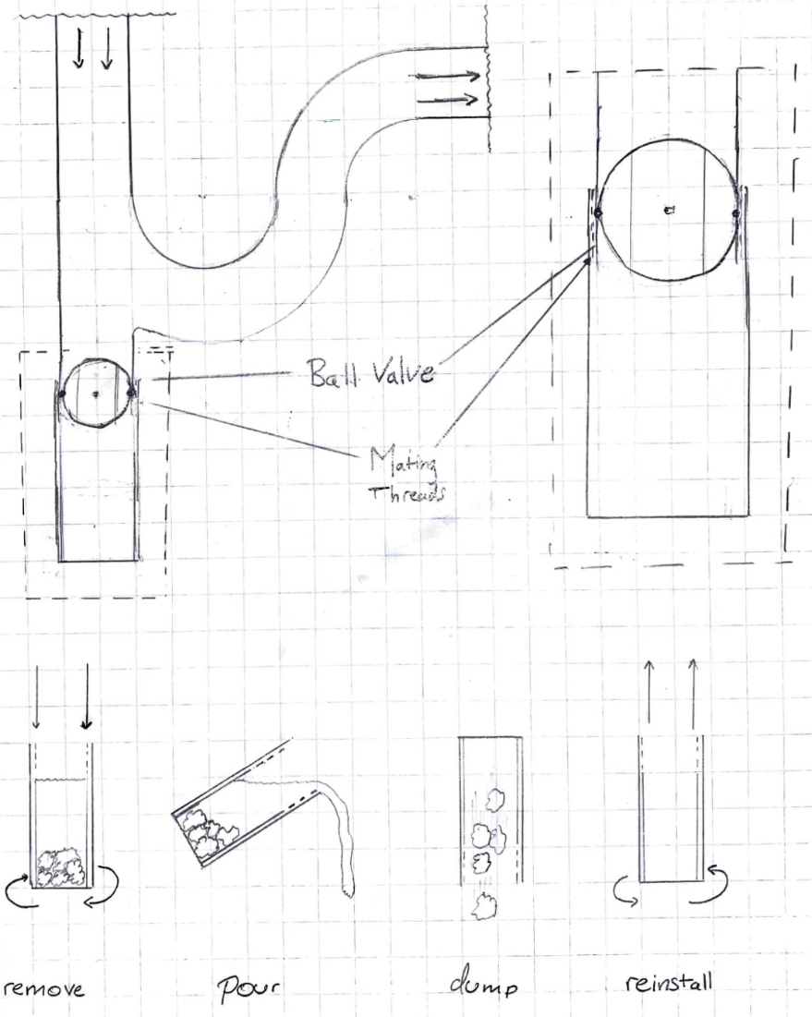

**Figure 1:** Representation of Candidate Design 1, a filter which separates waste through an alternate valve

____________________________________________________________________________________

The dropout filter option addresses the problem of unhygienic drain filter cleaning by replacing the conventional P-Trap found at the bottom all household sinks with a modified component that allows for more frequent and less time-consuming cleaning. The primary feature of the dropout filter is a detachable filter branch that follows the axis of the sink drain beyond the bottom of the P-Trap, which serves to catch any non-liquid debris that falls into the sink. This branch of the dropout filter is attached to the rest of the plumbing by threads on the structure – “Mating Threads” in the diagram – and can therefore be detached from the plumbing. To prevent standing water from leaking out of the P-Trap, a ball valve is installed on filter branch of the P-Trap, which should be open during regular operation, but must be closed during cleaning. Once the filter branch is removed, it will contain a mixture of excess water and debris that was collected. The water can be decanted back into the sink and the debris dumped into the garbage or compost (depending on the contents). To reset the system, the filter module can be threaded back into place and the ball valve opened.

Most household pipes in use today are made of PVC or a similar polymer which is melted and injected into a mold for production [1]. Manufacturing this design would likely have to be done with this process as there are few other cost-effective ways of producing intricate shapes in plastics on a large scale. The ball valve in particular was chosen because it can be injection molded for a very low cost with a handful of parts and without compromising reliability or function [1]. Installation can be made standard with whatever pipes happen to be in use (1.5-inch pipes are common in North American sinks [2] but are not used exclusively, so the exact dimensions were left ambiguous)

**Candidate Design 2: Brush Utensil**

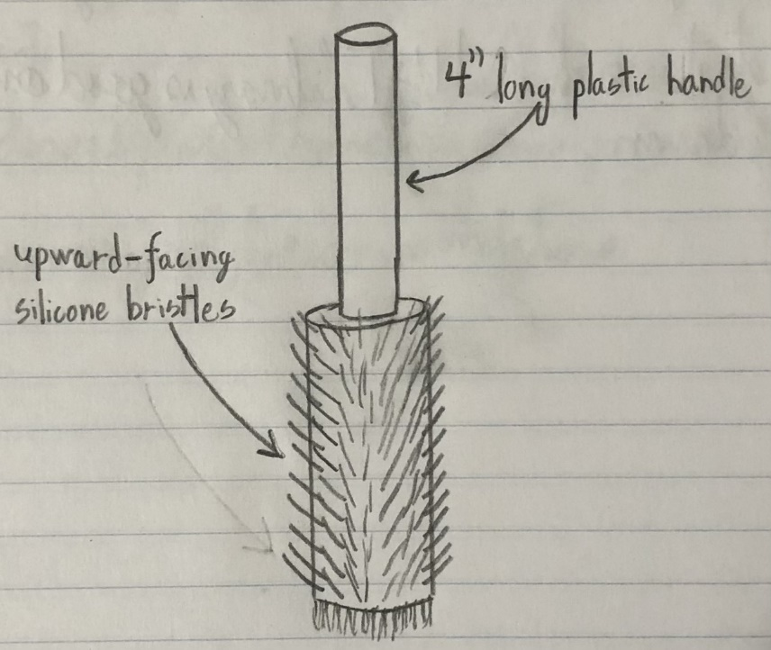

**Figure 2**: Representation of Candidate Design 2, a brush which cleans and picks up waste without requiring direct physical contact

____________________________________________________________________________________

This design is a brush-like device that should be able to easily deal with small food residue and unhealthy bacteria. The design consists of a short plastic handle, attached to a thin plastic beam that is covered in small silicone bristles. The plastic handle is 4” long with a diameter of 1.3”, since an average adult has a breadth of between 3.1-3.5”, and the handle should be at least as long as the breadth of the palm, along which it lies. Research indicates that the ideal diameter of a tool that is gripped similarly to this device is 0.197 times the length of your hand. Since adults’ mean hand length is 7.2”, their ideal diameter is ~1.42”. According to objectives 3 & 4 of the design brief, a design should be “ergonomic for consumers” and “safely used by everyone”, and a diameter of 1.3” accommodates adults’ needs while also considering ergonomics for children (ideal diameter ~1.08”). [3] The dimensions of the handle meet the need for ergonomics, while also keeping users’ hands a safe distance away from the bacteria and residue the tool collects (which accomplishes objective 6).

However, the primary feature of this design is the brush itself. The bristles on the side are made of silicone (easy to clean, and unlikely to accumulate germs) and face upward along the drain. [4] The upward-facing bristles maximize surface area with the drain when moving the brush down and can pick up larger pieces of food when brought back up. The bottom of the brush (also covered in bristles) is a flat circle with 1.5” diameter to allow the user to efficiently scrub the drain filter itself, and clean as much bacteria as possible. This design should accomplish the main goal of making cleaning the sink drain a more hygienic process. The length of the tool allows the user to keep the bacteria and residue off their hands, and the silicone bristles should make the process quicker, and means that the tool itself is easy to clean. The most important aspect of the tool, however, is the fact that maximizing the surface area between the brush and the residue means the user can do a lot of cleaning in very little time.

**Candidate Design 3: Vacuum Drain**

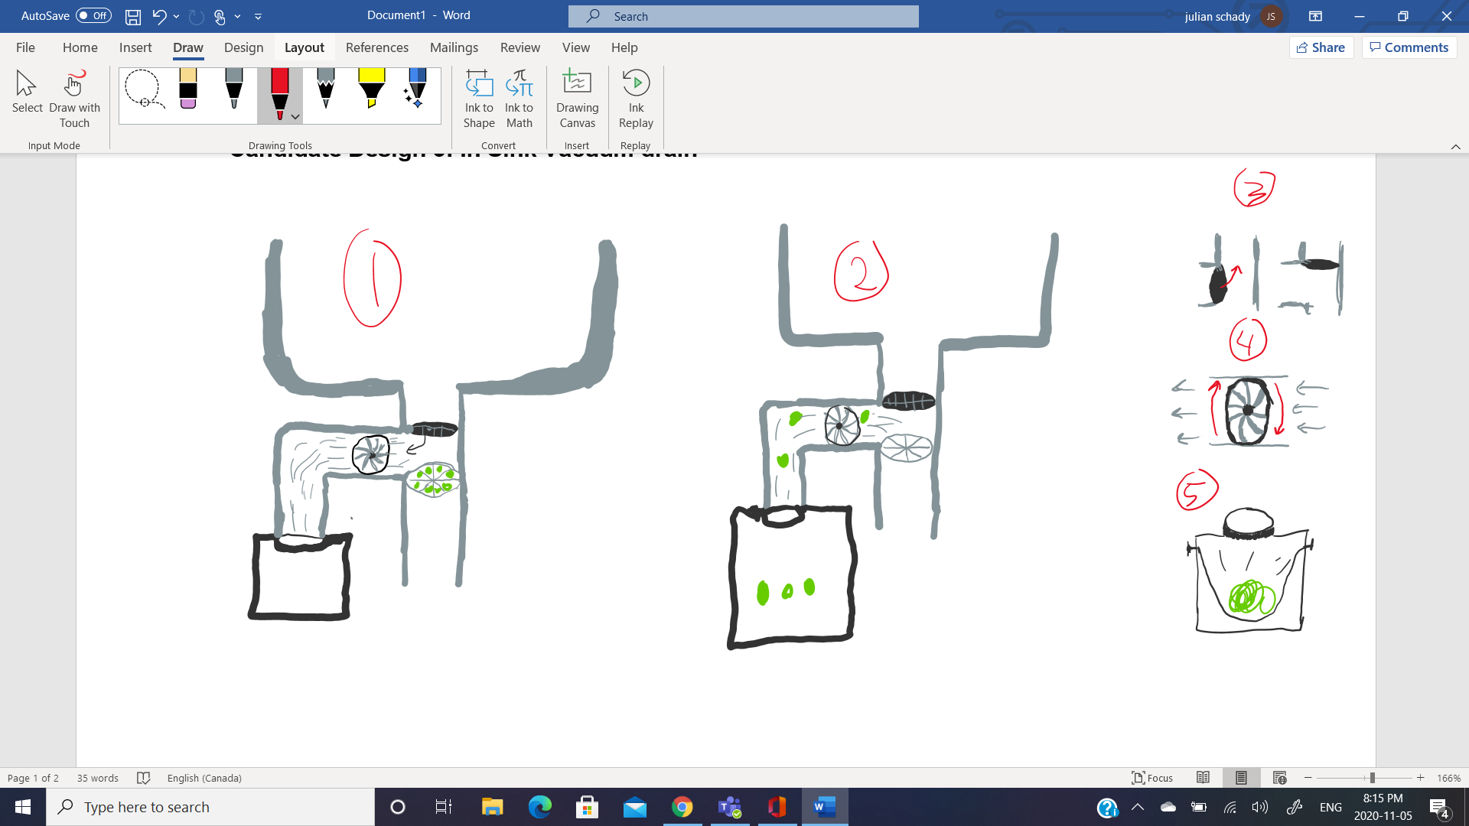



**Figure 3**: Representation of Candidate Design 3, which uses a vacuum to extract food waste in the pipes

____________________________________________________________________________________

This solution to the issue of cleaning sink filters involves a separate vacuum drain that can suck bacteria and food particles down its shoot into a trash compartment. The illustration above shows how the system works and the individual parts. The vacuum drain is placed right above the filter. It is turned on using a separate switch. This switch closes the first drain as seen in figure 3. It then turns on the fan seen in figure 4 which starts to suck the food and bacteria in. The food and bacteria are sucked down the other drain into a collection trach at the bottom as scene in picture 5. It can then be easily removed with a garbage bag. This product facilitates and improves the cleaning of a sink filter.

It does a good job at addressing all the objectives. With a strong enough suction it would be able to remove all food particles. The vacuum would suck with a force of 80 Newtons which is enough to suck up smaller food particles. [5] It would decrease the time to clean the filter, as no time is wasted taking out the filter. Its ergonomic for costumers as it is operated at the flip of a button. It is safe because it is in the drain and away from human appendages. It works on many kinds of filters because it just uses suction and doesn’t touch the actual filter. The cleaning process is much more hygienic because you do not touch anything. It is also less hideous because you do not see any of the food particles. It can be stored easily under the sink. Finally, it is durable as long as the fan lasts.

**Candidate Design 4: Disposable Filter**

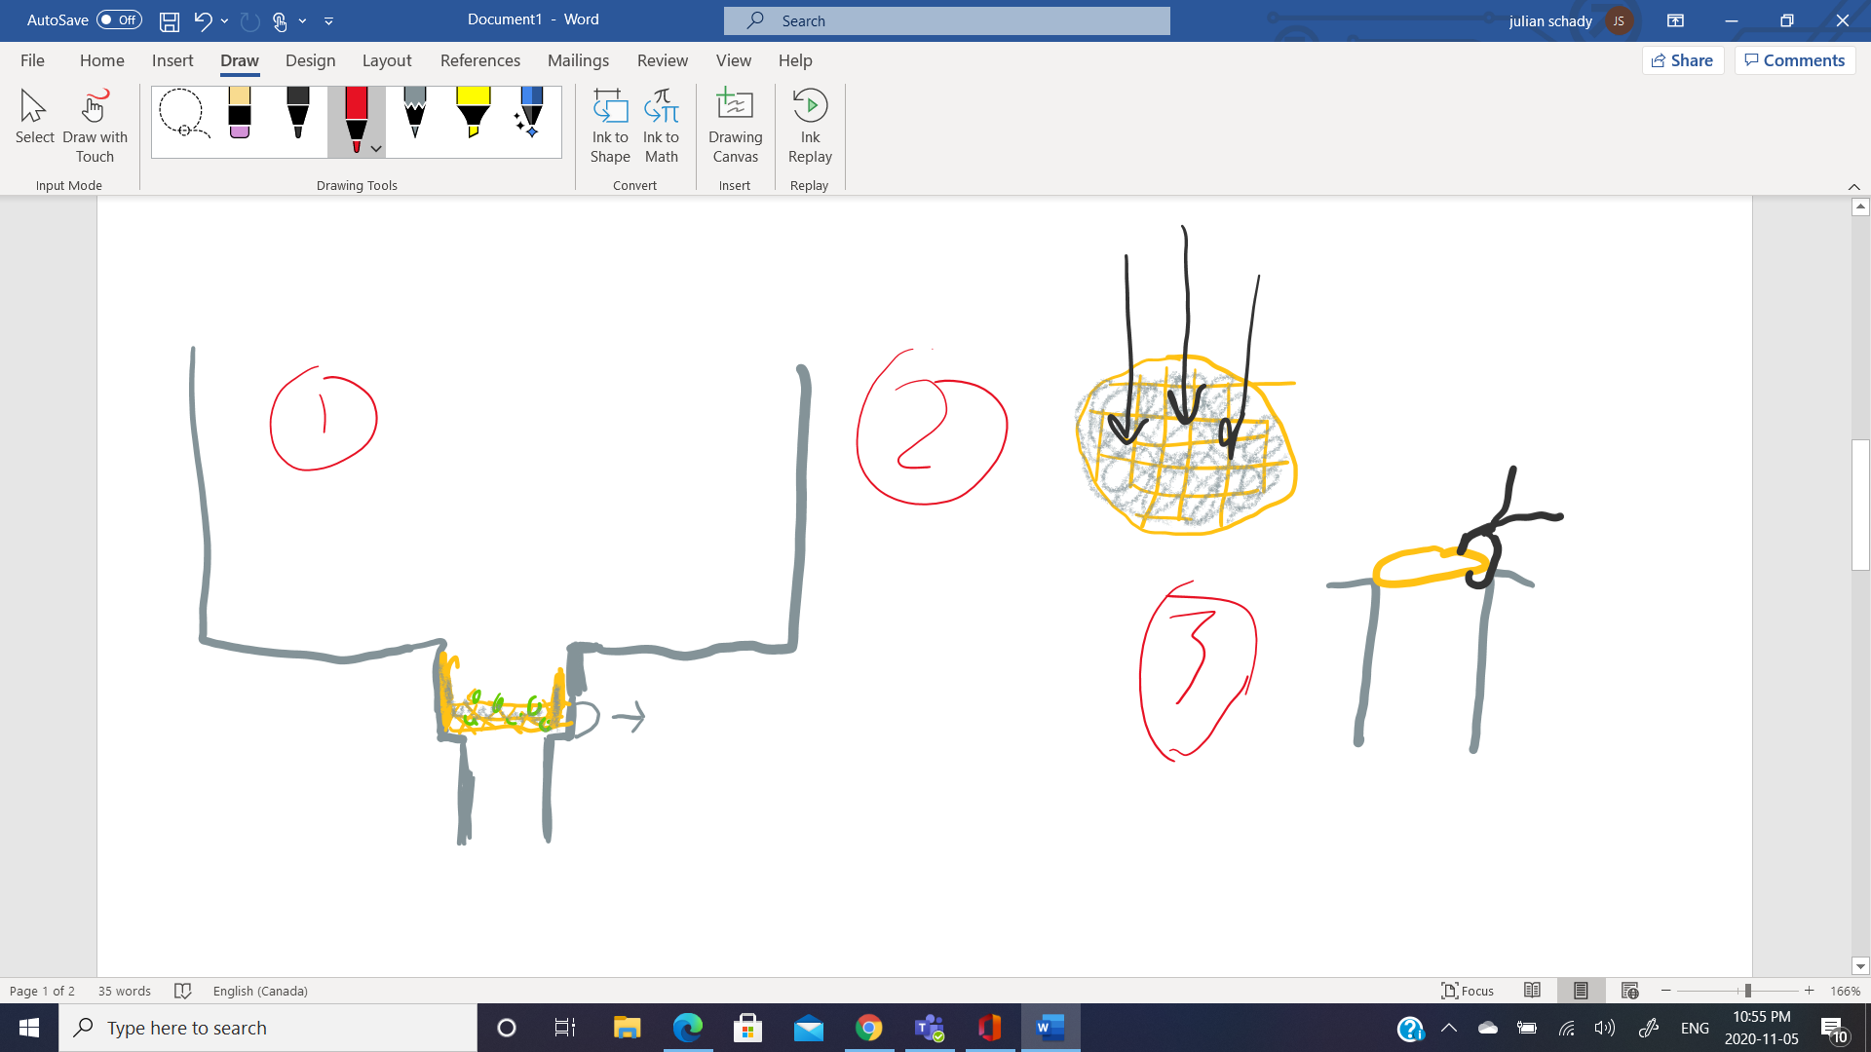

**Figure 4**: Representation of Candidate Design 4, a disposable filter simplifying the cleaning process

____________________________________________________________________________________

This solution to the issue of cleaning sink filters involves the use of disposable filters. Before getting into the use, it must be addressed that one of the constraints of the design brief was that the design must be reusable. Therefore, what justifies a non-reusable product and the violation of a constraint. The constraint violation is justified because this product still addresses the reason the constraint was made. The constraint about it being reusable was to ensure the product is ecofriendly. However, this does not rule out non reusable products. Many natural biodegradables are more ecofriendly than other reusable products. This is because a plastic or metal reusable filters have a higher carbon footprint than some natural filters. [6,7,8] Non reusable filters made of hemp or bamboo would be ecofriendly way of addressing this issue.

The Natural filter could be placed exactly where the normal one is as seen in picture 1. And could be removed with any device. It works just like a regular filter catching food particles. It could be tossed into the compost every week or whenever needed. There it could be biodegraded naturally.

This solution also addresses all the objectives. It can remove food particles just by tossing it out. It decreases the cleaning time because you don’t clean it. Its ergonomic for people because there is no skill required. It is safe for anyone because it has no sharp edges and does not need to be contacted by human skin. It also could be made to fit different filter sizes. It also makes the cleaning process more hygienic because it eliminates the cleaning process. It is less nasty to look at because you do not have to clean it out you simply toss it. They can be easily stored as they are as small as a filter. Finally, they can be replaced which means they don’t need to be excessively durable.

**Candidate Design 5: Mechanical Release Filter**

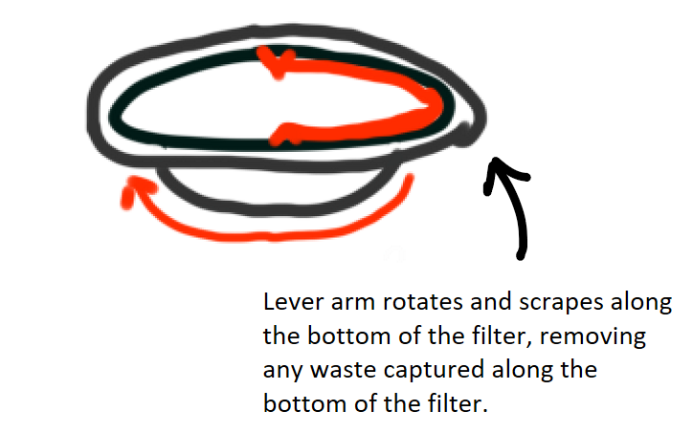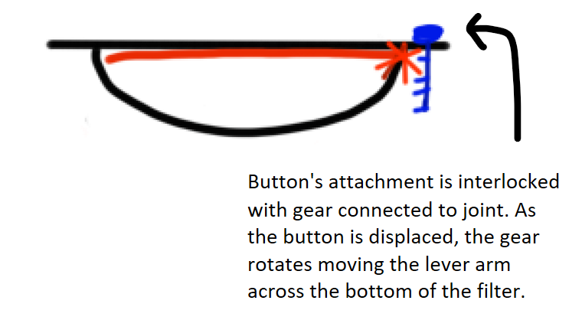

**Figure 5**: Representation of Candidate Design 5, a filter which mechanically removes waste with a scraper arm

____________________________________________________________________________________

This design involves the use of a mechanical aspect to release the food residue contained within the filter, such that there is no need for direct physical human contact, thereby making the process more hygienic.

It is activated by pushing on a button, that swings an arm along the curvature of the filter, thereby pushing the residue along until it leaves the filter. The button is indented such that it does not interfere with regular usage of the sink where it may impede water flow or also catch food waste, which would result in direct contact with the contaminated button, making this design fail to improve the hygiene of this process.

In addition, the design modifies the current design rather than creates an external tool, thus complying with many requirements, such as its dimensions, its resistance to daily use, whether it be impact from other kitchen tools or accessories, or whether it is resistant to water, food, or any other substance it encounters.

In terms of the material used for the swinging arm, stainless steel may not be preferred, as it may fail to scrape the residue stuck in the crevices of the filter. Instead, a material such as rubber would have slight elastic properties, and thus can deform slightly to reach inner crevices without causing excessive scraping, which may decrease the lifetime of the product. In addition, it satisfies the requirement that it must be inert and not react, as rubber is used in many applications, including cooking and baking, which occurs in kitchens.

**Divergence Tool Critique**

**Divergence Tool 1: Challenging Assumptions**

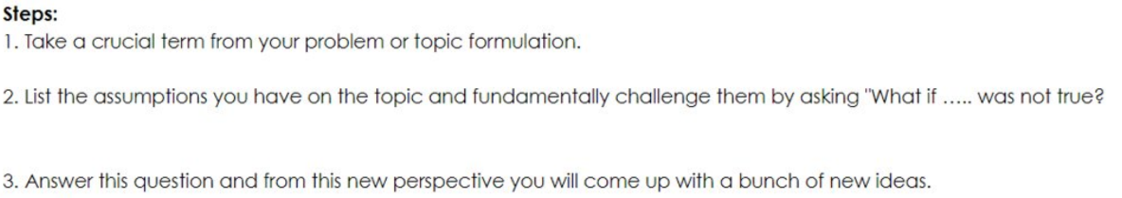

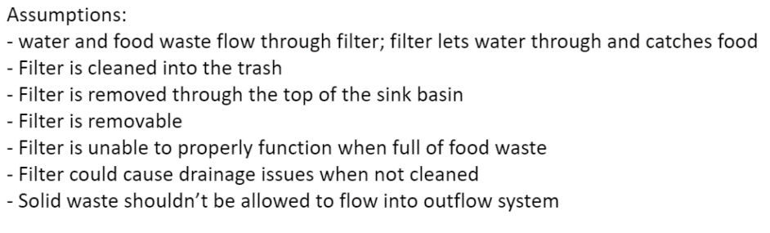

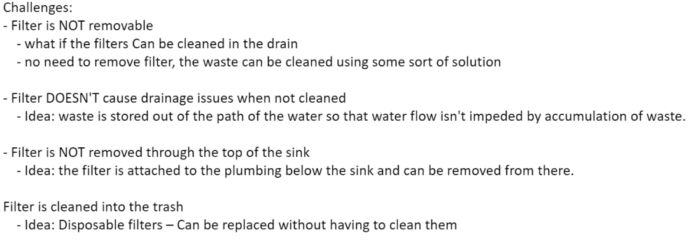

**Figure 6:** Images depicting usage of the Challenging Assumptions technique

____________________________________________________________________________________

One of the first tools we used was the Challenging Assumptions technique, described at the top of the figure above. We found that combining steps 1 and 2 into a single clear ‘Assumptions’ category worked better because it allowed us to append our idea onto the critical word(s) we decided upon. We then organized our ideas by filtering, then combining some of the assumptions that were either too similar or too unrelated (e.g., ‘The sink is on Earth’ didn’t seem within the scope of the design brief). With these assumptions, we began to prod at the ones we thought weren’t well justified, creating the list of challenges at the bottom of the figure. From this, we came up with our first ideas. The idea that the filter doesn’t have to be removed through the top of the sink and that it could store waste out of the path of the flow of water led to our design candidate 1, the dropout filter, while the idea that the filter doesn’t have to be removeable put us on the path to developing candidate design 3, the vacuum drain, which was developed in parallel with design tool 4.

While this tool led to some of our candidates, its greater value to us was in that it made us aware of limitations we were putting on our designs subconsciously early in our design process. This insight proved valuable in subsequent diverging activities when we were able to reflect and refine our ideas by asking if the assumptions were justified. In the future, I plan on using this tool early in the diverging process as it has shown to be effective at helping me understand the biases I have going into a design.

**Divergence Tool 2: Wishing (James)**

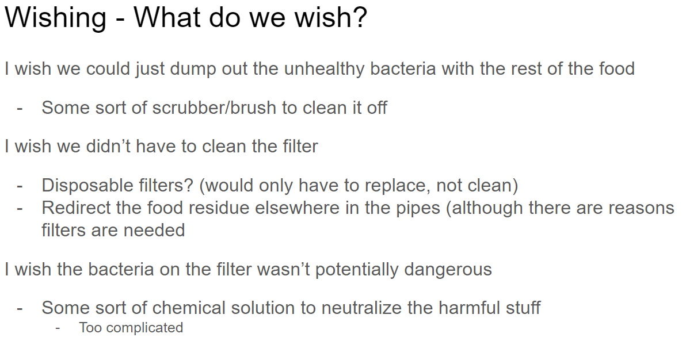

**Figure 7:** Images depicting use of Wishing to determine desires appropriate for final candidate designs

____________________________________________________________________________________

When we came up with our candidate designs, we found wishing to be a very helpful divergence tool because it helped us identify what we wanted in the designs. Wishing was an important tool to us early in the divergence process, as it helped us look at our objectives as problems that we could solve. It supported our process by giving us a standard to look up to, and a way to translate the design objectives into actual attributes of the candidate designs. For example, with the brush utensil (candidate design #2), a major factor in diverging to that idea was wishing that the unseen bacteria and residue that lingers on the filter could be dumped out just as easily as the larger bits of food. Through this, we realized that a solution that prioritizes scrubbing away the filter’s bacteria could be better than one that does not, so we came up with a design that can deal with the bacteria, while also keeping some distance between the user and the harmful residue.

We would definitely use this divergence tool again, especially since it is applicable in a wide variety of situations. Regardless of the problem, wishing should allow you to start the diverging process right and clarify to yourself what a design should accomplish, by comparing it to a theoretical design that is ideal in however many ways. It also allows you to have diversity in your designs. If you can come up with many different things to wish for, you can draw inspiration from many places, and come up with several good, diverse designs.

**Divergence Tool 3: Scamper (Julian)**

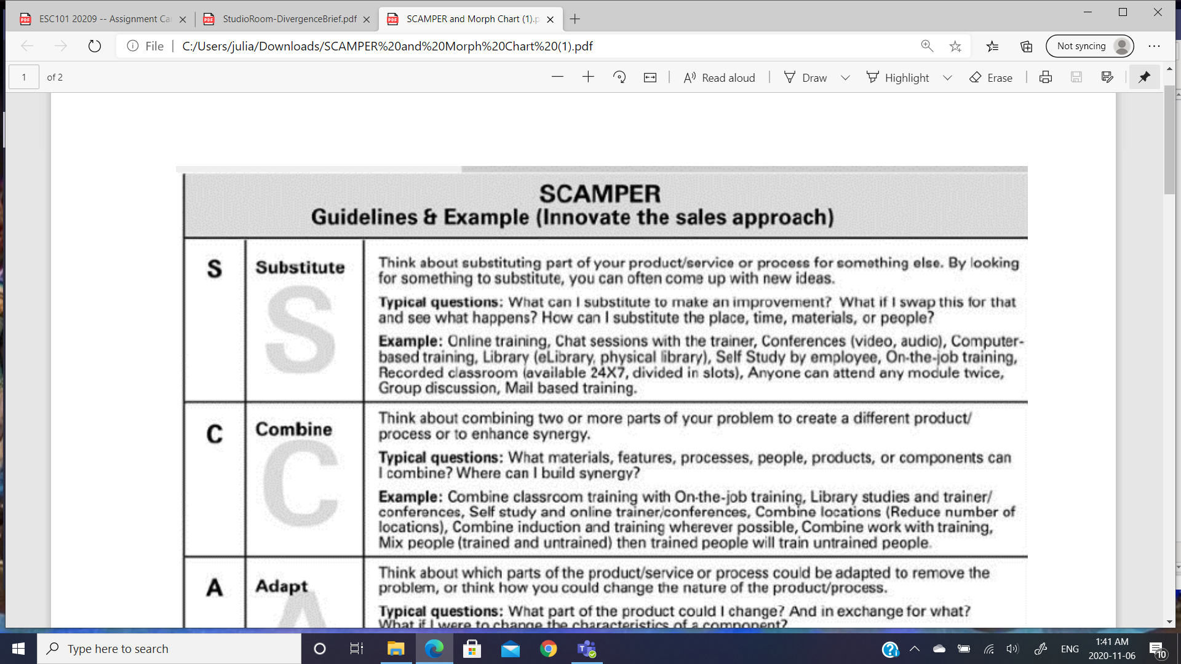

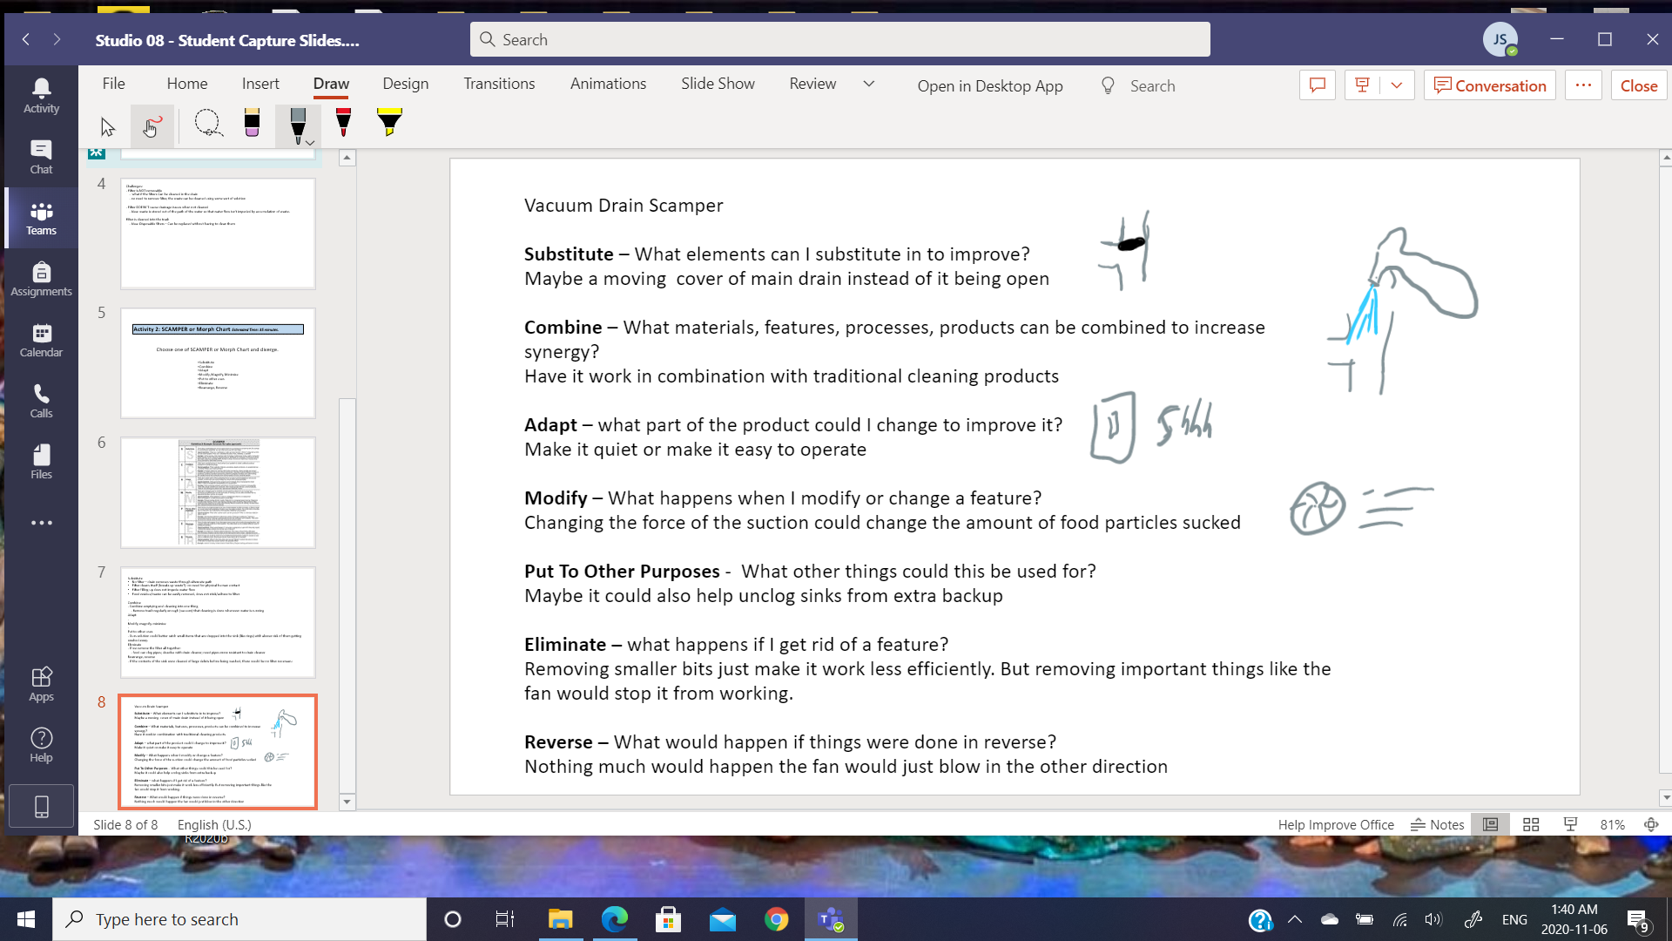

**Figure 8:** Images depicting usage of SCAMPER to improve and refine an existing design

____________________________________________________________________________________

The divergence tool SCAMPER is a multi-step process that broadens thinking and allows you to come up with new ideas. It has 7 steps that all ask you a question. Answering these helps you to come up with new ideas. Substitute asks what can be substituted in to improve the idea. The next step is combine. It asks how your idea synergizes with other things. The next step is named adapt. This asks what already existing features could be improved. The next step is named modify. This asks what changes will occur if something is changed. Next is put to other purposes. This asks what other purposes the idea could be used for. The next step is named eliminate. This asks what would happen if a feature was discarded. Finally, the last step is named reverse. This asks what would happen if the idea operated backwards.

SCAMPER was used particularly with Candidate Number 3, the vacuum drain. This tool was used to specifically diverge unto additional features for the design. Originally the idea was a basic vacuum to suck up the food particles. By using SCAMPER, a cover and the switch operator were added. A handheld vacuum was also eliminated. The substitute, adapt, and elimination steps were the most useful. Put to other purposes step was not useful because we have a specific problem that needs to be addressed, so there is no use in looking at other purposes. The Reverse tool was also not useful. This is because only one way works, and the reverse does not solve the problem. I would use this for a specific solution to multiple problems. However, it would not be good for general diverging.

**Divergence Tool 4: Brainstorming 6-3-5**

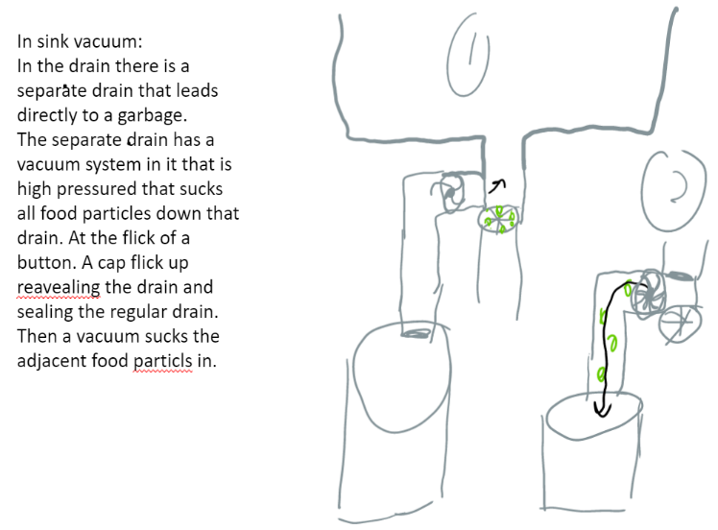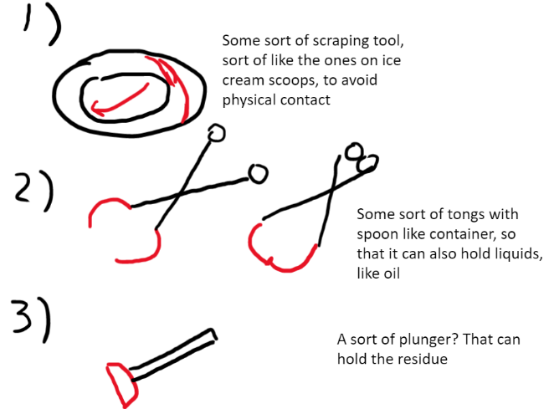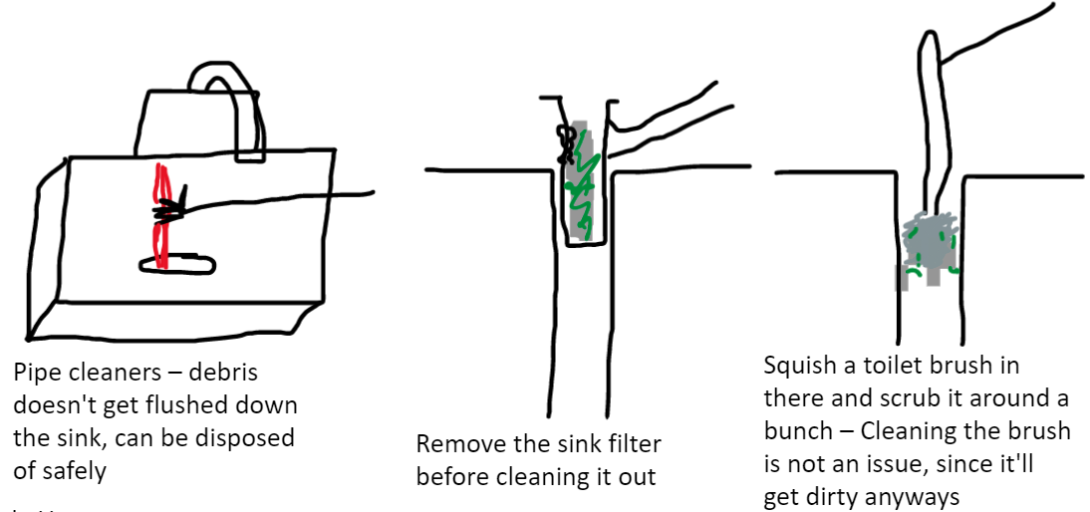

**Figure 9:** Images depicting range of initial ideas generated using Brainstorming 6-3-5

____________________________________________________________________________________

Brainstorming 6-3-5 serves as a variation of traditional brainstorming through an initial individual component. This ensures that everyone has a chance to represent their ideas from their unique personal knowledge and perspectives, before being influenced by others’ ideas. This lack of conformity usually results in more diverse ideas, allowing a broader foundation for divergence. This is shown in *Figure 9*, where the tool generated a multitude of ideas, ranging from simple cleaning devices, to more technical designs such as the vacuum pump. Following the initial idea generation, the designs are shared, discussed, and honed upon, in a collaborative manner. All in all, this divergence tool modifies brainstorming to generate more diverse ideas.

This tool was used near the beginning of our divergence process, as this tool excels at idea generation, allowing us to create a solid foundation to further diverge and eventually converge on. Many of the essences of our designs were created here, and later refined through other tools. While some ideas that were generated here were not in the final candidate designs, it nonetheless was helpful in reassuring us that we had considered that possibility, and that the ultimate exclusion was justified. Furthermore, it supported our divergence process as it aimed for diversity in designs, with the tool prioritizing individual ideas. The fact that some of our candidate designs originate from this tool demonstrates its ability to produce distinct yet relevant ideas.

We would use this tool again in future projects, since it efficiently combines both individual creativity in the initial design generation, and group creativity in the later discussion and revision. By generating an excessive number of ideas, the dismissal of some ideas demonstrates the quality and significance of the final ideas.

**References**

[1] “PVC Ball Valve Manufacturers, Suppliers and Industry Information,” IQS Directory, 2019. [Online]. Available: https://www.iqsdirectory.com/pvc-ball-valves/. [Accessed: 06-Nov-2020].

[2] T. Carter, “Finding the right size PVC pipe for each job,” The Washington Post, 17-Jun-2019. [Online]. Available: https://www.washingtonpost.com/business/2019/06/18/finding-right-size-pvc-pipe-each-job/. [Accessed: 06-Nov-2020].

[3] Y.-K. Kong and B. D. Lowe, “NIOSHTIC-2 Publications Search - 20026913 - Optimal cylindrical handle diameter for grip force tasks.,” Centers for Disease Control and Prevention, 26-Oct-2020. [Online]. Available: https://www.cdc.gov/niosh/nioshtic-2/20026913.html. [Accessed: 06-Nov-2020].

[4] A. Abramson, “Why You Should Make the Switch to Hygienic Silicone Toilet Brushes,” Apartment Therapy, 05-Oct-2019. [Online]. Available: https://www.apartmenttherapy.com/silicone-toilet-brush-36638734. [Accessed: 06-Nov-2020].

[5] M. Knight, “Does your vacuum cleaner have too much suction?” Which? Conversation, 18-Jan-2017. [Online]. Available: https://conversation.which.co.uk/home-energy/vacuum-cleaner-suction/. [Accessed: 06-Nov-2020].

[6] E. Thorns, “8 Biodegradable Materials the Construction Industry Needs to Know About,” ArchDaily, 02-May-2018. [Online]. Available: https://www.archdaily.com/893552/8-biodegradable-materials-the-construction-industry-needs-to-know-about. [Accessed: 06-Nov-2020].

[7] E. Bari, “Biodegradable Material,” Biodegradable Material - an overview | ScienceDirect Topics, 2006. [Online]. Available: https://www.sciencedirect.com/topics/engineering/biodegradable-material. [Accessed: 06-Nov-2020].

[8] V. Zenkova, “11 Biodegradable Materials That Will Save The Planet,” EcoFreek, 03-Feb-2020. [Online]. Available: https://ecofreek.com/biodegradable/biodegradable-materials/. [Accessed: 06-Nov-2020].

**Source Extracts:**

**[1]** PVC ball valves are manufactured from a member of the vinyl resin family. PVC stands for polyvinyl chloride and is a thermoplastic polymer material, meaning that it changes physical properties when it is heated or cooled. Thermoplastics, like PVC, are environmentally friendly because they can be melted and reshaped numerous times, which means they are not crowding landfills. PVC offers outstanding resistance to water, chemicals and concentrated acids. Because of its reliability and durability, PVC is a popular material for a variety of industrial, commercial and residential purposes. PVC plastic is commonly used to make pipes, identification cards, raincoats and floor tiles. Because of this, PVC ball valves offer consistent, reliable performance and a long product life, which makes them extremely cost effective. Adding to their benefits, PVC ball valves are also easy to clean and repair.

**[2]** As you might expect, it comes in different sizes. The most common sizes you’d use around your home would be 1½-, 2wo-, three- and four-inch. The 1½-inch size is used to capture water that might flow out of a kitchen sink, a bathroom vanity or a tub. The two-inch pipe is commonly used to drain a shower stall or washing machine, and it may be used as a vertical stack for a kitchen sink.

**[3]** Participants (n=24) rated the mid-sized handles (30, 35 and 40 mm) as the most comfortable for maximum grip force exertions. Using a polynomial regression the handle diameter that maximized subjective comfort was calculated as a function of the user's hand length. This optimal handle diameter was 19.7% of the user's hand length. Total finger force capability was inversely related with handle diameter.

**[4]** [Jeremiah Johnson, PhD](https://micro.utk.edu/faculty/johnson.php), assistant professor of microbiology at the University of Tennessee-Knoxville, says that silicone attracts fewers microorganisms (read: bad bacteria, including E. coli) than plastic because silicone is non-porous and resists the accumulation of organic matter from the toilet, which can attract germs. “For this reason alone, silicone would be more resistant to microbial contamination,” Johnson says. “That’s why it’s is being used more frequently in medical applications.” Another plus: Because silicone dries much faster than plastic, it’s also less likely to accumulate microbes.

**[5]** A vacuum cleaner that excels at picking up pet hair from carpets and fine dust from hard floors is all well and good, but not when the suction is so powerful it’s impossible to move when it’s switched on.

In the past few months, we’ve tested vacuum cleaners with push forces exceeding 80 newtons.

Put another way, it takes as much force to push some models a single stroke as it does to lift an Olympic-standard shot put or eight bags of sugar.

**[6]** As noted, there are a variety of natural fibers that may be suitable for BC use. Many natural fibers have exceptional strength per unit mass that makes them especially attractive for reinforcing materials. Natural fibers may be processed by hand, simple tools, or sophisticated industrial processes to render them useful for some purpose, but they are clearly distinguished from artificially synthesized fibers. Natural fibers tend to be rich in cellulose, abundantly available, and easy to handle and process. They can also be relatively inexpensive, although this is not always the case. The use of [natural fiber composites](https://www.sciencedirect.com/topics/materials-science/natural-fiber-composite) increased sharply in the 1940s because they were inexpensive, readily available, and could replace materials needed for more strategic purposes. Among these natural fibers, wood became the most abundantly used cellulose fiber and remains extensively used in the fiberboard, pulp and paper, panel products, and many other industrial sections.

**[7]** Perhaps one of the biggest architectural crazes within the last few years, countless [bamboo](https://www.archdaily.com/tag/bamboo) projects have been shared across the internet thanks to the material's aesthetic qualities, but more so for its sustainable credentials. If you needed a little reminder about why it has become so popular, bamboo can grow up to four feet a day, regrows after harvesting and is two to three times stronger than steel.

**[8]** It must have been a sign when the production of hemp became legalized in many states. Hemp can be grown in some seriously adverse conditions.

Add that with it being amazingly versatile; the number of uses is amazing:  
Biofuel, Clothes, Plastic, Paper, Cooking oil, Medicine

Hemp has a perfect [chance of stopping the deforestation problems](https://blogs.svvsd.org/octaviotlifeonland/) as it has the ability to make good grade paper without having to chop down trees.