PHY 180 Lab 1: Uncertainty Lab

Robert Purcaru

September 23, 2020

**1 Introduction:**

This experiment was intended to investigate how long it takes a standard 8.5”x11” piece of paper to fall 1.00 meter when released from rest in a horizontal orientation. This experiment was conducted by dropping a piece of paper from 1 meter above the ground, considering the paper to have fallen 1 meter once any part of the paper made contact with the ground.

**2 Procedure:**

1. First, an adjustable desk was raised until the work surface was about 1 meter off the ground. Then a weight attached to a fishing line was dangled off of a point marked with scotch tape on the desk to find the spot directly beneath the point on the desk. The point where the weight contacted the ground was then marked with another piece of scotch tape. Next, the hook of a measuring tape was secured to the point marked on the floor with another piece of tape and a paperweight before measuring the distance to the point marked on the desk. The desk was then readjusted until the bottom of the worksurface was 1 meter off the ground, as indicated by the measuring tape.

2. For each trial, the same blank piece of 8.5”x11” paper was held with my pinkie and ring fingers, supporting the length of the 8” side with the length of my palm. The paper was gently adjusted by sliding it along the bottom of the work surface until the center of the paper was around the tape marker on the desk. It is worth noting that pressing on the sheet of paper in such a way the entire sheet is under the table causes the paper to ‘stick’ to the bottom of the desk for a few moments after it is released, skewing the data. This problem can be mitigated by holding the paper so about half of it sits beyond the edge of the desk, supported by both hands on either side. Using my thumb, I held the ‘start’ button on the timer built into an iPhone and released it at the same time as the paper. As the paper fell, I moved closer to the floor so I could see underneath the paper and watch it as it approached the ground. The paper was considered to have fallen 1m when any part of the paper touched the floor (as opposed to when the center of the paper reached the floor). This is because the ground interacted with the paper as the paper approached the floor. This interaction affected the paper’s flight in different ways on different trials; sometimes it would hit the ground decisively and stop quickly, other times a corner would touch the ground but the paper would float for a moment and travel some distance horizontally before the whole paper reached the ground, causing it to stay airborne for longer. The timer was therefore stopped when any part of the paper reached the floor. This was indicated either by when I saw any part of the paper hitting the floor or when I heard the paper rustle as a result of hitting the floor, whichever came first. The time from the timer was then recorded and step 2 of the procure was repeated for a total of 40 trials.

3. Once the trials were completed, the height of the desk was measured once more using the two tape markers to confirm that the height had not changed while the data was being gathered; it had not.

**3 Data**

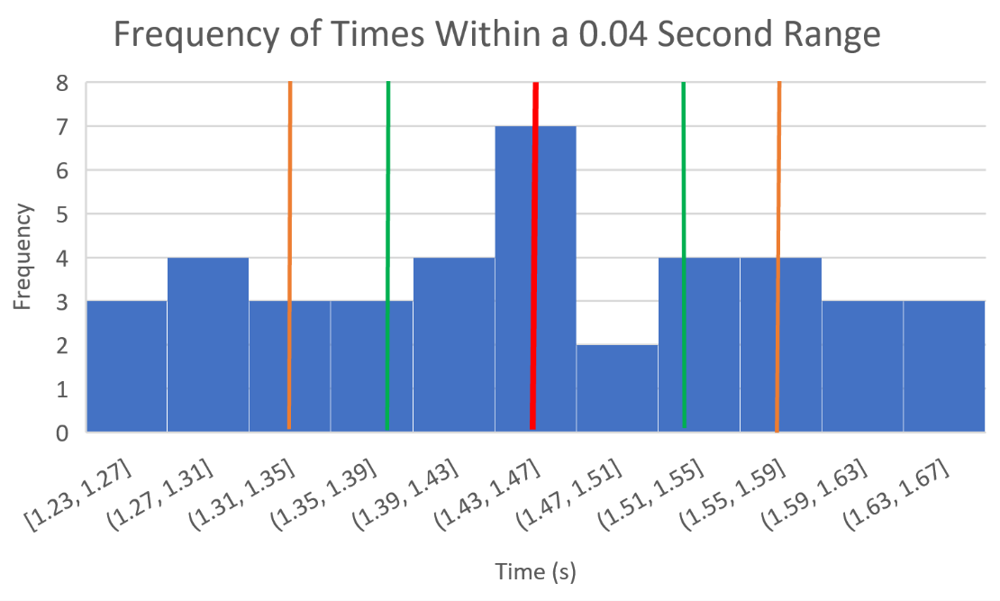**Figure 1 | Frequency of times recorded within a 0.04s range.** The central red line indicates the calculated average drop time. The orange lines show the statistical uncertainty of each data point, given by the standard deviation, with a value of ±0.12 seconds [Y value]. The vertical green lines show the uncertainty in the average, given by the measurement uncertainty in the experiment, with a value of ±0.07s [Z value]. A bucket size of 0.04s is used because it is the largest value that presents the data without losing any artifacts from smaller bucket sizes. Specifically, larger bucket sizes begin to make the data seem like it has a much more normal distribution than it does; one can see from histogram that the distribution does not continue to 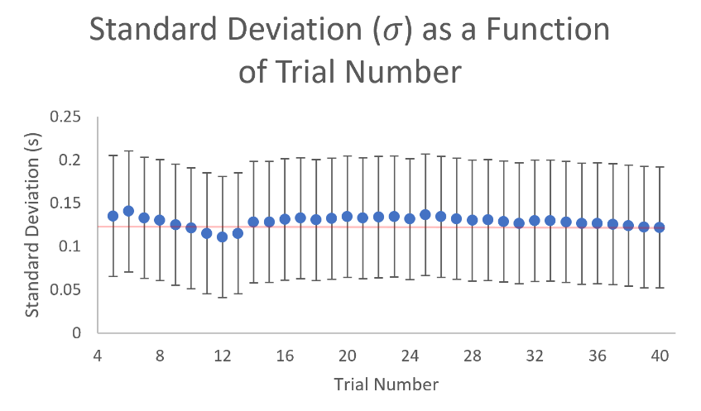decline noticeable after reaching one standard deviation on either side.

**Figure 2 | Standard deviation $(σ)$ as a function of trial number** ($N$)**,** after trial 5; values calculated where $N<5$ produced extraneous results as a result of the small sample size. The error bars represent a measurement uncertainty of 0.07 seconds. The horizontal line at 0.12 seconds shows the standard deviation after 40 trials across the plot. The plot illustrates that the data is statistically significant for all values shown since the error bars never extend to or beyond 0 on the vertical axis. Note there is relatively little variation in the calculated values.

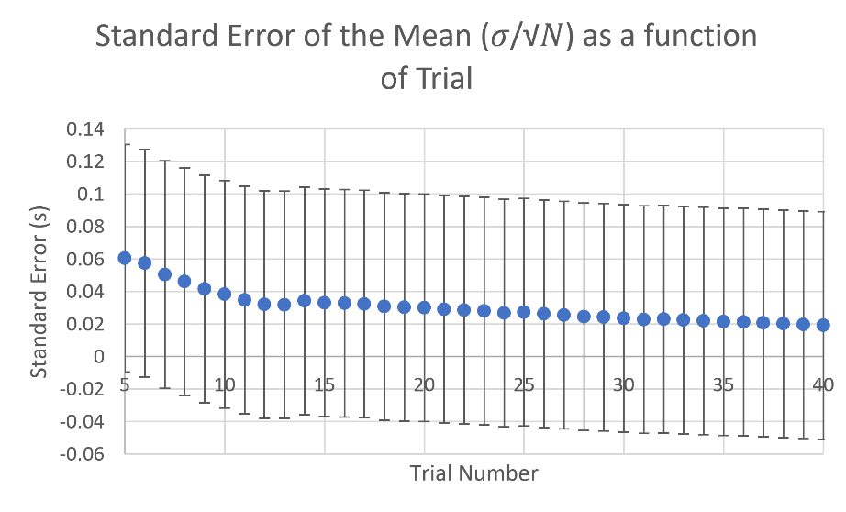**Figure 3 |** **Standard error of the mean $\left(\frac{σ}{\sqrt{N}}\right)$ as a function of trial number.** The data before trial 5 is not shown because the standard deviation $(σ)$ for trials before trial 5 are not considered significant (Figure 2). The standard error of the mean after 40 trials is 0.02 seconds, to one significant figure. The error bars show a measurement uncertainty of 0.07 seconds. Notice that the measurement uncertainty is greater than the standard error of the mean for all the values shown. This tells us that our calculated value for standard error of the mean is not statistically significant and therefore not suitable for use in a prediction.

**4 Analysis of Uncertainty**

**4.1 Position:** First we will consider the precision of the instrument being used to measure distance. A class II measuring tape has an uncertainty of no more than ±2.3mm over 10m, as provided by the manufacturer, Stanley. Next, my ability to use the measuring tape is not perfect. I measured as close to vertically as I could, however I am only confident in this measurement within a degree. Over a 1m, this results in an uncertainty of ±2mm. Additionally, the measuring tape marks every millimetre along its length, so my use of the measuring tape, assuming it is vertical, is accurate to ±0.5mm. After measuring and setting the desk with the marked point at 1m, I checked to see if the floor beneath the desk was level using a bubble surface level. This read 1.2o ± 0.2o off of horizontal across the center of the boards, resulting in an uncertainty of about ±2cm over 1m of floor surface due to the angle between the drop point and the floor. I estimate that the paper fell no further than 0.5m meter away from the drop point on any given trial, meaning that the overall uncertainty in the drop height due to the floor being out of level is ±2cm (note that this assumes the floor is both smooth and uniformly out of level). Finally, we must consider the uncertainty in my ability to hold and release the paper at the intended height. By pressing the paper against the bottom of the work surface of the desk around the marked point, the error in the position of the center of mass of the paper seems to come mostly from areas not properly supported by my hand, resulting in some parts of the paper sagging by about 3cm. However, since most of the paper was still parallel or pressed to the work surface, the error in the position of the center of mass is likely on the order of millimeters.

**4.2 Time:** To both release the paper and start the timer, I opened my right hand (which held both the paper and the start button on the timer) and released the paper with my left hand as close to simultaneously as I could. To estimate the uncertainty in the difference between when the timer started and when the paper dropped, I held two phones in one hand back to back and held the start button down on each of their timers. I then released them similarly to how I released the paper and the timer while I was collecting data. Then using a third phone, I took a slow- motion video of both of the displays while the timers were running and found the interval between the two times. I repeated this five times and found that the timers were no more than 0.4 seconds apart. To stop the timer, I watched the paper from close to the floor and waited as it descended and stopped the timer when I either saw or heard it hit the ground. Since I was anticipating the paper hitting the ground as I saw it fall, and not reacting to the stimulus blindly, I estimate that I stopped the timer within 0.07 seconds of it striking the ground. I approximated this value by trying to stop my phone timer as close to 2.00 seconds as possible and found that after 10 tries, I stopped the timer within 0.07 seconds of 2.00 seconds every time. The error inherent in the timer on my iPhone is less than the quantities it reported to me (on the order of ten thousandths of a second).

**4.3 Cumulative:** The most significant source of error from the measurement of 1 meter comes from the inclination of the floor, which results in an uncertainty of about ±2cm in drop height. From my observations, it is clear that the paper is not accelerating with 9.8 m/s2. Instead, it seems that the paper reaches its terminal velocity very quickly. Knowing this, we can approximate the relationship between distance fallen and time as linear. From this, we can infer an Xcm/m discrepancy in the drop distance causes an X% error in the time it takes for the paper to reach the floor. We then find an approximate 2% error in timing resulting from the height of the drop. Since the average drop time is 1.45 seconds, the inclination of the floor causes an approximate 0.03 second error. The most significant source of error from my time measurements was my ability to stop the timer when the paper hit the ground: about 0.07 seconds. Therefore, my greatest measurement uncertainty is 0.07 seconds. If I were to conduct this experiment again with the hope of reducing the measurement uncertainty, I would take a high-speed video using my iPhone, which can achieve 240 frames per second, for each trial.

**5 Conclusion**

The standard deviation of all 40 trials is calculated to be 0.12s, which gives the statistical uncertainty of any given measurement. From Figure 1, we find that about 40% of the results are within 0.12 seconds of the, which given the uncertainty and inherently chaotic nature of the experiment, is a reasonable approximation of the expected 33%. Since one standard deviation covers about 68% of data in general, I would expect that two of any three random data points from my classmates would fall within the range defined by 1.5 ± 0.1 seconds.

$$Y =0.1s$$

The standard error of my data is approximately 0.02 seconds. However, as is shown in Figure 3, we see that the standard error is not statistically significant because it is less than our measurement uncertainty. I cannot therefore make a justifiable prediction as two what range would include two of any three data points while excluding the third. I can however predict that if we were to separately average three of my classmate’s data points, all three of those averages would fall within the range defined by 1.45 ± 0.07 seconds.

$$Z =0.07s$$

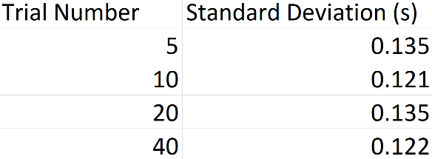**6 Appendix**

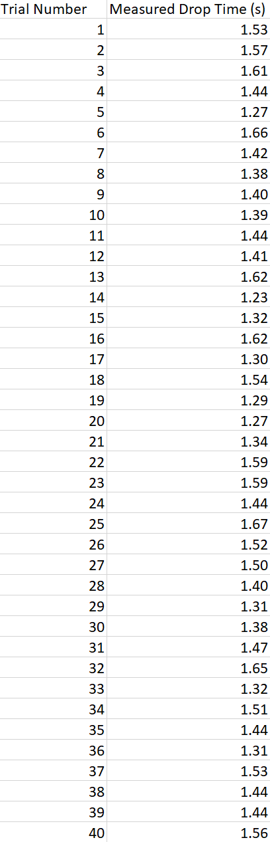**Figure 4 | Standard deviations after 5, 10, 20, and 40 trials.** Note the calculated standard deviations show relatively little variation as the number of trials increase.

**Figure 5 | Times collected in each trial conducted.** All times are recorded as they appeared on the timer used.