**CWRU Data Analytics** Robert Wood  
Unit 5 | Assignment – The Power of Plots 3/16/2019  
Pyber

**Three observable trends based on the data:**

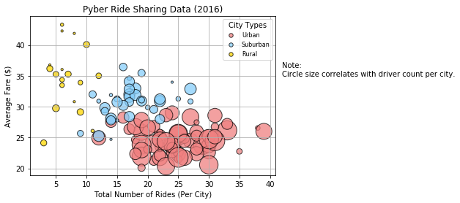

1. Cities in urban areas on average have more drivers, and a larger number of total rides than those in suburban areas, followed by rural areas.
2. On average, fares are the lowest in urban areas. This may be due to a combination of shorter trips (destinations within an urban area are likely to be a shorter drive than in a suburban or rural area) and a greater supply of drivers, keeping fares low.

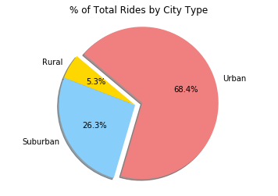 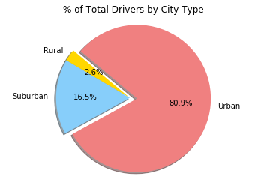

1. While rides in rural areas make up 5.3% of total rides, the total drivers in rural areas only make up 2.6% of all drivers. Therefore, we can observe that on average, drivers in rural areas will be busier (provide more total rides) than drivers in urban areas.