**CWRU Data Analytics** Robert Wood  
Unit 5 | Assignment – The Power of Plots 3/16/2019  
Pymaceuticals

**Three observable trends based on the data:**

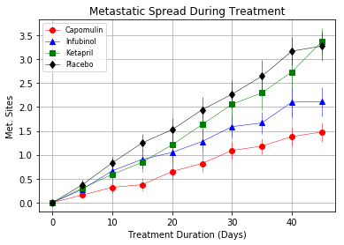

1. The three treatments examined (Capomulin, Infubinol, and Ketapril) all controlled metastatic site spread during treatment more effectively than placebo.

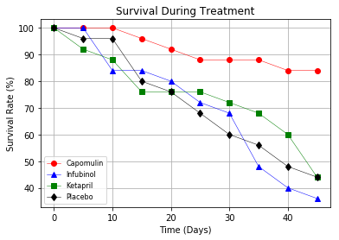

1. Survival during treatment over 45 days with Capomulin (84%) is significantly higher than Infubinol (36%), Ketapril (44%), or placebo (44%).

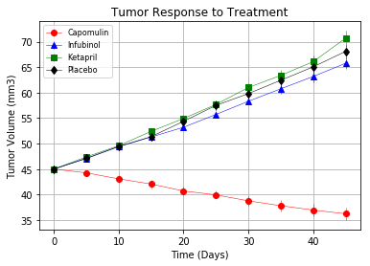 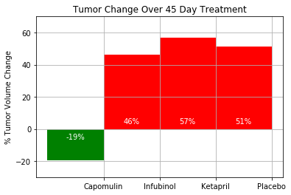

1. Of the treatments examined, Capomulin is the only treatment effective in reducing tumor volume (19% reduction over 45 days).