Formatting Open Science
true
true

Introduction
Agile development of science depends on the continuous exchange of information between the researchers [1]. In the past, physical copies of scientific works had to be produced and distributed. Therefore, publishers needed to invest considerable economical resources for typesetting and printing. Since the journals were mainly financed by their subscribers, their editors not only had to decide on the scientific quality of a submitted manuscript, but also on the potential interest for their readers. The availability of globally connected computers enabled the rapid exchange of information at low cost. Yochai Benkler (2006) predicts important changes in the information production economy, which are based on three observations:
- A nonmarket motivation in areas such as education, arts, science, politics and theology.
- The actual rise of nonmarket production, made possible through networked individuals and coordinate effects.
- The emergence of large-scale peer production, e.g. of software and encyclopaedias.
Immaterial goods such as knowledge and culture are not lost, when consumed or shared – they are ‘nonrival’ –, which enables a networked information economy, which is not commercially driven [2].

Preprints and e-prints
In some areas of science already existed a preprint culture, i.e. a paper-based exchange system of research ideas and results, when Paul Ginsparg in 1991 initiated a server for the distribution of electronic preprints – ‘e-prints’ – about high-energy particle theory at the Los Alamos National Laboratory (LANL), USA [3]. Later, the LANL server moved with Ginsparg to Cornell University, USA, and was renamed to arXiv [4]. Currently, arXiv (https://arxiv.org/) publishes e-prints related to physics, mathematics, computer science, quantitative biology quantitative finance and statistics. Just a few years after the start of the first preprint servers, their important contribution to scientific communication was evident [3,5,6]. In 2014, arXiv reached the impressive number of 1 million e-prints [7]. In more conservative areas, such as chemistry and biology, accepting the publishing prior peer-review took more time [8]. A preprint server for life sciences (http://biorxiv.org/) was launched by the Cold Spring Habor Laboratory, USA, in 2013 [9]. PeerJ preprints (https://peerj.com/preprints/), started in the same year, accepts manuscripts from biological sciences, medical sciences, health sciences and computer sciences. The terms ‘preprints’ and ‘e-prints’ are used synonymously, since the physical distribution of preprints has become obsolete. A major drawback of preprint publishing are the sometimes restrictive policies of scientific publishers. The SHERPA/RoMEO project informs about copyright policies and self-archiving options of individual publishers (http://www.sherpa.ac.uk/romeo/).

Open Access
The term ‘Open Access’ was introduced 2002 by the Budapest Open Access Initiative and was defined as:
“Barrier-free access to online works and other resources. OA literature is digital, online, free of charge (gratis OA), and free of needless copyright and licensing restrictions (libre OA).” [10]
Frustrated by the difficulty to access even digitalized scientific literature, three scientists founded the Public Library of Science (PLoS). In 2003, PLoS Biology was published as the first fully Open Access (OA) journal for biology [11,12]. Thanks to the great success of OA publishing, many conventional print publishers now offer a so-called ‘Open Access option’, i.e. to make accepted articles free to read for an additional payment. The copyright in this hybrid models might remain with the publisher, whilst fully OA usually provide a liberal license, such as the Creative Commons Attribution 4.0 International (CC BY 4.0, https://creativecommons.org/licenses/by/4.0/). OA literature is only one component of a more general ‘open’ philosophy, which also includes the access to scholarships, software, and data [13]. Interestingly, there are several different ‘schools’ of thinking on how to understand and define ‘Open Science’, as well the position that any science is open by definition, because of its objective to make generated knowledge public [14].

Cost of journal article production
In a recent study, the article processing charges (APCs) for research intensive universities in the USA and Canada were estimated to be about 1,800 USD for fully OA journals and 3,000 USD for hybrid OA journals [15]. PeerJ (https://peerj.com/), an OA journal for biological and computer sciences launched 2013, drastically reduced the publishing cost and offers its members a life-time publishing plan for a small registration fee [16]; alternatively the authors can choose to pay an APC of 1,095 USD, which may be cheaper, if multiple co-authors participate.
Examples such as the Journal of Statistical Software (JSS, https://www.jstatsoft.org/) and eLife (https://elifesciences.org/) demonstrate the possibility of completely community-supported OA publications. Fig. xx compares the APCs of different OA publishing business models.
JSS and eLife are peer-reviewed and indexed by Thomson Reuters. Both journals are located in the Q1 quality quartile in all their registered subject categories of the Scimago Journal & Country Rank (http://www.scimagojr.com/), demonstrating that high-quality publications can be produced without charging the scientific authors or readers.
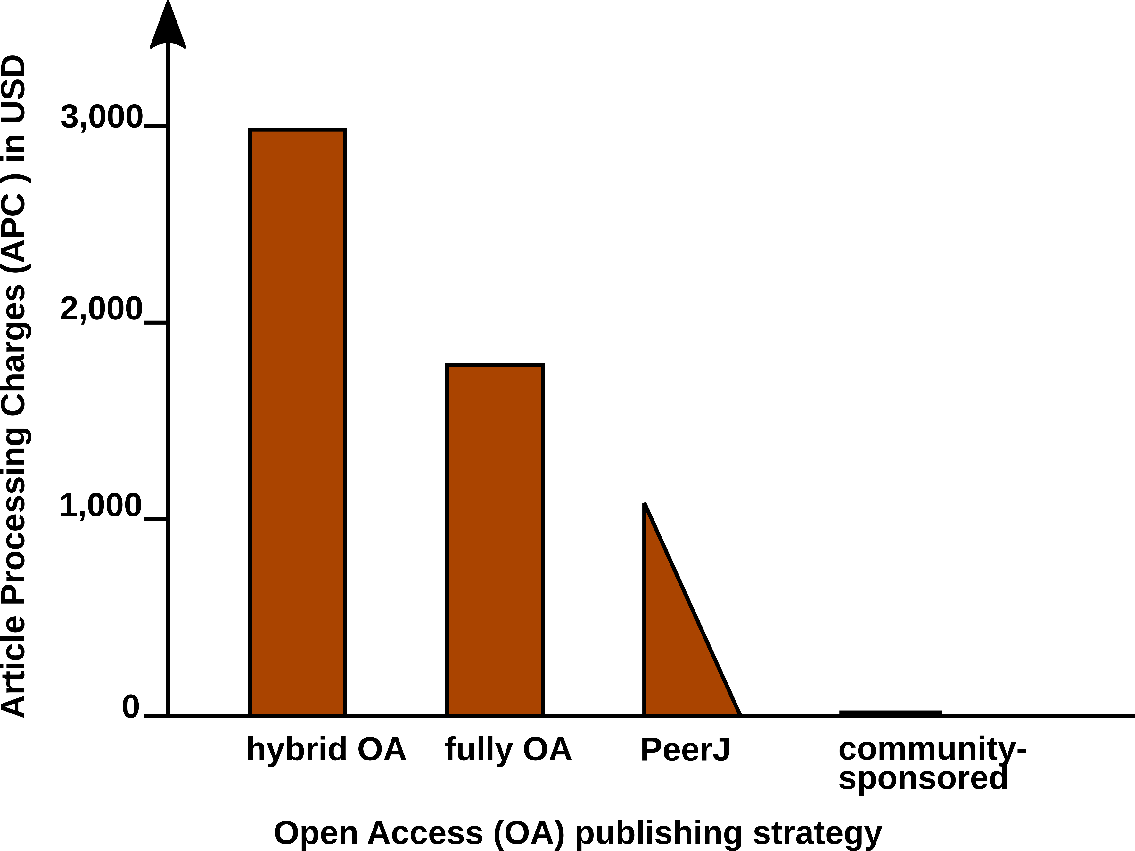 Figure xx. Article Processing Charge (APCs) that authors have to pay for with different Open Access (OA) publishing models. Data from [15] and journal webpages.
In 2009, a study was carried concerning the “Economic Implications of Alternative Scholarly Publishing Models”, which demonstrates an overall societal benefit by using OA publishing model [17]. In the same report, the real publication costs are evaluated. The relative costs of an article for the publisher are represented in Fig. xx.
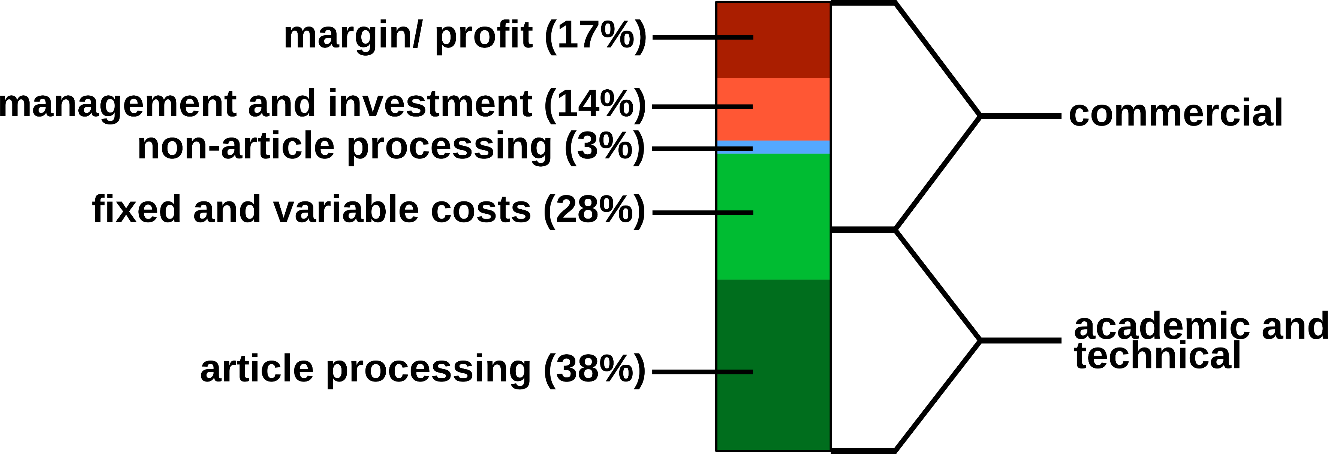 Figure xx. Estimated publishing cost for a ‘hybrid’ journal (conventional with Open Access option). Data from [17].
Conventional publishers justify their high subscription or APC prices with the added value, e.g. journalism (stated in the graphics as ‘non-article processing’). But also stakeholder profits, which could be as high as 50%, must be considered, and are withdraw from the science budget [18]. Generally, the production costs of an article could be roughly divided into commercial and academic/ technical costs (Fig. xx). For nonmarket production, the commercial costs such as margins/ profits, management etc. can be drastically reduced. Hardware and services for hosting an editorial system, such as Open Journal Systems of the Public Knowledge Project (https://pkp.sfu.ca/ojs/) can be provided by public institutions. Employed scholars can perform editor and reviewer activities without additional cost for the journals. Nevertheless, ‘article processing’, which includes the manuscript handling during peer review and production represents the most expensive part.
Therefore, we investigated a strategy for the efficient formatting of scientific manuscripts.

Current standard publishing formats
Ignoring the Guide for Authors, e.g. by submitting a manuscript with a different reference style, gives a negative impression with a journal’s editorial staff. Too carelessly prepared manuscripts can even provoke a straight ‘desk-reject’ [19]. Scientific journal accept either DOC(X), LATEX and/ or PDF submissions.
Although a submitted manuscript might be accepted by a journal ‘as is’, it still needs to be adjusted to the particular publication style in the production stage. Generally speaking, a scientific manuscript is composed from contents and formatting. Whilst the content, i.e. text, figures, tables, citations etc., may remain the same between different publishing forms and journal styles, the formatting can be rather different.
a which are presented in a certain format. This format depends on the intended use, e.g. for for submission to a particular journal, publication as a printed or electronic book, or for a webpage. Incompatible file formats, markdown with different target formats. Current publishing formats PDF HTML EPUB. Typesetting software, word processors such as Microsoft Word, LibreOffice, WPS Office, What You See Is What You Get (WYSIWYG), LaTeX What You See Is What You Want (WYSIWYW), hybrids such as LyX What You See Is What You Mean (WYSIWYM). Because of the sometimes complicated syntax specifications, simple conversions between file formats can be difficult or impossible. In academic publishing, the following types of works require the creation of different output formats from the same source text:
- For the publishing of a book, with a print version in PDF and an electronic version in EPUB.
- For distributing of a seminar script, with an online version in HTML and a print version in PDF.
- For submitting a journal manuscript for peer-review in DOCX, as well as a pre-print version with another journal style in PDF.
Table xx. Current standard formats for publishing
Type | Description | Use | Syntax | Reference
DOCX | Office Open XML | WYSIWYG editing | XML, ZIP | [20]
ODT | Libre Office | WYSIWYG editing | XML, ZIP | [21]
PDF | portable document | print replacement | PDF | [22]
EPUB | electronic publishing | ebooks | HTML5, ZIP | [23]
LATEX | typesetting system | high-quality print | TEX | [24]
HTML | hypertext markup | websites | (X)HTML | [25,26]
MD | Markdown | lightweight markup | plain text MD | [27,28]
Table xx. Examples for formatting elements and their implementations in different markup languages types.
Element | Markdown | LATEX | HTML
structure
section | # Intro | \section{Intro} | <h1><Intro></h1>
subsection | ## History | \subsection | <h2><History></h2>
 |  | {History}
text style
bold | **text** | \textbf{text} | <b>text</b>**
italics | *text* | \textit{text} | <i>text</i>
links
http link | <https:// | \usepackage{url} | <a href="https://
 | arxiv.org/> | \url{https:// | arxiv.org/"></a>
 |  | arxiv.org/}
Documents with the commonly used Office Open XML (DOCX Microsoft Word files) and OpenDocument (ODT LibreOffice) file formats can be opened in a standard text editor after unzipping. However, content and formatting information is distributed into various folders and files. Overall, markdown displays the simplest structure, which facilitates the editing of documents.
Several programs for the conversion between documents formats exist, such as the e-book library program calibre https://code.google.com/archive/p/faenza-icon-theme/. But the results of such conversions are often not satisfactory and require substancial manual corrections. Therefore, we were looking for a solution, which enables the creation of scientific manuscripts in a simple format, and the subsequent generation of multiple output formats. The need for hybrid publishing has been recognized outside of science[29,30], but the requirements specific to scientific publishing have not been addressed so far.

Concepts of markdown and Pandoc
Markdown was originally developed by John Gruber in collaboration with Aaron Swartz, with the goal to simplify the writing of HTML documents http://daringfireball.net/projects/markdown/.
Despite it’s original focus on the web, it is has been proven to be well suited for academic writing [27].
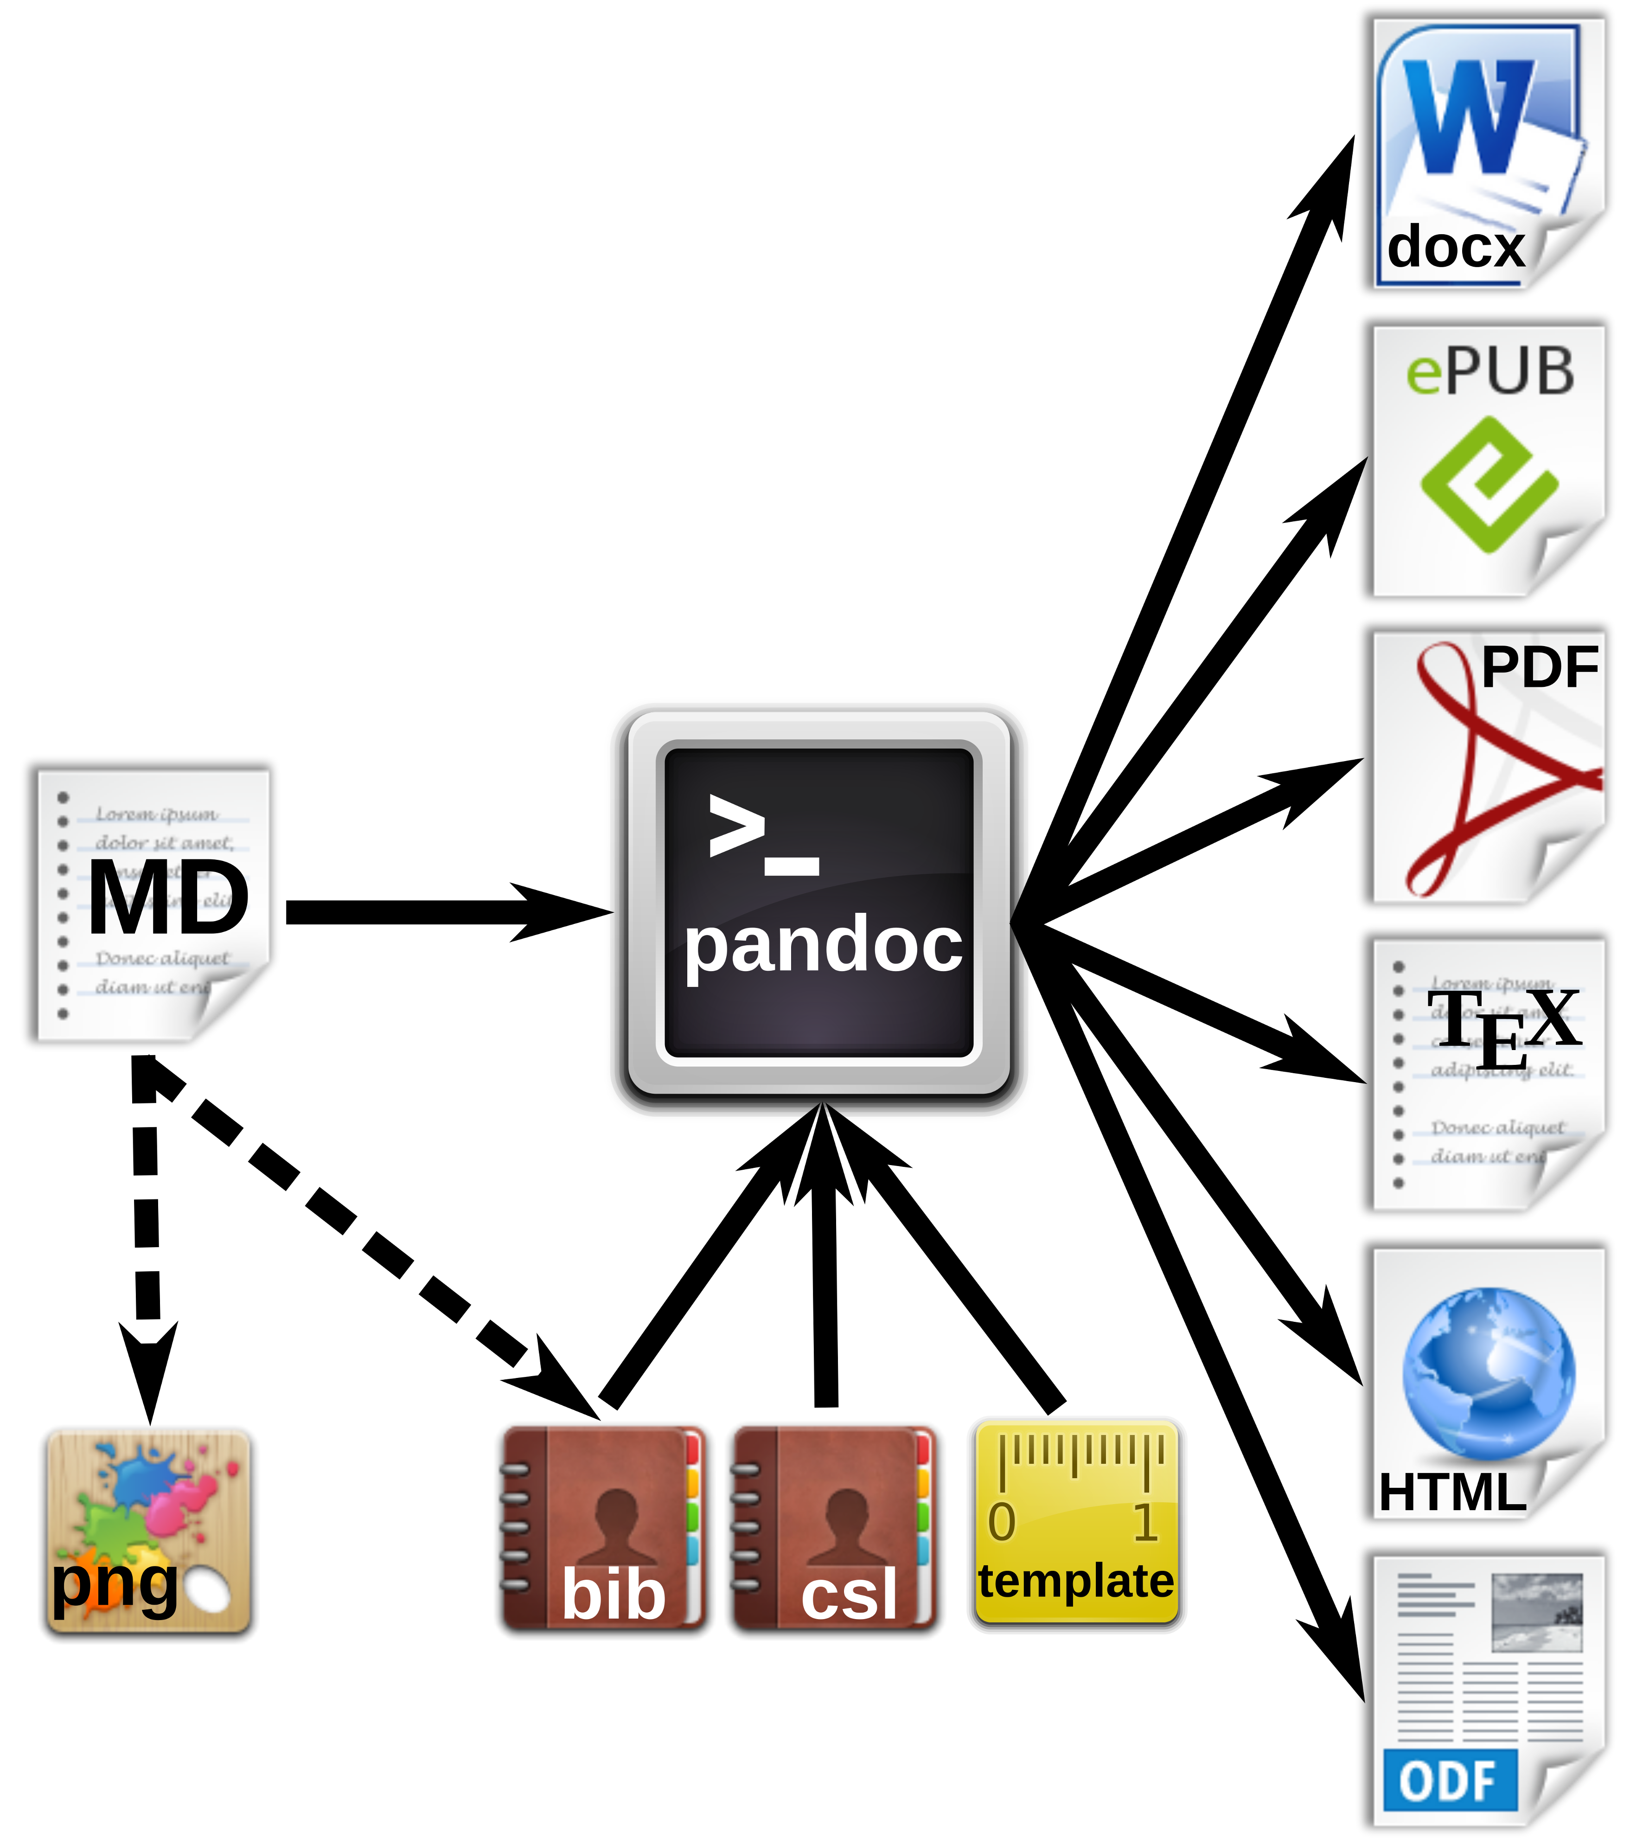 Figure xx. Workfow for the generation of multiple document formats with Pandoc.

Markdown editors and online editing
Fig. xx summarized various options for local or networked editing of MD files.
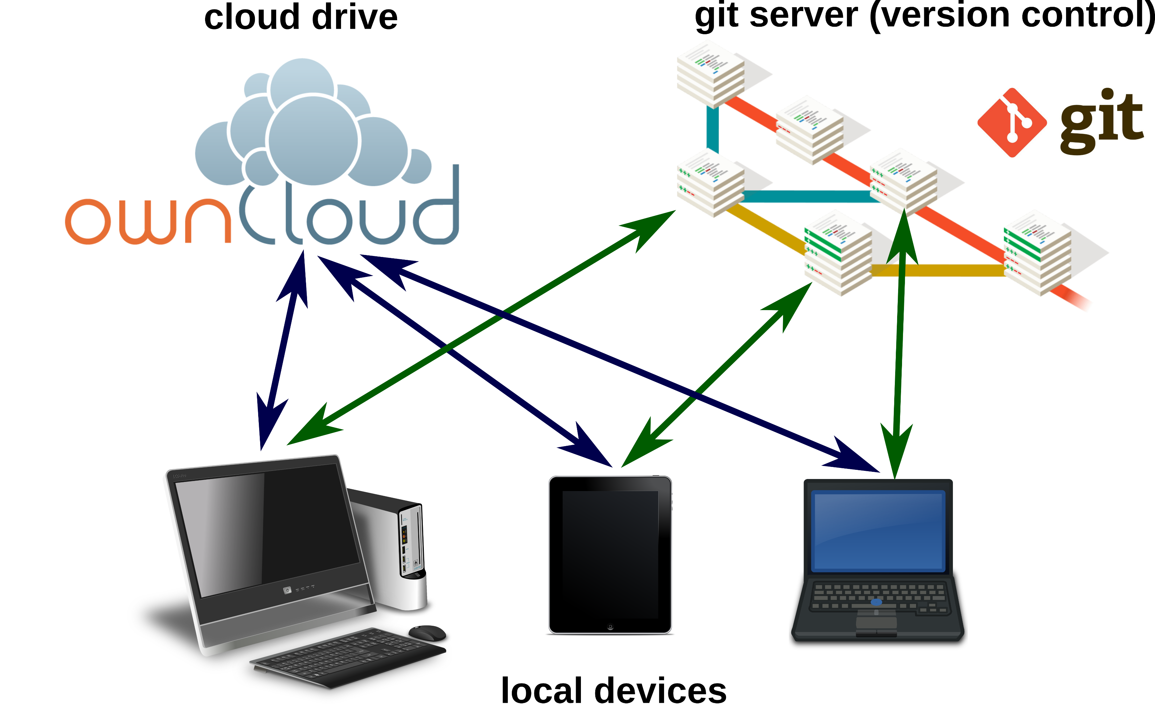
Figure xx. Markdownfile can be edited on local devices or on cloud drives. For advanced version control in collaborative working, a local or remote git repository may be used.

Markdown editors
Because of the simple syntax, basically any text editor is suitable for editing markdown files. For several popular text editors, such as vim (http://www.vim.org/), GNU Emacs (https://www.gnu.org/software/emacs/), atom (https://atom.io/) or geany (http://www.geany.org/), plugins provide additional functionality for markdown editing, such as syntax highlighting, live preview or structure browsing. On the other side, in the last years plenty of special mardown editors have been published. Many of those are cross-platform compatible, e.g. Abricotine (http://abricotine.brrd.fr/), Ghostview (https://github.com/wereturtle/ghostwriter) and CuteMarkEd (https://cloose.github.io/CuteMarkEd/). xx Writing on the go mobile devices, Even for tablets, Android and iOS devices, numerous free and low-cost applications exist. Parts of this text were written in xx JotterPad dictation and swipe softwarexx Various of those applications support the cloud storage of documents.
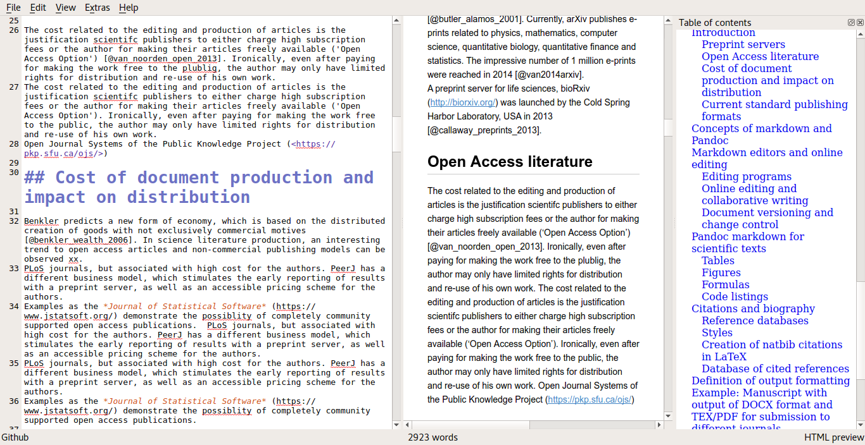 Figure xx. Editing window, HTML preview and table of contents using the CuteMarkEd editor.

Online editing and collaborative writing
xx Google Docs test editing.
In recent years, several platforms were developed for collaborative writing. The online editor StackEdit (https://stackedit.io) can be used for editing markdown files on a Google Drive (https://drive.google.com). OwnCloud with Markdown Editor plugin (see section xx).
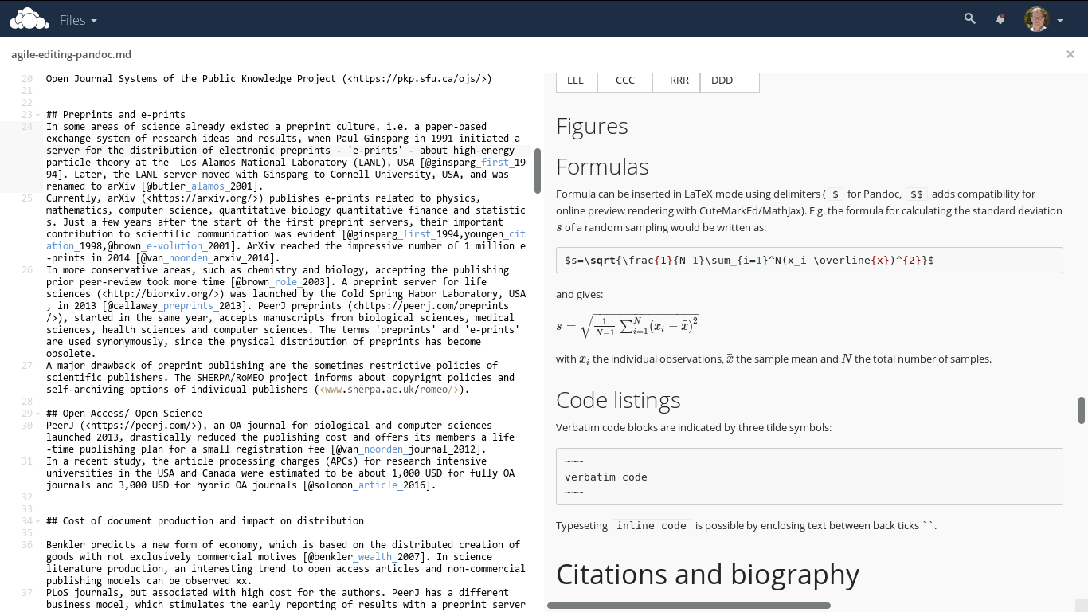 Figure xx. Direct online editing of this manuscript with live preview using the ownCloud Markdown Editor plugin by Robin Appelman.

Document versioning and change control
Integrated in editing software or cloud server, low overhead of the files diff, git.
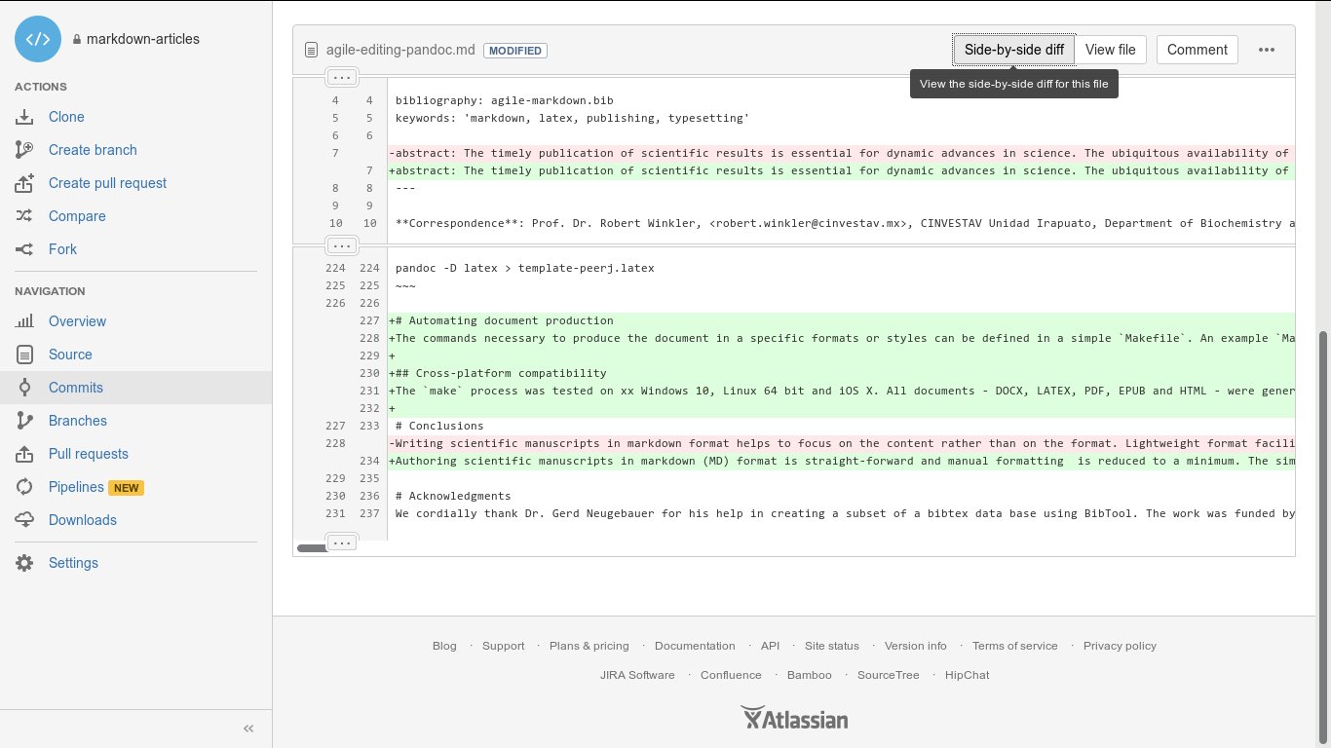 Figure xx. Version control and collaborative editing using a git repository on bitbucket.

Pandoc markdown for scientific texts
Following the potential of typesetting scientific manuscripts with Pandoc is demonstrated with examples for typical document elements, such as formulas, figures, tables, code listings and references. A brief introduction is given by [31]. The complete Pandoc User’s Manual can be found at http://pandoc.org/MANUAL.html.

Tables
Pipe tables are less strict in their syntax
Left | Center | Right | Default
:-----|:------:|------:|---------
LLL | CCC | RRR | DDD
gives
Left | Center | Right | Default
LLL | CCC | RRR | DDD

Figures

Formulas
Formula can be inserted in LaTeX mode using delimiters ($ for Pandoc, $$ adds compatibility for online preview rendering with CuteMarkEd/MathJax). E.g. the formula for calculating the standard deviation of a random sampling would be written as:
$s=\sqrt{\frac{1}{N-1}\sum_{i=1}^N(x_i-\overline{x})^{2}}$
and gives:

with the individual observations, the sample mean and the total number of samples.
Pandoc parses formulas into internal structures and allows conversion into formats other than LaTeX. This allows for format-specific formula representation and enables computational analysis of the formulas [32].

Code listings
Verbatim code blocks are indicated by three tilde symbols:
~~~
verbatim code
~~~
Typeseting inline code is possible by enclosing text between back ticks ` `.

Citations and biography

Reference databases
bibtex databases, which are supported by almost any reference management program.

Styles
Whereas natbib bibtex is supported by Pandoc, it is incompatible with DOCX xx. The Citation Style Language (CSL) http://citationstyles.org/ is used for the citations and bibliographies. This file format is supported e.g. by the reference management programs Mendeley https://www.mendeley.com/, Papers http://papersapp.com/ and Zotero https://www.zotero.org/. CSL styles for particular journals can be found from the Zotero style repository https://www.zotero.org/styles. The bibliography style, which Pandoc should use for the target document can be chosen or in the YAML block of the markdown document or can be passed as an command line option. The later is more recommendable, because different bibliography style may be used for different documents.

Creation of natbib citations in LaTeX
For citations in scientific manuscripts written in LaTeX, the natbib package is widely used. To create TEX output file with natbib citations, Pandoc simply has to be run with the --natbib option.

Database of cited references
To share the bibliography for a certain manuscript with co-authors or the publisher’s production team, it is often desirable to generate a subset of a larger database, which only contains cited references. If LATEX output was generated with the --natbib, the compilation of the file with LATEX gives an AUX file (in the example named md-article.aux), which subsequently can be extracted using BibTool https://github.com/ge-ne/bibtool: ~ bibtool -x md-article.aux -o bibshort.bib ~ In this example, the article database will be called bibshort.bib.
For the direct creation of an article specific BIB database without using LATEX, we wrote a simple Perl script mdbibexport (https://github.com/robert-winkler/mdbibexport).

Meta information of the document
Document information such as title, authors, abstract etc. can be defined in a metadata block written in YAML syntax. YAML (“YAML Ain’t Markup Language”, http://yaml.org/) is a data serialization standard with simple, human readable format. Variables defined in the YAML section are processed by pandoc and integrated into the generated documents. The YAML metadata block is recognized by three hyphens (---) at the beginning, and three hyphens or dots (...) at the end, e.g.:
---
title: 'Formatting Open Science'
author:
- name: Albert Krewinkel
affiliation: 1
- name: Robert Winkler
affiliation: 2
fullname: Prof. Dr. Robert Winkler
email: robert.winkler@cinvestav.mx
institute:
- index: 1
name: FTI Touristik GmbH, Berlin, Germany
- index: 2
name: >
CINVESTAV Unidad Irapuato, Department of Biochemistry and Biotechnology,
Laboratory of Biochemical and Instrumental Analysis,
Km. 9.6 Libramiento Norte Carr. Irapuato-León 36821 Irapuato,
Gto. Mexico
bibliography: agile-markdown.bib
keywords: 'markdown, latex, publishing, typesetting'
abstract: The timely ..
---

Example: Manuscript with output of DOCX/ODT format and TEX/PDF for submission to different journals.
DOCX the most common, but also LATEX only journals, PeerJ pre-print server

Development of DOCX template
A first DOCX document with bibliography in PLoS format is created with Pandoc DOCX output:
pandoc -S -s --csl=plos.csl --filter pandoc-citeproc
-o pandoc-manuscript.docx agile-editing-pandoc.md
The document settings and styles of the resulting file pandoc-manuscript.docx can be modified, and following it can be used as document template (--reference-docx=pandoc-manuscript.docx).
pandoc -S -s --reference-docx=pandoc-manuscript.docx
--csl=apa.csl --filter pandoc-citeproc -o outfile.docx agile-editing-pandoc.md
It is also possible to directly re-use a previous output file as template (i.e. template and output file have the same file name):
pandoc -S -s --columns=10 --reference-docx=outfile.docx --csl=apa.csl --filter pandoc-citeproc -o outfile.docx agile-editing-pandoc.md
In this way, the template can be incrementally adjusted to the desired document formatting. The final document may be employed later as Pandoc template for other manuscripts with the same specifications. In this case, running Pandoc the first time with the template, the contents of the new manuscript would be filled into the provided DOCX template. A page with DOCX manuscript formatting of this article is shown in Fig. xx.
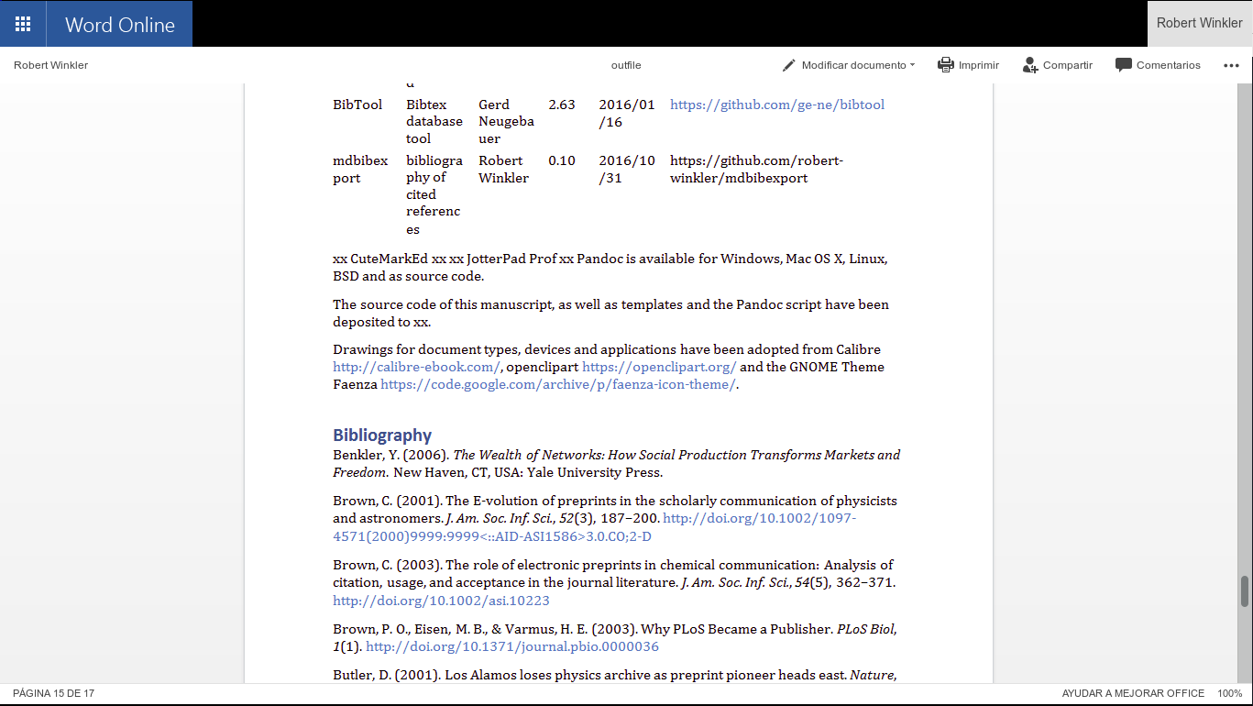 Figure xx. Editing a pandoc generated DOCX in Office 365.
The same proceedure can be applied for an ODT formatted document.

Development of a TEX/PDF template
pandoc -D latex > template-peerj.latex

Automating document production
The commands necessary to produce the document in a specific formats or styles can be defined in a simple Makefile. An example Makefile is included in the source code of this preprint. The desired output file format can be chosen when calling make. E.g. make outfile.pdf produces this preprint in PDF format.Calling make without any option creates all listed document types.

Cross-platform compatibility
The make process was tested on Windows 10 and Linux 64 bit. All documents – DOCX, LATEX, PDF, EPUB and HTML – were generated successfully, which demonstrates the cross-platform compatibility of the workflow.

Conclusions
Authoring scientific manuscripts in markdown (MD) format is straight-forward, and manual formatting is reduced to a minimum. The simple syntax of MD facilitates the document editing and collaborative writing. The rapid conversion of MD to multiple formats such as DOCX, LATEX, PDF, EPUB and HTML can be done easily using Pandoc, and templates enable the automated generation of documents according to specific journal styles. Altogether, the MD format supports the agile writing and fast production of scientific literature. The associated time and cost reduction especially favours community-driven publication strategies.

Acknowledgments
We cordially thank Dr. Gerd Neugebauer for his help in creating a subset of a bibtex data base using BibTool. The work was funded by the Consejo Nacional de Ciencia y Tecnología (CONACyT) Mexico, with the grant FRONTERAS 2015-2/814 and by institutional funding of the Centro de Investigación y de Estudios Avanzados del Instituto Politécnico Nacional (CINVESTAV).

Software and code availability
The relevant software for creating this manuscript used is cited according to [33]. Since unique identifiers are missing for most software projects, we only refer to the project homepages or software repositories:
Software | Use | Authors | Version | Release | Homepage/ repository
Pandoc | universal markup converter | John MacFarlane | 1.16.0.2 | 16/01/13 | http://www.pandoc.org
pandoc-citeproc | library for CSL citations with Pandoc | John MacFarlane, Andrea Rossato | 0.9.1 | 16/03/19 | https://github.com/jgm/pandoc-citeproc
ownCloud | personal cloud software | ownCloud GmbH, Community | 9.1.1 | 16/09/20 | https://owncloud.org/
Markdown Editor | plugin for ownCloud | Robin Appelman | 0.1 | 16/03/08 | https://github.com/icewind1991/files_markdown
BibTool | Bibtex database tool | Gerd Neugebauer | 2.63 | 16/01/16 | https://github.com/ge-ne/bibtool
xx CuteMarkEd xx xx JotterPad Prof xx Pandoc is available for Windows, Mac OS X, Linux, BSD and as source code.
The source code of this manuscript, as well as templates and the Pandoc script have been deposited to xx.
Drawings for document types, devices and applications have been adopted from Calibre http://calibre-ebook.com/, openclipart https://openclipart.org/ and the GNOME Theme Faenza https://code.google.com/archive/p/faenza-icon-theme/.

Bibliography
1. Woelfle M, Olliaro P, Todd MH. Open Science Is a Research Accelerator. Nat Chem. 2011;3: 745–748. doi:10.1038/nchem.1149
2. Benkler Y. The Wealth of Networks: How Social Production Transforms Markets and Freedom. New Haven, CT, USA: Yale University Press; 2006.
3. Ginsparg P. First Steps Towards Electronic Research Communication. Computers in Physics. 1994;8: 390–396. doi:10.1063/1.4823313
4. Butler D. Los Alamos Loses Physics Archive as Preprint Pioneer Heads East. Nature. 2001;412: 3–4. doi:10.1038/35083708
5. Youngen GK. Citation Patterns to Traditional and Electronic Preprints in the Published Literature. Coll res libr. 1998;59: 448–456. doi:10.5860/crl.59.5.448
6. Brown C. The E-Volution of Preprints in the Scholarly Communication of Physicists and Astronomers. J Am Soc Inf Sci. 2001;52: 187–200. doi:10.1002/1097-4571(2000)9999:9999<::AID-ASI1586>3.0.CO;2-D
7. Van Noorden R. The arXiv Preprint Server Hits 1 Million Articles. Nature News. 2014; doi:10.1038/nature.2014.16643
8. Brown C. The Role of Electronic Preprints in Chemical Communication: Analysis of Citation, Usage, and Acceptance in the Journal Literature. J Am Soc Inf Sci. 2003;54: 362–371. doi:10.1002/asi.10223
9. Callaway E. Preprints Come to Life. Nature News. 2013;503: 180. doi:10.1038/503180a
10. Suber P. Open Access. Cambridge, Mass: The MIT Press; 2012.
11. Brown PO, Eisen MB, Varmus HE. Why PLoS Became a Publisher. PLoS Biol. 2003;1. doi:10.1371/journal.pbio.0000036
12. Eisen M. Publish and be praised. The Guardian. 2003;
13. Willinsky J. The Unacknowledged Convergence of Open Source, Open Access, and Open Science. First Monday. 2005;10. doi:10.5210/fm.v10i8.1265
14. Fecher B, Friesike S. Open Science: One Term, Five Schools of Thought. In: Bartling S, Friesike S, editors. Opening Science. Springer International Publishing; 2014. pp. 17–47.
15. Solomon D, Björk B-C. Article Processing Charges for Open Access Publicationthe Situation for Research Intensive Universities in the USA and Canada. PeerJ. 2016;4: e2264. doi:10.7717/peerj.2264
16. Van Noorden R. Journal Offers Flat Fee for “all You Can Publish”. Nature News. 2012;486: 166. doi:10.1038/486166a
17. Houghton J, Rasmussen B, Sheehan P, Oppenheim C, Morris A, Creaser C, et al. Economic implications of alternative scholarly publishing models: Exploring the costs and benefits. http://www.webarchive.org.uk/wayback/archive/20140614041628/http://www.jisc.ac.uk/publications/reports/2009/economicpublishingmodelsfinalreport.aspx#downloads; 2009.
18. Van Noorden R. Open Access: The True Cost of Science Publishing. Nature. 2013;495: 426–429. doi:10.1038/495426a
19. Volmer DA, Stokes CS. How to Prepare a Manuscript Fit-for-Purpose for Submission and Avoid Getting a “desk-Reject”. Rapid Commun Mass Spectrom. 2016; n/a–n/a. doi:10.1002/rcm.7746
20. Ngo T. OFFICE OPEN XML OVERVIEW ECMA TC45. Ecma International; 2006 Dec.
21. Brauer M, Durusau P, Edwards G, Faure D, Magliery T, Vogelheim D. Open Document Format for Office Applications (OpenDocument) v1.0. OASIS; 2005 Feb.
22. International Organization for Standardization. ISO 32000-1:2008 - Document management – Portable document format – Part 1: PDF 1.7. ISO. http://www.iso.org/iso/home/store/catalogue_tc/catalogue_detail.htm?csnumber=51502; 2013.
23. Eikebrokk T, Dahl TA, Kessel S. EPUB as Publication Format in Open Access Journals: Tools and Workflow. Code4Lib. 2014;
24. Lamport L. LaTeX: A Document Preparation System. 2 edition. Reading, Mass: Addison-Wesley Professional; 1994.
25. Raggett D, Hors AL, Jacobs I, Le Hors A, Raggett D, Jacobs I. HTML 4.01 Specification. W3C; 1999 Dec.
26. Hickson I, Berjon R, Faulkner S, Leithead T, Navara ED, O’Connor E, et al. HTML5. W3C; 2014 Oct.
27. Ovadia S. Markdown for Librarians and Academics. Behavioral Social Sciences Librarian. 2014;33: 120–124. doi:10.1080/01639269.2014.904696
28. Leonard S. Guidance on Markdown: Design Philosophies, Stability Strategies, and Select Registrations. RFC Editor; Internet Request for Comments; 2016 Mar pp. 1–28.
29. DPT Collective. From Print to Ebooks: A Hybrid Publishing Toolkit for the Arts. In: Monk J, Rasch M, Cramer F, Wu A, editors. Institute of Network Cultures; 2015.
30. Kielhorn A. Multi-target publishing-Generating ePub, PDF, and more, from Markdown using pandoc. TUGboat-TeX Users Group. 2011;32: 272.
31. Dominici M. An overview of Pandoc. TUGboat. 2014;35: 44–50.
32. Corbí A, Burgos D. Semi-Automated Correction Tools for Mathematics-Based Exercises in MOOC Environments. International Journal of Interactive Multimedia and Artificial Intelligence. 2015;3: 89–95. doi:10.9781/ijimai.2015.3312
33. Smith AM, Katz DS, Niemeyer KE. Software Citation Principles. Peroni S, editor. PeerJ Computer Science. 2016;2: e86. doi:10.7717/peerj-cs.86

