Nama: Robert Wiliam

NIM: 2602091583

Documentation

1. User Authentication

Login + Register + Validation

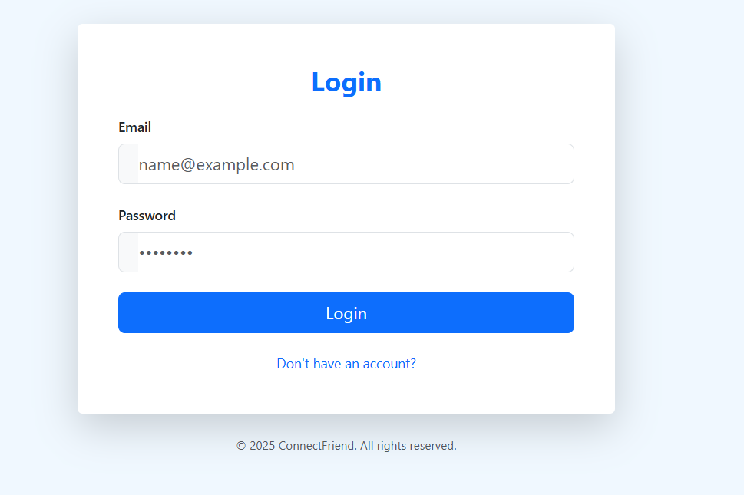

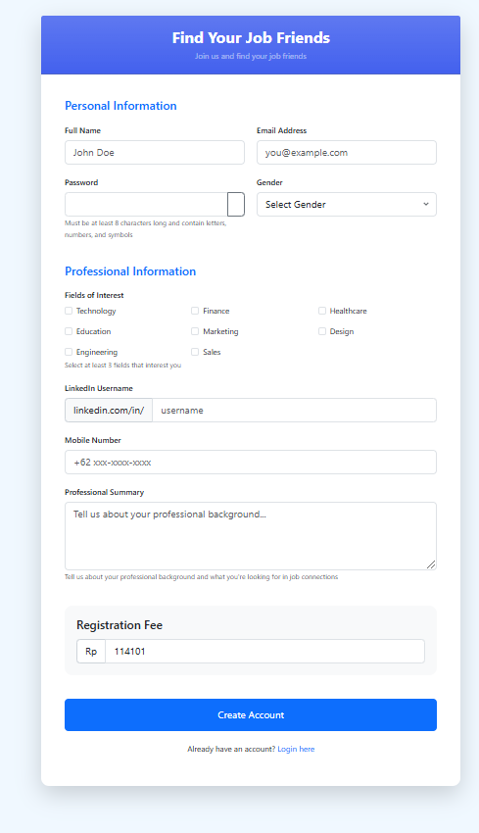

1. Payment

1. Friends

1. Messaging

1. Searching & Filtering

Normal:

Filter Male:

Filter by field of work:

1. Notification:

1. Topup Coins:

1. Visible & not visible:

1. Localization:

