Wep app.

I need to create web application, using react js, Node js , front and backend, Mongod, and cloudinary for images and media.

1. Home page, will have slider images, some text
2. About page, to have text and image ..
3. Contact us, to have contact form
4. Page to have grid image gallery, once user click on image ,to go to full screen lightbox, with left and right arrow to see all the images, each image will have text, on mobile user can zoom in and zoom out with the finger like facebook.
5. The app will have one dynamic post with featured image, the post will have title, date, text about, image gallery, and video, admin can choose photo or video.
6. Once the dynamic post working good, then we will map the posts to show them like timeline, do you remember facebook timeline, that will show title, featured image and some text and date , please see the image down.

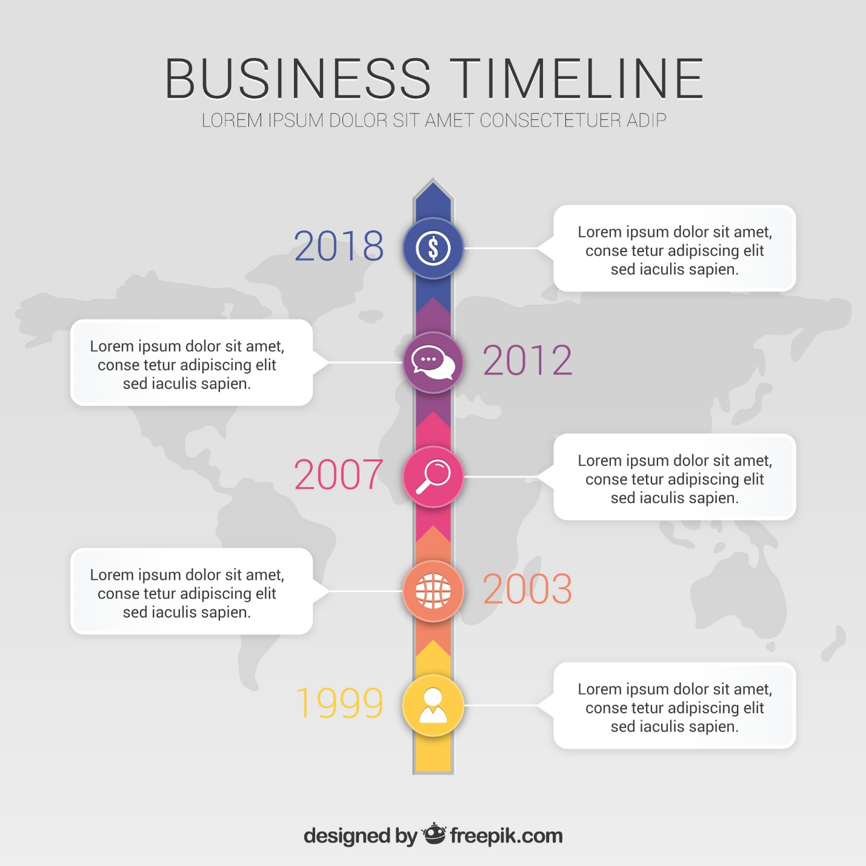

* The app should be deployed on my server , and tested in order to release the money
* The app should be fast , to load within 1-3 sec maxium, optimized , and fast.
* If there small points that not mentions here, and I will ask them in the work , you should do them, those will be small points ..
* Cause I am waiting from my client final things, but it will be some thing like this …