1. 

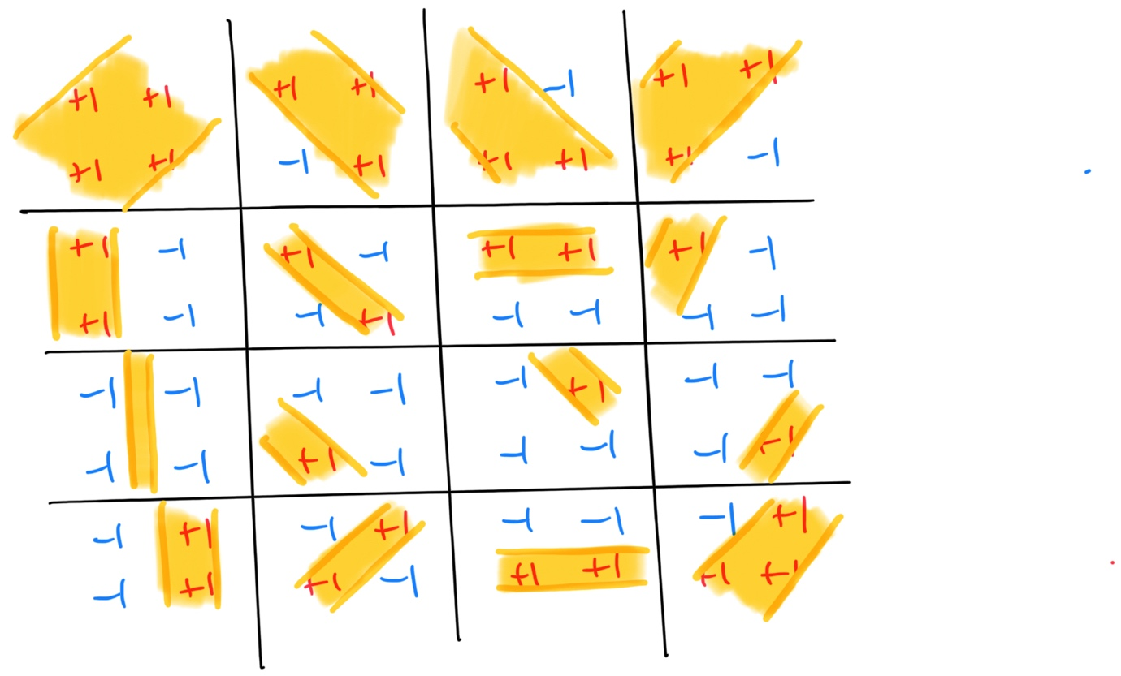

We can know from the picture above that the hypothesis set shatters n = 4, which means that the VC-Dimension of the hypothesis set is no less than 4.

1. For all integer n, we can generate $2^{n}$ different kind of hypothesis by letting $α$ equals to a sum of combination of elements in $S=\{\frac{4^{0}}{4^{n}}, \frac{4^{1}}{4^{n}}, \frac{4^{2}}{4^{n}}, …, \frac{4^{n-1}}{4^{n}}\}$ (a total of ${\left({n \atop 0}\right)+\left({n \atop 1}\right)+\left({n \atop 2}\right)+…+\left({n \atop n}\right)=2}^{n}$ different sums, including don’t take any, which means zero), these $2^{n}$ kinds of different hypothesis set can shatter this set of points: $P=\{4^{1}, 4^{2}, …, 4^{n}\}$. Therefore, the VC dimension of the hypothesis set is infinity.
2. Let $C$ be $H_{1}∩H_{2}$. Because $C⊆H_{2}$, so $H_{2}$ always has all hypothesis that $C$ has. This means that if $C$ can shatter a set of points $P$, $H_{2}$ can definitely shatter it by using the same hypothesizes that $C$ uses. On the other hand, it’s possible that we can find some hypothesis in $H_{2}$ that $C$ doesn’t have. This means that there probably exist a group of points $P_{2}$ that $H_{2}$ can shatter but $C$ can’t because $H_{2}$ uses some hypothesis that $C$ doesn’t have. Therefore $d_{vc}\left(H_{1}{∩H}_{2}\right)≤ d_{vc}(H_{2})$.

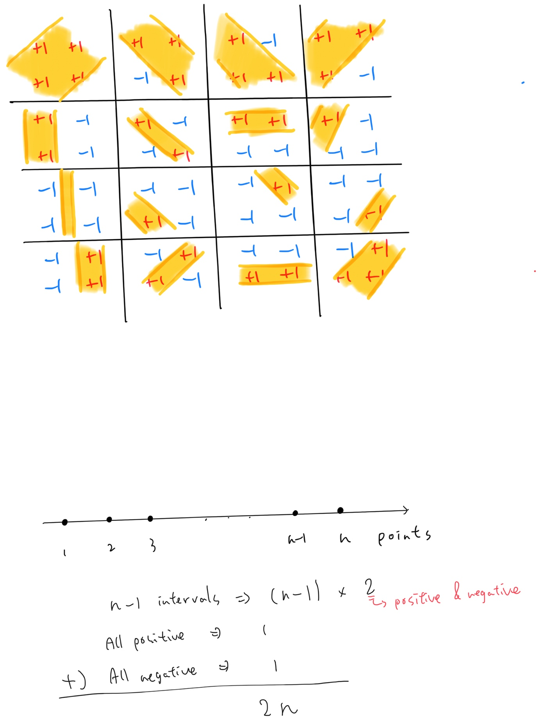

So $m_{H_{1}{∩H}_{2}}\left(N\right)=2N$. Therefore, $d_{VC}\left(H_{1}{∩H}_{2}\right)=2 (2×3<2^{3}=8)$.



Let’s divide the problem into four cases:

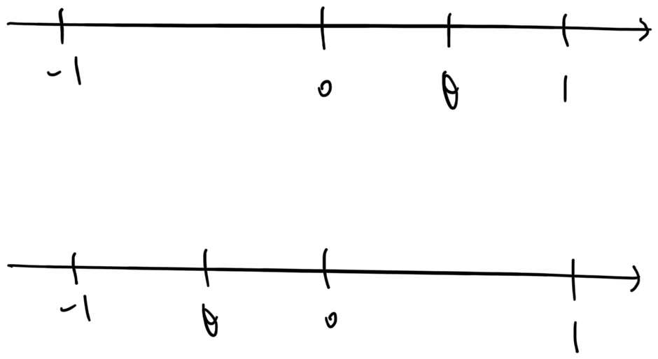

Case 1: $0≤θ<1, s>0$

$$E_{out}\left(h_{s, θ}\right)=\frac{1}{2}×0.2+\frac{θ}{2}×0.8+\frac{1-θ}{2}×0.2=0.2+0.3θ$$

Case 2: $0≤θ<1, s<0$



$$E_{out}\left(h_{s, θ}\right)=\frac{1}{2}×0.8+\frac{θ}{2}×0.2+\frac{1-θ}{2}×0.8=0.8-0.3θ$$

Case 3: $-1≤θ<0, s>0$

$$E_{out}\left(h_{s, θ}\right)=\frac{θ+1}{2}×0.2-\frac{θ}{2}×0.8+\frac{1}{2}×0.2=0.2-0.3θ$$

Case 4: $-1≤θ<0, s<0$

$$E_{out}\left(h_{s, θ}\right)=\frac{θ+1}{2}×0.8-\frac{θ}{2}×0.2+\frac{1}{2}×0.8=0.8+0.3θ$$

Combine the four equation above, we get:



$$E_{out}\left(h_{s, θ}\right)=0.5+0.3s(\left|θ\right|-1)$$

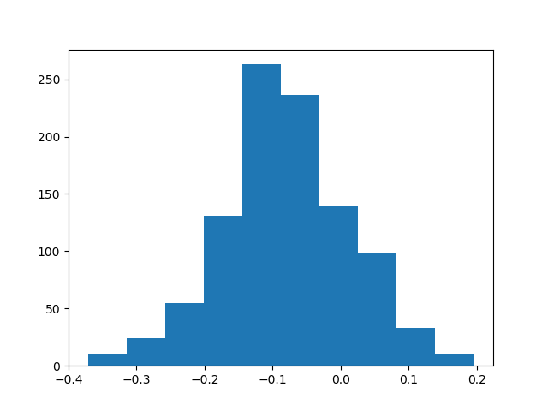

We can observe from the graph above that $E_{in}$ and $E_{out}$ is close even with noise.

1. Let’s prove it by induction.
   1. Base case:

* 1. Guess that $B\left(N, k\right)=\sum_{i=0}^{k-1}{\left({n \atop i}\right)}$
 $$B\left(N+1, k\right)=B\left(N, k\right)+B\left(N, k-1\right)$$

 $$=\sum_{i=0}^{k-1}{\left({N \atop i}\right)}+\sum_{i=0}^{k-2}{\left({N \atop i}\right)}$$

$$=\sum_{i=0}^{k-1}{\left({N \atop i}\right)}+\sum_{i=0}^{k-1}{\left({N \atop i-1}\right)}$$

$$=\sum_{i=0}^{k-1}{\left({N \atop i}\right)}$$

2. By Induction, the guess is correct.