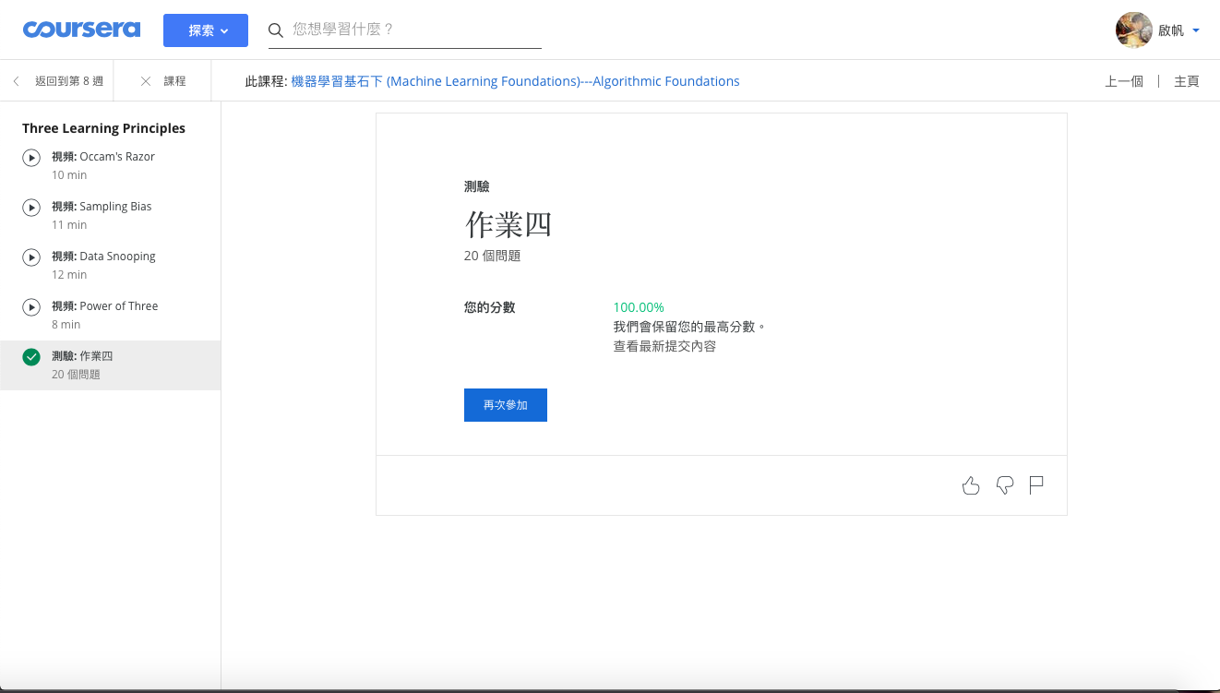



$$∇E_{aug}\left(w\right)=∇E_{in}\left(w\right)+∇(\frac{λ}{N}w^{T}w)$$

$$=∇E_{in}\left(w\right)+\frac{2λ}{N}w$$

So, the update rule is:



$$w\left(t+1\right)←w\left(t\right)-η∇E_{aug}\left(w\left(t\right)\right)=w\left(t\right)-η\left(∇E_{in}\left(w\left(t\right)\right)+\frac{2λ}{N}w\left(t\right)\right)=\left(1-\frac{2ηλ}{N}\right)w\left(t\right)-η∇E_{in}\left(w\left(t\right)\right)$$

Let $A=\left(-1, 0\right), B=\left(ρ, 1\right), C=\left(1, 0\right)$

$$E_{loo}=\frac{1}{3}\left(error\left(leave B out\right)+error\left(leave A out\right)+error\left(leave C out\right)\right)$$

Let $h_{xy}$ be the corresponding linear hypothesis which have the lowest square error on point x and y, which is the line constructed by x and y (the square error is zero).

$h_{AC}(x)=0, error\left(leave B out\right)=1$

$$h_{BC}\left(x\right)=\frac{1}{ρ-1}\left(x-1\right), error\left(leave A out\right)={(h_{BC}\left(-1\right)-0)}^{2}=\frac{4}{{(ρ-1)}^{2}}$$

$$h_{AB}\left(x\right)=\frac{1}{ρ+1}\left(x+1\right), error\left(leave C out\right)={(h_{AB}\left(1\right)-0)}^{2}=\frac{4}{{(ρ+1)}^{2}}$$

So, $E_{loo}(ρ)=\frac{1}{3}\left(1+\frac{4}{{\left(ρ-1\right)}^{2}}+\frac{4}{{\left(ρ+1\right)}^{2}}\right)$



$$Let E_{aug}(w)=\frac{λ}{N}{\left\|w\right\|}^{2}+E_{in}(w)=\frac{λ}{N}{\left\|w\right\|}^{2}+\frac{1}{N}{\left\|Xw-y\right\|}^{2}$$

$$∇E_{aug}(w)=\frac{2λ}{N}w+∇E_{in}(w)=\frac{2λ}{N}w+\frac{2}{N}(X^{T}Xw-X^{T}y)$$

SGD: $∇E_{aug}\left(w\right)=\frac{2λ}{N}w+∇E_{in}\left(w\right)≈\frac{2λ}{N}w+2(w^{T}x_{n}x_{n}-y_{n}x_{n})$

(use point $(x_{n}, y_{n})$ to approximate the true gradient)

So the update rule is:

$w_{t+1}=w_{t}-η∇E_{aug}\left(w_{t}\right)$

$$=w_{t}-η\left(\frac{2λ}{N}w_{t}+2\left(w_{t}^{T}x_{n}x_{n}-y_{n}x_{n}\right)\right)$$

$$=\left(1-\frac{2ηλ}{N}\right)w_{t}-η\left(2\left(w_{t}^{T}x_{n}x_{n}-y_{n}x_{n}\right)\right)$$

The update rule in Q3 looks like this:

$$w_{t+1}=\left(1-\frac{2ηλ}{N}\right)w_{t}-η∇E_{in}\left(w_{t}\right)$$

We can observe that $\left(1-\frac{2ηλ}{N}\right)w_{t}-η\left(2\left(w_{t}^{T}x_{n}x_{n}-y_{n}x_{n}\right)\right)≈\left(1-\frac{2ηλ}{N}\right)w_{t}-η∇E_{in}\left(w_{t}\right)$

So, the two update rules are probably approximately same, meaning that when we add virtual example $\tilde{X}=\sqrt{λ}I, \check{y}=0$ in the training data set and do normal SGD without regularization, it can reach the same result using GD with regularization.

For target function $\sin\left(ax\right), x∈[0, 2π]$, the squared error for $h\left(x\right)=wx$ is:

$$err\left(w\right)=\int_{0}^{2π}{{(\sin\left(ax\right)-wx)}^{2}dx}=-\frac{2wsin\left(2πa\right)}{a^{2}}-\frac{\cos\left(2πa\right)\left(\sin\left(2πa\right)-8πw\right)}{2a}+\frac{8π^{3}w^{2}}{3}+π$$

$$\frac{∂err(w)}{∂w}=-\frac{2sin\left(2πa\right)}{a^{2}}+\frac{\cos\left(2πa\right)\left(8π\right)}{2a}+\frac{16π^{3}w}{3}$$

To solve $\min_{w}{err(w)}$, we need to solve the equation $\frac{∂err(w)}{∂w}=0$. After calculation, we get:

$$w=\frac{\frac{2sin\left(2πa\right)}{a^{2}}-\frac{\cos\left(2πa\right)\left(8π\right)}{2a}}{\frac{16π^{3}}{3}}=\frac{3sin\left(2πa\right)-6πacos⁡(2πa)}{8π^{3}a^{2}}$$

So, for each x, the level of deterministic noise is $\left|\sin\left(ax\right)-\frac{3sin\left(2πa\right)-6πacos⁡(2πa)}{8π^{3}a^{2}}x\right|$