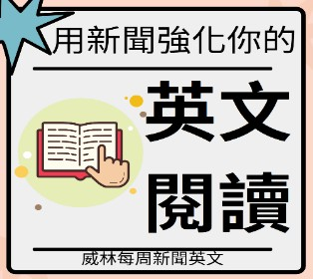
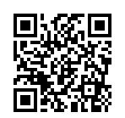
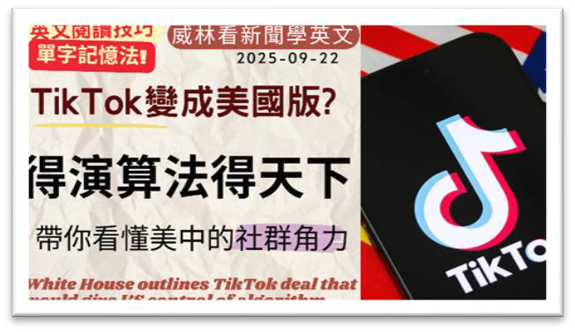
WEI
LIN
ENGLISH
本篇講解
威林每周英語新聞 EP.388 (2025-09-22)
[得演算法得天下?] TikTok變成美國版? 帶你看
懂美中的社群角力
影片單字
PAGE
1

1
sticking point
/ˈstɪk.ɪŋ pɔɪnt/
n. 爭議點
2
stick
/stɪk/
n. 枝條 v. 黏住
3
negotiation
/nɪˌɡoʊ.ʃiˈeɪ.ʃən/
n. 談判
4
algorithm
/ˈæl.ɡə.rɪ.ðəm/
n. 演算法
5
content
/ˈkɑn.tɛnt/ (n)
n. 內容；滿足 / adj. 滿足的
6
tentative
/ˈtɛn.tə.tɪv/
adj. 暫時的；猶豫的
7
board
/bɔːrd/
n. 板；董事會 v. 登上（船、機）
8
operation
/ˌɑː.pəˈreɪ.ʃən/
n. 運作；營運；手術
9
anticipate
/ænˈtɪs.əˌpeɪt/
v. 預期；預料
10
participate
/pɑːrˈtɪs.əˌpeɪt/
v. 參加；參與
11
much-anticipated
adj. 備受期待的
12
justice
/ˈdʒʌs.tɪs/
n. 正義；司法；公正
13
justify
/ˈdʒʌs.tə.faɪ/
v. 證明…正當；為…辯護
14
concern
/kənˈsɝːn/
n. 擔憂；關心； v. 使擔心
15
access
/ˈæk.sɛs/
n. 進入；使用權
16
pose
/poʊz/
v. 擺姿勢；提出；造成（威脅）
17
poised
/pɔɪzd/
adj. 準備好的；泰然自若的
18
immense
/ɪˈmɛns/
adj. 巨大的；龐大的
19
menace
/ˈmɛn.əs/
n. 威脅；危害 / v. 威脅
20
scale
/skeɪl/
n. 規模；刻度；比例
21
initial
/ɪˈnɪʃ.əl/
adj. 最初的；開始的 / n. 首字母
22
ban
/bæn/
n. 禁令 / v. 禁止
23
course
/kɔːrs/
n. 課程；路線；一道菜
24

boost

/buːst/

v. 提升；增加；促進 n. 提升；激勵
25
boom
/buːm/
n. 繁榮；激增 v. 激增

WEI
LIN
ENGLISH
1. A sticking point in negotiations appears to have been
over who will own the powerful algorithm that pushes
content to TikTok's 170 million American users.
2. The White House has announced that US companies will
now control TikTok's algorithm and Americans will hold
six of seven board seats for the app's US operations in a
much-anticipated deal with China.
3. The US Department of Justice previously expressed
concerns that TikTok's access to the data of US users
posed a national security threat of "immense depth and
scale".
4. While Trump initially called for TikTok to be banned
during his first term, he has changed course. He turned to
the hugely popular platform to boost his support among
young Americans during his successful 2024 presidential
campaign.
PAGE 2

