HIDDEN TREASURE

By GREG MENZA/Staff Writer
Lauri Dooley Miller came 600 miles to bridge the 200 years which separated her from her ancestor who helped found this small Tennessee town.

Miller flew from her Texas home to attend a ceremony Sunday sponsored by the Daughter’s of the American Revolution honoring Revolutionary War soldier James Dooley.
Lauri Dooley Moore, the fifth great-granddaughter of James Dooley, holds a yellow rose brought from Texas, as she shares about Dooley’s history at ceremonies to honor the Revolutionary War hero.
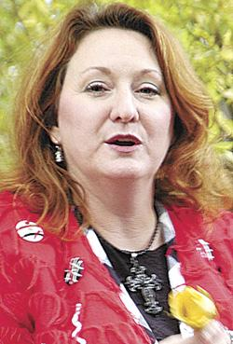

Staff photo by Greg Menza

“This is a big dream come true for me,” she said. “I’ve been on the trail of this man for a long, long time.”
Alvin Brown, a direct descendant of James Dooley and a member of the Tom Bigbee Chapter of the Sons of the American Revolution, welcomes guests at ceremonies held Sunday to honor Dooley.

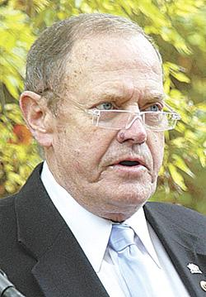Staff photo by Greg Menza

Miller is the fifth great-granddaughter of James Dooley, who is buried in his family cemetery located just off Highland Avenue. Until recently, the graveyard was overgrown and mostly forgotten.
A veil covers a marker sitting next to the gravestone of James Dooley. Three markers were unveiled and presented Sunday at the Dooley Cemetery to honor the Revolutionary War soldier and one of Maury County’s earliest settlers. Staff photo by Greg Menza

But thanks to Miller and a dedicated group including local DAR members Martha Sloan, Audrey Morgan and her husband Hal, Texas member Billie Kenyon, Sons of the American Revolution member and Dooley descendant Alvin Brown and others, the final resting place of one of the area’s first settlers has been cleared and markers placed by his grave to commemorate his accomplishments.

For the past 13 years Miller said she has been researching the life of her ancestor. The research has taken her to Washington D.C. and Richmond, Va., where she poured over works at the Library of Congress, the Colonial Archives and, in her estimation, hundreds of other locations.

Miller shared some of her findings about Dooley and his descendants with the more than 70 people who attended the ceremony despite the cold, blustery weather. Some of those descendants — Brown, Morgan and Eddie Dooley — were in attendance.

“He was an ordinary man who lived in extraordinary times,” Miller said. As I learned about him, I was reminded of the words from Proverbs — ‘A good name is better than wealth.’ James Dooley certainly did not have wealth, but his good name has remained through the centuries. He is known as a patriot, a pioneer, and a patriarch.”

Among her findings Miller learned that DNA testing has linked Dooley to Anne Henry Fleming, sister of Patrick Henry and that one of his descendants, Effie Gene Wingo, was the first congresswoman from Arkansas. He also is the patriarch of a long list of other patriots, she said.

“James Dooley first fought, at the age of 13, in the French and Indian War in 1759, and then served twice in militias at the beginning of the Revolutionary War in 1774 and again in 1781,” she said. “Since that time, one or more of his descendants have served in every major military conflict the United States has been involved in from the 1800’s to the present.”

During the ceremony, Dooley was honored by representatives of the DAR, SAR, the American Legion and the Central High School NJROTC. Members of the Tenassee and Andrew Carruthers — from Austin, Texas — chapters of the DAR and the Tom Bigbee Chapter of the Sons of the Revolution placed three markers at the Dooley Cemetery, one of Columbia’s oldest and best hidden cemeteries.

Assisted by members of American Legion Post 19 and local Boy Scouts, local descendants of Dooley worked for several months to clean up the cemetery in preparation for Sunday’s ceremony.

“We want to thank those who did so much work here to make this day possible and the members of Grace Nazarene Church who have been so wonderful, arranging for us to have access to this cemetery, ” said Brown.

After the scouts had cleaned the area, Brown said he hoped to partner with the American Legion and the Scouts again to make sure the cemetery didn’t fall such a state again.

The markers set up Sunday will be taken down until the can be mounted permanently in concrete.

The Dooley Cemetery is in a fenced-in grove of trees behind the church. It is accessible only through the private road that runs through the church property.

Greg Menza may be contacted at gmenza@c-dh.net or (931) 388-6464 ext. 3054.

