Gilmer Cemetery
Southport, Tennessee
5/27/02
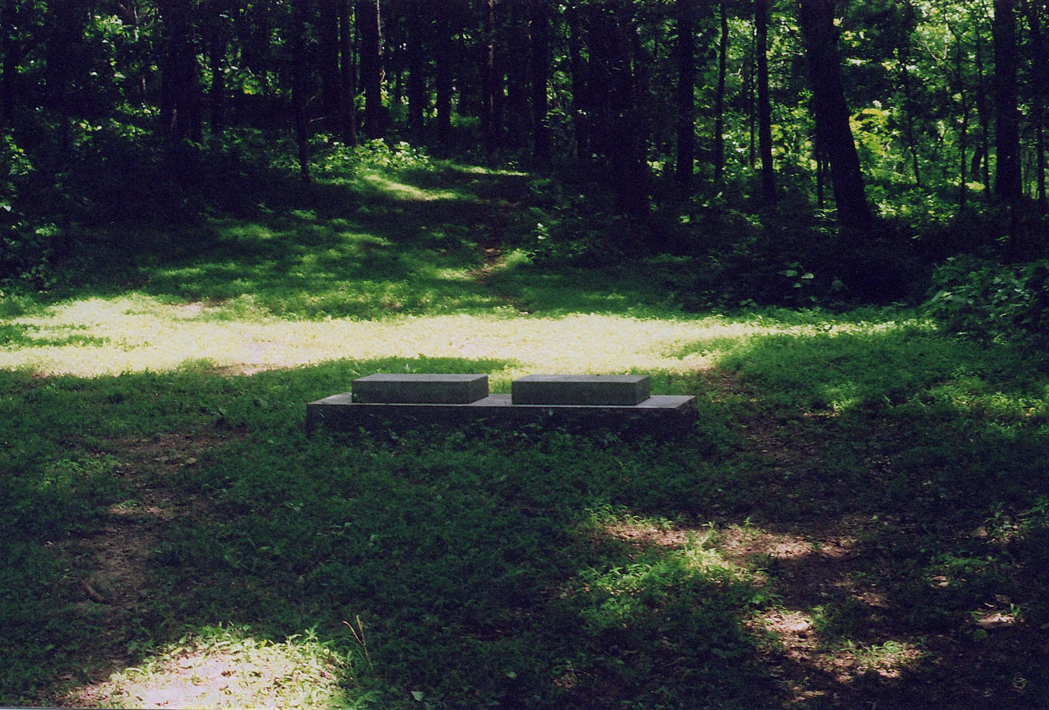
The grave site is on the previously owned farm of Misses Willie and Sammie Gilmer.
Field Grave Stones were replaced with a more modern stone sometime after 1990.

Jeremiah was an Elder in the McCain’s Cumberland Presbyterian Church and a member of the Tennessee State Legislature
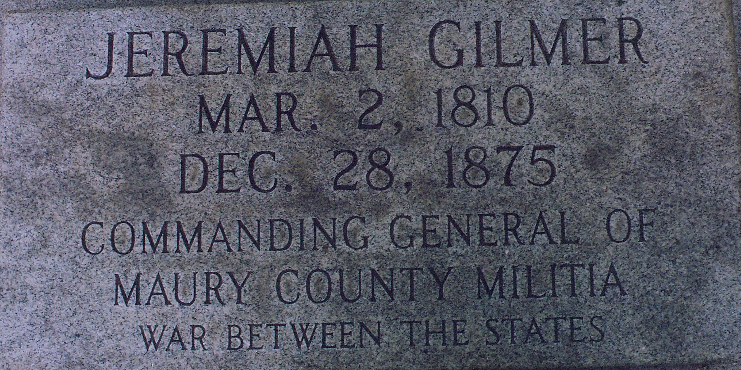
Henrietta’s maiden name was Adkisson and was thought to be Jeremiah’s second wife.
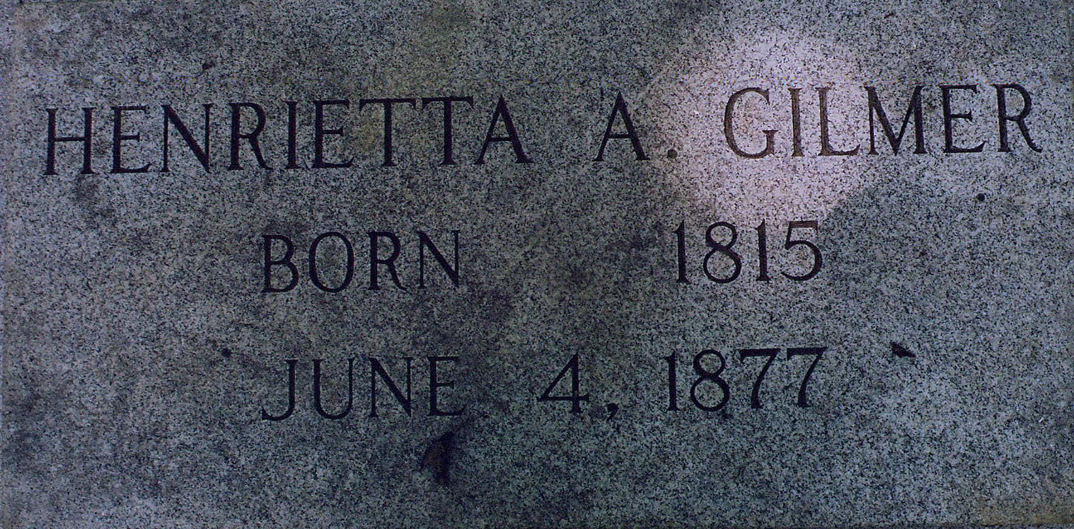

References: Hawkins, F. L. Maury County Cemeteries, 1989.
Lightfoot, M. P. & Shackelford, E. B. They Passed This Way, 1965.

