ALDERSON, Joe Willie, d. 1976. (u marker.)

ALDERSON, Lena Mae (Lawrence), 18 Jul 1915 - 9 May 2004. (u marker) obit

Lena Mai Lawrence Alderson, 88, of the Williamsport Community died Sunday, May 9, 2004 at Maury Regional Hospital.
Burial is in Mt. Nebo Community Cemetery in Williamsport.
A native of Maury County, she was the daughter of the late Gus
Abridged from Columbia Daily Herald 13 May 2004.

ANDERSON, Marvin W.(Wayne), 4 May 1952 - 5 Feb 2015. (s/o Marvin E. & Minnie Alice Runions Anderson; h/o Judy M. Matthews.) obit

Obituary for Marvin W. "Goldie" Anderson
Marvin W. “Goldie” Anderson, age 62, a native of Maury County, passed away on Thursday, February 05, 2015 at NHC Columbia.
Marvin was born on May 4, 1952 to the late Marvin E. Anderson and Minnie Alice Runions Anderson in Columbia, Tennessee. He was a member of the Church of Christ. Marvin married Judy M. Matthews and the two created a beautiful life together. Goldie worked for eight years at Universal Tire and for over twenty years at Keith Baker Homes.
The family will visit with friends on Sunday, February 8, 2015 from 12:00 p.m. until 2:00 p.m. at Williams Funeral Home in Columbia, Tennessee. Funeral services will immediately follow in the Chapel of Williams Funeral Home at 2:00 p.m. Burial will follow at Nebo Cemetery.
Marvin is survived by his loving wife of 38 years: Judy M. Anderson; brothers John R. (Jean) Anderson of Columbia, Tennessee, Ronald (Bonnie) Anderson of Pulaski, Tennessee, and Eugene (Janine) Smith of Goodsprings, Tennessee; sister Margie F. Morton of Mt. Pleasant, Tennessee; stepchildren Juanita Matthews (Wendell) Turrentine, Cynthia Matthews (Derrick) Webster, and Julie Matthews (Jay) Bragdon; and grandchildren: Tige A Kennedy, Jr., Tyesha Webster, Shannon Richardson, Brandon Richardson, Austin Richardson, Brandon Bragdon, Matt Bragdon and Sarah T. Turrentine; and great-grandchildren: Tige III, Navi, Ta’veah, La’Kiyah, Allyiah and Ma’Leah Kennedy
Marvin was preceded in death by his parents: Marvin E. Anderson and Minnie Anderson; sisters Shirley M. Runions and Margaret Kelley; and brothers Leroy Anderson and Henry Lee Anderson.
Williams Funeral Home is assisting the family with arrangements. Condolences may be shared with the family at www.williamsfh.com.
ARMSTRONG, Ben R., 25 Nov 1930 - 23 Apr. 1972. (s/o Fred Jackson Armstrong & Lou Willie Steward Snipes.) census
1940 Census, taken 4 Apr 1940, has Lou Willie Armstrong, 38, widow, home laundress, living in Sawdust, Maury County, TN. Children are: Irene, f, 21, home laundress; Fred, m, 19, farm laborer; Mary, f, 17; John W, m, 11; Ben R, m, 9; Annie L, f, 6; and Barbara J, f, 1.
US Social Security Death Index has Ben Armstrong, born 25 Nov 1930, died Apr 1972.

ARMSTRONG, Fred Jackson, 19 Jul 1883 - 9 Jun 1936. (s/o Ben & Tammie Ann Armstrong; h/o Lou Willie Steward Armstong Snipes.) dr
Tennessee Death Certificate has Fred Armstrong, born 1884 to Ben and Tammie Ann Armstrong, born in TN; he was a farmer married to Lou Willie Armstrong; died 9 Aug 1936 in Columbia, Maury County, TN at age 52 due to spinal meningitis. Contributing cause not related to principal cause: chronic myocarditis. Buried 11 Aug 1936 in Mt Nebo Cemetery. Informant was Mrs Lou Willie Armstrong of Columbia, TN.

ARMSTRONG, James Anthony, 1924 - 1931. (s/o Fred Jackson & Lou Willie Steward Snipes.) census
1930 Census, taken 22 Apr 1930, has Fred Armstrong, 50, farmer on own farm, married at 35 to Lou W, 30, married at 15, living in 8th Civil District, Maury County, TN. Children are: Ernest C, m, 13; Jun, f, 12; Fred Jr, m, 10; Mary M, f, 8; James A, m, 6; Walter, m, 4y 6m; and John H, m, 2y 3m.

BAKER, Alberta Mason Kinzer, 9 Dec. 1920 - 13 Apr, 2012.(u marker Oaks & Nichols Funeral Home.)

BISHOP, Diane (F) Morel (Robinson), 28 Jul 1943 - no date. (w/o Robert Paul Robinson mar 28 Nov. 1960; w/o William Cleveland Bishop, mar. 29 July 1971 in Maury Co. Tn. and shares same stone.)

BOOKER, Jannie Pearl Lawrence, 29 Apr. 1918 - 11 July 2015. (d/o Gus & Fannie Thomas Lawrence; w/o Walter Henry Booker.) obit
Mrs. Jannie Pearl Lawrence Booker age 97 of Columbia, TN. died Saturday, July 11, 2015 at Cumberland Manor in Nashville, TN.
Interment is in Mt. Nebo Community Cemetery.
The Maury County native was the daughter of the late Gus and Fannie Thomas Lawrence. She attended the Maury County school system and was a faithful member of Mt. Nebo Original Church Of God where she served on the Mother’s Board, Church Secretary and sang in the Choir and was the oldest member of the Church.
Although she had no children of her own she took pride and joy in caring and assisting rearing of her great nephews John Jr. and Llewendell and great great niece Keanea.
She was preceded in death by her husband, Walter Henry Booker, and all of her siblings: Gussie, Mary Sue, James, Robert, Bethel, Minnie, Lena, Walter and Lucille.
Columbia Daily Herald July 16, 2015

BOOKER, Walter Henry, 27 Jan. 1927 - 6 Sep, 1963. (h/o Alice _____; h/o Jennie Pearl Lawrence, mar. 7 Aug. 1948.) census
1930 Census, taken 16 Apr 1930, has Robert Booker, 68, farmer on a general farm, married at 20 to Alice, 48, married at 30, living in 8th Civil District, Maury County, TN. Children are: Ariter J, m, 5; James L, m, 4, farm laborer; and Walter H, m, 2y 3m.
1940 Census, taken 11 Apr 1940, has Robert Booker, 70, farmer, married to Alice, 50, living in 8th Civil District, Maury County, TN. Children are: R J, m, 15; James L, m, 14, farm laborer; and Walter H, m, 13.
Tennessee Marriage Records have Walter H Booker, 21, born 3 Jan 1927, and Jennie Pearl Lawrence, 30, born Apr 29, 1918, both from Columbia, Maury County, TN, married on 7 Aug 1948. Next of kin for groom is Robert Booker of Columbia, TN. Next of kin for bride is Gus Baker Lawrence of Columbia, TN.
US Social Security Death Index has Walter Booker, born 1 Jan 1926, died Sep 1963.

CHAMBERLAIN, J. L. 30 Nov. 1831 - 27 Sept. 1899. (h/o Mollie Bond Chamberlain, mar. 25 Aug. 1878.) Ref: Laura Modine
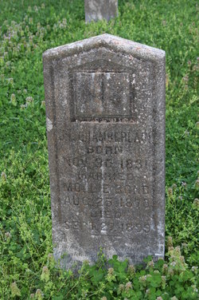

CLARK, Paul Clarence, 1945 - 2 Jan 2010. (s/o Velton Clarence & Myrtle Pruitt Clark.) obit
Paul Clarence Clark, 64, resident of West 13th Street, died Saturday, January 2, 2010 at Maury Regional Medical Center.
Funeral services will be conducted Tuesday at 12:00 noon at Oakes & Nichols with Rev. Rick Points officiating. Burial will follow in Mt. Nebo Cemetery. The family will visit with friends Monday from 4:00 to 8:00 p.m. and after 10:00 a.m. Tuesday at the funeral home. Notes of sympathy may be sent to www.oakesandnichols.com.
The Maury County native was the son of the late Velton Clarence Clark and Myrtle Pruitt Clark.
Mr. Clark was retired from the operations department of Lasko Corporation in Franklin. A dedicated worker all his life, he was an employee of Columbia Construction Company for several years and owned and operated Clark Tree Trimming Company for many years.
Survivors include sons, Herschel (Stacy) Brennan, Clarence Clark, and William Clark, all of Columbia; sisters, Velma McGaw of Mt. Nebo, Rosie (Henry) Kennedy of Mt. Pleasant, Pearlene Clark and Dorothy (Marion) Wilhoite, both of Columbia; grandsons, Chris Brennan, James Brennan, and Joseph Brennan, all of Columbia; nieces and nephews, Bessie, Abbie, Dora, Shelia, Sandra, Charles, and Sarah; several great-niec6es and great-nephews. He was preceded in death by a niece, Joyce.
Family and friends will serve as pallbearers.

CLARK, Pearlene, 26 Jan 1943 - 13 Oct 2013. (d/o Velton Clarence & Myrtle Pruitt Clark.) obit
Miss Pearlene Clark, 70, died Sunday, October 13, 2013 at her residence on Winding Way.
Burial in Mt. Nebo Cemetery.
The Maury County native was the daughter of the late Velton Clarence Clark and Myrtle Pruitt Clark. She had been employed at Miss Andrews Day Care Center and helped rear her nieces and nephews as if they were her own children. She also sat with the sick and the elderly. Miss Clark was a former resident of West 13th St. She enjoyed watching television especially the Hallmark Channel which played her favorite shows, Little House on the Prairie, The Waltons and Golden Girls and she talked everyday to her sister, Rosie. She was of the Baptist faith.
She was preceded in death by a brother, Paul Clarence Clark.

EASLEY, Shep, d. 1964. (u marker.)
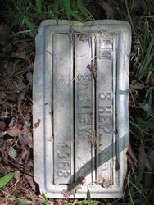
Photo by Ron Johnson

ESTES, John, 1876 - 1942.
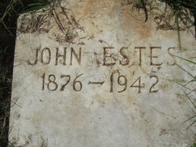
Photo by Ron Johnson

FITZGERALD, William Herbert, 19 Aug 1903 - 24 Sep 1990. Pap.
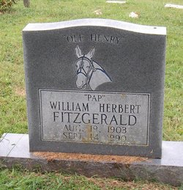
photo by Marsha Holder

FLY, Claude Eugene, 5 Jul 1942 - 17 Jan. 2014. (s/o Jasper Eugene & Mary Rugh Fite Fly; h/o Katherine Ann Burns Fly.) obit
Mr. Claude Eugene Fly, age 71, a long-time resident of the Sawdust Community, passed away on Friday morning, January 17, at his home in Columbia. Born in Maury County on July 5, 1942, he was the son of the late Jasper Eugene Fly and Mary Ruth Fite Fly of Sawdust.
Survivors include his sons: Randall Eugene Fly of Cookeville, Patrick Andrew Kaiser of Dallas, Nathaniel Franklin Fly and daughter: Sarah Katherine Fly, both of Columbia; his long-time loving companion, Susan B. Mayfield of Columbia; his grandchildren: Brandi Fly Johnson and Casey Fly Scott; great-grandchildren: Gavin Johnson, Carter Johnson, Chasity Fly, Addison Walker, Bryson Walker, Dakoda Walker and Allison Fly; brothers: Frank Morriss Fly, John Mark Fly, and Joe Lawrence Fly. Mr. Fly was preceded in his death by his wife: Katherine Ann Burns Fly; grandson: Patrick Fly; and infant sister: Pattie Ruth Fly.
After attending Woodrow School in Arkland, Mr. Fly graduated from Columbia Central High School in 1960, Austin Peay State University, BS 1964, and Purdue University, MS 1968. Claude enjoyed industrial arts and playing baseball in school and his passion - hot rodding. Claude started work in machine shops and went on to a life-long career as an industrial engineer at Converse USA, NC, followed by GE and his dream car job at Saturn. Claude's love of cars started with a red 56 Ford convertible, numerous Corvettes and Thunderbirds. Claude enjoyed farming and raising cattle in Sawdust and fishing and boating at his camp on the Tennessee River. As an educator, Claude taught industrial arts at CHS and Robertson Technical Institute in NC. While he was pursuing his education and career endeavors, he decided to add four beautiful children to the mix. He always stressed the importance of hard work and a good education as being the key ingredients to success and independence in life.
Arrangements are under the direction of Heritage Funeral Home

FLY, Polly, no dates.
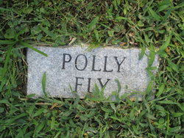
photo by Ron Johnson

GOODWIN, James C., 1864 - 1936. ((death records: born 10 Aug 1865 in Mississippi, died 25 May 1936; s/o James & Sarah Goodwin, both born in Miss.h/o Lena R. Rivers Goodwin and shares same stone.)

HARDIN, Jessie K., d. 13 Aug. 1912.
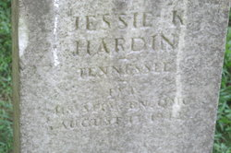
photo by Ron Johnson

HARLAN, James E., 19 Dec. 1937 - 1977.
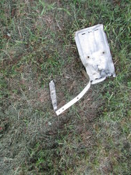
photo by Ron Johnson

HARLAN, William C., 19 Dec 1929 - 9 July 1982.
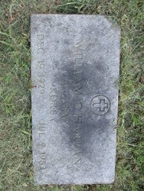
photo by Ron Johnson

HICKS, James Creighton, 4 Apr. 1856 - 28 July 1917. (h/o Kate Pugh Hicks, mar. 1895.) obit
James C. Hicks, one of the most generous, charitable and highly esteemed men of the community, died Thursday morning at his home on South High Street after an illness of several years. Mr. Hicks was 61 years of age and had been a member of the Christian church for a number of years. He moved to Columbia from Concord where he was engaged in the mercantile business and was likewise connected after coming to Columbia. He was a man of splendid character and was liked by every one who knew him. During his long illness, he never relinquished the consideration that he had for the hundreds of friends who administered to him nor the devotion that he had for his family. He is survived by his wife and two daughters, Misses Irene and Louise Hicks, also four brothers and four sisters. Funeral services were held Friday morning at Mt. Nebo church conducted by Elder F.C. Sowell, assisted by Rev. J.H. Barber. Maury Undertaking Co. in charge.
HICKS, Kate Pugh, 1 Mar. 1869 - 18 Jan. 1957. (w/o James Creighton Hicks.)

HIGHT, Bobby S., 8 Jan 1914 - 15 Dec 1988. (h/o Dora Kinzer Hight.)
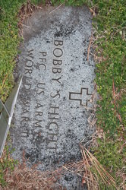
photo by Laura Modine

HIGHT, Dora Kinzer, 1 Sep 1924 - 14 Jan 2001. (w/o Bobby S. Hight and shares same stone.)
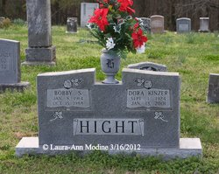
photo by Laura Modine

HODGE, Lizzie Roberts, Feb. 1871 - 16 Aug 1915. (d/o Isham & Eliza Roberts; w/o Henry Hodge.) census
1880 Census, taken 11 Jun 1880, has Isham Roberts, 50, farmer, married to Eliza, 40, living in 4th Civil District, Williamson County, TN. Children are: James, 17, farm laborer; Isham, m, 15; George, m, 12; Lizzie, f, 10; Sam, m, 8; Eol R, m, 6; Sunny, m, 4; and Mary, f, 2.
Tennessee Marriage Records have Henry Hodge married Miss Lizzie Roberts on 10 Apr 1898 in Maury County, TN.
1900 Census, taken 2 Jun 1900, has Henry Hodge, 20, born Jul 1879, miner, married for 12 years to Lizzie, 29 born Feb 1891, living in 10th Civil District, Maury County, TN. They have a son Charley, m, 10m, born Jul 1899.
1910 Census, taken 28 Apr 1910, has Henry Hodge, 28, miner, married for 12 years to Lizzie, 39, who had 5 children with all surviving, living in 8th Civil District, Maury County, TN. Children are: Charley, m, 11; George M, m, 7; Lena, f, 6; Mary F, f, 3; and Annie, f, 2.

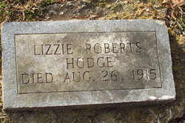
Photo by Ron Johnson
______________________________________________________________________________________STP

HOLT, Joe Calvin, 1943 - 1962.
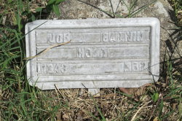
photo by Ron Johnson

HOLT, John, 8 Oct 1879 - 15 Apr. 1931. (s/o Sam Oakley & Lizzie Stammans Holdt.) dr & Census
Tennessee Marriage Records have John Holt married Izora Oakley on 27 Feb 1907 in Maury County.
Tennessee Death Records have Izora Holt, born 10 Jan 1892 to Sam Oakley and Lizzie Stammans, died 11 Apr 1930 in Mount Pleasant, Maury County, TN due to tuberculosis. Buried in Columbia, Maury County, TN on 13 Apr 1930.
1930 Census, taken 28 Apr 1930, has John Holt, 50, widower, laborer at phosphate mine, living in 8th Civil District, Maury County, TN. Children are: Minnie, f, 16; Frank, m, 19, laborer at phosphate mine; Pete, m, 18, laborer at phosphate mine; Lucille, f, 14; Edie, m, 10; Charles, m, 9; Annie M, f, 7; and Pauline, f, 3y 2m.
Tennessee Death Certificate has widower John Holt, born 8 Oct 1879 in TN to Ben Holt (and unknown mother) of TN, died 15 Apr 1931 at age 52 in Maury County, TN. Buried at Nebo Cemetery on 16 Apr 1931. He was a miner. Informant was John Holt of Columbia, Maury County, TN.

HOLT, Louise Holmes, d. 1997.
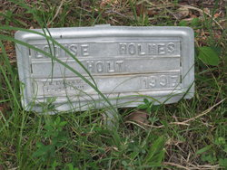
photo by Ron Johnson

HOLT, Roy A., d. 1994.
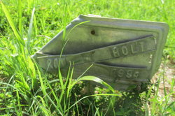
Ron Johnson

HOLT, Samuel D., d. 1992.
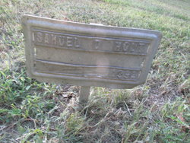
Ron Johnson

HOWARD, Mary Sue, 1904 - 1948.
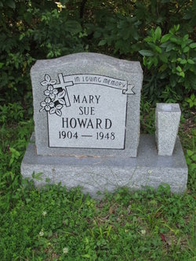
Ron Johnson

JOHNSON, Frances, 1887 - 1968.
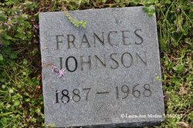
Laura Modine

JOHNSON, Gideon Polk, 16 Nov 1850 - 7 Dec. 1940. (s/o Richard & Katie Mangrum Johnson; h/o Adelia Sandefur Johnson.) note
Gideon Polk Johnson was born on November 16, 1850 in Maury County, Tennessee, the son of Richard Johnson and Katie (Mangrum) Johnson.
He was married to Adelia Sandefur (1851–1906).
A retired farmer, he was living at 1610 Holley Street, Nashville, was a widower and 90 year old when he died at home of a coronary occlusion on December 7, 1940. Burial was the next day in Mount Nebo Cemetery, Maury County.
Most of the above is from his Death Certificate, with Mrs O L McBride of 1610 Holley Street, Nashville as the informant.

JONES, Mary E., Jun, 1843 - 9 Nov. 1915. (d/o Andrew & Berthena P. Culberson Jones.) note
Mary's parents were Andrew Headen and Berthena P. (Culberson) Jones. She was born in either Chatham or Randolph County, North Carolina.
According to her death certificate, she was buried at Mt. Nebo. No headstone has been located for her.

KELLEY, Margaaret Alene, 12 May 1929 - 7 Apr 2013. (d/o Marvin & Pauline Kelly Anderson; w/o Ben Boyd Kelley.) obit
Margaret Alene Kelley, age 83, of Mt. Pleasant, passed away April 7, 2013, at Mt. Pleasant Health & Rehab.
Margaret was born on May 12, 1929, in Maury County to the late Marvin Anderson and Pauline Kelly Anderson. She was of the Pentecostal faith.
The graveside service for Margaret Kelley is Wednesday, April 10, at 10:00 AM in Mt. Nebo Cemetery with Rev. Henry Mobley officiating.
Survivors include: One daughter, Patricia (Donald) Francis of Columbia; two sons, James (Joyce) Robinson of North Carolina and Boyd O. Kelley of Columbia; grandchildren include, Maryann (Brandon) Acuff of North Carolina and Jonathan D. (Shannon) Francis of Columbia; two great grandsons, Jesse and Justin Jones of North Carolina; one sister, Margie Morton of Mt. Pleasant; three brothers, J.R. (Jean) Anderson of Cross Bridges, Marvin (Judy) Anderson of Columbia, and Ronald (Bonnie) Anderson of Pulaski; and one niece, Paula Beard of Columbia.
She was preceded in death by her husband, Ben Boyd Kelley and two grandchildren, David Robinson and Vicki Jones.
Family and friends will serve as pallbearers. Honorary pallbearers will be the Mt. Pleasant Health & Rehab staff, NHC Columbia staff, and Hospice Compassus staff.

KINZER, Malinda Locke, 1816 - 21 Feb. 1901. (w/o George Kinzer) news article
Married first to Hezekiah Powell Smithson. No reported marker.
Mrs. Malinda Kinzer, wife of the late George Kinzer, died Thursday of last week at her home one mile from Nebo. Deceased was one of the oldest residents of that part of the county, having reached the advanced age of 84 years. The remains were laid to rest Friday afternoon at 1 o'clock. -- Columbia Herald, March 1, 1901.
On last Thursday death also entered the home of one of our oldest people, Aunt Malinda Kinzer, as she was familiarly called, and being nearly 85 years of age. For long years she lived in our midst, but nine years ago she moved to Union and resided there until a few weeks ago, when she moved back to the home. Aunt Malinda was a Christian, and in her last days, when inflictions fell so heavily upon her, she often prayed to die, to be freed from pain and sorrow, and to go home to heaven; she leaves three children, and several grandchildren to mourn her departure. She lived with her granddaughter, Mrs. Lillian Godwin, who will sadly miss her grandmother. -- Columbia Herald, March 1, 1901.

KINZER, R. L., 13 Aug 1873 - 31 Sep 1875. (s/o J. A. & N. A. Kinzer.)
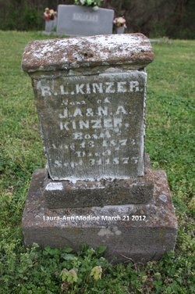
Laura Modine

