Wayne,
After all these pictures is a corrected Embler-Emler listing. Corrections are in red.
Mary Bob
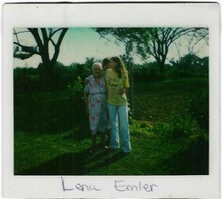
EMBLER, Josie Lena McNabb, 1890 - 1988
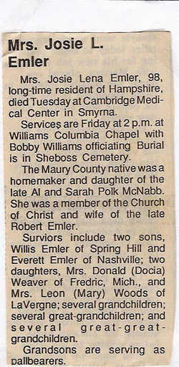
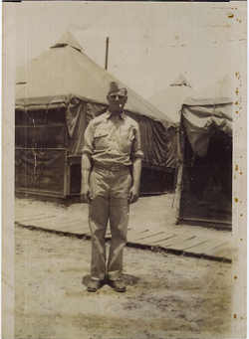
Odie Emler,
EMLER, Odie, 1913 - (17 Oct) 1987. ( Son Robert & Josie McNabb Emler; WWII; U. Marker.)
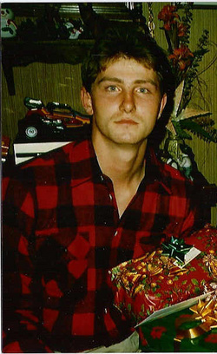
EMBLER, Robert Lee, 28 May 1966 - 9 Aug 1988.
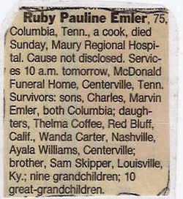
EMLER, Ruby Pauline.
EMLER, Ruby S., 30 Dec 1922 - 30 Aug 1998. (Wife of Olander C. Emler.)
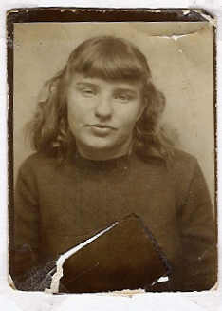
EMBLER, Sarah A.
EMLER, Sarah A., 18 Jul 1932 - 6 Jan 1984. "Forever with the Lord we all love and miss you."
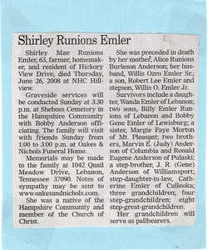< hasbox="2">
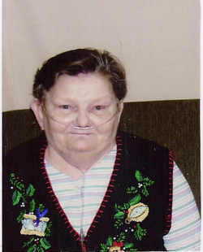< hasbox="2">
EMLER, Shirley Mae Runions,
EMLER, Shirley Mae Runions, d. 26 Jun 2008 in Columbia, Tn. (Dau. of Alice Runions Burleson Anderson; mar. to Willis Ozro Emler, Sr., son, Robert Lee Emler and stepson, Willis O. Emler, Jr. all preceded her in death.)
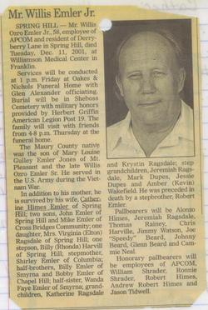
EMBLER, Willis Ozro "Sonny", Jr.
EMLER, Willis Ozro, Jr., 29 Mar 1943 - 11 Dec 2001.
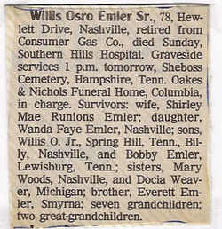
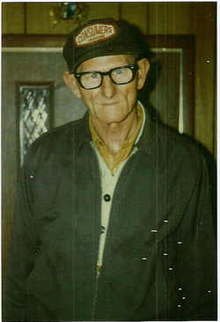
EMLER, Willis Ozro Sr.,
EMLER, Willis Ozro, Sr., 30 Mar 1916 - 4 Sep 1994.
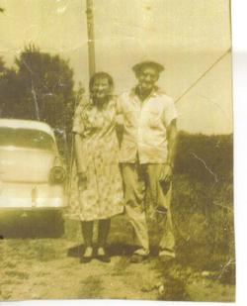
Cynthia Embler and Griffin K. Embler
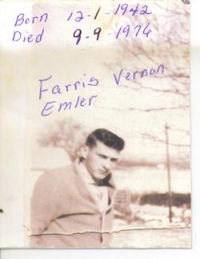
EMBLER, Farris Vernon

EMBLER, Griffin K., 15 Mar 1900 - 28 Oct 1982. (mar. to Cynthia Embler; photo courtesy of Peggy McNabb)
EMBLER, Cynthia, 10 Mar 1910 - 26 Dec 2000. (wife of Griffin K. Embler; photo courtesy of Peggy McNabb)
EMBLER, Robert W. H., 1901 - 1945.
EMBLER, Barney H., 1926 - 1928. (Infant son of Griffin and Cynthia R. Embler)
EMBLER, Farris Vernon, 1 Dec 1942 - 9 Sep 1976. (Son of Griffin K. & Cynthia Runions Embler; mar to Carolyn Runions on 24 Apr 1972. (Photo courtesy of Peggy McNabb.)
EMLER, Hill Leandres, 4 Aug 1828 - 14 Mar 1904.
EMLER, Mary Anna, 12 May 1838 - 8 Mar 1926. (Mar. Hill Emler in 1856; 10 children.)
EMLER, Robert Clark, 1881 - 1965. (Husband of Josie Lena McNabb Emler; son of Hill Leandre and Mary Ann Sellers Emler.)
EMLER, Josie Lena McNabb, 1890 - 1988. (dau. of John Allen "Al" McNabb and Sarah Ann Pope NcNabb; wife of Robert Clark Emler. Obit and Photo courtesy of Peggy McNabb and Wanda Emler)
EMLER, Olander C., 28 Sep 1910 - 15 Feb 1977. (Son of Robert Clark and Josie Lena McNabb Emler; Husband of Ruby Emler.)
EMLER, Ruby S., 30 Dec 1922 - 30 Aug 1998. (Wife of Olander C. Emler.)
EMLER, George B., 3 Oct 1921 - 4 Oct 1934, (Son of Robert Clark "Bob" and Josie Lena McNabb Emler; 13 yrs. old. Ref: Peggy McNabb.)
EMLER, Odie, 1913 - (17 Oct) 1987. (Son Robert & Josie McNabb Emler; WWII; U. Marker. Photo courtesty of Wand Emler)
EMLER, Sarah A., 18 Jul 1932 - 6 Jan 1984. "Forever with the Lord we all love and miss you." (photo courtest of Wanda Emler and Peggy McNabb)
EMLER, Bob Taylor, 8 Jan 1935 - 28 Dec 1937.
EMLER, Brenda G, 1951 - 1953.
EMLER, Robert Lee, 28 May 1966 - 9 Aug 1988. (Photo courtesy of Wanda Emler)
EMLER, Willis Ozro, Sr., 30 Mar 1916 - 4 Sep 1994. (Son of Robert Clark and Josie Lena McNabb Emler; mar. to Shirley Mae Runions Emler. Photo courtesy of Wanda Emler.)
EMLER, Willis Ozro, "Sonny" Jr., 29 Mar 1943 - 11 Dec 2001. (Son of Mary Louise Gulley Emler Jones and Ozro Emler Sr.; Veteran Pvt. U.S. Army, Vietnam; mar. to Catherine Himes Emler; preceded in death by stepbrother Robert Emler; photo and obit courtesy of Peggy McNabb.)
EMLER, Shirley Mae Runions, 16 May 1945 - 26 Jun 2008 in Columbia, Tn. (Maury Co. native; Dau. of Alice Runions Burleson Anderson; mar. to Willis Ozro Emler, Sr., son, Robert Lee Emler and stepson, Willis O. Emler, Jr. all preceded her in death. Obit courtesy of Wanda Emler)

