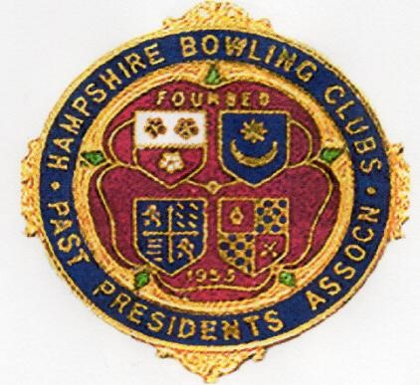
Are you a President or
Past-President of an
Outdoor or Indoor Bowls Club
in Hampshire?
Then why not belong to the Association formed just for you!

The Hampshire Bowling Clubs Past President’s Association was formed in 1953 to foster the Spirit of Fellowship
in the game of Bowls
The HBCPPA is open to Ladies and Gents
and we play a number of games Outdoors
and Indoors each year

We need your support to keep this old established
Association alive and not become part of
Hampshire’s bowling history.
Annual subscription won’t break the Bank, so visit our
Website: hbcppa.org to download an application
form or contact the Secretary, Peggy Marshall
email: marshall_p42@btinternet.com
 07900 004801
Don’t delay, join us today!

