Project Documentation

- Executive Summary
This project implements an end-to-end data engineering pipeline using the public IMDb bulk datasets. Apache Airflow orchestrates ingestion and validation, Parquet stores the raw data, DuckDB acts as the analytical warehouse, and dbt handles transformation, testing, snapshots, and analytical marts. The final models support analysis of directors and actors, movie runtime trends, ratings, genre quality, voting patterns, and person-genre performance.

- Dataset Description
The project uses the public IMDb bulk datasets available at https://datasets.imdbws.com. IMDb distributes the data as compressed `.tsv.gz` files, with missing values represented by `\\N`. The required sources used are `title.basics`, `title.ratings`, `title.crew`, `title.principals`, `name.basics`, and `title.akas`. The project also ingests `title.episode` as an additional source to preserve episode-to-series relationships. The dataset is large: the largest ingested source, `title.principals`, contains over 101 million rows, while `title.akas` contains over 58 million rows and `name.basics` over 15 million rows. Source files are converted to Parquet before being registered in DuckDB. IMDb publishes periodically refreshed bulk snapshots rather than an incremental event stream. Each run replaces the generated Parquet files instead of appending records, while changes in ratings and title metadata are preserved through dbt snapshots.

- Architecture Overview
The pipeline follows the sequence:
IMDb TSV.GZ → Airflow → Parquet → DuckDB → dbt → dimensional models and analytical marts → tests and documentation
Apache Airflow orchestrates source validation, conversion, loading, dbt transformations, snapshots, tests, and documentation generation. DuckDB is the local analytical warehouse, while dbt implements the staging, intermediate, dimensional, and analytical layers. The DAG is manually triggered and executes each stage according to its dependencies. Docker Compose provides the reproducible local environment.

- Data Modelling Explanation

The analytical layer uses a dimensional model centered on fct_title_ratings, supported by descriptive dimensions and bridge tables for IMDb many-to-many relationships.

Model | Grain | Primary Key | Foreign Keys | Source | Role/Modelling Justification
fct_title_ratings | One row per IMDb title | title_id | title_id → dim_title, year_key → dim_year | stg_title_ratings, stg_title_basics | Central fact containing rating, vote, runtime, and year measures.
dim_title | One row per IMDb title | title_id | None | stg_title_basics | Stores descriptive title metadata.
dim_person | One row per IMDb person | person_id | None | stg_name_basics | Stores actor, director, and writer information.
dim_genre | One row per unique genre | genre_key | None | stg_title_genres | Provides normalized genre values.
dim_year | One row per calendar year | year_key | None | stg_title_basics | Supports year and decade analysis.
bridge_title_genre | One row per unique title–genre association | (title_id, genre_key) | title_id → dim_title, genre_key → dim_genre | stg_title_genres, dim_genre | Resolves the many-to-many title–genre relationship.
bridge_title_crew | One row per unique title–person–role association | (title_id, person_id, role) | title_id → dim_title, person_id → dim_person | Crew and principals staging/intermediate models | Resolves title–person relationships for directors, writers, and actors.

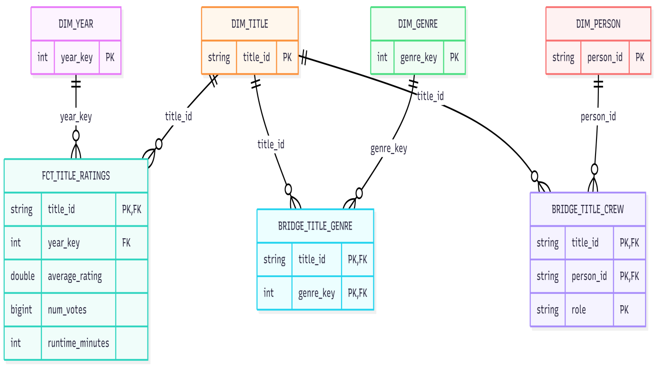

The bridge tables prevent duplication of title-level measures when a title has multiple genres or people. The dimensional model supports the final analytical marts: mart_top_directors, mart_runtime_by_decade, mart_genre_quality_analysis, and mart_person_genre_performance.
For historical tracking, dim_title_snapshot implements the required SCD Type 2 behavior using title_id as the business key. Changes to primary_title, genres, or runtime_minutes create a new historical version, preserving previous metadata through dbt snapshot validity fields.

- Project Structure Walkthrough
The repository separates orchestration, dbt transformations, generated data, tests, snapshots, documentation, and configuration so that the pipeline can be reproduced from version-controlled source files.

Project | Purpose
dags/ | Airflow DAG definitions and orchestration logic.
dbt_project/ | dbt transformation project.
dbt_project/models/staging/ | Source renaming, type casting, null handling, and basic cleanup.
dbt_project/models/intermediate/ | Reshaping of multi-value IMDb fields and intermediate transformations.
dbt_project/models/marts/ | Final fact tables, dimensions, bridge tables, and analytical marts.
dbt_project/snapshots/ | dbt snapshots used for historical tracking.
dbt_project/tests/ | Contains custom SQL data quality tests.
dbt_project/macros/ | Reusable dbt macros, when required.
raw/ | Generated Parquet source files; ignored by Git.
docs/ | Final documentation and project screenshots.
warehouse/ | Local DuckDB warehouse.
docker-compose.yml | Local Airflow and project environment configuration.
requirements.txt | Python dependencies.
.gitignore | Excludes generated data, databases, logs, and local environment files.
README.md | Project overview, setup, and execution instructions.

- Airflow DAG Explanation

The imdb_ingest_pipeline DAG orchestrates the complete IMDb ingestion and dbt transformation workflow. The DAG is currently triggered manually (schedule=None) with catchup=False. All tasks inherit one retry attempt with a two-minute retry delay.

Task/Group | Purpose | Dependency
prepare_directories | Creates the raw, download, DuckDB temporary, and warehouse directories. | Start
extract.validate_imdb_sources | Verifies that all configured IMDb source files exist and are non-empty | prepare_directories
convert.convert_imdb_sources_to_parquet | Converts the compressed TSV sources to ZSTD-compressed Parquet files. | extract
validate.validate_imdb_parquet_files | Checks that generated Parquet files exist, contain rows, and have valid columns. | convert
load.register_imdb_sources_in_duckdb | Registers each Parquet file as a DuckDB raw view. | validate
transform.dbt_run_staging | Builds the dbt staging layer. | load
transform.dbt_snapshot | Executes dbt snapshots for historical tracking. | dbt_run_staging
transform.dbt_run_dimensions_and_fact | Builds intermediate models, dimensions, bridges,the fact table and the analytical marts. | dbt_snapshot
transform.dbt_run_marts | Builds the final analytical marts used to answer the project deliverable questions. | dbt_run_dimensions_and_fact
data_quality.dbt_test | Executes the complete dbt test suite and fails the pipeline on critical test failures. | dbt_run_marts
documentation.generate_dbt_docs | Runs dbt docs generate to produce the dbt catalog, manifest, and browsable lineage documentation. | dbt_test

The dependency chain is:
prepare directories → extract → convert → validate → load → transform.dbt_run_staging → transform.dbt_snapshot → transform.dbt_run_dimensions_and_fact → transform.dbt_run_marts→ data quality.dbt_test → documentation.generate_dbt_docs
The DAG is idempotent because each source is converted first to a temporary Parquet file and only replaces the final file after successful validation. DuckDB sources are registered using CREATE OR REPLACE VIEW, preventing duplicate raw records when the DAG is rerun.
Critical validation and transformation failures propagate through Airflow's dependency chain, preventing downstream tasks from running. The successful final DAG run confirms that ingestion, dbt transformations, snapshots, analytical marts, testing, and dbt documentation generation can complete end-to-end without manual intervention between pipeline stages.
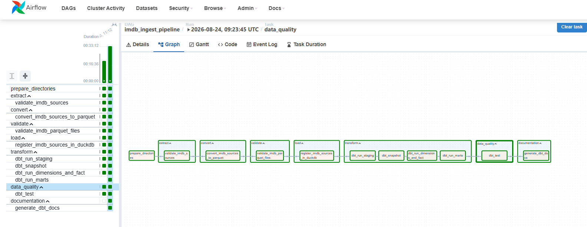

- Dbt Lineage and Tests
  - Dbt Lineage
The dbt documentation was generated successfully using `dbt docs generate`. The lineage graph provides traceability from the raw IMDb sources through the staging, dimensional, bridge, and fact models to the final analytical marts. The figure below shows the upstream lineage of mart_person_genre_performance. The mart can be traced back to the raw title.basics, title.ratings, title.crew, title.principals, and name.basics sources through the corresponding staging models, dimensions, bridge tables, and fct_title_ratings.
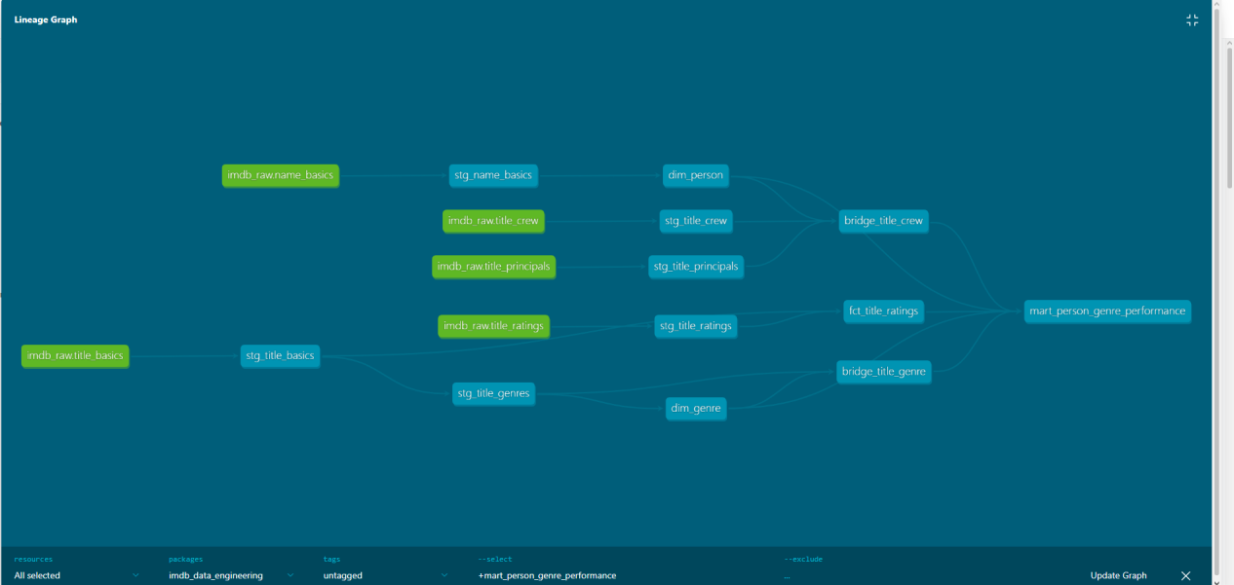
All dbt sources and models are documented in YAML files, including
descriptions for the models and their important analytical, key, and
relationship columns. These descriptions are exposed directly in the
generated dbt documentation site.
  - Snapshots
- ratings_snapshot tracks changes in average_rating and num_votes for each title_id, preserving how IMDb rating measures evolve between loads.
- dim_title_snapshot implements the required SCD Type 2 history for primary_title, genres, and runtime_minutes. New versions are created when these descriptive attributes change, preserving previous title metadata through dbt_valid_from and dbt_valid_to.
  - Tests
The dbt test suite validates keys, relationships, duplicates, accepted values, and IMDb-specific domain rules. Critical failures propagate to the final Airflow data-quality task.

Test | Model(s) | Purpose | Serverity
not_null | Fact, dimensions, bridges, intermediate models | Ensures required identifiers and measures are present. | Error
unique | fct_title_ratings, dimensions, staging ratings | Verifies logical primary keys are unique. | Error
relationships | Fact and bridge tables | Validates foreign-key references to dimensions. | Error
accepted_values(role) | bridge_title_crew | Restricts crew roles to director, writer or actor. | Error
average_rating_range | fct_title_ratings | Ensures average_rating is between 0 and 10. | Error
num_votes_non_negative | fct_title_ratings | Prevents negative IMDb vote counts. | Error
start_year_not_in_future | dim_title | Ensures title start years are not later than the current year. | Error
duplicate relationship tests | Staging, intermediate and bridge models | Prevent duplicate title–genre, title–person, director, writer, and known-for relationships. | Error
mart_top_directors business-rule tests | mart_top_directors | Validate minimum 5 titles, minimum 1,000 combined votes, rank range 1–10, and uniqueness of director/rank. | Error
mart_runtime_by_decade tests | mart_runtime_by_decade | Validates unique and non-null decades, positive average runtime, average rating within 0–10, and correlation within the valid range [-1, 1]. | Error
mart_genre_quality_analysis tests | mart_genre_quality_analysis | Validates unique/non-null genres, ratios within [0,1], and ensures only genres with at least 100 rated titles are included | Error
mart_person_genre_performance tests | mart_person_genre_performance | Validates non-null fields, accepted role values, person relationships, unique person-role-genre grain, valid genre references, and reproducible rating/vote metrics. | Error

- Answers to the Deliverable Questions
  - Question: Who are the top 10 directors by average rating, restricted to those with 5+ titles and 1,000+ combined votes?
Model: mart_top_directors joins bridge_title_crew, dim_person, and fct_title_ratings, filters directors with at least 5 titles and 1,000 combined votes, and ranks them by average_rating.
Result:
Rank | Director | Title count | Combined votes | Average rating | Weighted average rating
1 | Cat Santarosa | 499 | 18276 | 9962 | 9955
2 | Christopher Michale Dailey | 159 | 4837 | 9878 | 9827
3 | Bülent Dogan | 139 | 2898 | 9870 | 8493
4 | Kubilay Koçak | 42 | 1398 | 9867 | 7086
5 | Johnathan Ketelhut | 27 | 1661 | 9763 | 9770
6 | Halil Ibrahim Unal | 89 | 3204 | 9729 | 7125
7 | T. Suriavelan | 22 | 4477 | 9627 | 9139
8 | Zhongwei Qiu | 32 | 1088 | 9619 | 8989
9 | Paul Heising | 13 | 1828 | 9585 | 7797
10 | James B. Phelps | 53 | 1408 | 9564 | 9182

Interpretation: Cat Santarosa ranks first with an average rating of 9.96 across 499 titles, while differences between simple and vote-weighted averages show that high mean ratings do not always reflect equal audience support.

  - Question: Has the average movie runtime changed by decade, and does runtime correlate with rating?
Model: mart_runtime_by_decade joins fct_title_ratings, dim_title, and dim_year. It restricts the analysis to title_type = 'movie', excludes null or non-positive runtimes and null ratings, and aggregates the data by the consistently defined decade from dim_year. The mart calculates movie count, average runtime, average rating, and Pearson runtime-rating correlation using DuckDB's corr(runtime_minutes, average_rating) function.

Result:

Decade | Movie count | Average runtime | Average rating | Runtime-rating correlation
1920 | 3523 | 80.38 min | 5.91 | 0.114
1950 | 12292 | 92.50 min | 6.13 | 0.253
1970 | 21749 | 94.03 min | 5.89 | 0.204
1990 | 23970 | 98.00 min | 6.02 | 0.063
2010 | 88193 | 94.35 min | 6.19 | -0.004
2020 | 60353 | 97.22 min | 6.22 | -0.001

Interpretation: Average movie runtime generally increased from about 80 minutes in the 1920s to about 97 minutes in the 2020s, although the trend is not strictly linear. Runtime showed a modest positive correlation with rating in several mid-century decades, but the correlation is close to zero in recent decades, suggesting that movie length currently has little linear relationship with IMDb rating.

  - Question: Which genres have the highest ratio of “hidden gems” (high rating, low vote count) versus “overrated” titles (low rating, high vote count)?
Model: mart_genre_quality_analysis joins fct_title_ratings, bridge_title_genre, and dim_genre to calculate genre-level counts and ratios. Hidden gems are defined as titles with average_rating >= 8.0 and 100 <= num_votes < 10,000, while overrated titles have average_rating <= 6.0 and num_votes >= 100,000. Genres with fewer than 100 rated titles are excluded to avoid unstable ratios caused by small sample sizes.
Result:
Category | Genre | Ratio
Hidden gems | Action | 9.24%
Hidden gems | Mystery | 8.47%
Hidden gems | Adventure | 8.38%
Overrated | Horror | 1.23%
Overrated | Thriller | 1.01%
Overrated | Science-Fiction | 0.88%

Interpretation: Action has the highest proportion of hidden gems, followed by Mystery and Adventure, while Horror has the highest proportion of overrated titles, followed by Thriller and Sci-Fi.

  - Question: Who are the most consistently well-rated directors and actors of the last 20 years, and in which genres are they concentrated?
Model: mart_person_genre_performance combines bridge_title_crew, bridge_title_genre, dim_person, dim_genre, and fct_title_ratings. It is restricted to actors and directors from the last 20 years and keeps person-role-genre combinations with at least 5 titles and 1,000 combined votes. The mart calculates title count, combined votes, average rating, and vote-weighted average rating.
Result:
Person | Role | Genre | Title count | Combined votes | Weighted average rating
Cat Santarosa | director | Documentary | 496 | 18548 | 9973
Cat Santarosa | director | Adventure | 32 | 1240 | 9910
Varun Kasturia | actor | Romance | 15 | 3772 | 9893
Rudrakshi Gupta | actor | Romance | 16 | 3783 | 9892
Hermant Bharati | actor | Romance | 10 | 2380 | 9890

Interpretation: The mart shows that highly rated performance is concentrated differently by person and role. Cat Santarosa is strongly concentrated in Documentary as a director, while several highly rated actors are concentrated in Romance and Drama. The vote-weighted rating helps distinguish consistently strong performance from high ratings supported by relatively few votes.
- How to Run
The complete pipeline can be reproduced locally using Docker Compose and the Airflow DAG.
- Start the project environment:
From the project root, build and start the Docker services:
docker compose up -d --build
This starts PostgreSQL, the Airflow webserver, and the Airflow scheduler.

- Start from a clean DuckDB warehouse
Stop the services if necessary and remove the existing DuckDB warehouse file:
rm -f warehouse/warehouse.duckdb
The pipeline recreates the required raw views and dbt models during execution.

- Verify the Airflow services
Check that the containers are running:
docker compose ps
The Airflow UI is available at:
http://localhost:8585

- Trigger the IMDb pipeline
Trigger the imdb_ingest_pipeline DAG from the Airflow UI, or run:
docker compose exec airflow-scheduler \
airflow dags trigger imdb_ingest_pipeline
The DAG executes the complete dependency chain:
prepare directories
→ validate IMDb sources
→ convert TSV.GZ to Parquet
→ validate Parquet files
→ register sources in DuckDB
→ run dbt staging models
→ run dbt snapshots
→ build dimensions, bridges, fact table and marts
→ run dbt tests
→ generate dbt documentation

- Verify the pipeline
The DAG run should finish successfully with all critical tasks in the success state. The resulting DuckDB warehouse contains the dimensional models, snapshots, and analytical marts used for the deliverable questions.

- Open dbt documentation
From the Airflow webserver container, serve the generated dbt documentation:
docker compose exec airflow-webserver bash -lc \
"cd /opt/airflow/dbt_project && dbt docs serve --host 0.0.0.0 --port 8081"
The dbt documentation site is then available at:
http://localhost:8086
The site can be used to inspect model descriptions, tests, sources, and lineage from the analytical marts back to the raw IMDb datasets.

- Challenges and Lessons Learned
- Large IMDb Source Files and Memory Usage
Some IMDb sources contain a very large number of rows, especially files such as title.principals. An initial approach that loaded complete source datasets into pandas would require significant memory and would not scale well for the larger IMDb files. The conversion logic was therefore implemented using DuckDB directly. Conceptually:
IMDb TSV.GZ
↓
DuckDB read_csv()
↓
COPY ... FORMAT PARQUET
↓
Parquet file
This allows DuckDB to handle the conversion without requiring the complete dataset to be stored inside a pandas DataFrame.
Lesson learned: large source files should be processed using tools that can efficiently stream or scan data rather than loading the full dataset into Python memory.
- TSV-to-Parquet Conversion Issues
While generalizing the ingestion pipeline from title.ratings to the larger IMDb datasets, parsing and conversion problems occurred, particularly for title.principals. The DuckDB SQL used for the conversion was simplified and the source parsing settings were made explicit. The final approach uses DuckDB's read_csv function together with COPY to write the result directly to Parquet. This allowed the larger source files to complete successfully.
Lesson learned: implementing a complete vertical slice first made debugging easier because the ingestion design could be validated before applying it to every dataset.
- Modeling IMDb Many-to-Many Relationships
IMDb titles can belong to multiple genres and can be associated with many people in different roles. Storing these relationships directly inside the fact table would duplicate title-level measures and could produce incorrect aggregations.
The solution was to normalize these relationships using bridge_title_genre and bridge_title_crew. The crew bridge also standardizes the role into director, writer, or actor, allowing the same dimensional model to support several analytical questions.
Lesson learned: many-to-many relationships should be modeled explicitly with bridge tables so that analytical measures remain at a stable grain and joins stay reusable and testable.

- Integrating dbt execution and validation into Airflow

The dbt workflow contains several dependent stages, including staging models, snapshots, dimensions, fact tables, marts, tests, and documentation generation. Their execution order had to be coordinated so that downstream models were never built from incomplete upstream data.
The Airflow DAG was therefore organized into explicit transformation and validation stages. dbt test runs after the analytical marts are built, and dbt docs generate executes only after successful data-quality validation.
Lesson learned: orchestration should reflect data dependencies explicitly. Separating transformation, testing, and documentation into ordered tasks makes failures easier to diagnose and prevents invalid downstream outputs from being treated as successful pipeline results.

