Nome: Roberta Cristina de Abreu Turma: 4°ADS A
Prof. Gerson

LISTA 3

- sudo ls ../../ > arq.txt
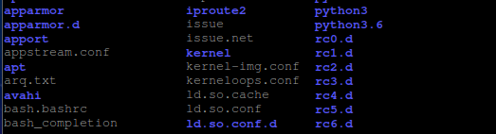

2 ) sudo chmod u+w /cdvar
ls –l
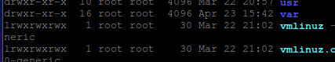
sudo chmod u+w srv
ls –l
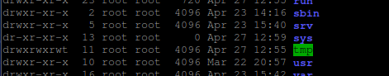

3) sudo adduser user1
sudo adduser user2
sudo adduser user3
cd ../../srv
mkdir user1 user2 user3
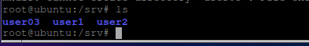
sudo chmod ug+rwx *
sudo chmod o-rwx *
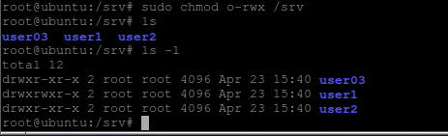
sudo chmod 770 *
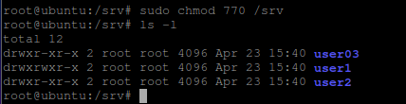

cd ../../var
mkdir user1 user2 user3
sudo chmod ug+rwx *
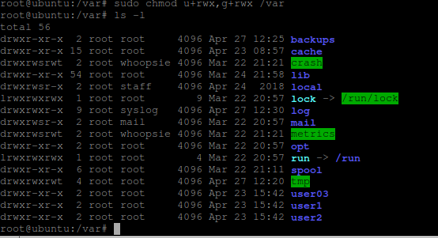
sudo chmod o-rwx *
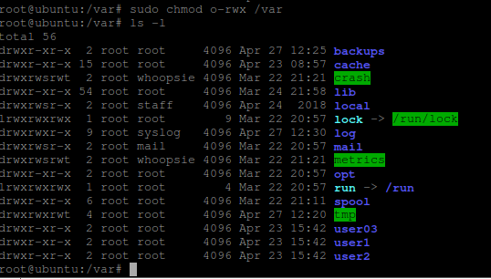
sudo chmod 770 *

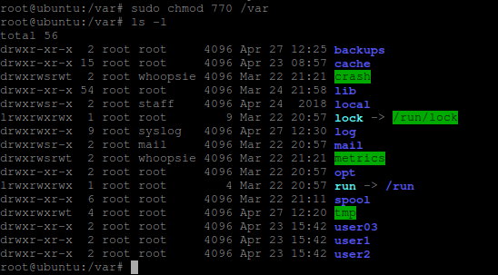

4) chmod a-rw+x /var /srv
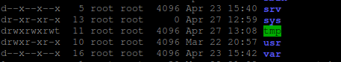
sudo chmod 111 /var /srv
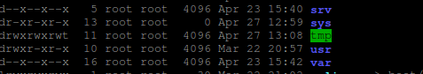

5) su - user1
cd />srv/user1
> vazio.txt
cd ../../var/user1
> vazio.txt
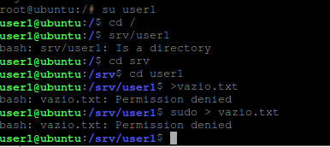
su - user2
cd srv/user2
> vazio.txt
cd ../../var/user1
> vazio.txt

su - user3
cd srv/user3
> vazio.txt

cd ../../var/user3
> vazio.txt

6) su - user1
> user1.txt
cp user1.txt ../../srv/user1
cp user1.txt ../../var/user1

su - user2
> user2.txt
cp user2.txt ../../srv/user2
cp user2.txt ../../var/user2

su - user3
> user3.txt
cp user3.txt ../../srv/user3
cp user3.txt ../../var/user3
