Nome: Roberta Cristina de Abreu Turma: 4°ADS A
Prof. Gerson

LISTA 6

- find . -group robertaabreu

find / -user user1
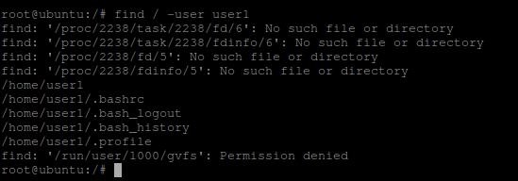
find . -group user2

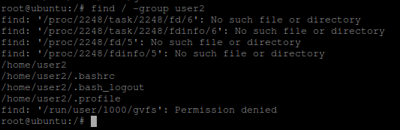

2) sudo updatedb

locate home/robertaabreu/*/*.txt
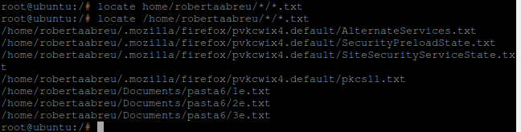
locate home/*/*.txt
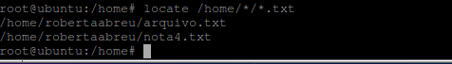
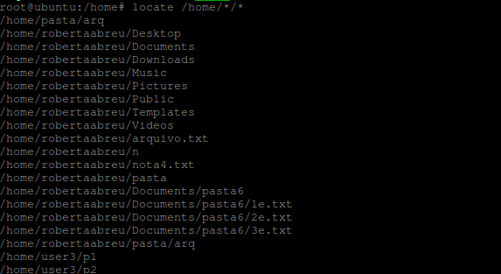

3) find /home/robertaabreu/*/*
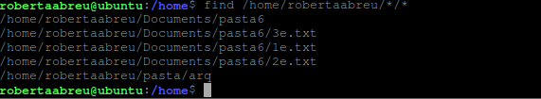

find /home/user1/*/*
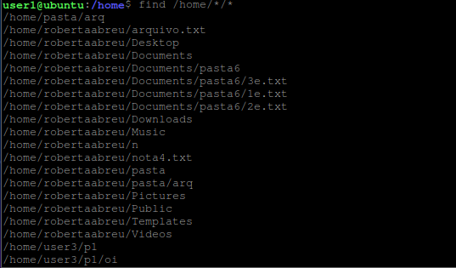

4) find – type d
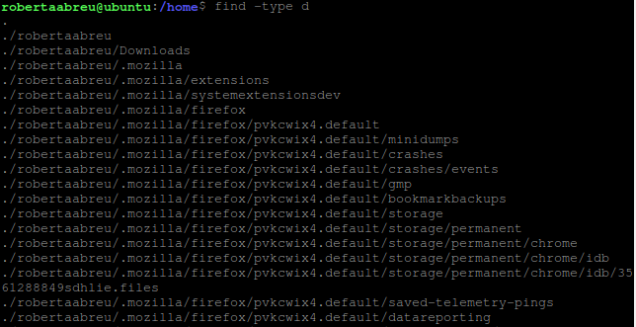
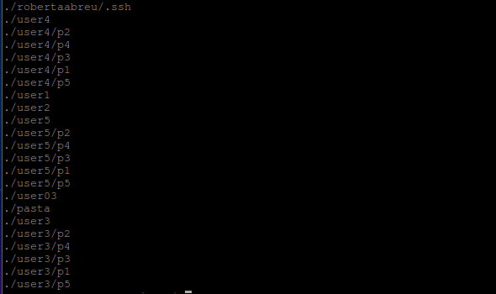

5) find . -type f -perm 777
find . -type f -perm 645
find . -type f -perm 654
find . -type f -perm 555

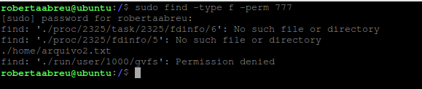

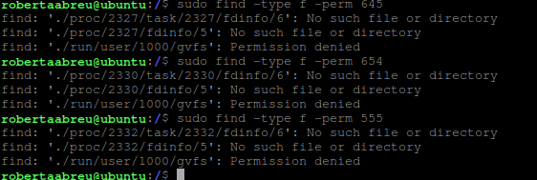

6) find . -type d -perm 777
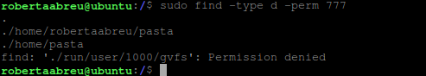
find . -type d -perm 645
find . -type d -perm 654
find . -type d -perm 555
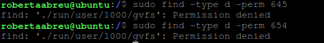

Find -r

7) find / -perm /a=x

8) find / -perm /a-x

