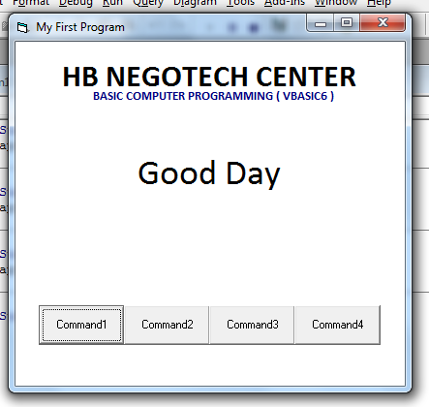
Activity 1 & 2 Display Mesage
Private Sub Command1_Click()
Label3.Caption = "Good Day"
End Sub
Private Sub Command2_Click()
Label3.Caption = "Welcome"
End Sub
Private Sub Command3_Click()
Label3.Caption = "PAJHOY SARITA!!!"
End Sub
Private Sub Command4_Click()
End
End Sub

Activity 3 Simple Calculator
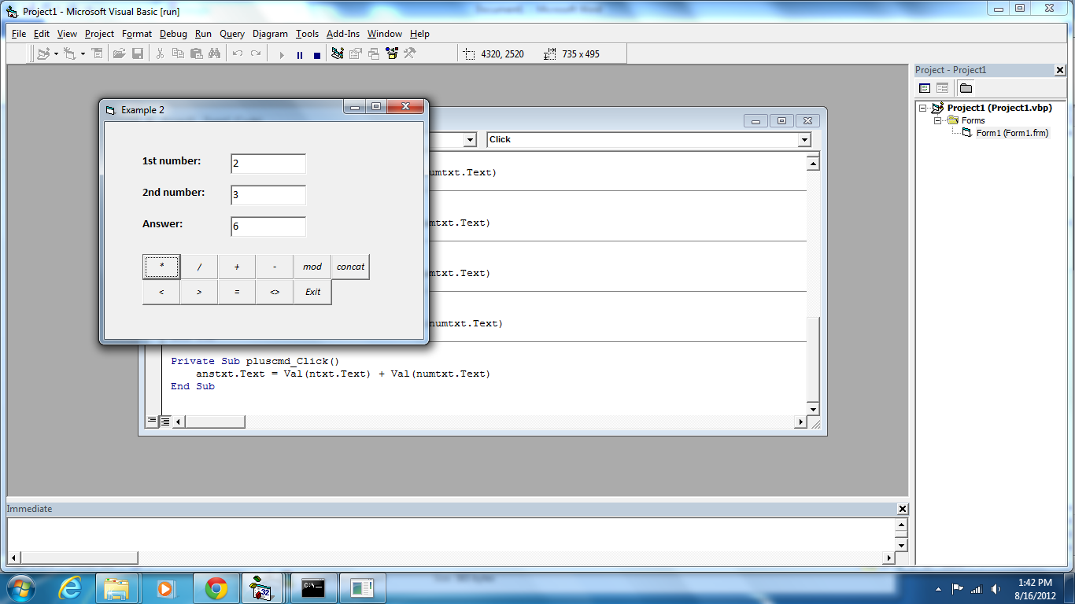
Private Sub concmd_Click()
anstxt.Text = (ntxt.Text) + (numtxt.Text)
End Sub
Private Sub dividecmd_Click()
anstxt.Text = Val(ntxt.Text) / Val(numtxt.Text)
End Sub
Private Sub dotcmd_Click()
anstxt.Text = Val(ntxt.Text) * Val(numtxt.Text)
End Sub
Private Sub equalcmd_Click()
If Val(ntxt.Text) = Val(numtxt.Text) Then
anstxt.Text = "True"
Else
anstxt.Text = "False"
End If
End Sub
Private Sub exitcmd_Click()
End
End Sub
Private Sub highcmd_Click()
If Val(ntxt.Text) < Val(numtxt.Text) Then
anstxt.Text = "True"
Else
anstxt.Text = "False"
End If
End Sub
Private Sub hlcmd_Click()
anstxt.Text = Val(ntxt.Text) <> Val(numtxt.Text)
End Sub
Private Sub lowcmd_Click()
anstxt.Text = Val(ntxt.Text) > Val(numtxt.Text)
End Sub
Private Sub minuscmd_Click()
anstxt.Text = Val(ntxt.Text) - Val(numtxt.Text)
End Sub
Private Sub modcmd_Click()
anstxt.Text = Val(ntxt.Text) Mod Val(numtxt.Text)
End Sub
Private Sub pluscmd_Click()
anstxt.Text = Val(ntxt.Text) + Val(numtxt.Text)
End Sub

Activity 5 & 6 Display Time&Date
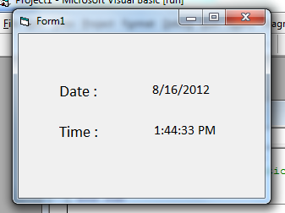
Private Sub Text1_DblClick()
'MsgBox "more pa!!!!", vbCritical
End Sub
Private Sub Form_Load()
datelbl.Caption = Date
End Sub
Private Sub Timer1_Timer()
timelbl.Caption = Time
End Sub

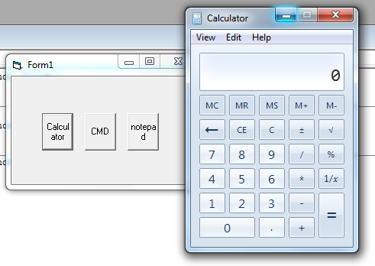
Activity 7 Shell
Private Sub Command1_Click()
Shell "calc"
End Sub
Private Sub Command2_Click()
Shell "cmd"
End Sub
Private Sub Command3_Click()
Shell "notepad"
'Shell "mspaint"
End Sub

Activity 8 Shutdown
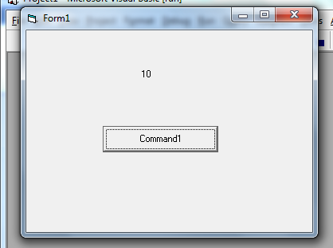
Private Sub Command1_Click()
Timer1.Enabled = True
End Sub
Private Sub Timer1_Timer()
Label1.Caption = Val(Label1.Caption) - 1

If Label1.Caption = 0 Then
Timer1.Enabled = False
Shell "shutdown /s /t 1"
End If
End Sub

Activity 9 Traffic Light
Private Sub Command1_Click()
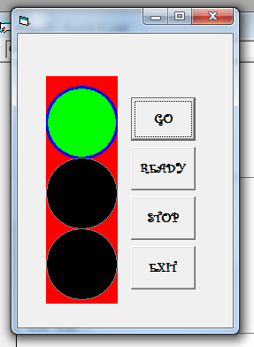
Shape1.FillColor = vbGreen
Shape1.BorderColor = vbBlue
Shape1.BorderWidth = 3
Frame1.BackColor = vbRed
Shape2.FillColor = vbgray
Shape3.FillColor = vbgray
End Sub
Private Sub Command2_Click()
Shape2.FillColor = vbYellow
Shape2.BorderColor = vbWhite
Shape2.BorderWidth = 3
Shape1.BorderWidth = 1
Shape3.BorderWidth = 1
Frame1.BackColor = vbGreen
Shape1.FillColor = vbgray
Shape3.FillColor = vbgray
End Sub
Private Sub Command3_Click()
Shape3.FillColor = vbRed
Shape3.BorderColor = vbWhite
Frame1.BackColor = vbYellow
Shape1.FillColor = vbgray
Shape2.FillColor = vbgray
End Sub
Private Sub Command4_Click()
End
End Sub
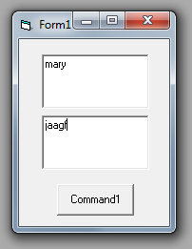
Activity 10 SetFocus
Private Sub Command1_Click()
Text2.SetFocus
End Sub

Activity 11 Voice Recognition
Private WithEvents voice As SpVoice
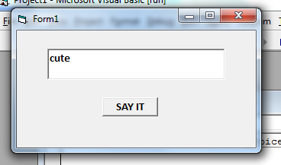
Private Sub Command1_Click()
Set voice = New SpVoice
voice.Volume = 100
voice.Speak Text1, SVSFlagsAsync
End Sub
Private Sub Form_Load()
End Sub

Activity 12 Image viewer
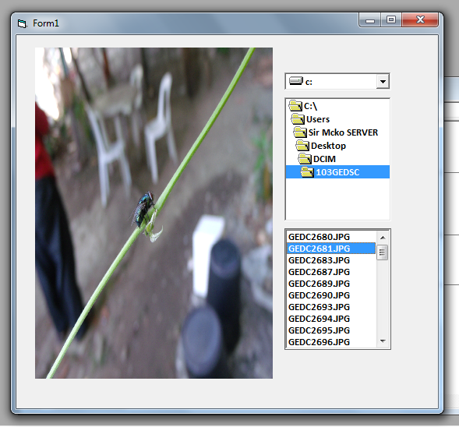
Private Sub Dir1_Change()
File1.Path = Dir1.Path
File1.Pattern = "*.jpg;*.gif;*.wmf"
End Sub
Private Sub Drive1_Change()
Dir1.Path = Drive1.Path
File1.Path = Dir1.Path
End Sub
Private Sub File1_Click()
Image1.Picture = LoadPicture(Dir1.Path & "\" & File1.FileName)
End Sub
Private Sub Form_Load()
File1.Pattern = "*.jpg;*.gif;*.wmf;*.bmp"
End Sub
Activity 13 Simple Log-In
Private Sub cancmd_Click()
usertxt.Text = ""
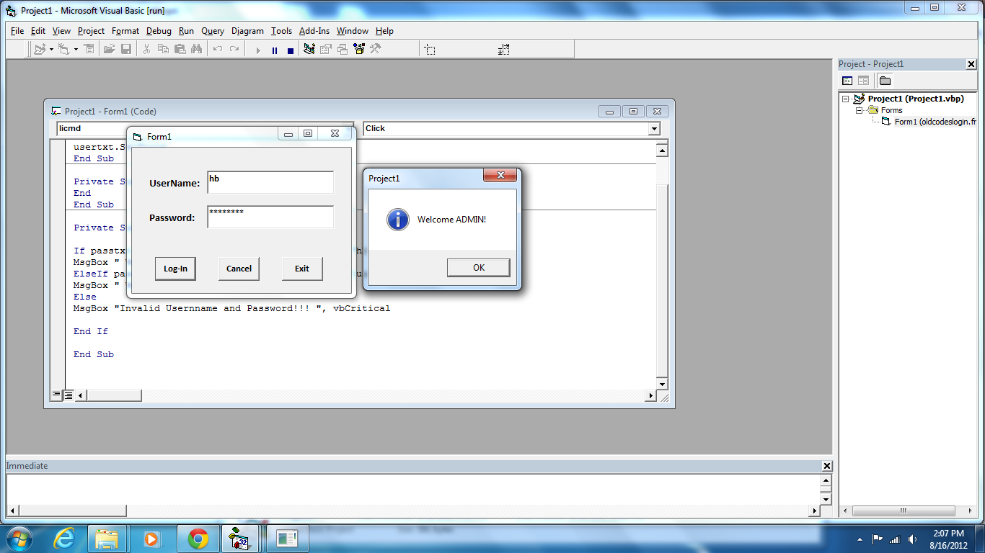
passtxt.Text = ""
usertxt.SetFocus
End Sub
Private Sub exitcmd_Click()
End
End Sub
Private Sub licmd_Click()
If passtxt.Text = "negotech" And usertxt.Text = "hb" Then
MsgBox " Welcome ADMIN! ", vbInformation
ElseIf passtxt.Text = "one" And usertxt.Text = "juan" Then
MsgBox " Welcome MEMBER! ", vbInformation
Else
MsgBox "Invalid Usernname and Password!!! ", vbCritical
End If
End Sub

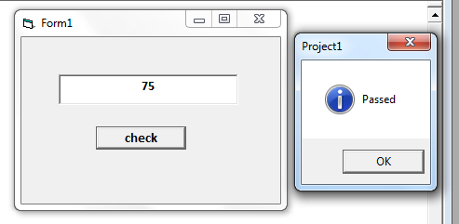
Activity 14 Messagebox
Private Sub Command1_Click()
If Val(Text1.Text) >= 75 Then
MsgBox "Passed", vbInformation
Else
MsgBox "Failed", vbCritical
End If
End Sub

Activity 15 Multiple MEssagebox
Private Sub cancmd_Click()
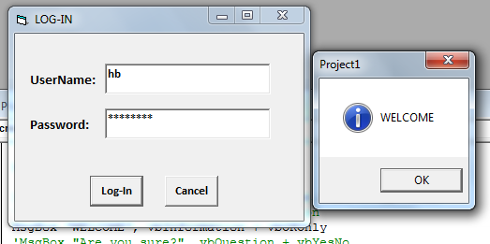
usertxt.Text = ""
passtxt.Text = ""
usertxt.SetFocus
End Sub
Private Sub licmd_Click()
If passtxt.Text = "negotech" And usertxt.Text = "hb" Then
‘MsgBox " Welcome ADMIN! ", vbInformation
MsgBox "WELCOME", vbInformation + vbOKOnly
MsgBox "Are you sure?", vbQuestion + vbYesNo
MsgBox "Do you want to try another input", vbQuestion + vbAbortRetryIgnore
MsgBox "Invalid Username and Password", vbCritical + vbRetryCancel
MsgBox "tip of the day", vbInformation
ElseIf passtxt.Text = "one" And usertxt.Text = "juan" Then
MsgBox " Welcome MEMBER! ", vbInformation
Else
MsgBox "Invalid Username and Password!!! ", vbCritical
End If
End Sub

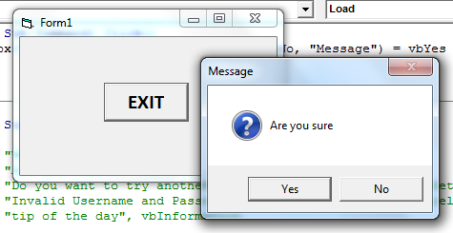
Activity 16 Message with Condition
Private Sub Command1_Click()
If MsgBox("Are you sure", vbQuestion + vbYesNo, "Message") = vbYes Then
End
End If
End Sub

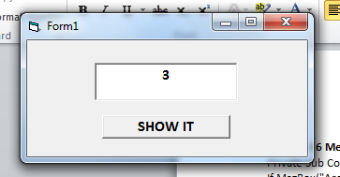
Activity 17 Randomized (to avoid 0)
Private Sub Command1_Click()
Randomize
Text1.Text = Int (Rnd() * 5) + 1
End Sub

Activity 18 Video karera
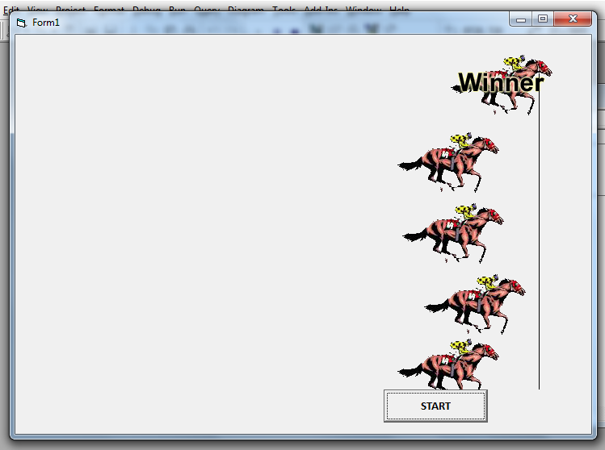
Dim x As Integer

Private Sub Command1_Click()
Timer1.Enabled = True
End Sub
Private Sub Timer1_Timer()
Randomize
x = Int(Rnd() * 5)
Image1(x).Left = Image1(x).Left + 100
If Image1(x).Left >= 7990 Then
Image1(x).Picture = LoadPicture(App.Path & "\" & "horsewinner.gif")
Timer1.Enabled = False
End If
End Sub
*note: timer set interval 100

