DARPA Small Business Innovation Research (SBIR)

DIRECT TO PHASE II TEMPLATE – VOLUME 2

These instructions and template apply to the Defense Advanced Research Projects Agency (DARPA) Small Business Innovation Research (SBIR) Direct to Phase II Opportunities announced under the DoD SBIR BAA.

The template (beginning on the following page) is the format model that may be used to prepare the Direct to Phase II Technical Volume. Do not include the instructions provided on this page or any bracketed [ ] guidance in the template.

Disclosure
Proposers that include in their proposals data which they do not want disclosed to the public for any purpose, or used by the Government except for evaluation purposes, must:
(1) Mark the first page of each Volume of the Submission with the following legend:
"This proposal includes data that must not be disclosed outside the Government and must not be duplicated, used, or disclosed-in whole or in part-for any purpose other than to evaluate this proposal. If, however, a contract is awarded to this offeror as a result of-or in connection with-the submission of this data, the Government has the right to duplicate, use, or disclose the data to the extent provided in the resulting contract. This restriction does not limit the Government's right to use information contained in this data if it is obtained from another source without restriction. The data subject to this restriction are contained in pages [insert numbers or other identification of sheets]"; and
(2) Mark each sheet of data it wishes to restrict with the following legend:
"Use or disclosure of data contained on this page is subject to the restriction on the first page of this volume."

I. STANDARD FORMAT: FEASIBILITY DOCUMENTATION AND TECHNICAL PROPOSAL

Format
The Technical Volume shall meet the following requirements:
- The Technical Volume must include two parts, PART ONE: Feasibility Documentation and PART TWO: Technical Proposal.
- Each part is not to exceed the page count specified in the corresponding DARPA Instructions for the DoD SBIR BAA, regardless of page content
- Single column format, single-spaced typed lines
- Standard 8 ½” x 11” paper format
- Page margins must be one-inch on all sides. A header and footer may be included in the one-inch margin.
- Font style of Times New Roman
- No font smaller than 10-point. For headers, footers, imbedded tables, figures, images, or graphics that include text, a font size of smaller than 10-point is allowable, though proposers are cautioned that the text may be unreadable by evaluators.

Unless otherwise noted, any and all content in the Technical Volume will count toward the limit.

The DoD Submission Website includes a section labeled Volume 5: Supporting Documents. Volume 5 is provided for small businesses to submit additional documentation to support the Technical Volume (Volume 2) and the Cost Volume (Volume 3). The DARPA Instructions will outline any Volume 5 allowances or requirements.

Delete this instruction page and begin the Technical Volume starting with the following page.

[Title]
Volume 2: Technical Volume

[Note: Remove the disclosure statement below if not applicable to your proposal. Refer to Instructions.]
This proposal includes data that must not be disclosed outside the Government and must not be duplicated, used, or disclosed – in whole or in part – for any purpose other than to evaluate this proposal. If, however, a contract is awarded to this offeror as a result of – or in connection with – the submission of this data, the Government has the right to duplicate, use, or disclose the data to the extent provided in the resulting contract. This restriction does not limit the Government's right to use information contained in this data if it is obtained from another source without restriction. The data subject to this restriction are contained in pages <insert numbers or other identification of sheets>.

PART ONE: Feasibility Documentation
[Provide documentation to substantiate that the scientific and technical merit and feasibility described in the Phase I section of the topic has been met and describes the potential commercial applications. Documentation should include all relevant information including, but not limited to: technical reports, test data, prototype designs/models, and performance goals/results.
- Maximum page length for feasibility documentation will be specified by the DARPA Instructions. If you have references, include a reference list or works cited list as the last page of the feasibility documentation. This will count towards the page limit.
- Work submitted within the feasibility documentation must have been substantially performed by the proposer and/or the principal investigator (PI). Documentation should include:
- technical reports describing results and conclusions of existing work, particularly regarding the commercial opportunity or DoD insertion opportunity, and risks/mitigations, assessments;
- presentation materials and/or white papers;
- technical papers;
- test and measurement data;
- prototype designs/models;
- performance projections, goals, or results in different use cases
- If technology in the feasibility documentation is subject to Intellectual Property, the proposer must have IP rights.
- Include a one-page summary on Commercialization Potential addressing the following:
- Does the company contain marketing expertise and, if not, how will that expertise be brought into the company?
- Describe the potential for commercial (Government or private sector) application and the benefits expected to accrue from this commercialization.
- DO NOT INCLUDE marketing material. Marketing material will NOT be evaluated.

PART TWO: Technical Proposal
- Identification and Significance of the Problem or Opportunity.
[Define the specific technical problem or opportunity addressed and its importance.]
- Phase II Technical Objectives.
[Enumerate the specific objectives of the Phase II work, including the questions the research and development effort will try to answer to determine the feasibility of the proposed approach.]
- Phase II Statement of Work (include Subcontractors and/or Research Institutions).
[The statement of work should provide an explicit, detailed description of the Phase II approach, indicate what is planned, how and where the work will be carried out, a schedule of major events and the final product to be delivered. The methods planned to achieve each objective or task should be discussed explicitly and in detail. This section should be a substantial portion of the total proposal.
- Human/Animal Subjects and/or Recombinant DNA. Proposers proposing research involving human and/or animal subjects or recombinant DNA use are encouraged to separate these tasks in the technical proposal and cost proposal in order to avoid potential delay of contract award. Please note that funds cannot be released or used on any portion of the project involving human/animal subjects or recombinant DNA research or activities until all of the proper approvals have been obtained (see DoD SBIR BAA for more information).
- Phase II Option Statement of Work (if applicable, specified in the corresponding topic). The statement of work should provide an explicit, detailed description of the activities planned during the Phase II Option, if exercised. Include how and where the work will be carried out, a schedule of major events and the final product to be delivered. The methods planned to achieve each objective or task should be discussed explicitly and in detail.]
- Related Work.
[Describe significant activities directly related to the proposed effort, including any conducted by the principal investigator, the proposing firm, consultants, or others. Describe how these activities interface with the proposed project and discuss any planned coordination with outside sources. The Technical Volume must persuade evaluators of the proposer's awareness of the state of the art in the topic. Describe any previous work not directly related but similar to the proposed effort. Provide the following: (1) a short description, (2) the client for which work was performed (including the Government Point of Contact to be contacted including e-mail address and phone number), and (3) date of performance including project completion.]
- Relationship with Future Research or Research and Development.
- [State the anticipated results of the proposed approach if the project is successful.
- Discuss the significance of the Phase II effort in providing a foundation for a Phase III research and development or commercialization effort.]
- Key Personnel.
[Identify key personnel who will be involved in the Phase II effort including information on directly related education and experience. A concise technical resume of the principal investigator, including a list of relevant publications (if any), must be included (please do not include Privacy Act Information). All resumes will count toward the page limit for Volume 2, as specified in the DARPA Instructions.]

[Principal Investigator Name]
[School, Degree, Year]

Relevant Experience
[A concise description of the principal investigator’s relevant technical experience and its application to this topic.]

Relevant Awards or Patents
[List any awards received or patents granted or applications submitted for work related to this topic.]

Relevant Publications
[List any publications relevant to this topic.]

[Repeat this format as necessary to address the qualifications of all key personnel.]

- Foreign Citizens.
[Identify any foreign citizens or individuals holding dual citizenship expected to be involved on this project as a direct employee, subcontractor, or consultant. For these individuals, please specify their country of origin, the type of visa or work permit under which they are performing and an explanation of their anticipated level of involvement on this project. Refer to the DoD SBIR BAA for more information. Supplemental information provided in response to this paragraph will be protected in accordance with the Privacy Act (5 U.S.C. 552a), if applicable, and the Freedom of Information Act (5 U.S.C. 552(b)(6)). Note: If no foreign nationals will be involved in proposed work, the word “None” can be substituted for the table.]

Name  [include direct employees, subcontractors, and consultants] | Foreign National (Yes/No) | Country of Origin | Type of Visa or Work Permit | Level of Involvement (Role)

- Facilities/Equipment.
[Describe available instrumentation and physical facilities necessary to carry out the Phase II effort. Justify equipment purchases in this section and include detailed pricing information in the Cost Volume. State whether or not the facilities where the proposed work will be performed meet environmental laws and regulations of federal, state (name), and local Governments for, but not limited to, the following groupings: airborne emissions, waterborne effluents, external radiation levels, outdoor noise, solid and bulk waste disposal practices, and handling and storage of toxic and hazardous materials.]
- Subcontractors/Consultants.
[Involvement of a university or other subcontractors or consultants in the project may be appropriate. If such involvement is intended, it should be identified and described according to the Cost Breakdown Guidance offered in the DARPA Instructions. For Phase II/Direct to Phase II, a minimum of one-half (50%) of the research and/or analytical work, as measured by direct and indirect costs, must be carried out by the proposing small business firm, unless otherwise approved in writing by the Contracting Officer. SBIR efforts may include subcontracts with Federal Laboratories and Federally Funded Research and Development Centers (FFRDCs). A waiver is not required for the use of Federal Laboratories and FFRDCs; however, proposers must certify their use of such facilities in Volume 1: Proposal Cover Sheet. Subcontracts with other Federal organizations are not permitted. Note that universities cannot publicly release information related to Export Controlled/ITAR restricted topics.]
- Prior, Current or Pending Support of Similar Proposals or Awards.
[If a proposal submitted in response to a corresponding topic is substantially the same as another proposal that was funded, is now being funded, or is pending with another Federal Agency, or another DoD Component or DARPA, you must reveal this on Volume 1: Proposal Cover Sheet and provide the following information:
- Name and address of the Federal Agency(s) or DoD Component to which a proposal was submitted, will be submitted, or from which an award is expected or has been received.
- Date of proposal submission or date of award.
- Title of proposal.
- Name and title of principal investigator for each proposal submitted or award received.
- Title, number, and date of BAA(s) or solicitation(s) under which the proposal was submitted, will be submitted, or under which award is expected or has been received.
- If award was received, provide contract number.
- Specify the applicable topics for each proposal submitted or award received.
Note: If this does not apply, state in the proposal "No prior, current, or pending support has been provided for proposed work."]
- Commercialization Strategy.
[DARPA is equally interested in dual use commercialization of SBIR/STTR projects that result in products sold to the U.S. military, the private sector market, or both. DARPA expects explicit discussion of key activities to achieve this result in the transition and commercialization strategy part of the proposal. The Technical Volume of each Direct to Phase II proposal must include a transition and commercialization strategy section. The Phase II transition and commercialization strategy shall not exceed 5 pages, and will NOT count against the proposal page limit.

Information contained in the commercialization strategy section will be used to determine suitability for participation in DARPA’s Embedded Entrepreneurship Initiative (EEI). Selection for participation in EEI will be made independently following selection for SBIR/STTR award. Please refer to the DARPA Instructions for more information on the DARPA EEI.

The transition and commercialization strategy should include the following elements:

  - A summary of transition and commercialization activities conducted during Phase I, and the Technology Readiness Level (TRL) achieved. Discuss the market, competitive landscape, potential stakeholders and end-users, and how the preliminary transition and commercialization path or paths may evolve during the Phase II project. Describe key proposed technical milestones during Phase II that will advance the technology towards product such as: prototype development, laboratory and systems testing, integration, testing in operational environment, and demonstrations.
  - Problem or Need Statement. Briefly describe what you know of the problem, need, or requirement, and its significance relevant to a Department of Defense application and/or a private sector application that the SBIR/STTR project results would address. Is there a broader societal need you are trying to address? Please describe.
  - Description of Product(s) and/or System Application(s). Identify the commercial product(s) and/or DoD system(s), or system(s) under development, or potential new system(s). Identify the potential DoD end-users, Federal customers, and/or private sector customers who would likely use the technology.
  - Business Model(s)/Procurement Mechanism(s). Discuss your current business model hypothesis for bringing the technology to market. Describe plans to license, partner, or self-produce your product. How do you plan to generate revenue? Describe the resources you expect will be needed to implement your business models. Discuss your plan and expected timeline to secure these resources. Understanding DARPA’s goal of creating and sustaining a U.S. military advantage, describe how you intend to develop your product and supply chains to enable this differentiation.
  - Target Market. Describe the market and addressable market for the innovation. Describe the customer sets you propose to target, their size, their growth rate, and the key reasons they would consider procuring the technology. Discuss the business economics and market drivers in the target industry. Describe competing technologies existent today on the market as well as those being developed in the lab. How has the market opportunity been validated? Describe the competition. How do you expect the competitive landscape may change by the time your product/service enters the market?
  - Funding Requirements. Describe your company’s funding history. How much external financing have you raised? Describe your plans for future funding sources (internal, loan, angel, venture capital, etc.).
  - Transition and Commercialization Risks. Describe the major technology, market and team risks associated with achieving successful transition of the DARPA funded technology. DARPA is not afraid to take risks but we want to ensure that our awardees clearly understand the risks in front of them. What are the key risks in bringing your innovation to market? What are actions you plan to undertake to mitigate these risks?
  - Expertise/Qualifications of Team/Company Readiness. Describe the expertise and qualifications of your management, marketing/business development and technical team that will support the transition of the technology from the prototype to the commercial market and into government operational environments. Has this team previously taken similar products/services to market? If the present team does not have this needed expertise, how do you intend to obtain it? What is the financial history and health of your company (e.g., availability of cash, profitability, revenue growth, etc.)?
  - Anticipated Transition and Commercialization Results. Include a schedule showing the anticipated quantitative transition and commercialization results from the Phase II project at one year after the start of Phase II, at the completion of Phase II, and after the completion of Phase II (i.e., amount of additional investment, sales revenue, etc.). After Phase II award, the company is required to report actual sales and investment data in its Company Commercialization Report at least annually.

- Technical Data Rights.
[Rights in technical data, including software, developed under the terms of any contract resulting from proposals submitted in response to DARPA topics generally remain with the contractor, except that the Government obtains a royalty-free license to use such technical data only for Government purposes during the period commencing with contract award and ending twenty years after completion of the project under which the data were generated. This data must be marked with the restrictive legend specified in Class Deviation 2020-O0007. Upon expiration of the twenty-year restrictive license, the Government has unlimited rights in the SBIR data. During the license period, the Government may not release or disclose SBIR data to any person other than its support services contractors except: (1) For evaluation purposes; (2) As expressly permitted by the contractor; or (3) For use, release, or disclosure that is necessary for emergency repair or overhaul of items operated by the Government. See Class Deviation 2020-O0007 – Protection of Technical Data and Software Under Small Business Innovation Research Program Contracts.
If a proposer plans to submit assertions in accordance with Class Deviation 2020-O0007, those assertions must be identified and assertion of use, release, or disclosure restriction must be included with your proposal submission. The contract cannot be awarded until assertions have been approved. Please note that only the table is included in the page limitation; any supporting data concerning the contract/grant number and awarding agency, as well as planned use or need of the data asserted, can be provided in Volume 5, Supporting Documents.

The following instructions apply to the fields in the table below (Identification and Assertion of Restrictions on the Government's Use, Release, or Disclosure of Technical Data or Computer Software).
- For technical data (other than computer software documentation) pertaining to items, components, or processes developed at private expense, identify both the deliverable technical data and each such item, component, or process. For computer software or computer software documentation identify the software or documentation.
- Generally, development at private expense, either exclusively or partially, is the only basis for asserting restrictions. For technical data, other than computer software documentation, development refers to development of the item, component, or process to which the data pertain. The Government's rights in computer software documentation generally may not be restricted. For computer software, development refers to the software. Indicate whether development was accomplished exclusively or partially at private expense. If development was not accomplished at private expense, or for computer software documentation, enter the specific basis for asserting restrictions.
- Enter asserted rights category (e.g., Government purpose license rights from a prior contract, rights in SBIR data generated under another contract, limited, restricted, or government purpose rights under this or a prior contract, or specially negotiated licenses).
- Corporation, individual, or other person, as appropriate.
- Enter “none” when all data or software will be submitted without restrictions.]
Identification and Assertion of Restrictions on the Government's Use, Release, or Disclosure of Technical Data or Computer Software
The Offeror asserts for itself, or the persons identified below, that the Government's rights to use, release, or disclose the following technical data or computer software should be restricted:

Technical Data or Computer Software to be Furnished with Restrictions | Basis for Assertion | Asserted Rights Category | Name of Person or Organization Asserting Restrictions
[(LIST)] | [(LIST)] | [(LIST)] | [(LIST)]

[Completion of this table and submission of the proposal constitutes signature for the information listed in the table above.]

Advocacy Letters (OPTIONAL)* Feedback received from potential Commercial and/or DoD customers and other end-users regarding their interest in the technology to support their capability gaps. Advocacy letters that are faxed or e-mailed separately will NOT be accepted.
Letters of Intent/Commitment (OPTIONAL)* Relationships established, feedback received, support and commitment for the technology with one or more of the following: Commercial customer, DoD Program Management (PM)/ Program Executive Office (PM/PEO), a Defense Prime, or vendor/supplier to the Primes and/or other vendors/suppliers identified as having a potential role in the integration of the technology into fielded systems/products or those under development. Letters of Intent/Commitment that are faxed or e-mailed separately will NOT be accepted.
*Advocacy Letters and Letters of Intent/Commitment are optional, and should ONLY be submitted to substantiate any transition or commercialization claims made in the commercialization strategy. Please DO NOT submit these letters just for the sake of including them in your proposal. These letters DO NOT count against any page limit.
In accordance with section 3-209 of DOD 5500.7-R, Joint Ethics Regulation, letters from government personnel will NOT be considered during the evaluation process.]

II. WHITE PAPER & SLIDE DECK FORMAT

Format
The Technical Volume must include two parts. Part one should be a white paper and part two should be a slide deck. These deliverables should be combined as a single Portable Document Format (PDF) for upload to DSIP:

- Type of file: The Technical Volume must be a single PDF file, including graphics. Perform a virus check before uploading the Technical Volume file. If a virus is detected, it may cause rejection of the proposal. Do not lock or encrypt the uploaded file. Do not include or embed active graphics such as videos, moving pictures, or other similar media in the document.
- Length: The length of each part of the technical volume (white paper and slide deck) will be specified by the corresponding topic. The Government will not consider pages in excess of the page count limitations.
- Layout: Number all pages of your proposal consecutively. Font size should not be smaller than 10-point on standard 8-1/2" x 11" paper with one-inch margins. The header on each page of the Technical Volume should contain your company name, topic number, and proposal number assigned by DSIP when the Cover Sheet was created. The header may be included in the one-inch margin.

PART ONE: White Paper (not to exceed 20 pages)
Provide the following information:
- Goals and Impact: Clearly describe what is being proposed and what difference it will make (qualitatively and quantitatively), including a brief discussion on how this directly relates to the topic.
- Phase I Feasibility: This topic is accepting Direct to Phase II proposals ONLY. To be eligible, proposers must demonstrate that the documented feasibility work as required in the topic has been achieved outside of the SBIR program.
- Technical Plan: Outline and address all technical areas and challenges inherent in the approach and possible solutions for overcoming potential problems. Provide specific objectives, metrics, and milestones at intermediate stages to demonstrate a plan for accomplishment of the project objectives. Propose additional appropriate qualitative and quantitative metrics specific to the approach, as needed. Intermediary milestones should occur at no greater than 1-month increments.
- Management and Capabilities: Designate key personnel who will be involved in the Phase II effort. Provide a brief summary of expertise of the team, including subcontractors and key personnel. Describe the organizational experience in this technology area, previous work not directly related to the proposed effort but similar, existing intellectual property required to complete the project, and any specialized facilities to be used as part of the project. List Government-furnished materials or data assumed to be available. Describe any specialized facilities to be used as part of the project, the extent of access to these facilities, and any biological containment, biosafety, and certification requirements.
- Transition and Commercialization Plan:
- Describe the commercial product or DoD system to be developed.
- Discuss the potential end users – DoD, Federal, and/or private sector customers. Discuss your business model for this technology (i.e., how to you anticipate generating revenue with this technology?). Who are you selling to directly or indirectly, a supplier, an integrator, or an end user?
- Describe your company’s funding history. Discuss how much additional funding above this proposed effort (include additional required technology development, staffing requirements, infrastructure requirements, intellectual property (IP) strategy costs, etc.) that will be required to bring this technology to market and how you anticipate going about getting that funding (e.g., Government science & technology (S&T) contracts, investment).
- Describe the timeline to maturity for sales or transition to an end user. Describe your IP strategy.
- Describe the technology, market, team and business risks associated with this proposed effort and your plan to mitigate these risks.

PART TWO: Slide Deck (not to exceed 15 slides)
Provide the following information (convert the completed deck to a pdf and attach it to the white paper):

- What are you trying to do and how does this directly relate to the topic?
- Technology and commercial product: Specifically, what are you proposing to produce – software, system, application? Be specific on what your proposed technology development is targeting as an end state.
- How is the technology approached today? Who is doing the research, development and delivering products/services? What are the current limitations in the technology and commercial marketplaces?
- Technical and commercial value proposition: How have you substantiated the feasibility of your approach? What is innovative in your approach and how does it compare to the state-of-the-art? Why do you think it will be successful both from a technical and commercial perspective? If you are successful, what difference will it make? Discuss your proposed business model – how do you expect to generate revenue from your technology?
- Technical and commercial risks: What are the key technical and commercial challenges and how do you plan to address/overcome these?
- Technical and commercial market analysis: Who will care and what will the impact be if you are successful? What/who are the markets/industries/integrators/stakeholders that would/should care?
- Cost, schedule and milestones: Provide a summary of your cost volume. Provide a summary of your schedule and milestones. How much will your proposed effort cost in total? How long will it take? What are your technical milestones for achieving the proposed efforts? What are your transition and commercialization plan milestones? Discuss how much funding will be required to bring your proposed technology to market and execute on your proposed transition and commercialization plan. Include any funding raised to date and expected plans for raising any additional required funding (Government contracting revenue, product sales, internal research and development (R&D) investment, loan, angel or Venture Capital investment, etc.). Describe timeline to maturity for operational use or commercial sales.
- Management: Overview of team, facilities and qualifications.
- Technical summary quad chart: Use SBIR Direct to Phase II Quad Chart Template provided at https://www.darpa.mil/work-with-us/for-small-businesses/participate-sbir-sttr-program.
- Commercialization summary quad chart: Use the DARPA Transition and Commercialization Support Program (TCSP) template, located at https://www.darpa.mil/work-with-us/for-small-businesses/commercialization-continued.

NOTE: All letters of recommendation, CVs, and Technical Data Rights Assertions (see Sec I, item 12, above) can be loaded in Volume 5: Supporting Documents.
DIRECT TO PHASE II – Quick Start Guide

Getting Started in the Defense SBIR/STTR Innovation Portal (DSIP):
Be sure to check out https://www.dodsbirsttr.mil/submissions/learning-support/training-materials for helpful Job Aids. If this is your first time proposing through the DSIP, be sure to check out the following guides and videos to help you get started quickly:
- Registration and Login / Registration Help Video
- Submission Dashboard / Submissions Dashboard Help Video
- Proposal Landing Page / Proposal Landing Page Help Video
- Firm Forms

Starting a new proposal:
- After you have successfully registered and logged into DSIP, select “Start New Proposal.”
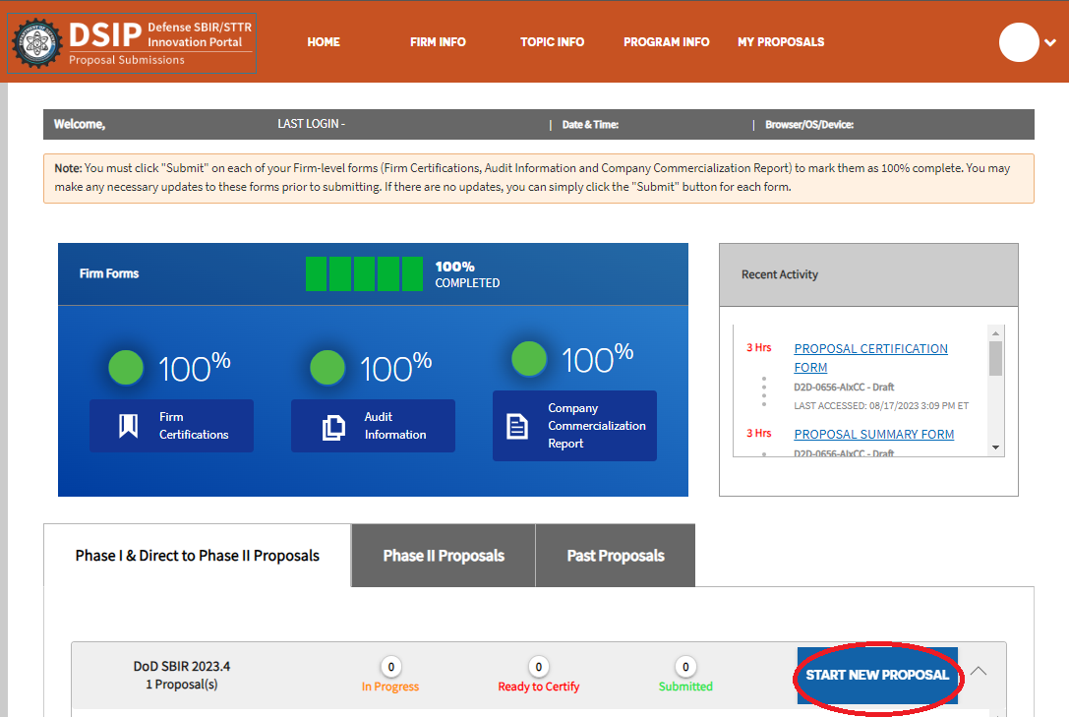

- Select “Direct to Phase II,” “DARPA” as the Component, select the respective topic you are proposing to, add your title, and select “Create Proposal.” An example screenshot is provided below.
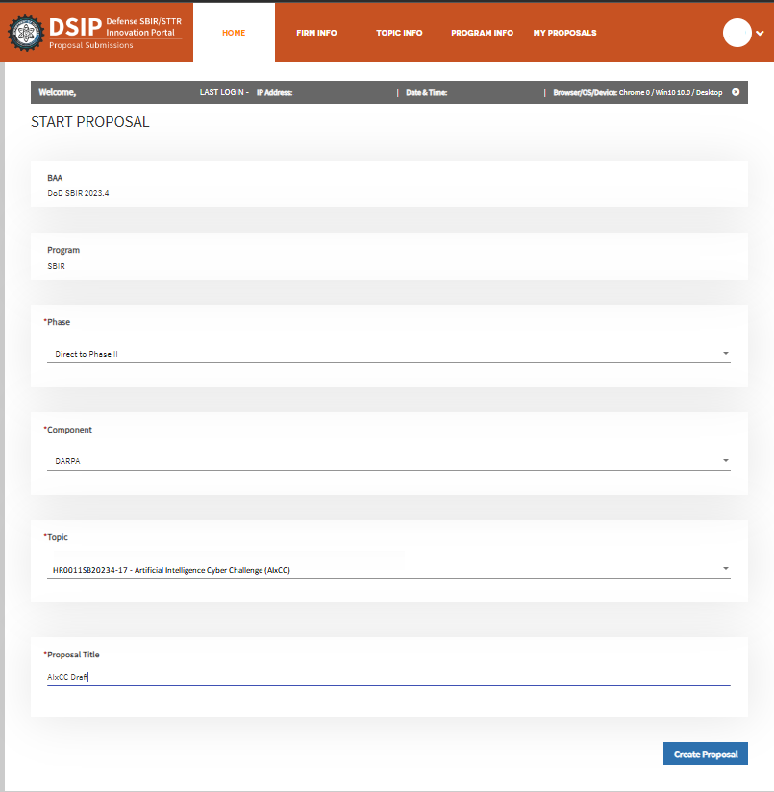

Volume 1: Cover Sheet (completed in DSIP)
This includes three screens that proposers will need to complete:
- Proposal Summary
- Proposal Certification
- Contact Information

Volume I – Proposal Summary
- Add the proposed base duration, and the Option 1 duration. An example screenshot is provided below.

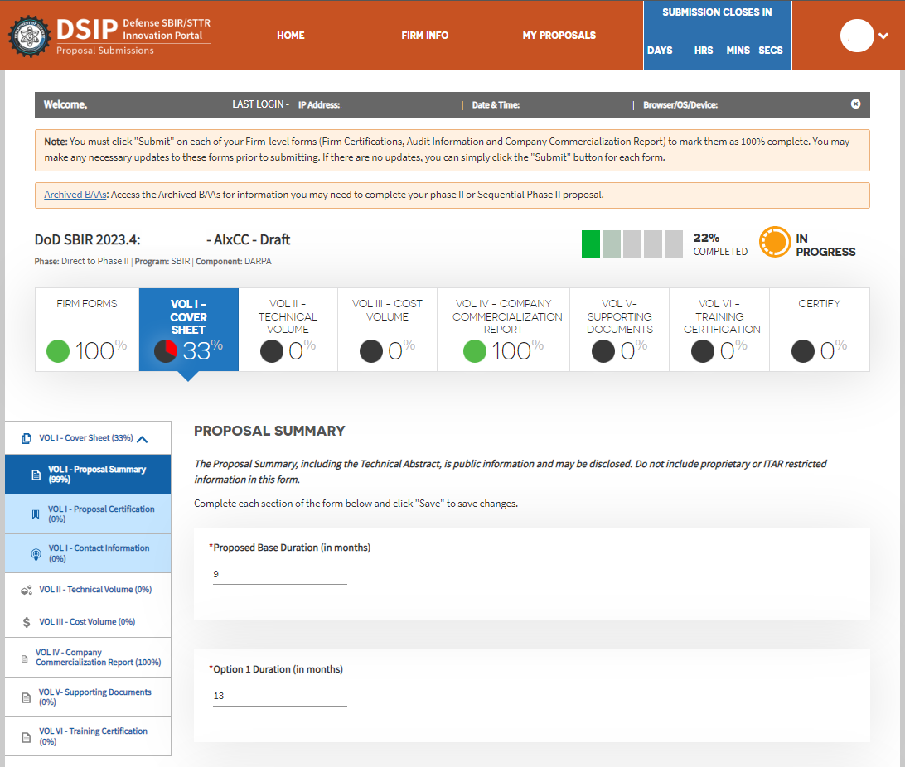

- Add the Technical Abstract, Anticipated Benefits/Commercial Application of the Research or Development.
- Enter the page numbers separated by a space of the pages in the proposal that are considered proprietary.
- List a maximum of 8 key words or phrases, separated by commas, that describe the project.

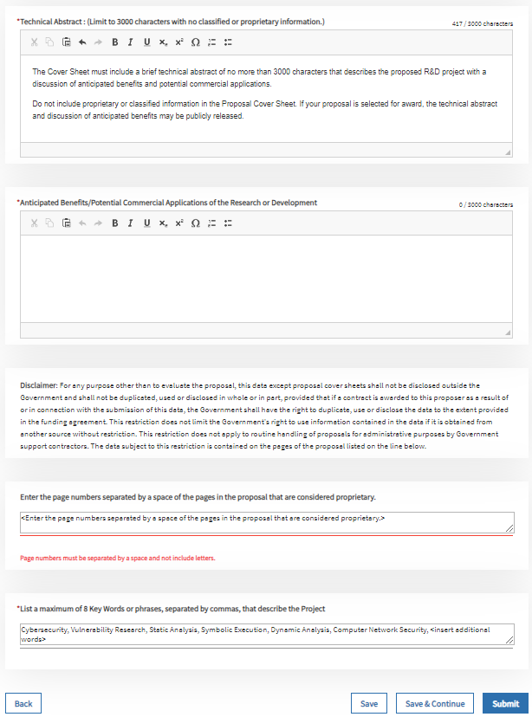

Volume I – Proposal Certifications
- Complete the answers to the questions.
- Note: The Proposal Certifications for Percentage of Work (Question 1) are automatically calculated based on the budget information provided. Once the budget is completed, you will need to go back to VOL I Cover Sheet - Proposal Certification and submit your certifications.
- Updating any subsequent budget information and clicking "Submit" on the budget after it has already been submitted will reopen your VOL I Cover Sheet - Proposal Certification. You will be required to resubmit Proposal Certification under VOL I Cover Sheet.

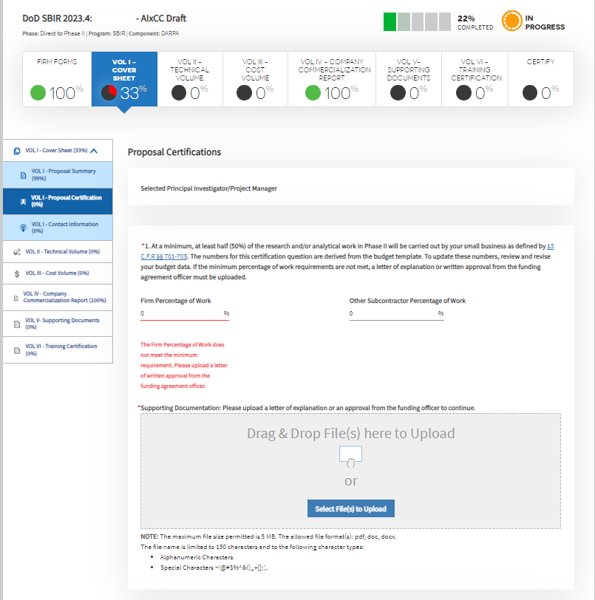
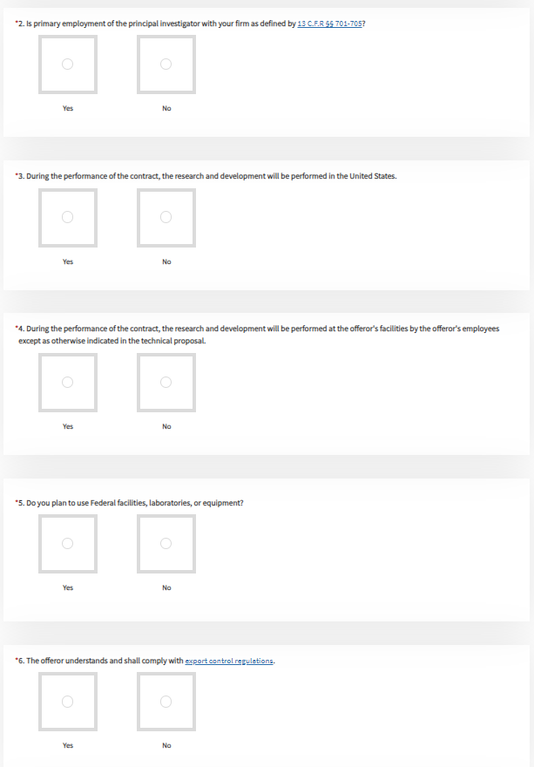
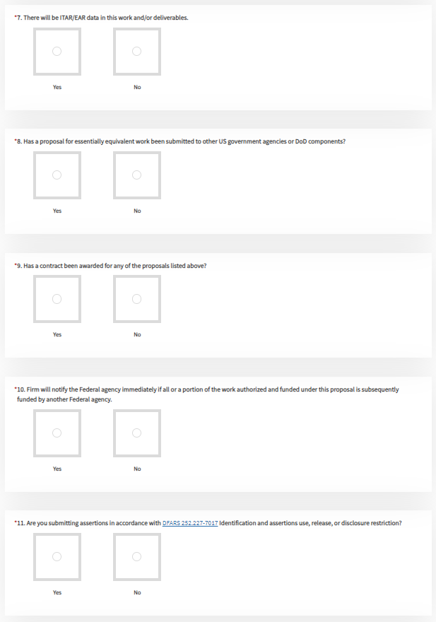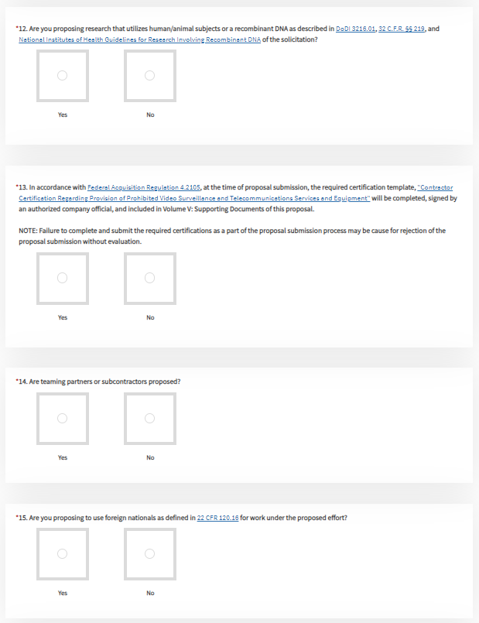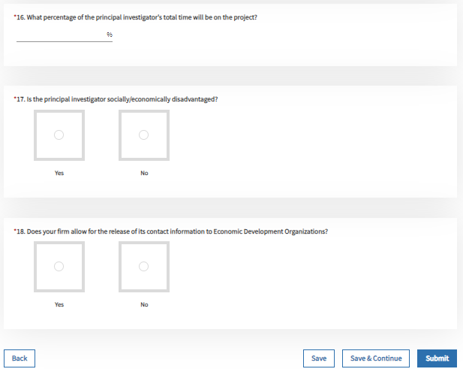
Note: "Contractor Certification Regarding Provision of Prohibited Video Surveillance and Telecommunications Services and Equipment" must also be attached to Volume 5

Volume I – Contact Information
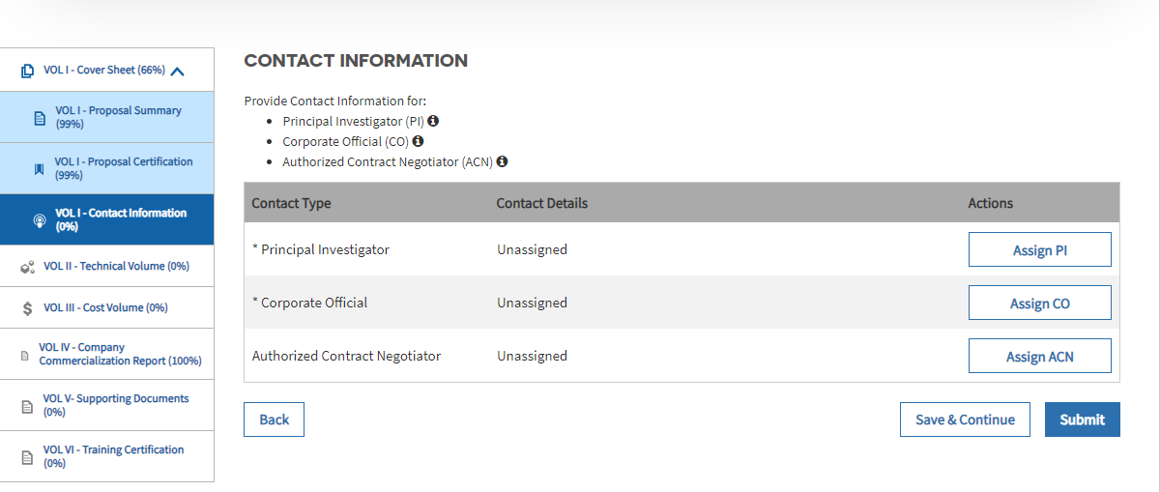

You may need to add the Contact Details for the Principal Investigator, Corporate Official, and Authorized Contract Negotiator if they are not already in the DSIP system.

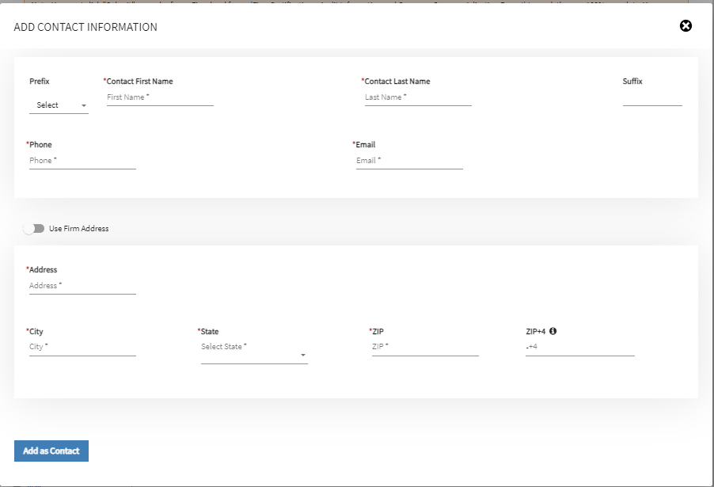
Once Volume 2 is complete, please upload the document to DSIP. An example screenshot is provided below.

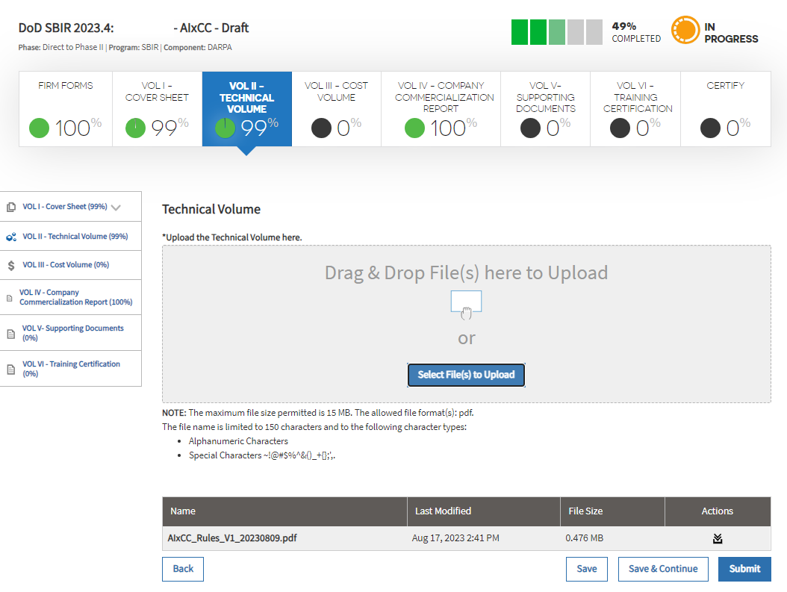
Volume III – Cost Volume
Proposers are required to use the Direct to Phase II – Volume 3: Cost Proposal Template (Excel
Spreadsheet) provided at https://www.darpa.mil/work-with-us/communities/small-business/sbir-sttr-participate. The Cost Volume (and supporting documentation) DOES NOT count toward the page limit of the Technical Volume.

Content of the Cost Volume (Volume 3)
Some items in the Cost Breakdown Guidance below may not apply to the proposed project. If such is the
case, there is no need to provide information on each and every item.

ALL proposed costs should be accompanied by documentation to substantiate how the cost was derived.
For example, if you proposed travel cost to attend a project-related meeting or conference, and used a
travel website to compare flight costs, include a screenshot of the comparison. Similarly, if you proposed
to purchase materials or equipment, and used the internet to search for the best source, include your
market research for those items. You do not necessarily have to propose the cheapest item or supplier, but
you should explain your decision to choose one item or supplier over another. It’s important to provide enough information to allow contracting personnel to understand how the proposer plans to use the requested funds. If selected for award, failure to include the documentation with your proposal will delay contract negotiation, and the proposer will be asked to submit the necessary documentation to the Contracting Officer to substantiate costs (e.g., cost estimates for equipment, materials, and consultants or subcontractors). It is important to respond as quickly as possible to the Contracting Officer’s request for documentation.

Cost Breakdown Guidance:
- List all key personnel by name as well as by number of hours dedicated to the project as direct labor. Special tooling and test equipment and material cost may be included. The inclusion of equipment and material will be carefully reviewed relative to need and appropriateness for the work proposed. The purchase of special tooling and test equipment must, in the opinion of the Contracting Officer, be advantageous to the Government and should be related directly to the specific topic. These may include such items as innovative instrumentation and/or automatic test equipment. Title to property furnished by the Government or acquired with Government funds will be vested with DARPA; unless it is determined that transfer of title to the contractor would be more cost effective than recovery of the equipment by the DARPA.
- Cost for travel funds must be justified and related to the needs of the project.
- Cost sharing is permitted for proposals under this announcement; however, cost sharing is not required nor will it be an evaluation factor in the consideration of a proposal.
- All subcontractor costs and consultant costs must be detailed at the same level as prime contractor costs in regard to labor, travel, equipment, etc. Provide detailed substantiation of subcontractor costs in your cost proposal. Enter this information in the Explanatory Material section of the online cost proposal form. The Supporting Documents Volume (Volume 5) may be used if additional space is needed.

For more information about cost proposals and accounting standards, see the Defense Contract Audit Agency (DCAA) publication titled “Audit Process Overview – Information for Contractors” available at: http://www.dcaa.mil.

When the cost spreadsheet is complete, please upload to DSIP. An example screenshot is provided below.

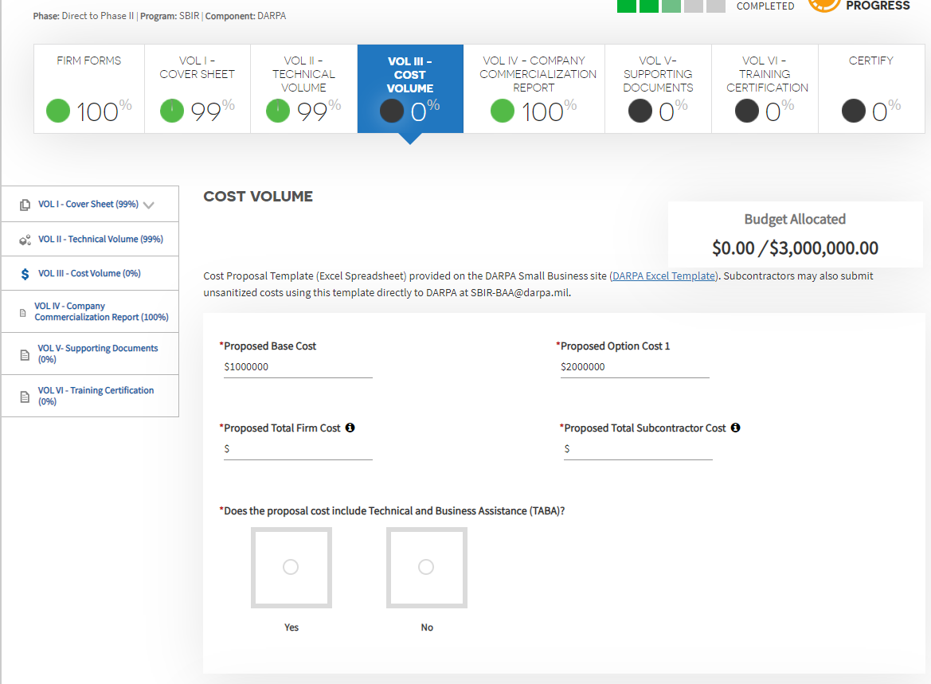

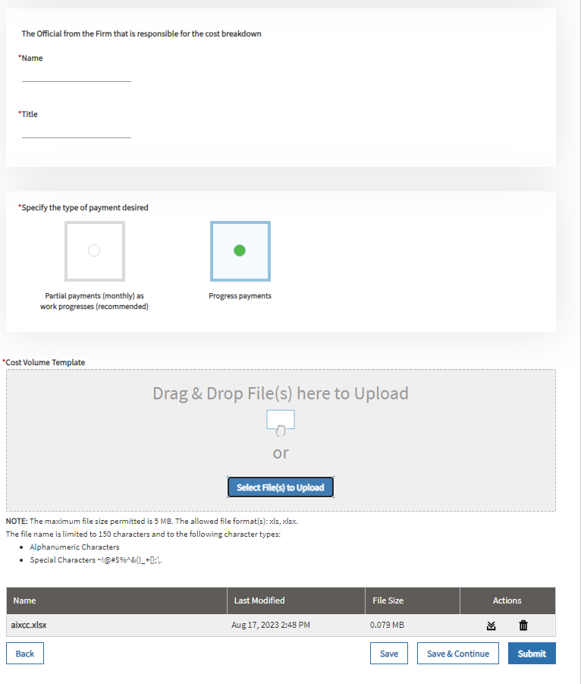

Volume IV – Company Commercialization Report
The Company Commercialization Report (CCR) allows companies to report funding outcomes resulting from prior SBIR and STTR awards. The CCR is required for Phase I and Direct to Phase II proposals. Please refer to the DoD STTR Program BAA for full details on this requirement. Information contained in the CCR will not be considered by DARPA during proposal evaluations.
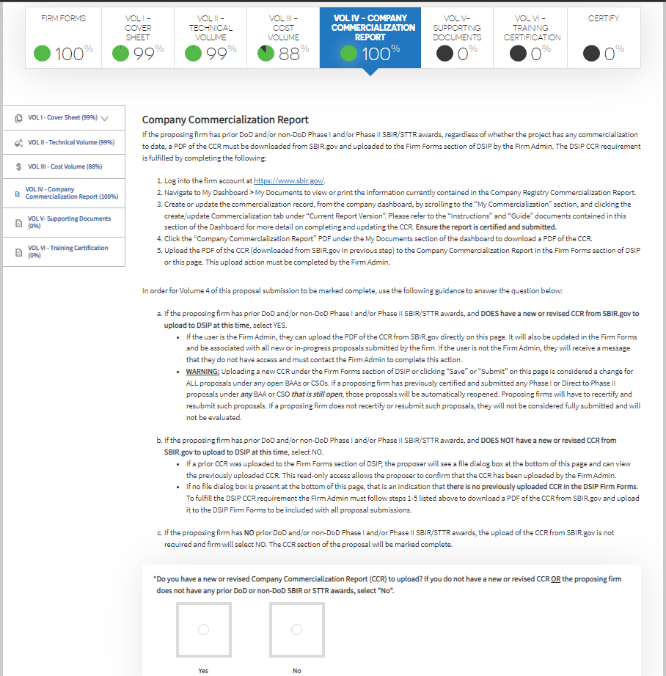

Volume V – Supporting Documents

The following documents may be included in Volume 5, if applicable to the proposal. Refer to

DARPA-specific instructions for additional Volume 5 requirements. Reminder: A

completed proposal submission in DSIP does NOT indicate the mandatory supporting

documents have been uploaded in accordance with DARPA-specific

instructions.

1. Letters of support

2. Additional cost information

3. Funding agreement certification

4. Technical data rights (assertions)

5. Lifecycle certification

6. Allocation of rights

7. Verification of Eligibility of Small Business Joint Ventures, if applicable

8. DD Form 2345, Militarily Critical Technical Data Agreement, if applicable (see section

3.2 of the DoW preface)

Volume VI – Fraud, Waste and Abuse Training and Certification
The Fraud, Waste and Abuse (FWA) training is required for Phase I and Direct to Phase II proposals.
FWA training provides information on what represents FWA in the SBIR/STTR program, the most
common mistakes that lead to FWA, as well as the penalties and ways to prevent FWA in your firm. This
training material must be thoroughly reviewed once per year. Plan ahead and leave ample time to
complete this training based on the proposal submission deadline. Knowingly and willfully making any
false, fictitious, or fraudulent statements or representations may be a felony under the Federal Criminal
False Statement Act (18 U.S.C. Sec 1001), punishable by a fine of up to $10,000, up to five years in
prison, or both. Understanding the indicators and types of fraud, waste, and abuse that can occur is critical
for the SBIR/STTR awardees’ role in preventing the loss of research dollars.

Proposers must review the training slides found on DSIP and check the box marked “I hereby acknowledge that I have reviewed, understand and accept all content and requirements provided in the Fraud, Waste, and Abuse training.”

Training certificate will appear to the right of “View Training Slides” once the material is reviewed.

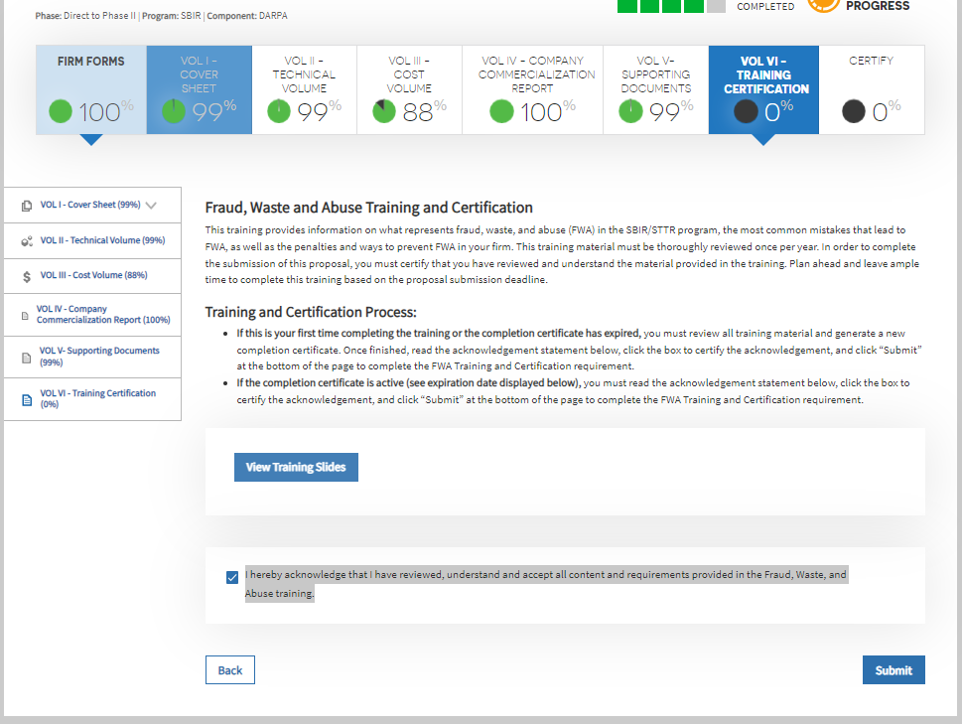

Submission Checklist
The following items apply as part of the submission package:

 | Item | BAA Section | Applicability | Comment
 | Volume 1  (Proposal Cover Page) | Appendix A. III.a | Required of all proposers | - Brief technical abstract of no more than 3000 characters that describes the proposed R&D project  - A discussion of anticipated benefits and potential commercial applications.
 | Volume 2  (Technical Volume) | Appendix A. III.b | Required of all proposers | - Format outlined on page 1  - White Paper (NTE 20 pages), must cover:  - Goals and Impact  - Phase 1 Feasibility  - Technical Plan  - Management and Capabilities  - Transition and Commercialization Plan (max. 5 pages, counted as part of the 20 pages mentioned above)  - Slide Deck (NTE 15 slides) – converted to PDF  - Addresses 8 questions  - Technical summary quad chart (template provided)  - Commercialization summary quad chart (template provided)  - Conform to stated page limits and formatting requirements. Include all requested information.
 | Volume 3  (Cost Volume) | Appendix A. III.c and d | Required of all proposers | - Proposers are required to use the Direct to Phase II – Volume 3: Cost Proposal Template (Excel Spreadsheet) provided at https://www.darpa.mil/work-with-us/for-small-businesses/participate-sbir-sttrprogram, under SBIR/STTR BAA FORMS & TEMPLATES
 | Volume 4  (Company Commercialization Report) | Appendix A. III.e |  | - If the proposing firm has prior DoD and/or non-DoD Phase I and/or Phase II SBIR/STTR awards, and DOES have a new or revised CCR from SBIR.gov to upload to DSIP at this time, select YES.  - If the proposing firm has prior DoD and/or non-DoD Phase I and/or Phase II SBIR/STTR awards, and DOES NOT have a new or revised CCR from SBIR.gov to upload to DSIP at this time, select NO.  - If the proposing firm has NO prior DoD and/or non-DoD Phase I and/or Phase II SBIR/STTR awards, the upload of the CCR from SBIR.gov is not required and firm will select NO. The CCR section of the proposal will be marked complete.
 | Volume 5 (Supporting Documents | Appendix A. III.f | Required of all proposers | Mandatory Forms to upload:  - Contractor Certification Regarding Provision of Prohibition on Contracting for Certain Telecommunications and Video Surveillance Services or Equipment  - Disclosure of Funding Sources
 | Volume 6 (Training Certificate) | Appendix A. III.g | Required of all proposers | - Review Training materials in DSIP, training certificate will appear in DSIP after the link is selected.

