Prolegomena to Art’s Transdisciplinarity

Fourth International Integral Theory Conference
“Integral Impacts: Using Integrative Metatheories to Catalyze Effective Change”
Sonoma State University
Rohnert Park, CA
July 16-19, 2015

Michael Schwartz, PhD Columbia University
Professor, Department of Art
Georgia Regents University

The Project
This paper is prolegomena to art’s transdisciplinarity, a project ontologically motivated through inquiry into the transcendental conditions of art. It opens with the question: “what does the socio-cultural world need to be like for art to have emerged and endured as a human activity and product?” A answer to this question, as retrodictive explanation (proper to critical realist social theory), is that art emerges as response to the tetra-arising matrix of certain type of psychic, bodily, cultural, and systemic tensions and contradictions – this matrix always already dialectical in the Bhaskerian and Laskean senses (figure 1).
The motivation for this project comes from seeing how the various disciplines engaging art today have respective strengths and weaknesses, being only partially open to one another other for inspiration and insight. Art history is strong on the concreteness of works of art in their historical specificity; it is weak on questions of what art is (often hedging its bets or oscillating in its definitions on the run) and given its positivistic legacy still angles towards “fact over value”; or when engaging in normative questions, does so either without clear normative grounds, deflecting normativity back into the historical cultural horizon (“what they believed or valued”), or enacting normative assessment in a mechanical manner (as in “politically correct” judgments sans sufficient critical and philosophical underlaboring). Art criticism is stronger in matters of evaluation, if often lacking much scale or scope in its mobilizing of historical frames and lineages (regularly truncating historical inquiry to the very recent past), bric-a-brac in its normative concerns and theorizing (with select exceptions among critic-historians). Philosophy is strong on the contours of art in general, and has in recent years offered an increasingly vital brand of philosophical criticism of the arts (Deleuze, Sallis), but even in some of these instances, as Günter Figal has noted, art is often engaged for the purposes of furthering philosophy's own theoretical agendas; where we can add that the historical specificity of art is most often muffled or dampened (philosophy often allergic to art history even at it regularly folds into its own procedures the art historical archive). Given that art today is all ubiquitous, so much so that we take it for granted in our everyday lives, this fragmentation of inquiry is at cross purposes with what is called for by our planetary situation. This study then is prolegomena to art’s transdisciplinarity in lieu of the ontological and normative complexity today of art and its institutions.
What is one then to make of a concept like “transdisciplinary”? Terms like crossdisciplinary, interdisciplinary, transdisciplinary, etc., are in widespread and diverging usage these days. I shall be deploying such terms in a distinctive manner that pays to clarify at the outset. A discipline is an established academic research Fach, like art history, with institutional conditions, discourses, publication venues, methodologies, objects of analysis, flows of symbolic capital, economic exchanges, and so on. Disciplines are internally complex, sometimes messy, and do not always have clear boundaries from other disciplines. Since there are subdisciples within a given discipline, inclusive of methods (and ontological concerns) adapted from other disciplines, we do well to approach a given discipline from a metadisciplinary stance, allowing for and welcoming such intradisciplinary diversity into an open integrative embrace. The metadisciplinary is how a discipline, as internally messy and diverse, becomes organized into a higher order of knowing the objects and processes proper to its scope and focus of study. Interdisciplinary, in turn, refers to the higher order integration of differing disciplines or rather of metadisciplines (hence is technically “intermetadisciplinary”). Transdisciplinary is interdisciplinarity to the second power, in the case of the present project: (1) each discipline embraced in its metadisciplinary richness and complexity; (2) bringing metadisciplines into higher order interdisciplinary interrelation and integration; and (3) doing so with more than one level of such interdisciplinary (see the Main Chart at the end of this document). Following a suggestion of Stein’s, it is perhaps only with transdisciplinary that there emergences a change in kind in our understanding of the objects and processes under study, hence the prefix trans.
In the wake of the metatheory dialogues between integral theory and critical realism, questions arise as to the respective weighing of epistemics, methodology and ontology in the generation and discerning of transdisciplinary schemes. Critical realism is brilliant in its diagnostic of the epistemic fallacy and in advancing ontology. Its depth ontology of the real is decisive, the distinction between transitive and intrusive illuminative. And yet some of its criticisms of integral theory’s stress on epistemics and methodology, even while insightful, edges into being overstated and one-sided; as there is a tendency in original critical realism to direct attention away from the epistemic in lieu of its game-changing critical diagnostic of the epistemic fallacy and its vindication of ontology.
Critical realism posits three non-identity depth strata of the real – empiricities, events, and generative mechanisms. The first two constitute the actual, where most philosophies of science have attempted to account for scientific knowledge of nature by engaging such actualities in seeking the constant conjunction of events – the error of actualism. Rather, knowing occurs in being, where the generative mechanisms of nature (and in a qualified sense of the social) are independent of the human. Generative mechanisms give rise to events and events may register as empiricities (where the plurality of generative mechanism in play for any given event-set entails non-identity at the heart of the real). What is perhaps underappreciated in critical realist discourse is the degree to which the specific generative mechanisms in question can only be investigated if certain empiricities appear to humans, the latter by no means pre-given but overdetermined and conditioned by scientific practice (methods), the capacities of the scientists (epistemics - in part determined by cognitive development), and the tetra-arising (and tetra-dynamic) worldspaces of actualities as delineated by integral theory’s mega-phenomenology. There is a multi-directional mutual conditioning between and among empiricities, events, and structures that entails no epistemic fallacy.
When we turn to the human sciences and their investigation of the socio-cultural, methods cannot artificially produce closed systems as in the natural sciences so to isolate a generative mechanism, but rather the investigator is thrown into the open system of the socio-cultural under investigation (entailing the need for retrodictive explanation). Types of knowing, methodologies, and regions of being are more intimately intertwined than in the natural sciences. For critical realist social theorist Frédéric Vandenberge this entails that the distinction in knowing, developing in the philosophical underlaboring for the natural sciences, between the intransitive and the transitive, begins to collapse for the human sciences. He argues that hermeneutics and phenomenology need a much more prominent place than they already have in critical realist social theory and practice (I could not agree more) – engendering a critical hermeneutics over and above a critical naturalism of the social sciences. Given this understanding of the human sciences, the wager in this paper is that the existing epistemologies and methodologies of the disciplines already under way in the investigation of art are in the first instance (if requiring critical scrutiny) the soundest entry point into the domains of actuals to be studied as regards art, as these actuals condition the kinds of generative mechanisms that may be explored -- and indeed have been explored in these disciplines.
In this study the quadrant scheme is used to map and chart the respective domains of knowing and being. A more ramified integral approach, as I have argued elsewhere, would differentiate individual and social holons, as these two perspective-constellations are the within and without of one another. Yet this holonic differentiation, along with further metatheoretical refinements of the quadrant model (which abound more and more in integral studies), would complexify what is already a complex presentation, such that the still useful short-hand of the quadrant scheme will be deployed as skillful means, replete with truth-value, in what is a prolegomena. Turning then to the Main Chart (end of paper), there are four principal metadisciplinary domains that register and engage art’s being. Tropology of Drives (TD) investigates the reworking and redirecting of the four fundamental drives as these are operative in a tetra-arising socio-cultural world of constellated tensions, where art is birthed from and is a response to some aspect of this noospheric tension field. Art is too a distinctive response to such tensions, such that the Philosophy of Art and Aesthetics (PAA) clarifies what is unique about art (what distinguishes art, as response to such tensions, from other modalities like political transformative praxis). Art therein is what in dialectical critical realism is designated as a concrete universal <-> concrete singular, that there is a generality to what art with there being only singular instances of art. Whereas PAA addresses with clarity the former, Art History (AH) and Art Criticism and Evaluation (ACE) address with focus the latter. Also, as proper to critical realist social theory there is no inherent split between facts and values, where art as socio-cultural is no exception. While AH and ACE each address both the facts and values of art, art history leans more towards the “fact” side, art criticism and evaluation to the “value” side. Looking again at the Main Chart, we see that in the main in moving from top to bottom there is a flow from generality to specificity.
Each metadisciplinary domain has an operative principle, a meta-organizing conatus that constellates and animates the dynamic interplays of the subdomains and elements contained within that matrix. Once that conatus is activated in thought, it allows for integrative and open-ended second order simplicity in knowing. Each higher matrix “frames” in an open and flexible manner those below. And too the holarchical vertical scheme is not rigid, but fluid, dynamic, moving, taking on multiple configurations, in line with Bhaskar’s insights about superstructures and infrastructures and Morin’s about parts/wholes. The vertical scheme itself is a stratified dialectical constellation that is dynamic. Figures shift, such that the TD matrix as atop a tree-like scheme can be also pictured as the fertile ground and noospheric soil where art (1) in its concrete universality <-> concrete singularity and (2) as value-infused social arti-fact comes into being.

Tropology of Drives (TD)
Tropology is an emergent metadiscipline that clarifies the socio-cultural tension-fields that condition and give rise to art. There are within a given quadrant domain inherent noospheric tensions pertaining at bottom to the root drives and processes of agency and communion: (1) intra-agential, (2) intra-communal, and (3) between agency and communion. In the UL, analytic psychology (as brilliantly integrated by Washburn) maps development tensions in the formation of egoic steering mechanisms and identity formation, tensions which persist to some degree even when an individual’s development has been comparatively healthy and minimally shadow-laden. (How well this psychological model extends to global peoples and their individual development and how well it applies to prior historical epochs are open questions.) In the LL, Girard’s groundbreaking model of mimetic desire and rivalry (in part intended to subsume Freud’s analytic psychology, but given Washburn’s synthesis this is not the case) is a powerful explanatory and interpretive method. One becomes socialized and acculturated in part via the imitation not only of the practices of others but also of their desire for some object. One is indebted to others for being empowered into the lifeworld of a society, while also being in (often unconscious) rivalry with others over objects of desire, which as desired are absent and also projected as scarce. An intensification of human aggression is birthed through such mimetic rivalry, strong enough to destroy socio-cultural order and functionality. A variety of compensatory mechanisms have arisen in history, such as sacrifice, scapegoating, and scandal, which periodically diffuse societal aggressions that are for the most part communal tensions. Shifting to the UR, bodily pain and illness is a more or less constant tension in lieu of the conatus toward pleasure, health, and well-being (pace Freud), as with the emergence of sophisticated immunological mechanisms in advanced organisms. In the LR, with respect to historical techno-economic modes of production, system tensions emerge between and within the relations of production and the means of production, where the Marxian critical literature abounds in decisive explications of the contradictions in any number of historical formations.
The tensions within a given quadrant-domain also fold outwards and impact other quadrant- domains. To give an example. Tensions within the modern phases of the capitalist mode of production of the LR (1) generate ideologies (LL), (2) shape the forms of experience per the analyses of Lukács and DeBord (UL), and (3) within systemic master-slave class relationships painfully impact and regulate the laboring bodies of factory workers (UR) -- to wit Chaplin’s classic scenes as a factory worker possessing a machine-conditioned body out of the control of individual will in the 1936 film Modern Times. To give another example, tensions inherent to the infant’s psychic separation from what Washburn calls the dynamic ground of being. as growth out of pre-differentiated fusion with the mother/Mother, unfurls the conatus to return to that dynamic ground, if often enacted in unhealthy ways by regressing to primitive stages of development (in contrast to the “regression in service of transcendence” that Washburn articulates); regularly entailing the seeking of substitutes for wholeness through the overriding of basic needs, wants, and desires (Wilber, Loy), which can be bodily (fast food), cultural (internet porn), and social-economic (unlimited personal wealth). In addition to tensions that are (1) intra-quadrant as also (2) impacting other quadrants, (3) the tensions proper to two or more quadrants domains holistically interrelate, generating the real social field of the demi-real with its splits, ills, ideologies and absences:
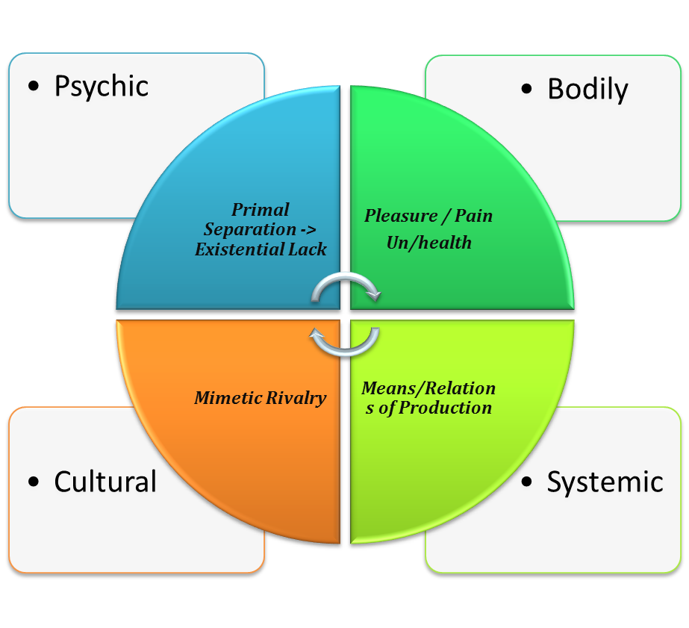
Figure 1 – Depth-Stratified Tetra-Arising Social-Cultural Tension Field

This tension-field involves, primarily if not exclusively (or so is the hypothesis), the fundamental horizontal drives of agency and communion. The tensions qua tensions are met and addressed, again primarily if not exclusively, by the fundamental vertical drives of eros and agape. Eros drives forth changes in kind – macro, meso, micro -- hence transformation as novel emergence. Agape drives towards the gathering of a tension-field into greater wholeness, “squeezing” together the tensed fault-lines, agape’s movement towards harmonization pressuring the absenting of determinate and quasi-determinate absences (in the co-operating of eros and agape). In accord with Bhaskar’s four-stadia dialectic of MELD, this tensed social-field is depth-stratified, its generative mechanisms both within and beyond a given quadrant-domain, as these are non-identical to the actuals of the field itself. The tensions themselves are traces of the presence of determinate and quasi-determinate absences.
Art is birthed in as response to such tension-fields. In this retrodictive explanatory account, art is the mimetic-imaginative negation of determinate or quasi-determinate absences (in the sense of Bhaskarian and Laskean dialectics) such that art qua art is the “filling” of that absence. Art is not reductively a psychic substitute (Freud, Summers), although it can be that; rather, art in its fullness and health is a promise (cf. Bloch, Derrida) that can orient and empower socio-cultural activity in any number of ways. Proper to its tropological force, art as promise has as its second order norming principle the redirecting and reworking of fundamental drives in their concrete historical instantiations and incarnations within a given socio-cultural formation. This facet of the “art-conatus” -- to echo and play upon Riegl’s famous concept of Kunstwollen (the will or spirit of art) -- can itself be held captive by the demi-real, such that the promise of art turns into a false promise -- art gone sick – where any given artwork is often an admixture of progressive, regressive, and ongoing value-currents.
While a plausible opening as retrodictive explanation, the tropological construal leaves the determination of art qua art underdefined. As stated, three additional metadisciplinary domains flesh out further the ontology and axiology of art as promise: (1) philosophy of art and aesthetics (PAA) clarifies art’s more general ontological distinctiveness qua art; (2) art history (AH) addresses art’s historicity and concreteness as this or that work of art in this or that nest and rhizome of contexts; and (3) art criticism and evaluation (ACE) addresses art’s axiological actuality as embodying values, discerning the comparative health/unhealthy of a given artwork’s promissory offering.
Philosophy of Art and Aesthetics (PAA)
Philosophy of art and aesthetics has as its conatus and second order norming principle the gathering-doubling of being (Heidegger) that brings forth the distinctive twofoldness (Wollheim, Merleau-Ponty) of the artwork. The artwork is a concrete folding of being within being, a doubling of world within the world; not then a theory about being (although art can also be theoretic as with strains of conceptual art), nor an item of equipment in the Heideggerian sense (although art can also be a decisive item of equipment as with Baroque altarpieces functioning as liturgical furniture); but a gathering and doubling of being in place, as with pictures where the fabric of the visual is doubled within the visual in gathering into the pictorial various kinds of invisibles, a picture as the visible to the second power. Four main dimensions of this ontological gathering and folding are sited via the quadrants. The UL is proper to aesthetics, the UR proper to the sensorium of embodiment, the LL to cultural symbolization as art’s media, and the LR to the environing/implacement of art.
Proper to the domain of the UL, aesthetics has two facets: (1) shining and (2) affecting, as these constitute the immediate look and the feel of the artwork. Shining has various modes and displaces/embraces the misunderstood and often underspecified terms of beauty. There are modes of shining in that art can fold into itself states and does so in various mixes of differing intensity and convincingness (see section below on “Art, Reality, Spiritualty” as well as Wilber’s scattered writings on modes of transpersonal art) —shining then a facet of art’s capacity for enchantment where strains of modern art and especially visionary-integral art mobilize this aesthetic dimension of art for re-enchantment ends. There are subtle shinings, causal shinings, subtle-and-causal shinings, shinings of subtle beings, subtle shinings pervading gross beings, where this kind of typology reworks the inherited terms of beauty and sublimity as no longer necessarily opposed to one another. In turn, affecting (cf. Deleuze and Guattari) has two facets: (2a) a vibrational-rhythmic quality and (2b) an emotive-mood quality, where (i) local, sharper, and foregrounded emotions and (ii) pervasive background fundamental moods (Heideggerian Bestimmungen) form a differential continuum. For example, boredom has been considered a collective cultural background mood of earlier twentieth-century modernity (as Heidegger suggests in his writings circa 1930) against which other emotions come and go; while it can also be a foreground emotion in its own right. Together (1) a specific mode of shining and (2) an intensification of affect fold as the look-feel of the artwork, that work’s silent significance and most direct communication – that is to say: its aesthetic.
With respect to the UR there is the sensorium of embodiment. Here I draw on work developed in conjunction with Dr. Clayton Shotwell, Professor of Ethnomusicology at Georgia Regents University, where we have mapped a quadrant articulation of this topic (hence in the context of PAA a quadrant-matrix within a quadrant), expanded to include the eight zones on the one hand and on the other advancing a comparative of the various senses, emphasizing of seeing, hearing, and touching. The text within the chart serves as the presentation:

Zone 1  Phenomenology of that sense (including outer sense and inner representations, “imaginative” in the sense of NLP) | Zone 5  Cognitive science of that sense
Zone 2  Development of that sense, to that extent that there are discernable stages; outside view of different modes of that sense (not necessarily developmental), including unconscious factors (e.g., male gaze in psychoanalytic theory). | Zone 6  Behaviors of that sense, e.g., how the physical eye moves and focuses/unfocuses in looking at a picture
Zone 3  The meaningful exchanges through that sense through specific practices felt-from the inside (e.g., mutual gazing, mutual listening in conversation, touching and being touched in love making) [the interior of zone 7 exchanges] | Zone 7  The energy exchanges through that sense through specific practices [the exterior of zone 3 exchanges]
Zone 4  The patterns of meaningful exchanges via the senses. Also, discourse regimes (and their underlying rules) for any given sense. | Zone 8  The system of exchanges of a given sense, e.g., the patterns of people exchanges glances at a bar (as a system, a set of repeating patterns that are self-organizing)

Figure 2- Comparative Sensorium: Seeing-Hearing-Touching in the AQAL Eight Zone Matrix

Key is that the various senses are to be compared with one another within a zone and throughout the interplays amongst the eight zones, all the while with reference to embodied motility and dwelling with art (as an opening, restricting inquiry to the gross body).
For the LL there is the cultural symbolics of the various media of art, about which there is a robust philosophical literature. Hegel recognized five basic art types or media. Although he propounds a philosophical history of art, he did not historicize the media themselves, which in the introductory portions of the Lectures are posited as having transhistorical capacities with shifting degrees of adequacy for expressing spirit’s evolving idea. Nietzsche, in The Birth of Tragedy, accounted for changing art types through the historical interplay and strife between the Apollinian and Dionysian forces. This model can be understood as pointing towards the emergence and decay of various art media, as with rise and fall of ancient Greek drama. The art critic and historian Michael Fried, in his youthful and influential essay “Art and Objecthood,” forwards that there is a changing “essence” proper to Western painting -- that in light of painting’s history and sequence of innovations, leading edge artists are called to invent a next move in painting’s (modernist and self-referential) self-disclosure of its own ever changing “essence,” the emergent innovations never known ahead of time nor guided by a pre-given telos. Benjamin, in his essay on the reproducibility of the work of art, investigates the emergence of new media in modernity, like photography and film, seeing technological innovations as an essential conditioning of what an artwork is and how it functions and makes sense. In brief, the types of art media, their historical emergence and decay, art media having distinctive and open-ended expressive capacities, where technologies impact both function and expression, are all important components of what art- media are. Sallis’ notion of the art-matrix, in part a displacement of the notion of media, is an especially robust conceptualization that may well have the expanse to hold and underlabor for these various dimensions.
Proper to the LR is the environing/implacement of art, how and in what manners an artwork is of and also differentiates itself from its environment, contexts, and systems. This is in the end inseparable from the type of art-media therein and the senses it involves, presenting a certain aesthetic look-feel, that is to say, the four dimensions of art’s gathering-doubling are always already interrelated as regards any singular instance of art.
Art History (AH)
Shifting focus to art as concrete-historical singular, there are robust disciplines as organized and in the main divided from one another through media distinctions. From musicology and ethnomusicology to literary history and criticism to film studies to communication mediology, each of these domains calls for its own metadisciplinary clarification and exploration. In this instance, as has been the case all along in this study, art history will serve as example, with focus on the media of pictures.
Art history is a Fach with a venerable and rich historiography. It has reached a moment of crisis (admitting the overuse of this term). Although it is not the place to describe and explain that crisis, we can say that a metadisciplinary approach, coupled to a trandisciplinary scheme, is one way perhaps to move the discipline forward out of this crisis in a more or less preservative manner.
With regard to pictures (but also sculpture and other art-historical media), there is a distinction to be made between the pragmatics of makers, users, receivers and a semiotics of the artifact (echoing Charles Morris). Superimposed on a drawing Light of the Muse by Philip Rubinov Jacobsen is a charting of the basic pragmatic and semiotic zones:
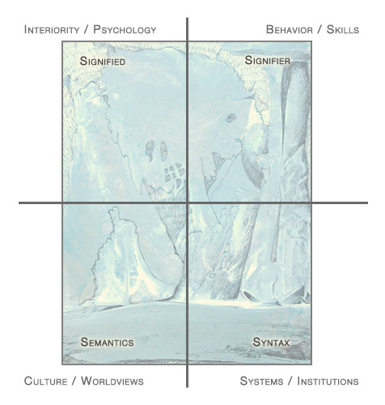
Figure 3 - Basic Zones of Pragmatic and Semiotic Art History
This divides external (pragmatic) and internal (semiotic) art history, a distinction going back many generations in the historiography of art history. In our approach both ways are honored, each coordinated via perspective-domains, and too are integrated, the divide between external and internal in the end dissolving in a dynamic constellation of the picture. The pragmatic matrix can be expanded to the eight hori-zones proper to an integral methodological pluralism of makers, users, receivers, with the quadrants of the semiotic matrix numbered with reference to the IMP scheme: UL as 9, LL as 10, UR as 11, and LR as 12. There are thus at minimum 12 perspective-zones proper to a picture and similar art-historical media. Here is a diagram of 12 perspective zones of the pragmatics of the artist and the semiotics of her painting:
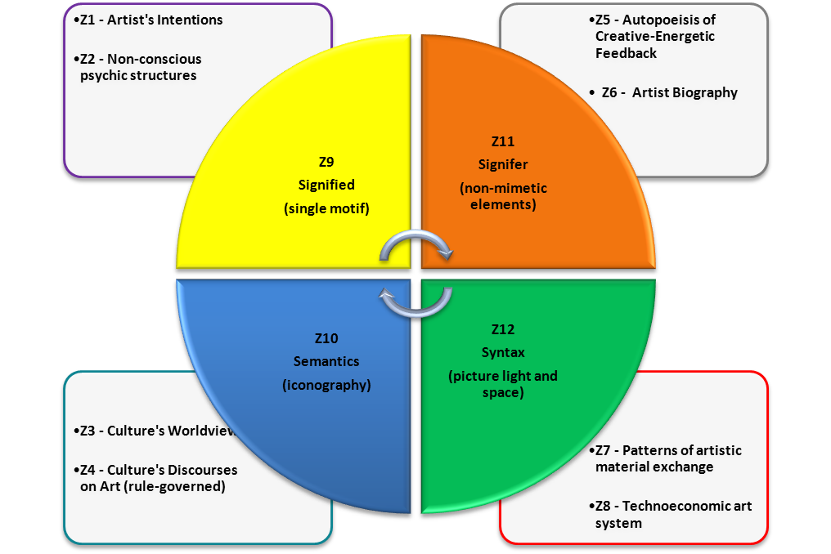
Figure 4 – 12 Zones of an Integrative Pragmatic-Semiotic of the Picture

Demonstrating operations of these zones and their constellated interrelation exceeds this prolegomena. For a simplified eight-zone guided practical engagement with the Jacobson drawing, as introductory to such issues, see the “Appendix” below.
Yet another facet of metadisciplinary art history is integral historiography. By and large integral circles employ modernist narrative logics of a macro or meta kind, stories about the evolution of the kosmos, sometime scaled down to that of humanity, with an occasional binary (“dialectical”) twist in the Habermasian dignity and disaster theme. The postmodern moment of micro-histories, let alone philosophically informed and researched genealogies (as in the recent work of Sloterdijk on the modern imperative of self-development), is rare in integral circles. Even when narrative capacities expand along with perspective-taking into turquoise and indigo waves, where attunement to historical time becomes vast and beyond one’s lifetime (coordinating high level action logics, or what I would call action schemata), and where the modes of temporality can come to exceed linearity, integral tends to fall back upon modernist tales of irreversible linear historical time—or said otherwise, orange historiographic imagining is carried forward into higher altitudes of cognition and embodied being in the world without much adjustment.
A second-tier integral historiography embraces the postmodern moment in critical fullness, leading to enacting and coordinating the complexities of various forms of narrative logics, modes of temporality, and scales of investigation. Historical schemas too proliferate, inclusive of Hegel-like meta-stories, Foucaultian genealogies, and Benjaminian messianics. Temporalities and tempos of becoming bloom—both in horizontal and vertical ways (the latter proper to Heideggerian ontological eventing, Ereignis, and also to gross-subtle-causal “causalities” cum emergence). Macro, meso, and micro scales of inquiry and scholarship all are enacted and honored, the micro no longer dominated in an orange top-down universal-subsuming manner. Integral historiography is also conducted in a manner that gathers sufficient data to flesh out the specific historical inquiry. There are no less than five moments or tropes of an integral historiography: (1) antiquarian: textured research, attentive to surface structures, that objectifies the past horizon with the present (3rd person); (2) dialogical-axiological: a value “dialogue” between the two horizons (2nd person); (3) monumental-exemplary: aspects of the past are taken back into to the present as exemplary moments and monuments (1st person); (4) genealogical-symptomatic: discerning individual and collective dissociations and kinks that engender unnecessary pain and truncated growth at any given tetra-wave of development (shadow diagnosis); (5) messianic-karmic-eudaimonic: the recollecting of the unnecessary pain and suffering of ancestral sentient-beings, the lessons gleaned as such from the historiographic work to be imbibed and lived so to move us in the direction of preventing those past forms of unnecessary pain and suffering from happening ever again, redeeming -- from the messianic point of view of a utopian future – that past suffering without then forgetting those who came before, all in light of the coming forth of the eudaimonic society of the flourishing of each and all.
Another facet of integral historiography is that of how historical inquiry engages and (re)figures time (where time – as well as space -- is disclosed differentially for all four quadrants), reflection upon which includes issues of narrative, emplotment, the relation between history and fiction, and the interplay between big picture master-narratives and more thematically focused historical accounts of varying degrees of scale such that the big picture changes in light of ongoing historical research, this research itself illumined by the big picture tale. With regard to the quadrants themselves, there is the lived time of the UL (Husserl, Heidegger), the interactive time of cultural-symbolic exchange (Bourdieu), the objective time of natural processes (natural science, e.g., the space-time of quantum mechanics), and the time of systems (systems theory) – where how these interact and co-constellate is as important as it is daunting. Here DeBord’s chapters on time in Society of the Spectacle are an inspiring exploration of how the chronological unfolding of modes of production condition individual and collective senses of time.
Metadisciplinary art history takes up and integrates these pragmatic, semiotic, and historiographic dimensions through attunement to and internalization of the conatus of the concretizing-historicizing of works of art.

Art Criticism and Evaluation (ACE)
In our consumer culture we train up in the making of snap evaluative judgements, including with regard to works of art. But as we have seen, art is multi-dimensional and complex – better then to bracket our value judgments prior to “getting to the fact of the matter” with sufficient patience and depth. In this light the directives of Lonergan are most welcome. In the opening sections of Method in Theology, he posits the training up of “differentiated consciousness.” Lonergan forwards a zone 1 method of working with intentional acts sedimented in consciousness. Achieving differentiated consciousness is to engage in phenomenological reductions that unearth and differentiate from one another several types of intentional acts that otherwise are operative in a chaotic, confused manner. As I understand his adaptation of Husserl, first a certain kind intentional act (and its object) are de-sedimented by making them object to awareness. Second this is done for each of the types of intentional acts. Third, those intentional acts – attentiveness, methodical understanding, rational judgment, value judgement – are each trained up and exercised. Fourth, these differentiated intentional acts, now trained up, are integrated with one another, such that over time this settles into the ongoing operations of mind as power of the knowing and acting subject. This is perhaps less a growth in developmental altitude as much as work within a given wave, a kind of “transversal development.” Procedurally, one moves from sustained attention to gather sufficient evidence; methodological enactment to forward and deepen understanding; “rational” reflection as a meta-step back to judge the sufficiency of the first two moments (an ethos of self-honesty inclusive of assessing one’s evidential thoroughness and understanding biases); and upon an affirmative answer to the third moment, a moral judgment as to the value of what in our case is the artwork, this judgment based on some normative criteria. Lonergan’s differentiated consciousness and its attendant procedures are important correctives to current socio-cultural practices, where evaluation is often instantaneous, of a knee-jerk brand, pre-rational, consumer-oriented, and entitled in sentiment, which bypasses the sustained gathering of data for methodological investigation.
In making value judgments about art, the differentiation of historical horizons is all-important, especially in an age of virulent “political correctness” coupled with the waning of historical sensibilities. One differentiates the past horizon within the present (antiquarian moment). The artwork’s reworking of drives and meanings is then evaluated within its own context for progressive, regressive, utopic, and ideological dimensions; setting this into dialogue with the present moment and its norms (dialogic-axiological moment). Judgment involves: (1) evaluating the values of the work with regard to the norms of its own historical horizon; (2) evaluating the norms of the work with regard to the present historical horizon; and (3) setting these evaluative judgments into critical dialogue with one another, where what can come out of this encounter are normative insights, and even from the past itself, folded into the present as moral resource (monumental-exemplary moment).
What then about normative criteria of making value judgments of art?
Integral theory embraces both non-duality and duality. The perfection of the non-dual, the inherent and forever goodness of all that is and that can ever be, is always already “rubbing up against” the brokenness and suffering of the duality that it always is. Holy sparks ignite, a murmuring can be heard -- a silent whisper that is the call of good, the good always already calling actuality to be otherwise. This call of the good reverberates through the quadrants, differentiating as a tetra-call – as the hyper-goods of freedom, responsibility, vitality, and justice (figure 5). This tetra call of the good is the moral source, the normative touchstone, for our moral judgments – including those about art. It is, translated as the dynamic calling of the good, a condition of the possibility of what Bhaskar calls the pulse of freedom from primal scream to the eudaimonistic society as the flourishing of each as the flourishing of all; where this pulse of freedom, as real moral ideal, pervading the socio-cultural as geo-historical tendency, without necessarily ever becoming actualized in lieu of the splits and ills of the demi-real. The evaluation of the artwork is considered in this light, attuning to the tetra-call, drawing upon critical realism’s forms of emancipatory and metacritique, analyses of ideologies and TINA formations, explications of modes of alienation, and diagnostic of splits, ills, and absences -- all as proper to the demi-real -- to be coupled with integral’s insights into holonic forms of shadow (arrogant, dissociative). Such would be the normative grounds for judging an artwork’s promise; evaluating this promise via the principle of the enhancing-increasing of moral goodness through art.

Figure 5 – Tetra Call of the Good

Art, Reality, Spirituality (ARS)
Integral theory posits gross, subtle, causal, witnessing and non-dual states of being. These states presumably access realms of being that in some respect exist independently of human being –although to argue for this reality-thesis, as regards states accessing pre-existing realms, is a challenging task, one bracketed in this prolegomena. It may be that between states as transitive access to intransitive realms of being is not as clear-cut as it is for nature as investigated by science. In any case, what can be said for now is that these state- realms can and are be accessed by, pointed to, and transmitted by works of art. (The discussion above on the modes of aesthetic shining is grounded in the view that art, in some manner, accesses or references state-realms.) What is entailed in this process of art pointing to / expressing state-realms is not as self-evident as it might first appear.
What we can offer for the moment, if as intuition, is that: (1) a given medium of art has propensities as respective strengths and weakness in comparison to other media for referencing and expressing a specific state-realm; and (2) that this medium’s referencing and expressing of specific a state-realm itself has stronger and weaker, more direct and less direct, artistic instantiations of its doing so. The first point is an extension of insights from the discussion about an art-media’s open-ended expressive capacities. The second point stems from Wilber’s scattered writings and remarks on art; Wilber having generated brief, suggestive, and innovative typologies of how strongly/weakly an artwork references/expresses a state-realm, constituting an originary if unfinished project. Related to this theme, the ARS box in the Main Chart offers speculations on the conatus/principles that animate art in relation to each the various state-realms – a contribution that stands as a hypothesis pending further research and reflection.
Because state-realms pervade all the ontological domains of the four metadisciplinary matrices, ARS is an irreducible and essential component of the overall project. One tantalizing question is how and to what degree do these state-realms impact the gross domain when alienated from the human gross domain in contrast to when they are integrated with the human gross domain? Wilber, Bhaskar, and others have much to offer these kinds of considerations, while too there is much work still to be done.

The Impact: Metatheory Catalyzing Effective Change in the Arts
This prolegomena to the metatheoretical project of art’s transdisciplinarity is not theorizing onto itself but has been catalyzing effective change over the past decade in the training of young studio visual artists at Georgia Regents University (a Carnegie-Mellon tier one research institution in the University of Georgia System). Grounded in professional competency (and publications) in art history, art criticism (inclusive of curation), critical social theory, metatheory (integral theory and critical realism), continental philosophy of art and aesthetics, moral philosophy, and comparative spirituality, this metatheoretical project informs a four-course undergraduate sequence that has impacted well over a 100 art student graduates over the past decade and a half (see note 47). One student, Katie Harris, deeply engaged with integral theory, created a senior art exhibition the Brilliance of Nothing (figure 6; March 23-April 2, 2012) that “transcended and embraced” the divergent display protocols of gallery modernism and installation postmodernism. Her art exhibition subsequently won a university-wide undergraduate research award, with her giving a campus-wise presentation (Fall 2012). The works in her show presented themselves as self-standing monuments in their own right (modernist), absorbing viewing attention into the effective modelling and evoking of the emptiness and fullness dimensions of causal state-realms; while there was also an activating of the exhibition environment as a whole (proper to postminimalist installation currents), establishing interrelationships amongst all facets of the exhibition (including the price list, in thematizing economic currents otherwise invisible of that lived space), such that rather than absorption into the world of a given artistic artifact, a beholder finds herself immersed in an installation environment enchanting her embodied motility – these two paradigms of display and reception seamlessly integrated with exemplary artistic coherence. Or, in the artist’s very own words:
Art today most often expresses what are called “first tier,” pre-integral modes of thinking and being in the world where the motif for exhibiting in a gallery is almost entirely to display the work against the background of the exhibition hall or installed in the gallery space. Instead, I take an integral approach that transcends and embraces both modernist display and post-modernist installation, working towards art that is incipiently “post-postmodern.” The reason for this experiment is to propel art to a higher and fuller cognitive and artistic wave of development. Extensive research was performed on topics of analog and digital photography, ceramic post minimalist floor sculpture, integral theory, causal states of energy, voids, monochromes aspiring to express these kinds of spiritual states, artwork of the 19402-1970s, and modern and postmodern modes of displaying art. This research was used to create the art, and to develop an experiential installation for the viewer as they entered the gallery space. The result yields two main products: integrally created artwork that challenges the traditional boundaries of medium and an experiential installation of works in a professional gallery space holding both modern and postmodern gallery characteristics simultaneously while maintaining overall cohesiveness.
Brilliance as Nothingness as a whole modeled second-tier stage-consciousness, provoked states of causal emptiness and fullness, while honoring the everydayness of our lives as enchanted embodied dwelling. This is just one instance of how the project of art’s transdisciplinarity is already impacting actual art.

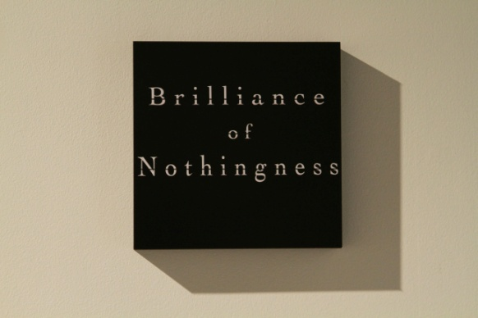
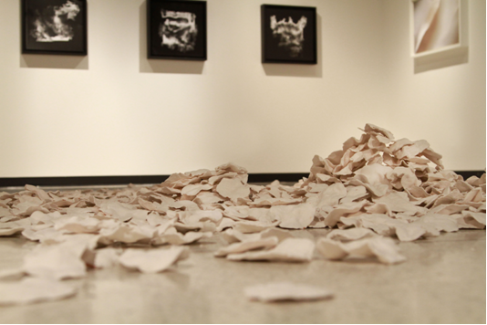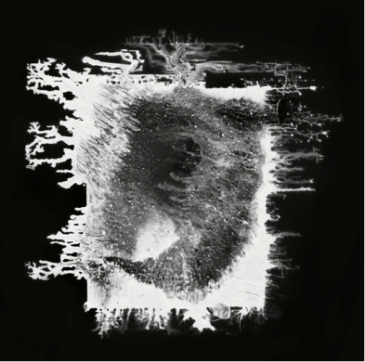
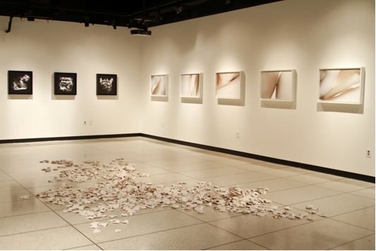

Figure 6 –Katie Harris, Brilliance of Nothingness, 2012
Appendix
Drawing on Schwartz 2009 in referencing figure 3, this appendix is a gentle introductory guide into an integrative engagement with Jacobson’s drawing Light of Muse.

- Pragmatics
Via email I asked Jacobson some questions about the drawing: its size, materials, and working methods. His generous reply is included below.
We sometime forget that in looking at art on the internet we are looking at a reproduction. It is important in this light to reconstruct sensuous features imaginatively to deepen and attune our aesthetic engagement.
Most of what follows is proper to the artist’s individual interior (intentions, states) and individual exterior (behavior, skills): the UL and UR of the artist’s being in the world and making the drawing.
The opening of Jacobson’s response reports that this “piece was commissioned,” pointing towards social-cultural dimensions: to the artist’s meaningful relationship and interactions with the patron (LL), and to the artist’s social and economic exchanges with the patron (LR). These collective dimensions will not be developed as finely in the present exploration.
Please pay attention to Jacobson’s account of the genesis of this automatic drawing; looking carefully at the drawing in light of this account:
This piece was commissioned. The collector wanted an "automatic drawing" (which, when finished, I sometimes call "Shambhala"), but in truth it should be left open: so 'automatic drawing' is fine.
It is 11 x 14 inches in size. Its materials are heavy weight paper, resin-oil painting medium, glass powder, egg tempera white, water, cobalt blue and zinc white oil paint, black felt pen.
The paper itself was originally a light silver gray with an almost metallic like feel to the surface, heavily coated with a semi-glossy finish. I then made an 'imprimatura' or first-ground with powdered glass, and a slightly tinted blue-white oil color all mixed together in a home-made resin-oil painting medium. A glaze was evenly applied to the surface. This took about 10 minutes. Let dry.
I then took my egg tempera white and diluted it in water. I dipped a twisted rag into the white, sopping wet. I then sat and stilled my mind. In a clear 'no-mind' state I took the white-wet-rag and rolled it on the surface, squeezed more white out of the rag and let it drip and pour onto the paper and then removed some white. So a kind of add and subtract process randomly creating abstract forms. This part took about 2 minutes. Let dry.
Finally, I came back to the piece with a black felt pen and sat. I looked at the piece - became lost in the abstract forms until in a few moments I saw the entire celestial scene (not unlike a Rorschach test) … like some landscape made of light. I immediately started making the vision solid by drawing it out from behind the veil of the surface it lived in. This final stage took about 20 - 30 minutes and was quite fluid and liberating unlike my more meticulous works that can be labor-intensive for months.
Notice how this account shapes and deepens one’s sense of the drawing.

- Semiotics
With regard to the drawing, the first two semiotic perspectives concern, for the most part, the content or the what; while the second two perspectives concern, for the most part, the form-and-materials or the how -- the ways the drawing “makes sense.”
Step 1: Signified (UL)
The contents of the representation: the recognizable objects in the drawing, its individual motifs.
We see a tree, other forms indicating flora/rocks/ mountains; a background that is perhaps radiant sky, perhaps a distant element of the landscape itself; and a foreground of earth that, at right especially, indicates a ledge or plateau.
To be sure, the specific natural motifs are often allusive in this drawing, the same form open to multiple identifications, and in some places confounding scale (e.g., proximate rocks/ more distant mountains).
Step 2: Semantics (LL)
This perspective discloses the theme of the drawing and the semantic field or fields in which this overarching theme belongs. We reconstitute this wider semantic field by referencing texts on the theme and related pictures. (Traditionally this is the method of iconography).
The general theme of the drawing is nature and place; the pictorial genre landscape. We could read texts on the status of nature, as well as those on sacred places like Shambhala (which the artist mentions in his account of the drawing process). We could look at various traditions of pictorial landscape: including Western landscapes (which emerged during the 16th and 17th centuries), Asian landscapes, drawing and watercolor close-ups of nature (as the drawing plays on scale).
Step 3: Signifier (UR)
Individual elements of pictorial signification: size, scale, lines, shapes, color, value, format (shape of field), position of elements in the field, types of forms (delineated, painterly), boundaries of image-field and internal to the field, kinds of marks, materials.
(The artist’s account relays the physical size and materials of the drawing. Note too that any given material has a sensuous-feel and a distinctive not-easy-to-articulate expressive or affective quality. See above the section on PAA and the discussion of aesthetics.)
The field is a vertical rectangle (stressing the vertical rather than horizontal axis of perception). Shapes of the recognizable motifs are formed through external black contours lines. (Notice the qualities of these external contour lines – their thicknesses or thinness, amount of ink, rhythm-flow, and so on.)
Internal contours, minimal in this drawing, form shapes within -- as with openings in the tree-like motif. Other internal marks evince surface texture, shading, and apparent solidity. The marks forming the upper background are repetitions of a like mark, yet fluid and spontaneous in feel, each mark singular.
This upper background has a more or less uniform whitish ground. The inside of a number of the mid-level shapes have decisively painterly tones and hues: luminous and shimmering whites, blues, and pinks that radiantly, and mysteriously, dissolve or complicate the status of the form’s surface; in places “out shining” surface solidity altogether. With these painterly blotches we have an invitation to re-enact part of the artist’s own creative process: his looking into abstract forms and allowing recognizable realities to emerge.
Step 4: Syntax (LR)
Syntax is the wider arrangement, ordering, and patterning of the image-field established through the formal relationships amongst the visual elements (signifiers), picture light, and picture space (figure/ground; void).
The image-field as a whole is articulated into delineated areas through external contour lines, generating an interlocking and intersecting array of shapes. Inside any given delineated area is a distinctive pictorial rendering – from various modes and effects of line to blotches of shimmering tones and hues. Light, variously indicated, seemingly radiates outward rather than cast from an external source onto objects. Figure/ground relations shift and oscillate; with the foreground ambiguating its dimensions of depth and height.
The whole is dynamic, multivalent, and radiant: maintaining throughout compositional integrity.

Step 5: Part/Whole
- Practice moving into each semiotic perspective.
- Then back and forth amongst them, comparing and contrasting.
- Get a sense of the uniqueness of each. And allow the perspectives to affect one another, such that there is a deepening sense of their interplay.
- Notice that through this interplay there slowly emerges a sense of the integration of the what (UL, LL) and the how (UR, LR) of the drawing.
- There is no conclusive end to this expanding and deepening play of part and whole.
- The animating principle or conatus is the concretization of this art-work in its (historical) singularity.

- Pragmatics <--> Semiotics
Now take the integrating process further – bringing together the external and internal perspectives while looking at the drawing. This is the ongoing dance of part and whole in understanding. It is a circle, or perhaps a spiral, such that there are no analytic rules for how to take up the perspectives on art and integrate them into greater and greater fullness and non-fixity, an openness for the ongoing process of deepening understanding, the conatus of the concretizing-historicizing of just-this artwork.

Bibliography
Agar. J. (2014). Post-Secularism, Realism and Utopia: Transcendence and Immanence from Hegel to Bloch. London and New York: Routledge.
Benjamin, W. (1968a). “The Work of Art in the Age of Mechanical Reproduction.” In: Illuminations: Essays and Reflections. New York: Schoken Books.
Benjamin, W. (1968b). “Theses on the Philosophy of History” In: Illuminations: Essays and Reflections. New York: Schoken Books.
Bhaskar, R. (1986). Scientific Realism and Human Emancipation. London: Verso.
Bhaskar, R. (1989). The Possibility of Naturalism: A Philosophical Critique of the Contemporary Human Sciences, 2nd ed. New York: Harvester Wheatsheaf.
Bashkar, R. (1993) Dialectic: The Pulse of Freedom. New York: Routledge
Bhaskar et. al. (2015a). Metatheory for the 21^{st-}Century: Critical Realism and Integral Theory in Dialogue. London and New York: Routledge.
Bhaskar et. al. (2015b). Metatheory for the Anthropocene: Emancipatory Praxis for Planetary Flourishing. London and New York: Routledge.
Bloch. E. (1988). The Utopian Function of Art and Literature: Selected Essays. Cambridge, MA and London: The MIT Press
Bogue, R. (2003). Deleuze on the Arts (3 volumes). London and New York: Routledge. I: Deleuze on Literature; II: Deleuze on Cinema; III: Deleuze on Music, Painting, and the Arts.
Bourdieu, P. (1990). The Logic of Practice. Stanford CA: Stanford University Press.
DeBord, G. (1994). The Society of the Spectacle. New York: Zone Books.
DeKay, M. (2011). Integral Sustainable Design: Transformative Perspectives. London: Routledge, Earthscan Publishing.
Deleuze, G. (2003). Francis Bacon: The Logic of Sensation. Minneapolis: University of Minnesota Press.
Deleuze, G and F. Guattari(1994). What is Philosophy? New York: Columbia University Press.
Derrida, J. (1992). The Other Heading: Reflections on Today’s Europe. Bloomington: Indiana University Press.
Edwards, M. (2010). Organizational Transformation for Sustainability: An Integral Metatheory. London and New York: Routledge
Elkins, J. (n.d.). http://www.jameselkins.com/, retrieved 5-3-2015.
Esbjörn-Hargens, S. (2012). Tetra-Dynamics: Quadrants in Action. Sebastopol, CA: MetaIntegral Foundation.
Figal, G. (2015) “At the Limit: A Commentary on Transfigurements.” In: On the True Sense of Art: A Critical Companion to the Transfigurements of John Sallis, eds. J. Wirth, M. Schwartz, and D. Jones. Evanston: Northwestern University Press.
Freud, S. (1961). Civilization and its Discontents. (The Standard Edition.) New York: W. W. Norton & Company.
Fried, M. (1967). “Art and Objecthood.” Artforum 5, 12—23.
Gadamer, H. (1975). Truth and Method. London and New York: Continuum.
Girard, R. (1996). The Girard Reader. Crossroads Herder.
Goodman, Nelson. (1976). Languages of Art. Indianapolis: Hackett.
Harris, K. (2012). Artist Statement / Abstract for Undergraduate Research Award Presentation at Georgia Regents University, Augusta GA (used with permission of the artist).
Harvey, D. (2014). Seventeen Contradictions and the End of Capitalism. Oxford: Oxford University Press.
Hegel, G.W.F. (1975). Hegel's Aesthetics: Lectures on Fine Art. 2 volumes. Oxford: Oxford University Press.
Heidegger, M. (1962). Being and Time. New York: Harper and Row.
Heidegger, M. (1975). “Origin of the Work of Art.” In: Poetry Language Thought. New York: Harper.
Holland, D. (2013). Integrating Knowledge Through Interdisciplinary Research: Problems of Theory and Practice. London and New York: Routledge.
Hoy, D. C. (2009). The Time of Our Lives: A Critical History of Temporality. Cambridge MA and London: The MIT Press.
Kelly, N. A. (2014). “Conscious Cosmopolis: Bernard J. F. Lonergan’s Critical Realism as a Complementary Approach to Integral Theory.” Journal of Integral Theory and Practice 9(1): 12-37.
Laske, O. (2008). Measuring Hidden Dimensions of Human Systems: Foundations of Requisite Organization.Vol. 2. Medford, MA: Interdevelopmental Institute Press.
Lonergan, B. (1971). Method in Theology. Toronto: University of Toronto Press.
Loy, D. (1996). Lack and Transcendence: The Problem of Death and Life in Psychotherapy, Existentialism, and Buddhism. Amherst, NY: Humanity Books
Lukács. G. (1971). History and Class Consciousness: Studies in Marxist Dialectics. Cambridge MA: MIT Press.
Marx. K. (1972). The Grundrisse. New York: Harper and Row.
Marx, K. (1980). Economic and Philosophic Manuscripts of 1844. Moscow: International Publishing House.
Merleau-Ponty, M. (1993). “Eye and Mind.” In: The Merleau-Ponty Aesthetics Reader. Evanston: Northwestern University Press.
Morin, E. (2008). On Complexity. Hampton Press.
Nietzsche, F. “(1997). On the Use and Disadvantages of History for Life.” In: Untimely Meditations. Cambridge UK; Cambridge University Press.
Nietzsche, F. (2000). The Birth of Tragedy. Oxford and New York: Oxford University Press.
Rentschler, M. (2008). “Advancing Integral Art.” Journal of Integral Theory and Practice 3 (3), 128-160.
Riegl, A. (1985 ). The Late Roman Art Industry. Rome: G. Bretschneider.
Sallis, J. (1998). Shades - Of Painting at the Limit. Indianapolis: Indian University Press.
Sallis, J. (2008). Transfigurements: On the True Sense of Art. Chicago and London: University of Chicago Press.
Schwartz, M. (2007). “Occasions of Art.” Plenary Talk at Annual Meeting of the Comparative and Continental Philosophy Circle, Seattle University. https://www.academia.edu/8683933/Occasions_of_Art, retrieved 5-2-2015.
Schwartz, M. (2008). “Foreward.” In: P. R. Jacobson, Promethean Flames: Rekindling and Re- visioning the Creative Fire (volume two of a trilogy on art and spirituality), https://www.academia.edu/8707706/Towards_a_Post-postmodern_Art_An_Alternative_Art_History_, retrieved 5-5-2015.
Schwartz, M. (2009). “Looking at the Overlooked: Integrally Experiencing a Jacobson Drawing.” Parts1-5. https://www.integrallife.com/art-galleries/aesthetic-practice-looking-overlooked, retrieved 5-2-2015.
Schwartz, M. (2010). “Frames of AQAL, Integral Critical Theory, and the Emerging Integral Arts.” In: S. Esbjörn-Hargens, ed. Integral Theory in Action. Albany NY: SUNY Press.
Schwartz, M. (2013a). Book review of DeKay (2011). Integral Review 9 (1), 106-109.
Schwartz, M. (2013b). “On Social Holons, Ideologies of Integral, and the Kosmopolitan Call of Politics: Beyond Methodological Individualism in Integral Theory and Praxis.” Journal of Integral Theory and Practice 8 (3 and 4), 163–174.
Schwartz, M. (2013c). “Mandala: on the Logos of Place.” Paper presented at the Annual Meeting at the Pacific Association for the Continental Tradition, University of San Francisco. https://www.academia.edu/8620611/Mandala_On_the_Logos_of_Place, retrieved 5-5-2015.
Schwartz, M. (2014). “Bhaskarian Dialectics, Meta-Reality and Integral’s Third Tier.” Invited paper presented at the International Conference on Critical Realism, University of London.
Schwartz, M. (2015a). In the Spirit of Wholeness: Integral Art and its Enchantment Aesthetic. (Art Exhibition Book Catalog). Sebastopol, CA: MetaIntegral Foundation.
Schwartz (2015b). “MetaReality and the Dynamic Calling of the Good.” Journal of Critical Realism (special issue on the philosophy of metaReality).
Schwartz, M. (2015c). “After Integral Gets Real: On Meta-Critical Chiasma of CR and IT.” In: Bhaskar et al (2015a).
Schwartz, M. (2015d). “On the Post-Metaphysics of Painting: Raphael at the Limit.” In: On the True Sense of Art: A Critical Companion to the Transfigurements of John Sallis, eds. J. Wirth, M. Schwartz, and D. Jones. Evanston: Northwestern University Press.
Schwartz, M. (2015e). “On Bhaskarean and Laskean Dialectics (In Memory of Roy Bhaskar 1944-2014). Paper presented at the Annual Meeting of the Comparative and Continental Philosophy Circle. University of Iceland. Reykjavik, Iceland.
Schwartz, M. (2016). “Sallis and Dzogchen Buddhism.” Frontiers of Philosophy. Draft available at https://www.academia.edu/8620552/Sallis_and_Dzogchen_Buddhism, retrieved 5-5-2015.
Schwartz (forthcoming).”Tetra Call of the Good.” In M. Schwartz and S.Esbjörn-Hargens, eds. Dancing with Sophia: Integral Philosophy on the Verge. Albany, NY: SUNY Press
Sloterdijk, P. (2013) You Must Change Your Life: On Anthropotechnics. Malden MA; Polity.
Stein, Z. (2007). “Modeling the Demands of Interdisciplinarity: Toward a Framework for Evaluating Interdisciplinary Endeavors.” Integral Review 4, 92-107.
Stein, Z. (2013). Personal communication
Summers, D. (2003). Real Spaces: World Art History and the Rise of Western Modernism. Phaidon Press.
Vandenberghe, F. (2014). What's Critical About Critical Realism?: Essays in Reconstructive Social Theory. London and New York: Routledge.
Verstegen, I. (2012). A Realist Theory of Art History. London and New York: Routledge.
Washburn, M. (2003a). Embodied Spirituality in a Sacred World. Albany NY: SUNY Press.
Washburn, M. (2003b). “Transpersonal Dialogue: A New Direction.” Journal of Transpersonal Psychology, 35 (1),1-19.
Webb, E. (2009). Worldview and Mind: Religious Thought and Psychological Development. University of Missouri Press.
Wilber, K. (1996). The Atman Project: A Transpersonal View of Human Development. Revised edition. Wheaton, Illinois and Chennai (Madras) India.
Wilber, K. (n.d.). “To See a World: Some Technical Points.” http://www.integralworld.net/kiefer.html, retrieved 5-3-2015.
Wilber, K. and C. Fuhs (n.d.). Core Integral - Advanced Integral Course: First Lesson. https://www.coreintegral.com/advanced-integral-course-details, retrieved 5-2-2015.
Wind, E. (1984). “Warburg’s Concept of Kulturwisssenschaft and its Meaning for Aesthetics” (1930). In: The Eloquence of Symbols: Studies in Humanist Art. Oxford: Oxford University Press.
Wollheim, R. (1990). Painting as an Art. The A. W. Mellon Lectures in the Fine Arts. Princeton: Princeton University Press.

Art’s Trandisciplinarity (Main Chart)

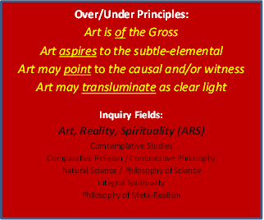

Bhaskar 1989 and Bhaskar 1986.
On this four stadia dialectic, see Bhaskar 1993 and Laske 2008. (For commentary, see Schwartz 2015e.) See also Esbjörn-Hargens 2012, whose initial presentation of the tetra-dynamics course deeply altered my sense and enactment of the quadrant model. I now see his teaching as a dialectic of the quadrants, where the specific forms of tetra-dynamics contribute to the terms of Bhaskar’s four moments of the MELD scheme and also of Laske’s twenty-eight dialectical though forms (DTFs).
A generation ago there was the likes of Leo Steinberg (University of Pennsylvania); today scholar-critics such as Thomas Crow (Institute of Fine Arts, NYU) and Hal Foster (Princeton University).
Deleuze 2003; Sallis 1998.
Figal 2015. On should add that Gary Shapiro’s ongoing work on the philosophical history of Earth Art is an exemplary integration and cross-fertilization of continental philosophy and art history, rare in the honoring of the best of both disciplines.
“Archive” in the Foucaultian sense; see Schwartz 2015d.
Schwartz 2007.
Stein 2007.
On these dialogues, see Bhaskar et al 2015a and 2015b. For stress on integrative methodology, see Edwards 2010; and for stress on realist ontology, see Holland 2013.
For an extended discussion, see Schwartz 2015c
Vandenberghe 2014
Schwartz 2013b and Schwartz 2015c.
As regards the proliferation of metatheoretical models in integral studies, while these are welcomed with gratitude, there may be a tendency towards an abstracting from specific knowledge domains (cf. critical realism and its view of philosophy as underlaborer for already existing sciences) in generation of evermore “shining” models, a symptom perhaps of beautiful soul syndrome that seems to pervade many an integral worldspace (although too this syndrome seems to be waning). Hence the importance of the title of the current conference: “Integral Impacts: Using Integrative Metatheories to Catalyze Effective Change.” In this regard, see below the section on “The Impact: Metatheory Catalyzing Effective Change in the Arts.” See also note 47.
Bhaskar 1993
cf. the discussion of Nancy and Sallis in Schwartz 2015d.
Stein 2013, who in my working with him on a consulting project that involved Lectica testing explained principles as what at higher altitudes gather emergent but still disparate skills into wholes, entailing a leap in the order of knowing and of skilled-capacity in a given life-domain, therein “norming the [prior lower level] norms.” Wilber and Fuhs n.d. discuss second simplicity as achieved through the activation and internalization of the three principles of non-exclusion, enactment, and enfoldment.
Bhaskar 1993 and Morin 2008.
Washburn 2003a and Washburn 2003b. This latter article contains important insights as regards the UL and the distinction between of lines of development that ascend as structural-hierarchical and others that require, at some point in the line’s development, descent as spiral-dynamic (“regression in the service of transcendence)”.
Girard 1996.
For example, see Marx 1980, Marx 1972, and Bhaskar 1993. On contemporary capital and its seventeen contradictions, see Harvey 2014.
Lukács 1971 and DeBord 1994.
Wilber 1996 and Loy 1996.
On the demi-real, see Bhaskar 1993.
“Trace” in line with the Levinasian and Derridean senses of the term. On dialectical tensions as traces of the presence of absence, see Schwartz 2014.
Freud 1961; Summers 2003.
On the themes of utopia, hope, and promise see Bloch 1988; Derrida 1992; Agar 2014. See also Schwartz forthcoming; Schwartz 2015b; and the section “Art Criticism and Evaluation” below.
Riegl 1985 was concerned in the first instance with formal developments internal to art itself, although in the end the sense of a given historical Kunstwollen is aligned with that historical moment’s worldviews as found in (external-to-art) philosophies and theologies.
Heidegger 1975.
See Wollheim 1990 and also Merleau-Ponty 1993.
For further discussion of artistic twofoldness as the gathering-doubling conatus of the work of art, see Schwartz 2007.
See Sallis 2008. In his many books, Sallis has shown that there is no single term or sense of beauty in Plato (which belies the integral notion of the big three going back to classical Greek philosophy), while advancing that the notion of shining is more robust than the inherited philosophical terms of beauty for the enactment of contemporary philosophical art criticism.
For example, Wilber n.d.
Schwartz 2008; Schwartz 2015a
Deleuze and Guattari 1994.
Heidegger 1962
Theoretically, this is a something of a Baumgartenian manner of construing the aesthetic of artworks, aligning in part with aspects of Washburn’s views (2003a and 2003b) on human development vis-a-vis the dynamic ground of being as descending return to that ground. Practically, one of the absences in art theory-practice-teaching is the lack of repeatable procedures to tease out through the skillful use of language the varying aesthetic look-feels of artworks in a manner more on the order of a pointing out for one another rather than as categorical subsumption that closes down the ongoing and deepening experience of the artwork.
See Esbjörn-Hargens 2012 on the tetra-dynamics of fractals and scanning.
For example: Hegel 1975, Nietzsche 2000, Goodman 1976, Deleuze (via Bogue 2003).
Fried 1967.
Benjamin 1968a. In a somewhat related vein, communication studies (often stressing the technological) are another rich source of insight into art media.
For an initial explication of Sallis’ notion of matrix in relation to prior senses of media, see Schwartz 2015d.
There are pioneering metatheoretical and metacritical scholar-practitioners working in several of these disciplines: Ed Sareth, Nick Wilson, Clayton Shotwell (music and musicology), Mark Allan Kaplan (film studies), and Dana Klisanin (communication media), to name a few.
For an integral study of architecture (a core art-historical media) as sustainable design, see DeKay 2011. For a review of this book, see Schwartz 2013a.
The numerous solo-authored books, articles, blogs, and edited volumes of James Elkins are a crucial inroad into the state of art history today (see Elkins n.d.). For a critical realist account of aspects of contemporary art history, see Verstegen (2012).
What follows draws on Schwartz 2009.
For example Wind 1984, a paper first published in German in 1930. Here Wind opposes the formalist and internal autonomy of art approaches of Riegl and Wölfflin to that of the cultural-context approach of Warburg.
Rentschler 2008 has published a preliminary typology of methods for each pragmatic zone. A parallel approach has been developed over the years in my teaching of university studio artist students, with focus especially on the methodologies and insights of the historiography of art history. In the third of a sequenced four course curriculum, students are introduced to the twelve zones of the pragmatic-semiotic approach, including exploration of zone interplays and constellations. In the fourth course they contribute to the integrally-enacted survey of art since the second world as “the history of contemporary art.” Their final project is this fourth class is an integral studio critique of one of their own artworks that must take up and integrate as many zone-perspectives as possible, their presentation conducted in the third person (“she created this work”), making their prior artist activity an object of reflection, which through the auto-critique becomes folded as such back into their ongoing development as artists, animating, clarifying and energizing that process, as a kind of Hegelian Bildung. Here is one an example of metatheoretical impact in the training of young artists; see further the section “The Impact” below.
This section draws on Schwartz 2010 and Schwartz 2013b.
Sloterdijk 2013.
Benjamin, 1968b.
The first three of these draw upon Nietzsche and Gadamer; the fourth on Freud and Foucault; and the fifth on Benjamin and Bhaskar.
Hoy 2009
Bourdieu 1990.
DeBord 1994
Lonergan 1971. For comparative analysis of Lonergan’s approach in relation to integral theory, see Kelly 2014.
Webb 2009 raises indirectly the question as to what level of cognitive development is required to conduct this differentiation of consciousness
On the integral moral philosophy of the tetra call of the good, see Schwartz forthcoming.
On the tetra-call of the good reformulated as the dynamic call of the good proper to metaReality, explicated as the condition of possibility of the axiology of freedom (opening up other axiologies centered in responsibility and in justice), see Schwartz 2015b. This latter paper was written after that on the tetra-call but has come into print first.
Hence the importance of the novel approach of the philosophy of metaReality (PMR), which folds into phenomenological analysis also transcendental argumentation about the metaReal (non-duality) as necessary condition for aspects of everyday social life. While this approach is robust and important, it is not clear that Bhaskar’s transcendental arguments extend far and wide enough to sustain certain of PMR’s seeming claims about the metaReal as condition (even “source” or “foundation”) of the real tout court. This is a live debate in critical realist circles. So, for example, Vandenberghe has suggested that the clear distinction in knowing between the transitive (epistemology) and intransitive (ontology) proper to the philosophy of transcendental realism of the natural sciences becomes partially collapsed in the subsequent philosophy of critical naturalism of the social sciences; and then, with the Bhaskarian spiritual turn of PMR, the distinction falls away altogether – or such is his provocative re-evaluation. As small contribution addressing a few issues involved, Schwartz 2015b distinguishes two modes of the transcendental with regard to non-dual metaReality: T₀ and T₁. The former references aspects of the metaReal that are transcendental to the real as enabling condition. The latter is the Self-appropriation of aspects of the former, such that there is an intensification of the conditioning force of the transcendental, as in appropriating non-dual love fueling one’s actions. Further, drawing on integral theory’s 1-2-3 of spirit, it is argued that there are three meta-perspectives that access differing dimensions of the metaReal, these dimensions as enabling conditions of aspects of the real (Bhaskar’s notion of transcendental identification now complemented by those of transcendental hearkening and transcendental releasement). Nevertheless, the stronger thesis that the metaReal is independent of the human as “foundation” of the real remains, for me at least, an open question.
A few of the questions that seem to be involved have been explored in a recent series of papers. In Schwartz 2016 there is a philosophical comparison between Sallis’ notion of the natural elementals and the Dzogchen Buddhist sense of the natural elements, leading to cross-fertilized insights. In Schwartz 2013c there is an exploration, grounded in Sallis’ post-deconstructive phenomenology of the logic of the imagination, that fleshes out the exorbitant logics (space-time-place-sense) of three subtle worldspaces -- using integral terms, that of (1) a subtle domain shamanic state-structure, (2) a subtle domain Vajrayana state-structure, and (3) a third-tier violet “stage-structure” (what is better called a configuration), leading into the exploration of their respective overlap and differences, where the third tier mode incorporates much of the first two while having additional novel dimensions. Also, in Schwartz 2014 there is a presentation of the Bhaskarean dialectics of a third-tier violet-configuration involving processes of transformation per group practice. Along with Schwartz 2015b and its consideration of the question of the non-dual metaReal as transcendental of the real, these are some initial ventures underlaboring for ARS.
Fried 1967 would come to define these two artistic modes as absorption and theatricality, pitting them even in this early essay against one another; the young Fried a critical defender of late modernist painting contra minimalism.
Harris 2012.

