Robert Bennethum CMSPC 441 HW 3

Problem and Approach
The problem is making a path-finding code for a delivery robot. It is to use the A* algorithm to make it work. I have decided to use a min heap to track nodes and pick the next node to be the one with the lowest f(n) score. Using the Manhattan distance gives the h(n) function. The path is completed by backtracking from the destination to the start.

Output
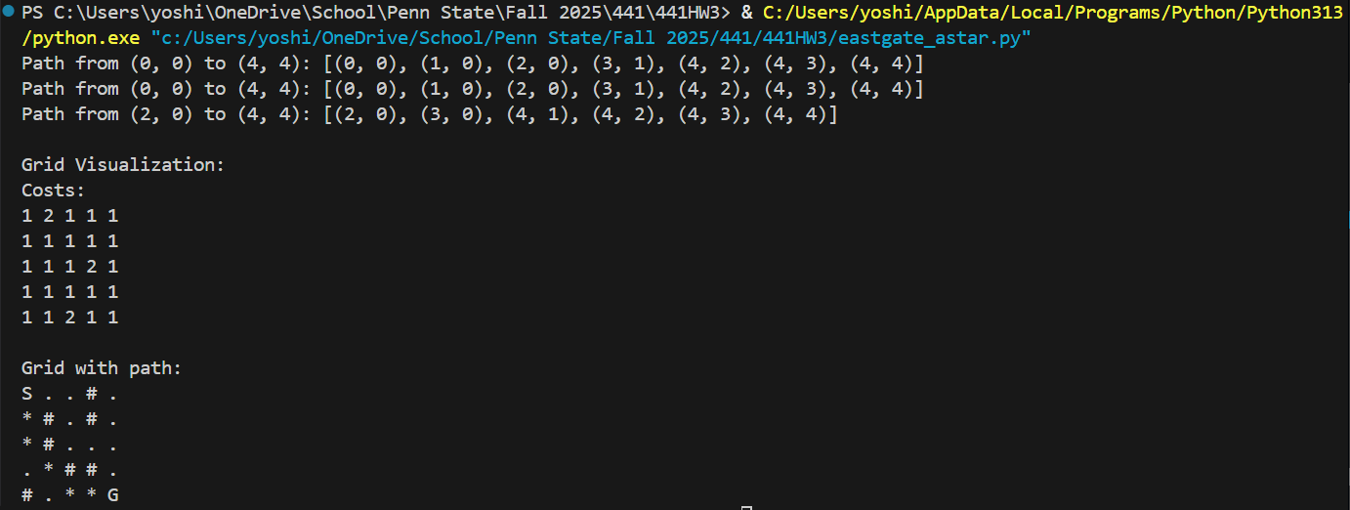
The paths are generated properly with the ability to traverse through in all 8 axes. The visualization shows how the path looks.

Heuristic Admissibility & Diagonal’s Effect on Optimality
The heuristic is admissible because the heuristic is never overestimating the actual cost.
The diagonal move helps by making a better optimal path because there are less steps and even though the cost for a diagonal movement is more than a 4-axis movement, it is still cheaper than making 2 steps to get to the same place.

Visualization
I have included the visualization in the code.

Assumptions
I have assumed that the objects are not moving after the program starts and all the information that is fed to the robot is still accurate when it gets to it. I am also assuming that the grid is fixed like a chess board and it can’t move halfway between spaces.

