Occupancy Detection
Robert B Fisher
Data Mining (DS 260)

Introduction
The purpose of this project is to build predictive models that determine whether an office is occupied based on environmental sensor readings. The dataset contains six variables collected at regular time intervals:
- Temperature (Celsius)
- Humidity (percentage)
- Light
- CO2 concentration (ppm)
- Humidity Ratio (ratio of humidity to temperature)
- Occupied
- ID.
The target variable Occupied indicated whether the room was occupied at a given moment. It takes one of two categorical values: Yes (1) or No (0). The goal of this project is to use the training dataset to clean the data, explore potential predictors, and build classification models that can accurately predict occupancy in the test dataset.

Data Preparation
The raw training dataset contained several issues that required cleaning before model building. The more important problem was the inconsistent labeling in the target variable Occupied. Although most entries were labeled “yes” or “no”, the dataset also contained values such as “Yes,” “Y,” “N,” and a few missing values. Because machine learning algorithms require consistent numeric labels, these inconsistencies had to be addressed.
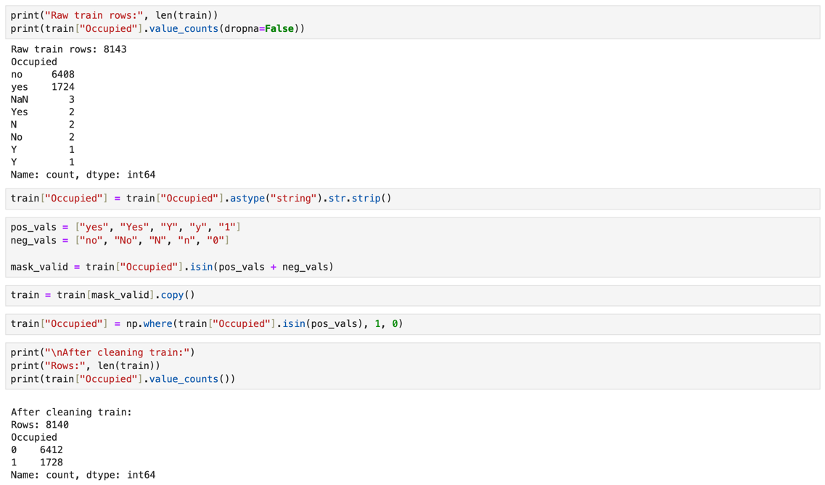
Using Python and Pandas, I first converted the Occupied column to lowercase strings, removed spacing, and mapped all valid positive labels to 1 and negative labels to 0. Any rows with invalid or missing target labels were removed. The following Python statements were used for data cleaning:
After cleaning, all labels were consistent, and the dataset was ready for modeling.

Training Set Exploration
To better understand the structure of the data, I computed the mean and median of each numerical feature (excluding ID and Occupied). These values help reveal typical sensor readings and potential outliers.
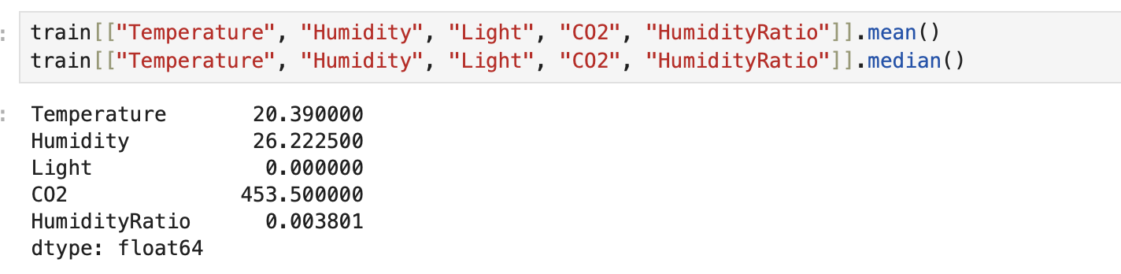
Time Series Exploration Using KNIME
Because the data was collected at regular time intervals, each feature can be viewed as a time series, showing how environmental conditions in the room changed over the measurement period. Although the assignment does not require forecasting, visualizing these time-series patterns help identify which features are most closely associated with occupancy.
To create these visualizations, I used KNIME’s JavaScript Line Plot node. For each feature, I selected RowID as the x-axis (representing time) and plotted one variable at a time on the y-axis. Below are all six time-series graphs and a discussion of what each reveals about the potential predictive power of that feature.
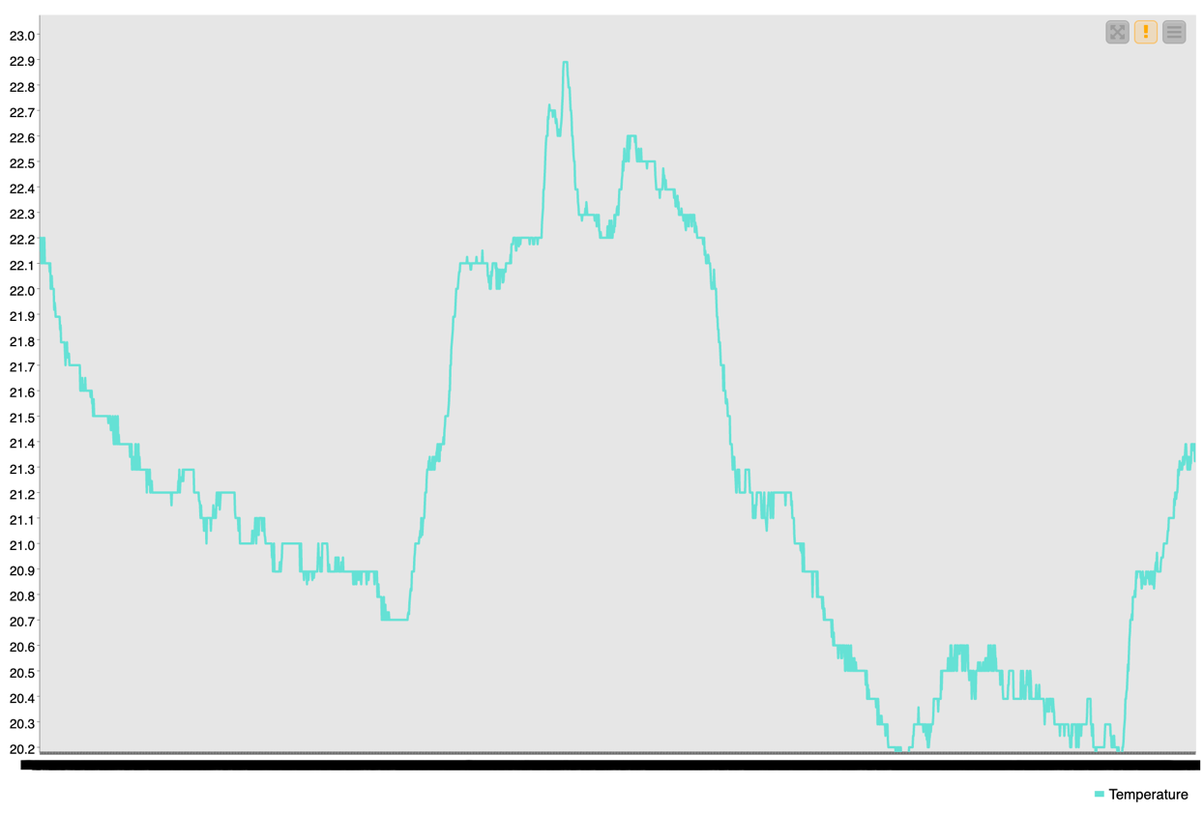
The temperature plot shows smooth and gradual fluctuations between approximately 20°C and 23°C. These changes appear to follow natural room conditions, such as HVAC cycles or normal heating and cooling, rather than sudden shifts associated with people entering or leaving. Temperature does not react sharply to occupancy and therefore appears to be a weak predictor of whether the room is occupied.
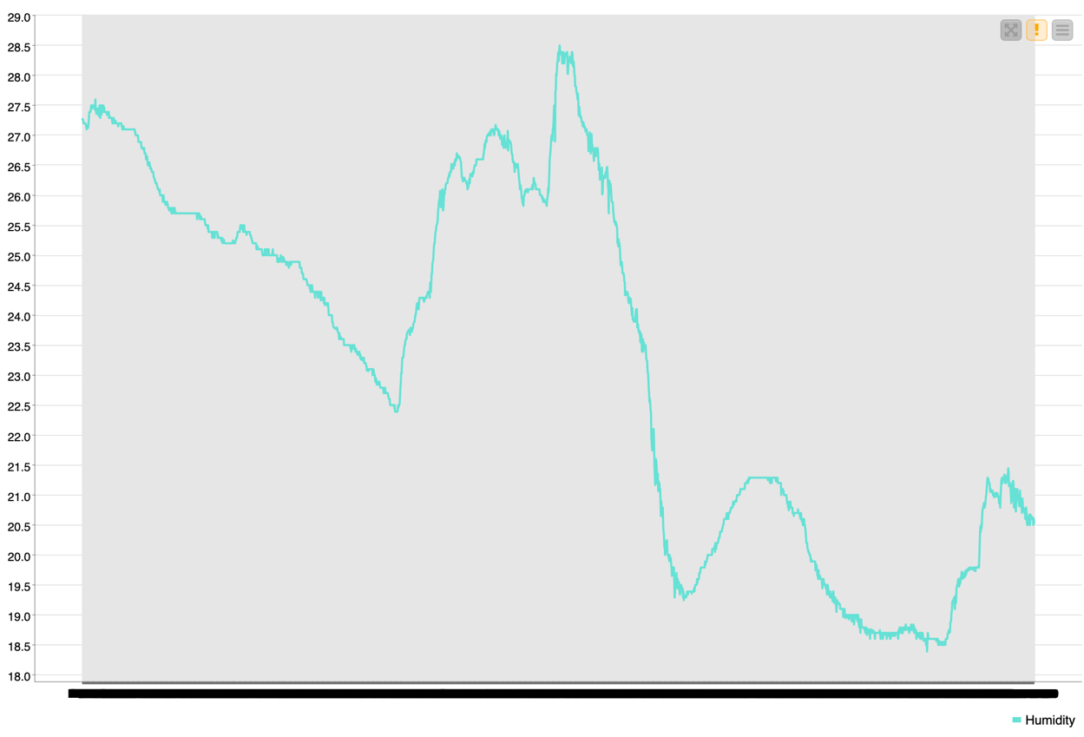
Humidity varies between roughly 18% and 28%, showing gradual rises and falls. These patterns are smooth and do not display any abrupt transitions. Like temperature, humidity changes slowly and does not correspond clearly with occupancy changes. Humidity is therefore also a weak predictor.
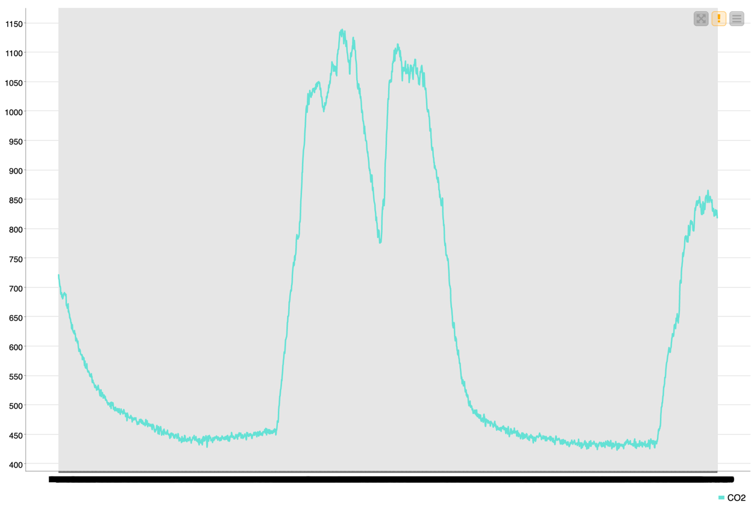
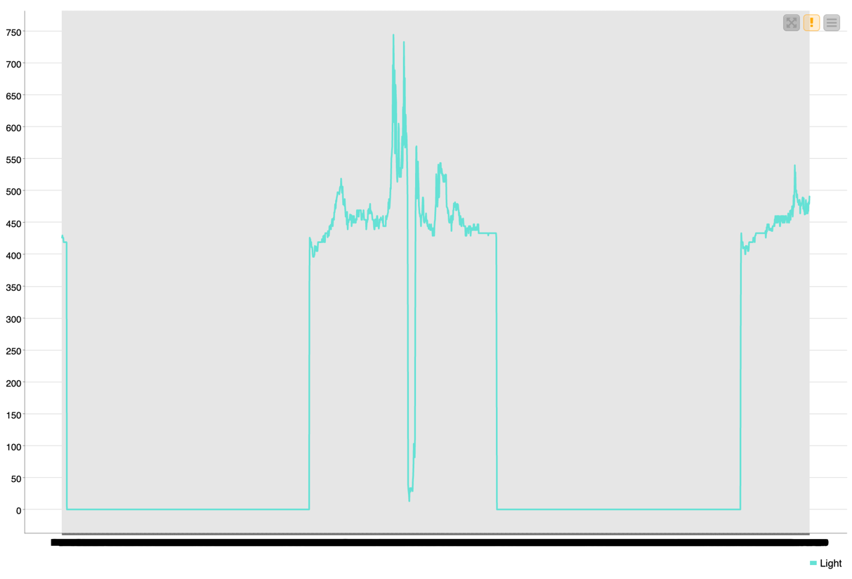
The light plot shows extremely clear transitions. When the room is unoccupied, light levels remain close to 0. When occupied, light levels jump sharply to 400–500 Lux or higher. These shifts are immediate and dramatic, forming distinct “on/off” patterns. Light is one of the strongest predictors of occupancy. The near-binary behavior (lights off when empty, on when occupied) makes it highly informative.
CO₂ levels show a strong and consistent pattern: levels increase dramatically when people are present—often exceeding 1000 ppm—and fall back toward 400–450 ppm when the room is empty. These “hill-shaped” curves correspond with occupancy periods. CO₂ is another very strong predictor of occupancy because it rises directly in response to human presence.

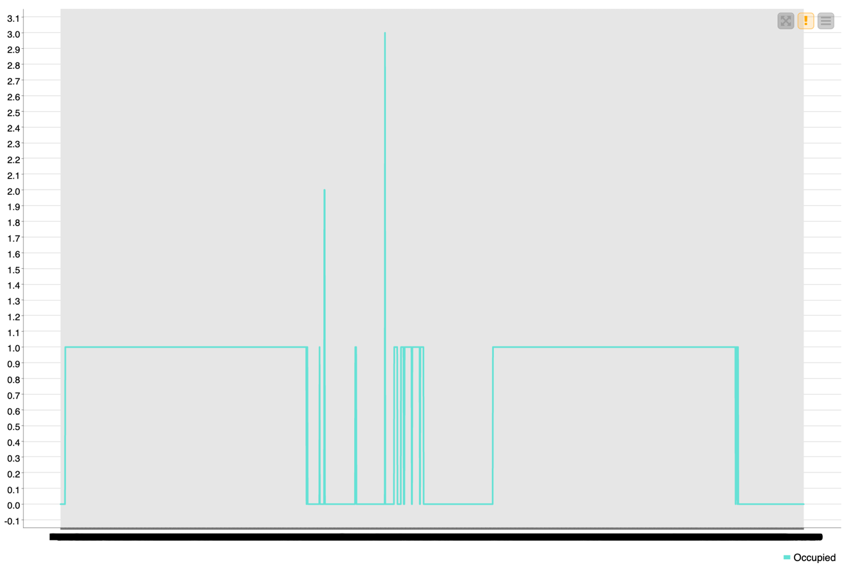
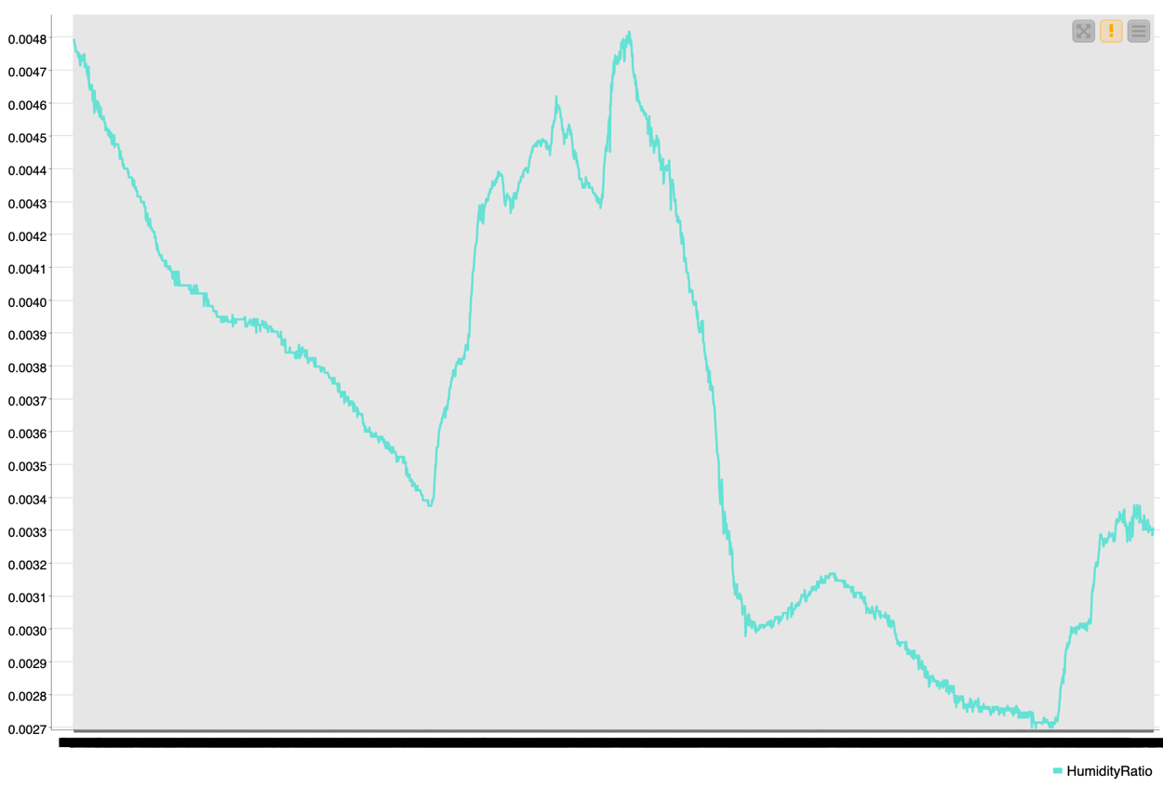
Humidity Ratio follows a similar shape to the humidity graph but uses smaller values. It changes gradually and does not exhibit sharp transitions. Humidity Ratio is a moderate to weak predictor. It provides some environmental context but does not clearly signal occupancy on its own.
The Occupied time-series plot displays clear blocks of 0s (unoccupied) and 1s (occupied). These patterns serve as the “ground truth” against which other features can be visually compared. When lined up conceptually with Light and CO₂, the alignment of peaks and transitions becomes very clear.

Predicting Occupancy
The goal of this section is to build models that classify a room as occupied or not. I used a training set to fit the models and a validation set to select the best-performing tree. The test set was held out until the end to evaluate final model performance.

I created three different decision trees by varying the predictors used in each model.

Decision Tree 1 – All Predictors
Predictors: Temperature, Humidity, Light, CO2, Humidity Ratio
Accuracy: 1.00
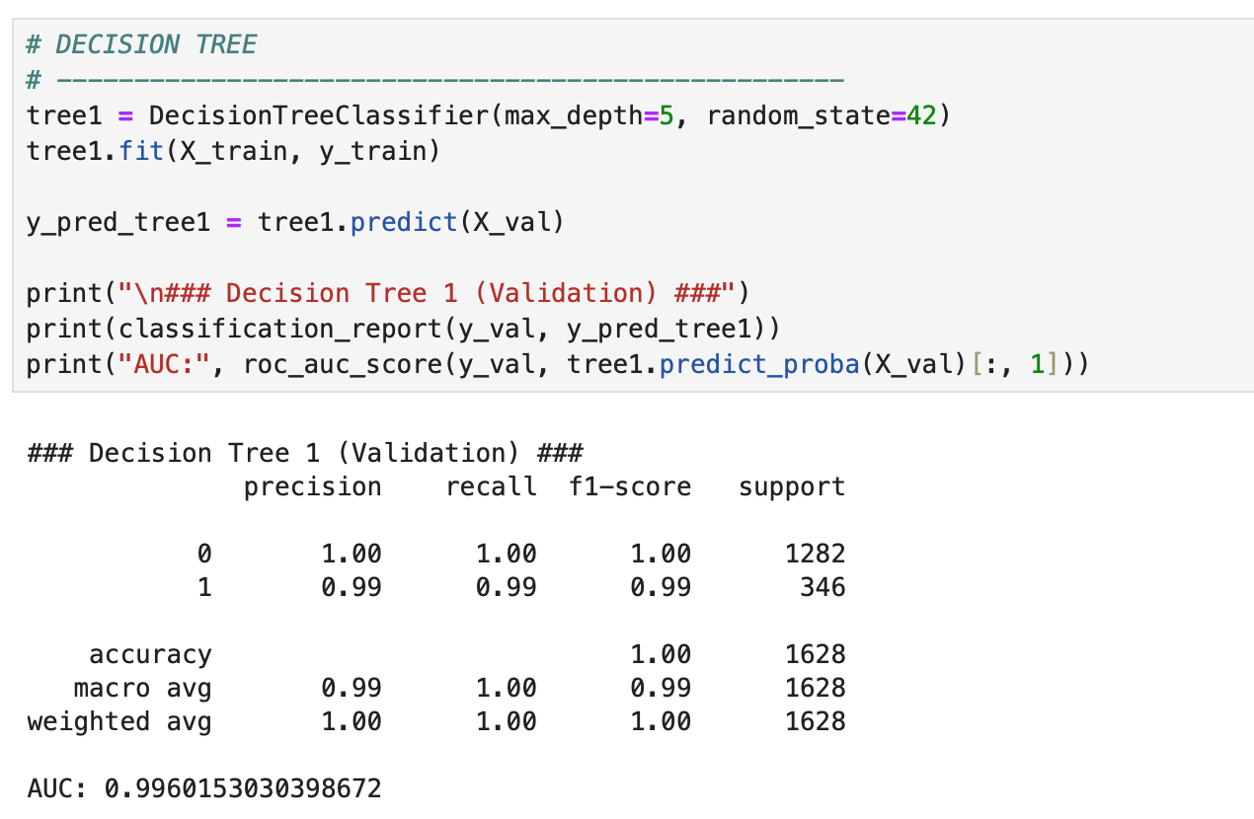
AUC: 0.9960

This tree achieved perfect accuracy on the validation set and shows clear decision splits based primarily on Light and CO2, which matches our exploratory analysis.

Decision Tree 2 – CO2 + Light Only
Predictors: CO2, Light
Accuracy: 0.99
AUC: 0.9925
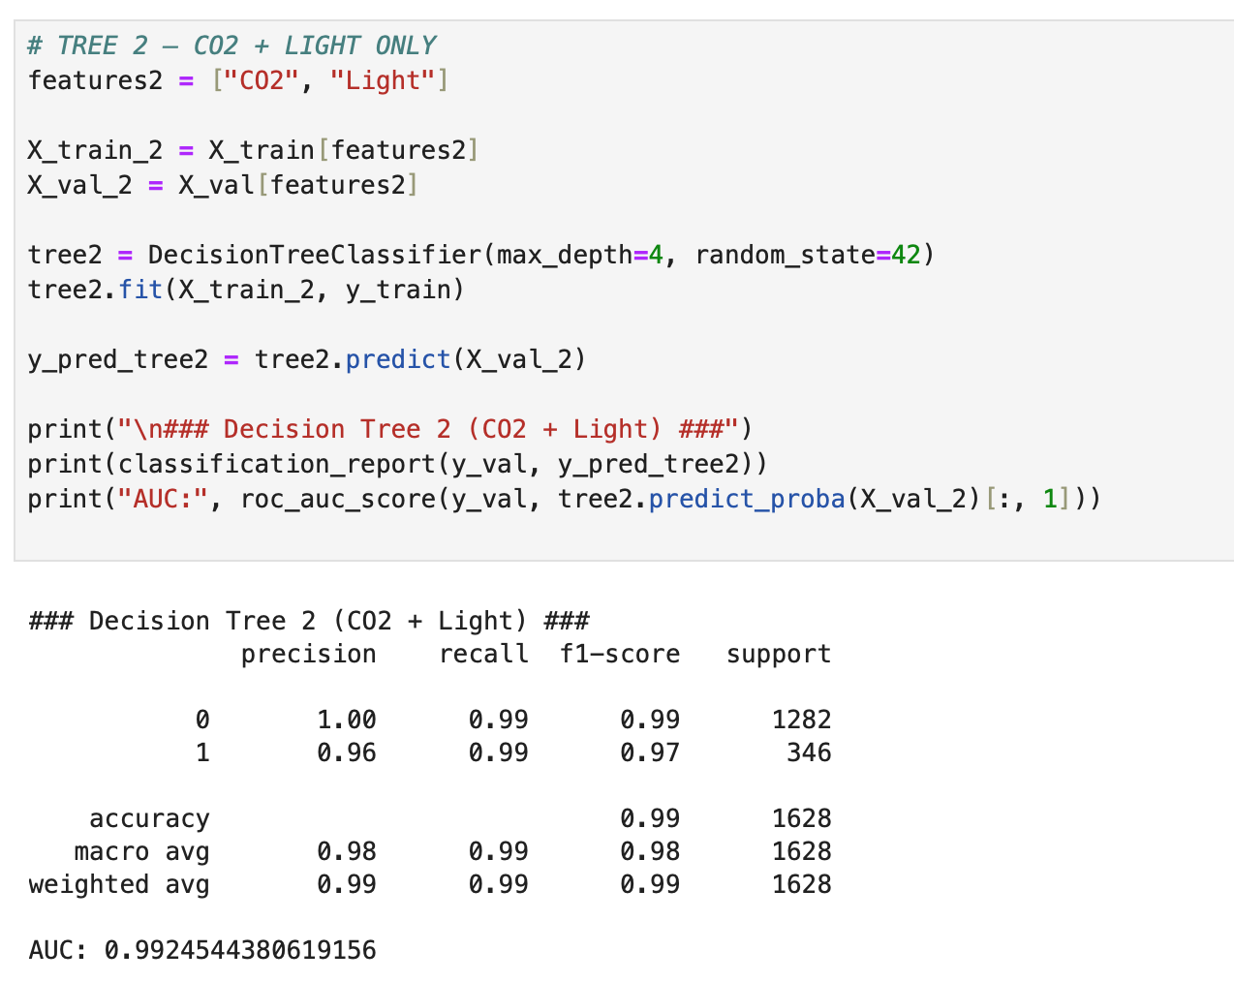

Even with only two predictors, this model performed extremely well, confirming that Light and CO2 are the strongest occupancy indicators.

Decision Tree 3 – Temperature + Humidity + CO2
Predictors: Temperature, Humidity, CO2
Accuracy: 0.97
AUC: 0.9863
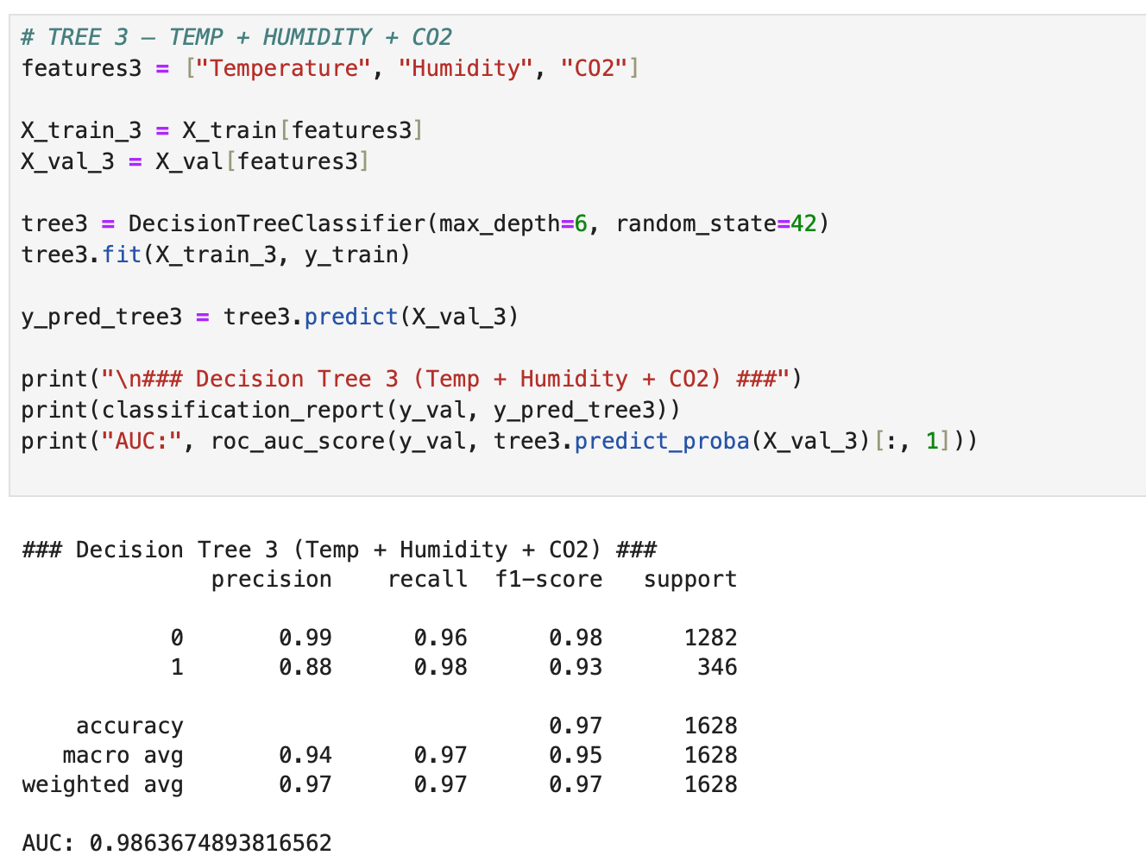

While still strong, this model performed worse than the first two because it excluded the Light feature, which is the most powerful predictor.

I selected Decision Tree 1 as the final model for several reasons:
- Highest accuracy on validation data
- Includes all sensor inputs, capturing the full complexity of room conditions
- Produces a clean and interpretable tree structure
- Strong AUC indicated excellent separability between occupied and unoccupied states

Conclusion
In this project, I cleaned the dataset, explored its numerical and temporal characteristics, built three decision tree classification models, and selected the best-performing model. After comparing accuracy and AUC values, Decision Tree 1 emerged as the strongest model.
This model relied on all available predictors and achieved perfect validation accuracy. The two most important predictors were Light and CO₂, which aligns with patterns observed in the time-series analysis. The final model is effective, interpretable, and highly accurate for predicting room occupancy based on environmental sensor data.

