Enzyme Linked ImmunoSorbent Assay → ELISA is a tool used to detect and measure proteins, biomarkers, and small molecules (among countless other targets) using antibodies. There are many different formats for an ELISA; in this case the Streptococcus equi subsp. equi ELISA is in a sandwich format. In this format, there is a capture antibody and a detector antibody to detect and measure the Streptococcus “SeM” protein. See figure below:

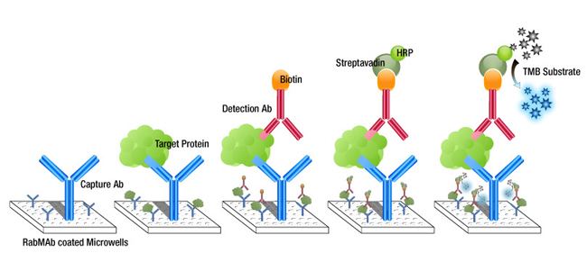
Monoclonal antibody MAB212P coated on plate, Target protein is Streptococcus equi subsp equi bacteria, detection antibody is MAB211P-Biotin, tracer is Streptavidin HRP and TMB is the HRP enzyme substrate.

Terminology:
- Tween – Detergent used in the wash buffer
- ON@4°C – Overnight at 4 degrees Celsius
- RT – Room Temperature
- Capture – Antibody coated on the plate
- Detector – Antibody paired with the capture to detect the target (Strep equi)
- Biotin label – Small molecule conjugated to the tracer antibody, as anchor for detection
- SA – Streptavidin, this is what biotin binds at a very high affinity
- HRP – Horse Radish Peroxidase, this is the enzyme that reacts with the developer, and is conjugated to the SA
- Tracer – Streptavidin HRP, binding to the biotin on the tracer antibody
- TMB – Substrate that when exposed to HRP generates a blue product
- HCL – Hydrochloric acid, 0.6N, used to stop reaction of HRP and TMB, changing color to yellow
- Wash – plate is washed between steps, using an automated plate washer filled with PBS Tween 0.05%.

Materials:
- MAB211P-biotin (detector antibody)
- MAB212P (capture antibody)
- Nunc immunosorbent microtiter plates
- Streptavidin HRP (Jackson Immunoresearch)
- 0.15M PBS, pH 7.6, coating buffer (SOP attached)
- 1% Non Fat Dried Milk in PBS (blocking buffer)
- 0.15M PBS, 0.05% tween 20, wash buffer
- Strept-avidin HRP (binds biotin labeled antibodies)
- TMB (substrate)
- 0.6N HCL (stop solution)
- MAB211P-biotin detector, MAB212P – capture. (matched pair monoclonal antibodies)
- PlyC Lysin (recombinant phage lysin that disrupts the Streptococcus membrane expose the surface SeM protein).

Equipment:
- 12 channel pipet, pipet tips for 200 ul, 1000 ul.
- Single channel pipets, p20, p100, p1000 and accompanying tips
- Reagent boats
- ELISA Plate Washer
- ELISA plate reader (A450)
- Timer

Protocol:
ELISA Plate
 | 1 | 2 | 3 | 4 | 5 | 6 | 7 | 8 | 9 | 10 | 11 | 12
A
B
C
D
E
F
G
H

- Prepare a plate map for your samples and controls
- Coating the plate:
  - Prepare enough of MAB212P (capture antibody) to coat # of desired wells with 50 ul of MAB212P at 2 ug/ml in PBS.
    - If stock antibody is at 1 mg / ml, this is a 1:500 dilution (1000 ug / 2 ug).
      - To prepare 10 mls of coating antibody, pipet 20 ul of the antibody (at 1 mg/ml) to 9.98 ml of PBS, mix well / gently
      - Pipet 50 ul of the antibody solution into each well using a multichannel pipet:
  - Cover plate and incubate plate at 4C overnight
  - Next day, wash plate 1X using automated plate washer (fill 300 ul)
- Blocking:
  - Prepare 1% NFDM in PBS
    - 1 gram NFDM + 100 ml of PBS
    - Do not keep this reagent for more than 1 week at 4C.
  - After capture antibody coating and washing, pipet 300 ul in each well using multi-channel.
    - Incubate 1 hour at RT OR ON at 4C.
    - Wash plate 1X post blocking.
- Running the ELISA: Include + and – controls.
  - Positive control, a sample from culture and (-) control, wells with NO antigen (strep equi)
  - Prepare the sample:
    - Strep equi CF32 culture (or your sample from water / compost) starting at 1:50K dilution treated with lysin at 10μg/mL in PBS (15min incubation at 37⁰C prior to addition to plate).
      - The starting dilution of your water / compost sample may be different, likely much more dilute than the culture we worked with. Start neat, and do 10 fold dilutions to see where you are.
    - Pipet 50 ul of prepared sample (and controls) into designated wells
    - Incubate for 30 minutes @ 37C or 1 hour at RT, with rotation if possible.
    - During this incubation , prepare a 0.5 ug/ml solution of the detector antibody MAB211P-biotin, in blocking buffer (1% NFDM)
    - Wash plate 1X with automated plate washer, tap out residual liquid
    - Pipet 50 ul / well of the detector antibody (MAB211P-biotin)
    - Incubate@ 37C for 30 minutes or 1 hour at RT, with rotation if possible.
    - During this incubation, prepare a 1:10,000 dilution of the Streptavidin HRP in wash buffer (1 plate requires 5 mls)
      - We typically have a 1:10 stock dilution and prepare a 1:1000 of that
        - 5 ul (1:10) in 5 ml of wash buffer.
    - Wash plate 1X with automated plate washer, tap out residual liquid
    - Pipet 50 ul of the Streptavidin HRP @ 1:10,000 and incubate the plate @ 37C for 30 minutes or 1 hour at RT, with rotation if possible.
    - Wash plate 4X, tap out residual liquid
    - Add 50 ul / well of the TMB, start timer for 10 minutes (cover plate)
    - In 10 minutes, stop the enzyme reaction by adding 50 ul of 0.6N HCL
    - Read the plate at A(450)

Typical Results using a CF32 culture provided by University of Kentucky:

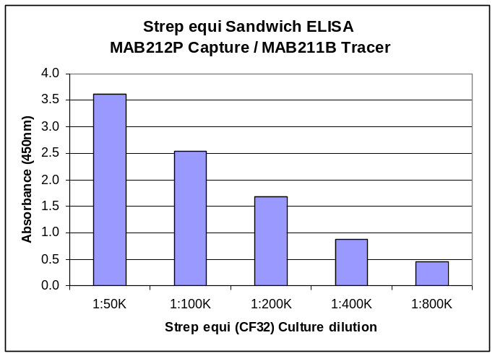

SOP for the PBS used at MBS, recipe for 1 liter: Add chemicals to 900 mls, adjust pH and QS to 1 liter.

NaCl → 8 grams
KCL → 0.2 grams
KH₂PO₄ → 0.2 grams
Na₂HPO₄ → 1.15 grams

pH to 7.6 with either 6N HCL or 5N NaOH

