Budgetize:

Money tracking Android Application

  - Bachelor thesis

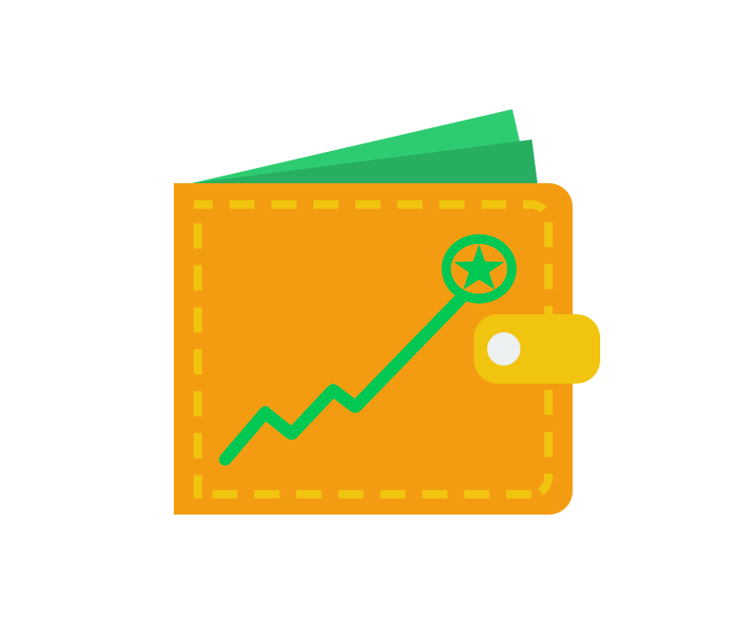

Robert Marian Roland CIOTOIU

Supervisor:
Prof. dr. eng. Marius MARCU

Introduction

Motivation
Most people are usually neglecting how they spend their money. As in the past decades the card payments are continuing to grow in popularity and people are tending to spend more. This is due to the impression that our money is only a number on the screen. This fact is leading us to spend more and to care less about their importance.
All over the world, too many people with different income amounts, are struggling to manage their budgets. I am also seeing around me, that the majority of people are only thinking about how to make more money to solve their financial issues, but they don’t realize this is redundant if their debts will increase proportionally.
Nowadays, mobile phones are part of our everyday life. We carry them everywhere we go, we check them on average 60 times a day and we spend almost 3 hours every day on the phone [1]. According to Statista [2], 3.5 billion people are owning a smartphone and this number is growing with 300 million people per year. This tool, which we have in our hands every day, it is capable to do a lot of things which makes our life easier. From checking the weather, reading news, making bookings, calls, meetings to doing payments, checking balance and even help us to improve the way we are managing our budget.
Banks are starting to incorporate into their mobile applications tools like “Analytics” in order to improve transactions tracking, money saving and budget administration. This is very useful to use in case of having bank accounts only to one bank. But things get more complicated when we have multiple types of bank accounts (e.g. credit, debit, savings) at multiple banks. Also, bank applications usually do not allow users to add transactions to those analytics as for example to track cash payments.
What defines 2020 is the power of getting information. We are now one click distance to find an answer for what we need. In bank industry, this thing is very new. Banks used to hold the data very secured, only for them or eventually for partner banks. Today, thankfully to the initiative of Open Banking, we can have third party applications made any organization, which are able to display to the end users, data about their bank accounts and even allow them to make payments.

The problem
Firstly, the root cause of all our financial issues is the lack of financial education. We are not used to write all the incomes and expenses down to a paper, to eliminate the unnecessarily monthly payments and to learn how to avoid useless acquisitions. Surely, at one point of our life, we tried that, but this is not easy to do and maintain, and most of the people quit as soon as they start.
Even if we are determined to do that, in nowadays, it is almost impossible to keep that tracking on a paper. We would need to use special software, which is generally hard to use for the average user and which usually require a monthly subscription. Writing down every transaction we made is hard and requires a lot of time. To keep the tracking of a family expenses is even harder.
Simply writing down the transactions on the mobile phone every time we make one and sum up at the end of the day with reports gathered from each bank account will never work. If every member of the family has more than one account at more than one bank, the tracking and the ability to improve the way we spend our money would require too much effort.

The solution
This overwhelming process of keeping the track of expenses can be simplified a lot using the power of information.
Mobile phones and Internet are enablers for digitalization of almost everything. In our case, the incomes and expenses which used to be written down on a paper. The most important think we have nowadays, is the information. How we get that information, how we process it and, the most important thing for a user, is how we display it.
From already 5 years, we can get that information from any bank. We can process information from any bank account and decide how to display it in a manner which helps the end users to evaluate their spending in relation to their income.
The solution I came with, in order to solve all the above issues, is an Android Application in which any end user of a smartphone can add any type of transaction, set-up recursive transactions, categorize those in virtual wallets and link real bank accounts to them. By linking the bank account to a wallet, the application will assure automatic synchronization of transactions. All these functionalities are intuitive and easy to use by any Android user. Also, the application will offer all these functionalities for free as the income will be generated by applying the Freemium Business Model. It will contain only ads with minimal impact on user experience and some usage limitations on the key functionalities of the application.
I chose to develop the application on the Android platform because it has 70.68% [3] of smartphone market share, it is free to develop application and it is very cheap to publish on the Android Marketplace.
The application will enable user’s interest to manage their finances and will cover the lack of financial education we are currently have in our society.

State-of-the-art

Overview
On the market, there are a lot of applications available for tracking expenses. Many of them are destinated for businesses and for people which already have some experience on managing their budget. In general, applications designed for an average user, require a monthly subscription in order to use the application and some special functionalities like linking bank account and cloud synchronization. The applications that are free usually neglects the user interface and the user’s experience.

Main competitors
Researching the Android and IOS Marketplace, I found three main potential competitors at this time. In the next paragraphs, I will make a comparison by exposing the benefits and detriments of using Budgetize or any of the following leaders in the Smartphones Marketplace.
One application I found which almost combines all the principles I had in mind when I developed Budgetize is Wally. Wally has been removed from Android Marketplace and it is only available now on IOS. I still want to compare my application to Wally because it was the only one I could found, to be able to link my bank account for free and to import my history transactions.
Wally is free to use, but also has some paid functionalities. It has a wide range list of supported banks which can be linked to the application, it also allows to organize the transactions on categories and wallets, we can add transactions manually and it is able to display information about the introduced and imported data in a lot of ways, all of those for free. Until there we are sharing the same functionalities, but what differentiates Budgetize from Wally are features like creating foreign accounts and ability to switch the currency of any wallet which we offer for free. But the most important advantage of Budgetize is the user experience.
From the first touch of Wally, I have been overwhelmed of the many configurations and views, the lack of animations, crashes in some cases and how unintuitive is the application to use at the first sight. For sure Wally has a lot more ways to display the information about the data we introduced/import, has more configurations and it has some interesting features for the premium version, but the target of Budgetize is to be appealing to anyone who installs the application, to demonstrate it is very easy to manage the budget and to track the expenses.
Another big competitor is Spendee. The strongest element of Spendee is the user experience and the user interface. Animations, reports and analytics are very well displayed. The application is easy to use and very intuitive. One important feature of Spendee, which Wally doesn’t seems to have at least in the free version, is the biometric access to the application. I consider that feature extremely important for an application which is handling sensitive data like bank account information.
Even having all the benefits from above, the downside of the application is that you need to add each transaction manually without having any other possibility in the free version. For importing transactions from bank accounts and create multiple virtual wallets, there are multiple premium versions which require monthly or yearly payment, or a big one-time payment.
Only on Android Spendee has over 1.000.000 downloads and over 28.000 reviews with a rating of 4,1 starts of 5 [4]. Those numbers demonstrate that there is a need in area of financial management.

//TODO: review the third app. Choose between: Moneytree, Bankin’, PocketGuard and Simple

Conclusions
Budgetize by combining the main key functionalities, for saving user’s time on adding the transactions manually, with easiness of using the application and an appealing user interface. Also, Budgetize has been developed with security awareness, offering the end user credibility and safety.
Having into consideration the above-mentioned features of Budgetize, I definitely think those will create its own place on the Android Marketplace and enable the opportunity of acquiring a lot of users.

