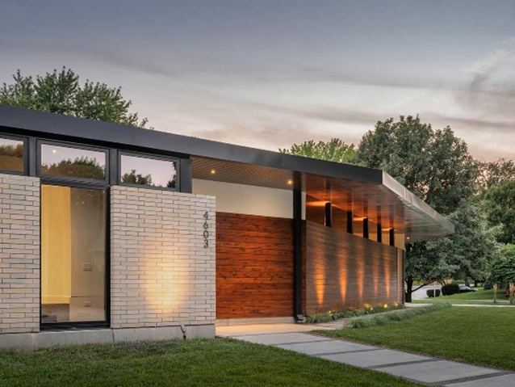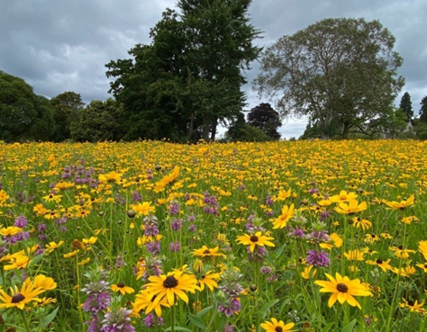

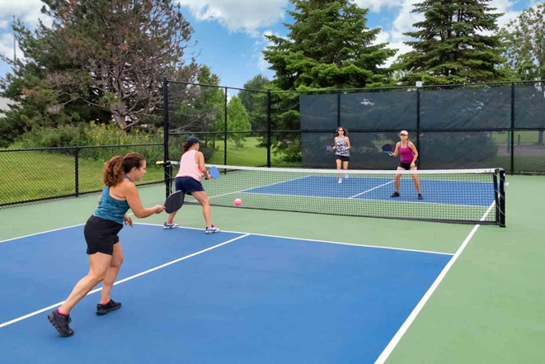

**I am a resident of Groton, CT and I want to express my support for Mr. D’Agostino’s development proposal for the S.B. Butler Elementary School.**

Like many of my fellow residents, I believe the best use of the property should include green space, a multi-use recreational park and a use that would produce tax revenue for the Town of Groton.

I have met with Mr. D’Agostino and was pleased to learn that he is very much in support of providing **Green Space**, a **Multi-Use Recreational Park** and an **adaptive reuse of the existing Historic Butler School**, into a primary residence and a B&B, which would give the town a low intensity use that would produce additional tax revenue for the Town of Groton.

It is also nice to know that Mr. D’Agostino is willing to fund a new **Multi-Use Recreational Park** for our neighborhood, if the town is unable to do so. Mr. D’Agostino’s proposal would include paved walking paths for residents and their pets, cedar benches for relaxation and picnics, ample parking, perhaps a community garden, an athletic area which may includea pickleball court or two, an improved Tee-ball diamond, open space for other sporting activities and an updated playground with rubber flooring for the safety of our neighborhood children.

Mr. D’Agostino would be in favor if Town Officials decide that the parkremain in the ownership and care of the Town of Groton. Mr. D’Agostino’s interest lies with the adaptive reuse of the Mid-Century historic Butler School where many residents and resident children previously attended. The school building has been part of our neighborhood for a long time and should remain so.

Currently, there are just two bed and breakfasts in a town of 38,000 residents, namely The Steamboat Inn and Captain’s Mansion. All the other local bed and breakfasts are in Stonington which receive the tax revenue that benefits that town. Mr. D’Agostino intends to provide a sensitively designed lodging space for guests who prefer a quiet, peaceful and friendly place to stay in Groton.

Mr. D’Agostino’s proposal would be a low-impact alternative to other much more intensive reuse options recently offered, such as multi-family and/or affordable housing or a multi-use development, which some residents may not favor.

I am aware that there are some residents who are concerned about the future of the public park if the Town Officials decide to transfer ownership to Mr. D’Agostino. Mr. D’Agostino’s attorney had stated that the park will be protected in perpetuity by a restrictive covenant, which means the park will always remain a public park. Also, any conditions of the land use approval for the reuse of the former school as a B&B would be binding on any future owner or operator.

Some residents may have concerns about increased traffic; it is important to mention that the school’s previous use had considerable traffic flow which included many buses twice a day, parents dropping off and picking up students, and recreational use during and after school. A bed and breakfast and a public park would have substantially less traffic impact compared to the previous use of the property.

I understand that the Town Owned Property Evaluation Committee will soon be making a formal recommendation to the Town Council on the disposition of the S.B. Butler School.  I believe that a public Request for Proposals (RFP) process should be undertaken to allow for the highest and best reuse of this property.

This is a wonderful opportunity for our town that should be seriously considered. Mr. D’Agostino’s proposal would not just benefit the immediate neighborhood, but would benefit the Town of Groton as a whole!

**Let’s save the memories of the Butler School and enjoy a new Multi-Use Recreational Park and open space too !**

Thank you for your consideration.

Todd Valentine

Groton Resident

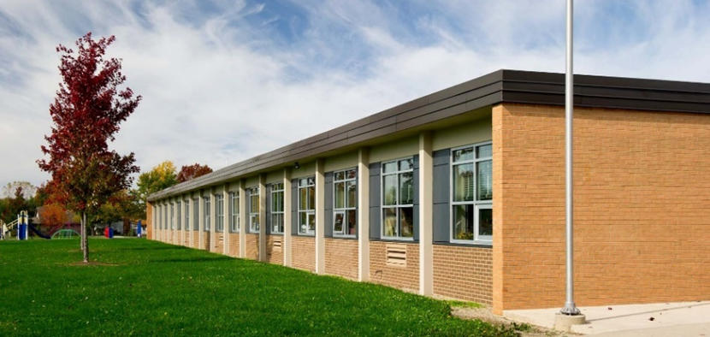****

**Download this document at *https://robertdag759.github.io/sb.docx***