Robert J. Esposito III

Professor Zesk

Configuration Management/ENGN 4010

23 April, 2018

Toy Car Packaging-First Pilot/Prototype Test

Goal:

For the first pilot/prototype testing, our goal is to test to see if the toy car (specifically the tires) will fit into the car bed without the car bed falling from the toy car.

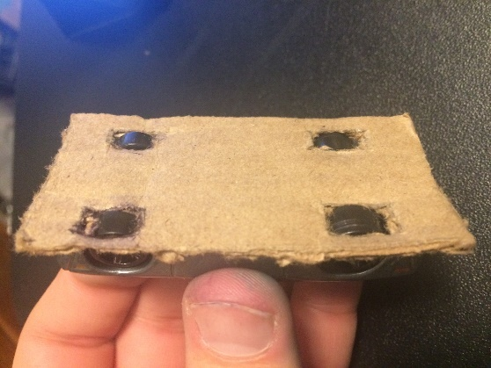 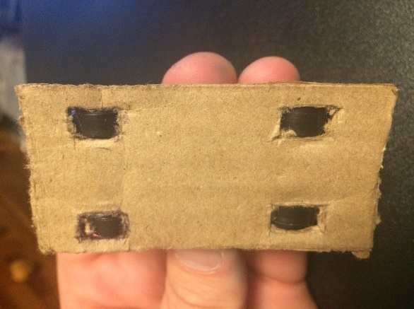 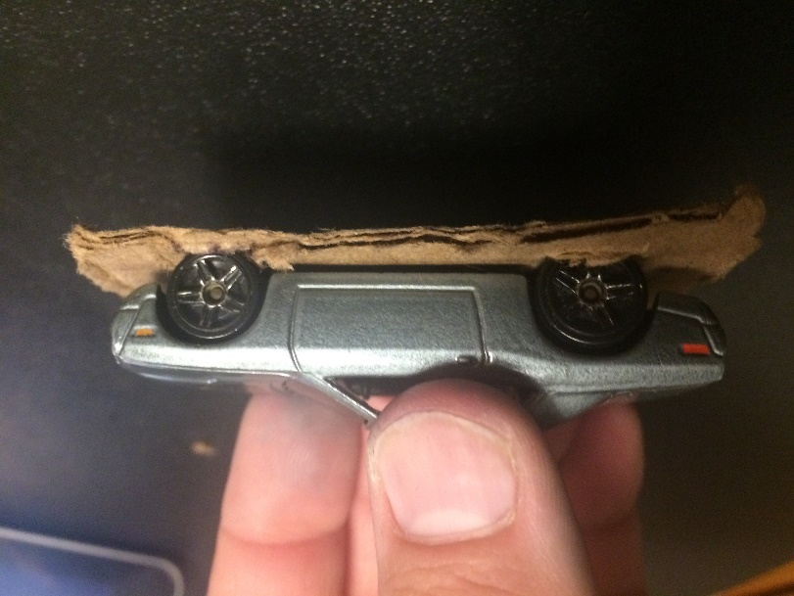

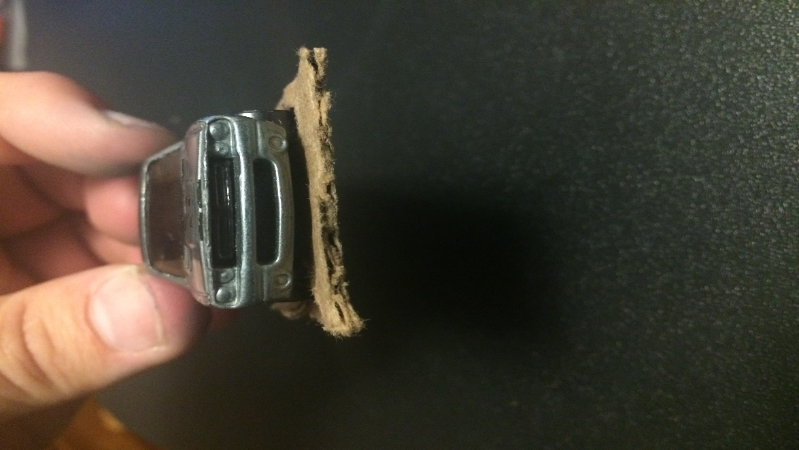 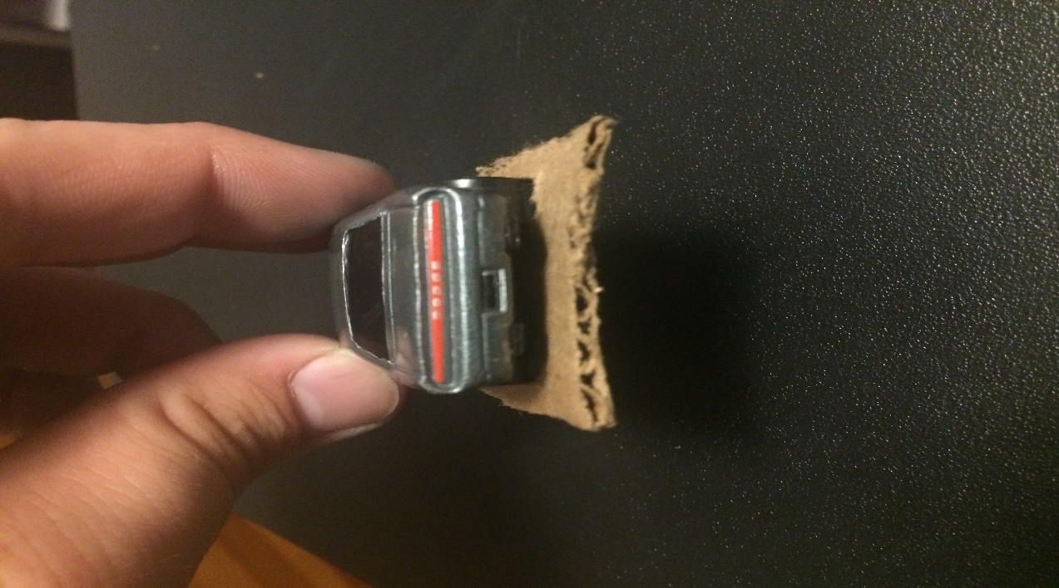 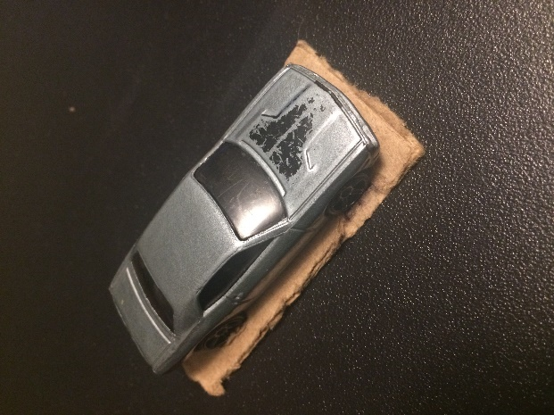

Result:

Based on our first pilot/prototype testing, the toy car was able to hold the bed without any additional assistance or resources. The toy car tires all fit perfectly into each tire slot and was able to withstand holding the bed.