

Asset Tracking System

User Manual

User Manual

Developed

By



**Overview**

This document provides an operational guide for users of the Asset Tracking Software developed for the College of William & Mary by Alpha Systems.

The systems consist of the following applications:

1. FAM Windows DeskTop Application - WMAssetDesktop.exe
   1. Provides secure SSO login
   2. Uses WmAssetWebServiceClientNet.dll for https:\\ connection to web service
   3. Controls the inventory process
   4. Imports asset data from downloaded csv files
   5. Schedules department inventories
   6. Determines which users are assigned to department inventories
   7. Allows FAM staff to review and edit scanned assets
   8. Provides audit trail of inventory thru exported csv files
   9. Provides final csv file used to update W&M asset system
2. Android W&M Mobile application - com.alphasystems.wmassetinventory.apk
   1. Provides secure SSO login
   2. Uses WmAssetWebServiceClientNet.dll for https:\\ connection to web service
   3. Provides mobile application for users to scan assets scheduled for inventory
3. Web Service – WMPgsqlapi
   1. Provides secure connections to WM PostgreSQL database

**FAM Desktop Application**

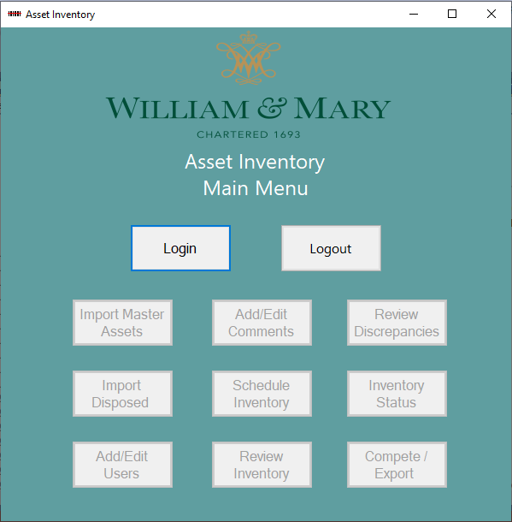

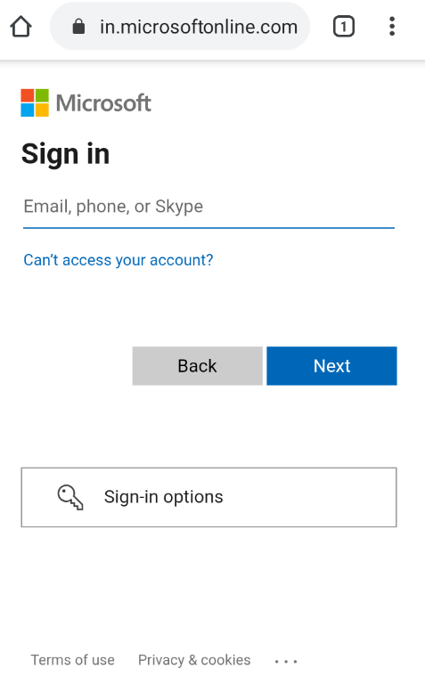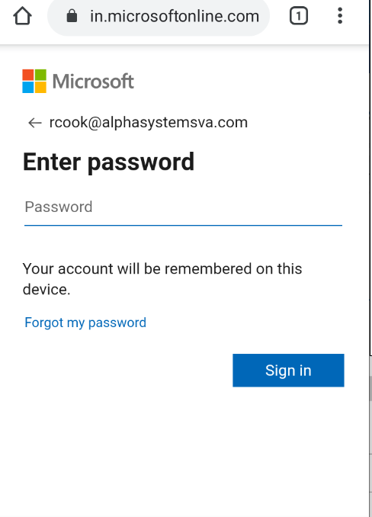

**Login Process**

User: Enters email and password.

Software: Uses Microsoft Entra ID single sign-on(SSO) to authenticate the login.

If the user is authenticated the Main Menu buttons are enabled, otherwise an invalid user/password is displayed.

**Main Menu**

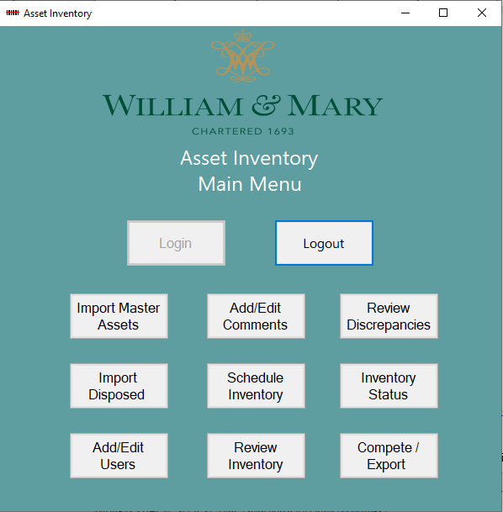

**Overview**

Import Master Assets – Imports CSV file of assets from Banner System – only used for reference to identify assets

Import Disposed Assets - Imports CSV file of disposed assets from Banner System – only used for reference to identify assets

Add/Edit Users – Enters or Edits users to assign to departments for inventory

Add/Edit Comments – Enters or Edits comments for drop down on mobile units

Schedule Inventory – Schedules department inventories and loads assets for inventory

Review Inventory – Allows FAM staff to review department inventory in process and move to final status.

Review Discrepancies – Allows FAM staff to review discrepancies and resolve and move to final status.

Inventory Status – Displays status of current department inventory

Complete/Export – Allows final review/edit of department inventory. Export final department csv for update to Banner system.

**Add/Edit Users**

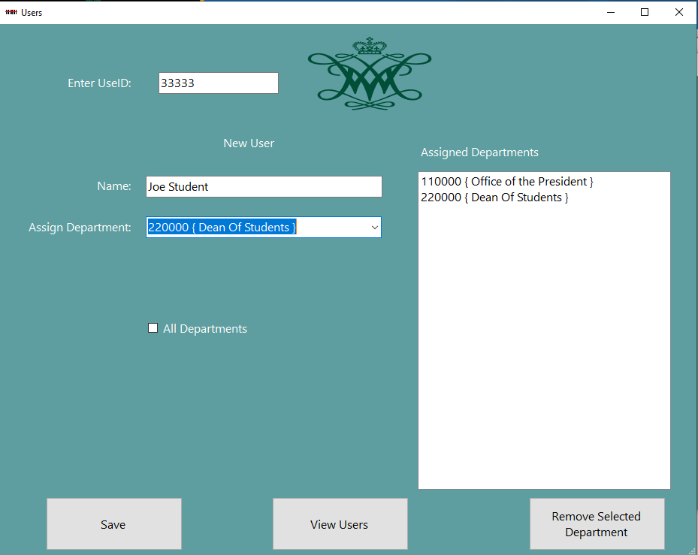

* User: Enters UserID.
* If a record exists for the UserID then the Name and assigned departments are returned for update.
* Current Record is displayed.
* If a record does not exist for the UserID then the Name and assigned departments are blank.
* New User is displayed.
* To assign a department select a department from the drop down list and the department is moved to the assigned list.
* To remove a department select a department on the assigned list and click the remove selected department button.
* To assign a user to all departments, check the all departments check box.
* Click the save button to save changes.

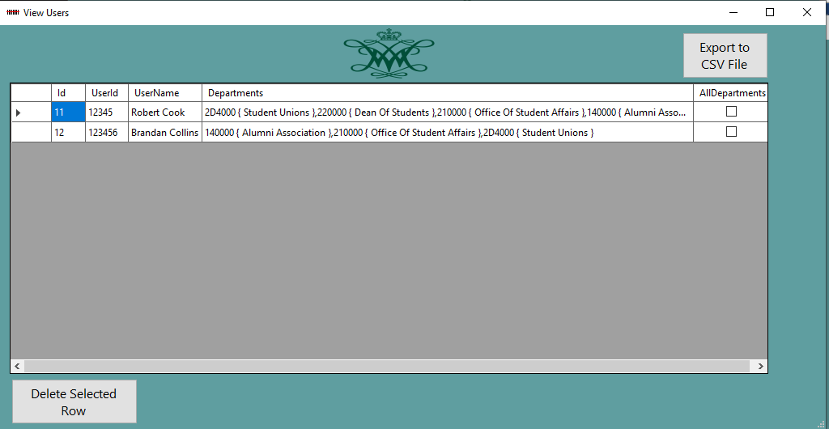

* Click the View Users button to display current users.
* To delete a user, select the row and click the Delete Selected Row button.
* To create a list for reference, click the Export to CSV file button.

**Add/Edit Comments**

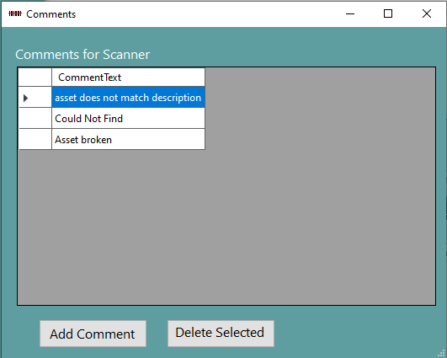

Datagrid displays current comments for drop down list used for mobile application.

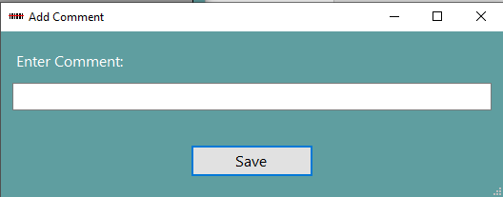

* To add a comment click on Add Comment button.
* Enter the comment
* Click on Save.

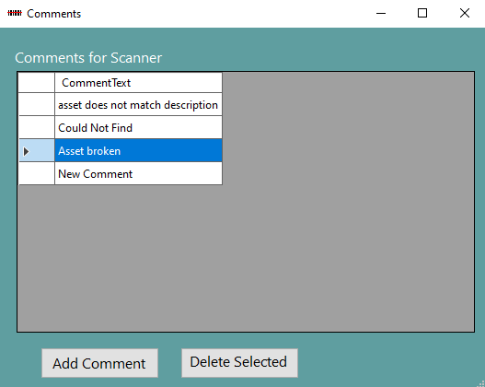

* To delete a comment
* Select the row
* Click Delete Selected

**Import Master Assets**

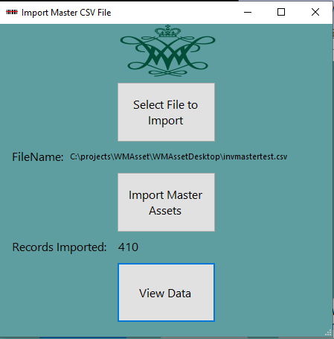

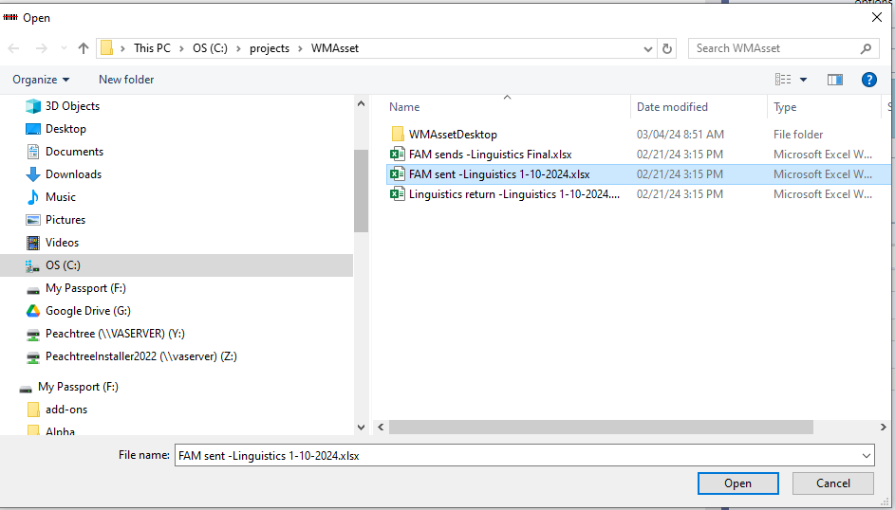

User: Selects file to import from file dialog box. Only files with .csv extension are displayed. Software displays selected file name.

User clicks Import Master Assets Button

Software: Clears the current asset table and department table. Reads and parses csv file and inserts records into asset table and department table. Displays record

count when done.

**View Data**

User: Looks over the imported data and if it has format problems reruns the import.If the problem persists the csv file needs to be checked.

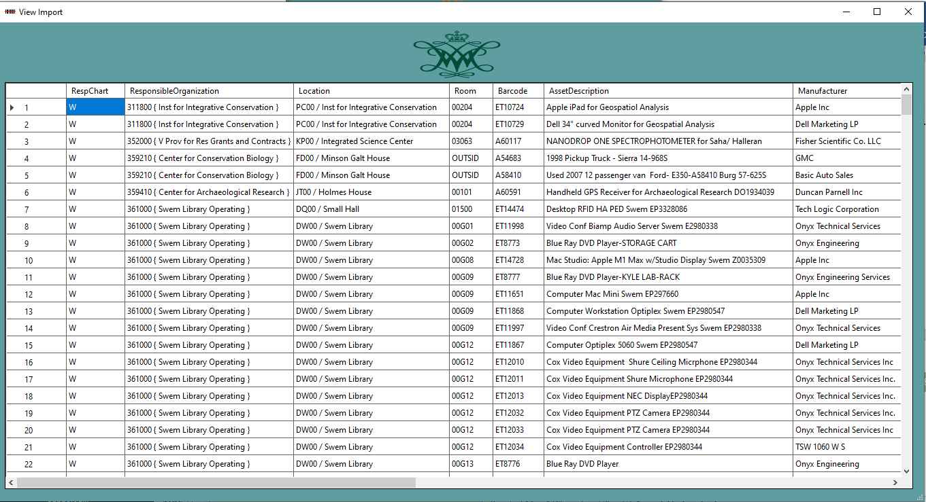

**Import Disposed Assets**

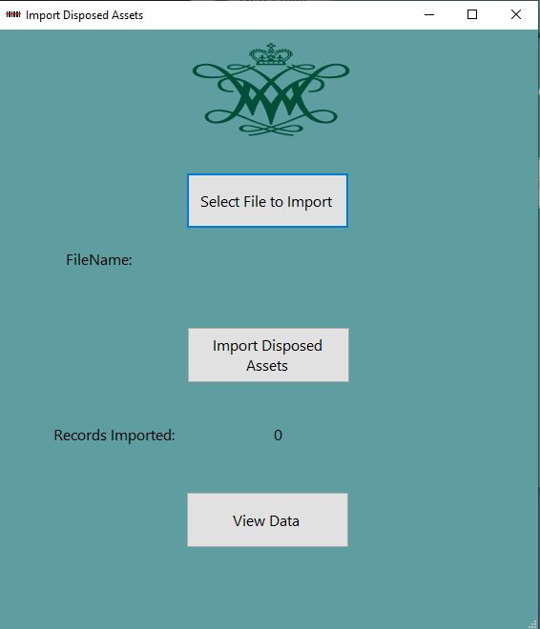

User: Selects file to import from file dialog box. Only files with .csv extension are displayed. Software displays selected file name.

User clicks Import Disposed Assets button

Software: Clears the current disposedasset table. Reads and parses csv file and inserts records into disposedasset table. Displays record count when done.

**View Data**

User: Looks over the imported data and if it has format problems reruns the import.

If the problem persists the csv file needs to be checked.

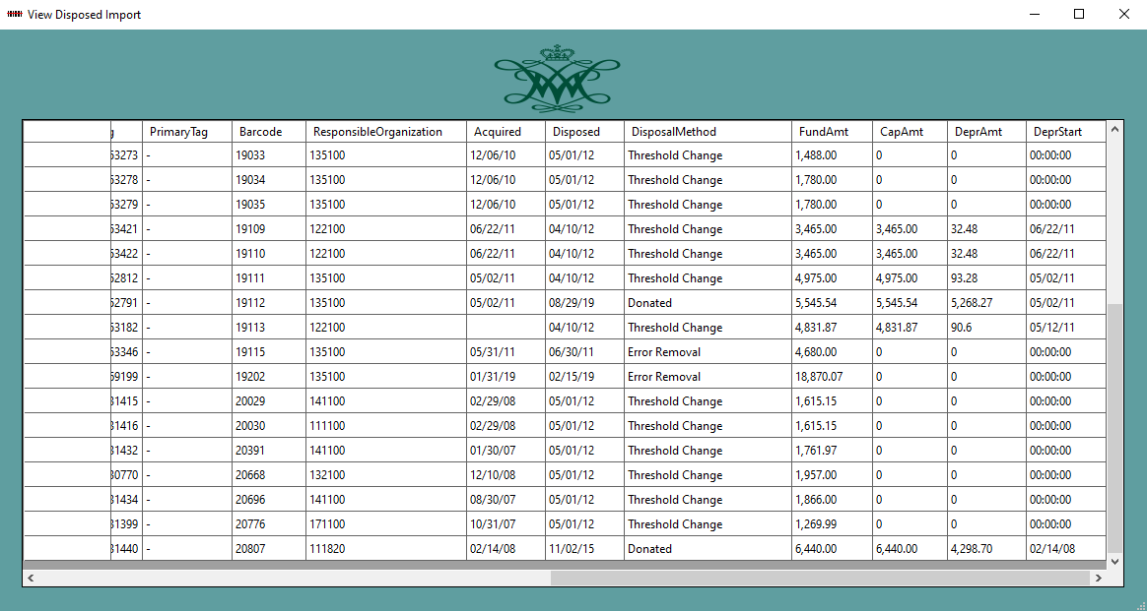

**Schedule Inventory**

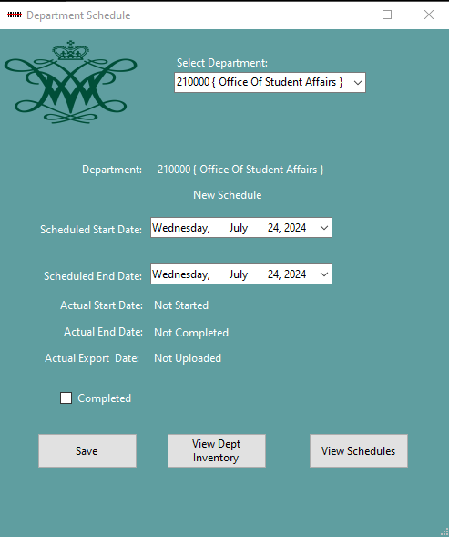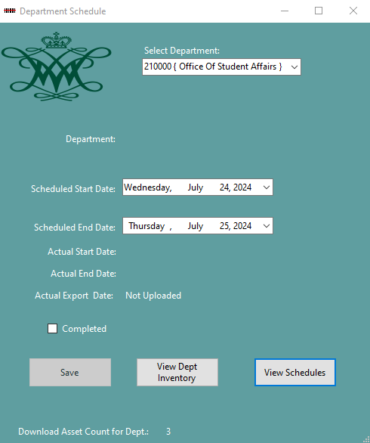

User: Selects Department for drop down list. Selects dates for start date and end date.

Software: Populates list with departments from departments. Pulls record from inventory schedule table for the selected department. If the schedule does not exist, New Schedule is displayed below the department name. If the schedule exists it displays Current Schedule below the department name. The user selects the scheduled start and end date for the schedule. Actual start date and actual end are generated by the mobile app when the user starts the inventory and completes the inventory. The completed checkbox is checked when the current inventory is moved to the final inventory. The upload date is entered when the final inventory is exported and the schedule is deleted.

New Schedule

When the Save button is clicked on a new schedule the software populates the inventory assets table with assets from the department, displays the number of assets inserted into the inventory assets table and enables the View Dept Inventory button.

Current Schedule

When the Save button is clicked on a current schedule the software updates schedule start and end dates.

**View Dept Inventory**

Displays the assets loaded into the asset inventory table.

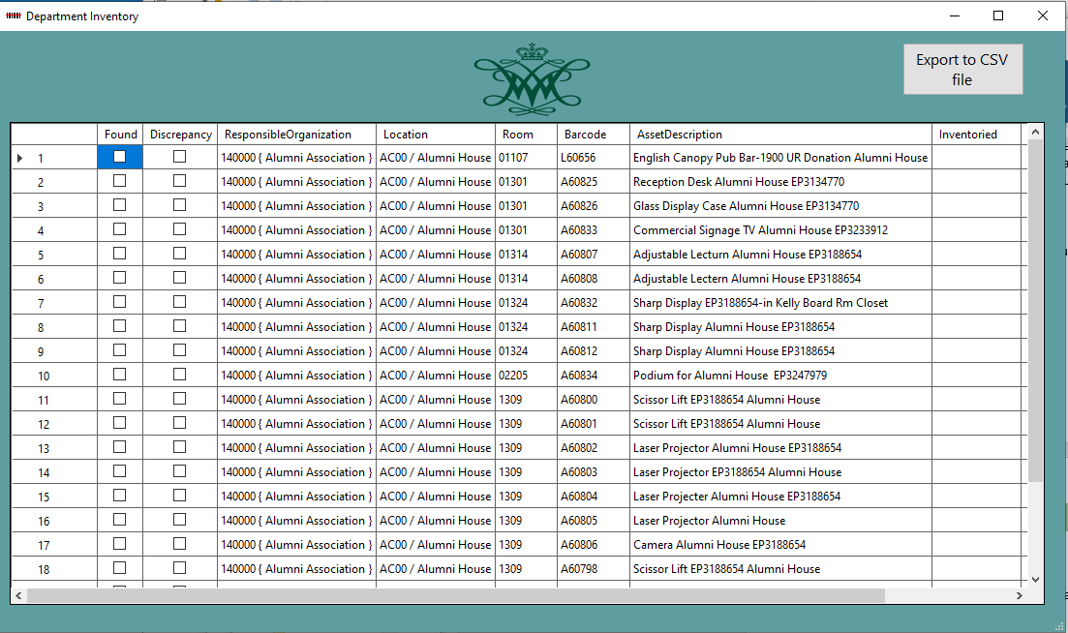

**View Schedules**

Displays the current schedules and allows the user to export the schedules to a csv file.

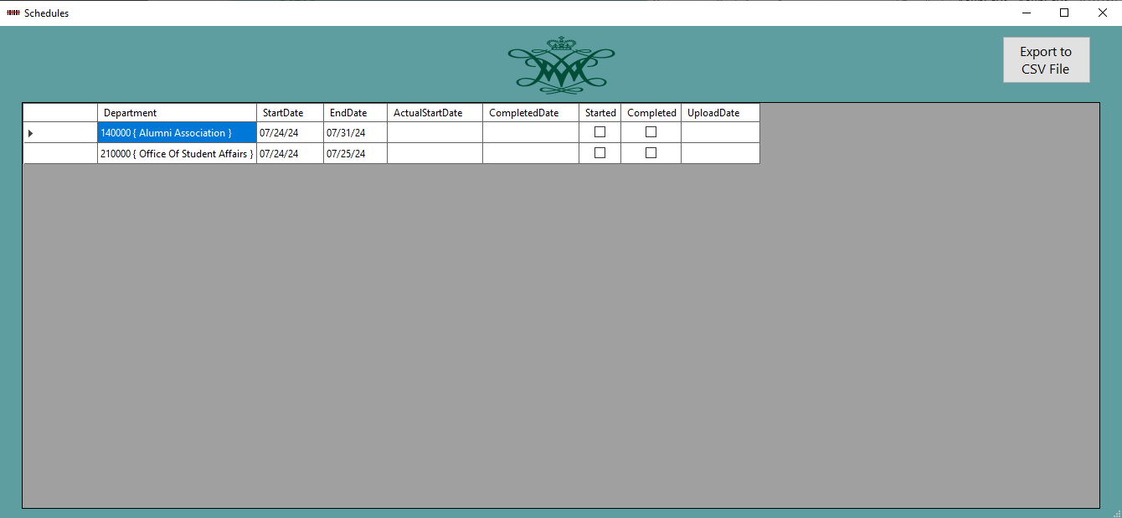

**Review/Edit Inventory**

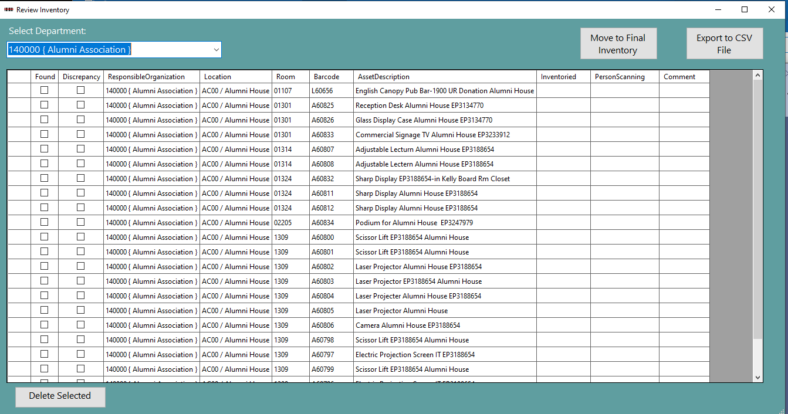

* User selects Department from list of departments.
* The datagrid is populated with the current assets in inventory from the asset inventory table.
* Location, Room, Person Scanning, and comments are editable columns.
* Move to Final button allows you to move assets to the final review if the mobile units have completed the inventory.
* Delete Selected allows you to delete a selected row.

**Review/Edit Discrepancies**

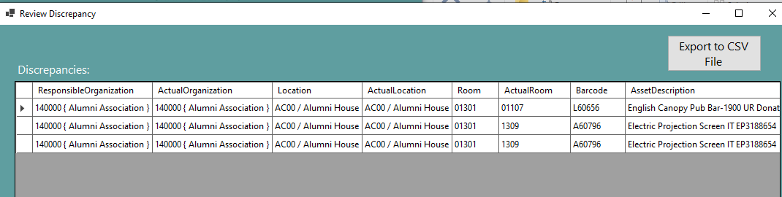

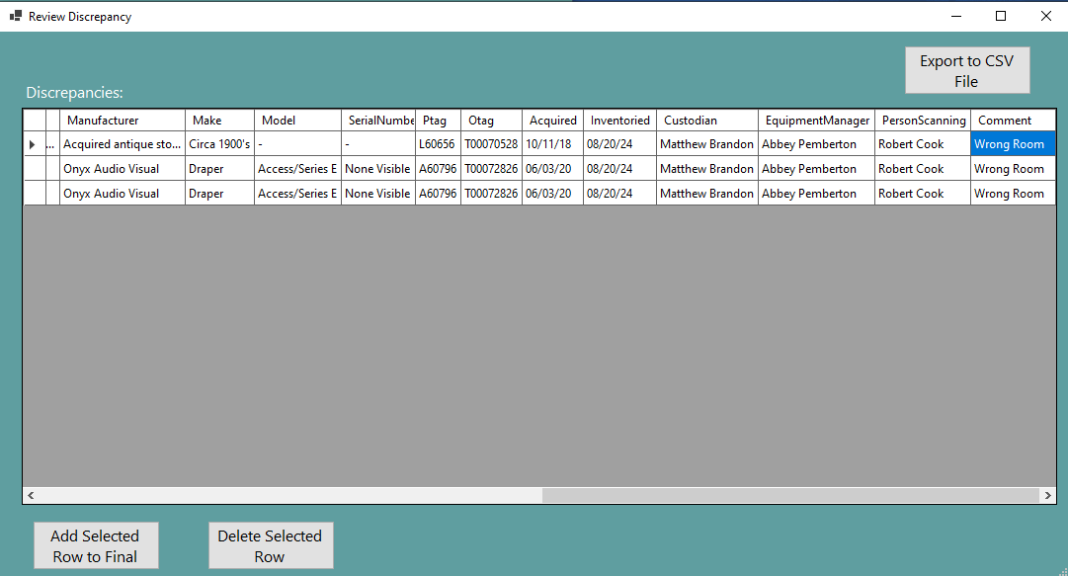

* Discrepancies must be handled one row at a time
* Only Actual Location, Actual Room, Person Scanning, and Comment can be edited.
* The Location & Room will be updated to the actual location or actual room in the final.
* To update to the original Location or original Room change the actual values to the original.
* To delete a row, select the row and click the delete Selected Row button.
* To move a row to the final inventory, select the row and click Add Selected Row to Final button.

**Complete Inventory**

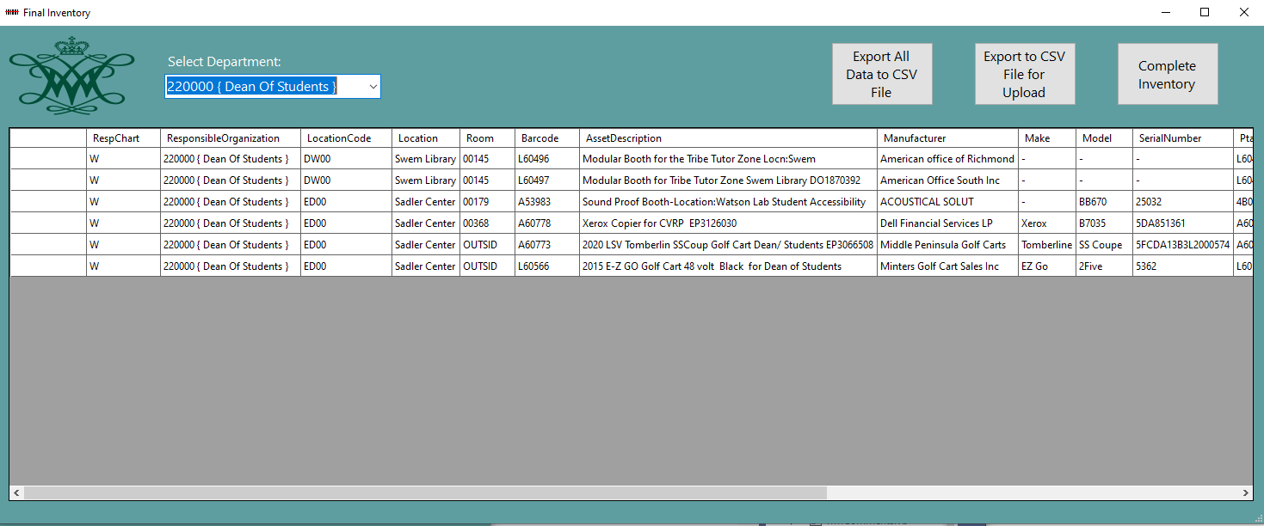

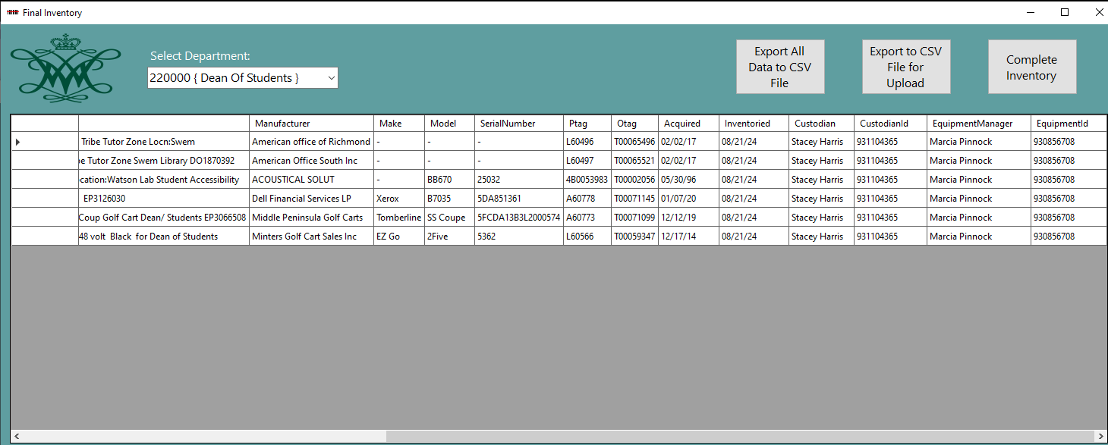

Location Code, Location, Room, Custodian, Custodian ID, Equipment Manager, Equipment ID can be edited on the final review.

Export All to CSV file exports all the data in the grid to 220000 { Dean Of Students } Final Review All.csv

Export to CSV file for Upload exports just the data used for the update. File name is 220000 { Dean Of Students } FinalDept.csv

Complete Inventory:

-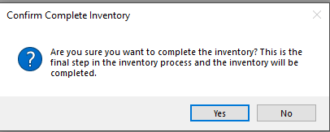

Yes

* + If you still have not resolved discrepancies then the you must clear them to continue.
  + The export date is added to the schedule.
  + Final report is generated with inventory summary data. (see below)
  + **220000 { Dean Of Students } FinalDeptComplete.csv**
* No lets you return to the edit step.

**Final Department Report**

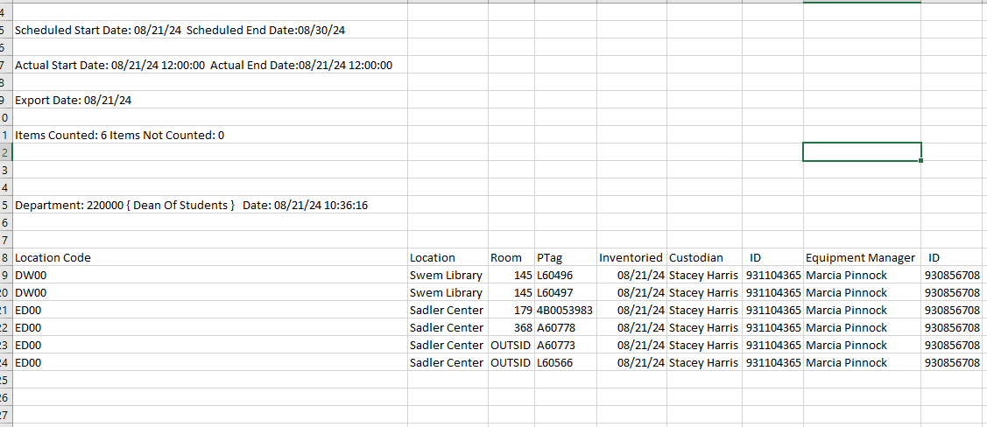

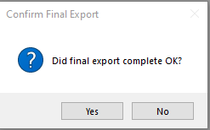

If the reports completed correctly then click yes, if not the click no and repeat.

When you click yes the follow happens:

* The schedule for the department is deleted.
* Inventory Assets for the department are deleted.
* Discrepancies for the department are deleted.
* Final Inventory Assets are deleted.

IMPORTANT: MAKE SURE YOU EXPORT CSV FILES DURING YOUR PROCESS OF REVIEWING/EDITING THE DATA PRIOR TO THE FINAL. THE FILES WILL SERVE AS YOUR AUDIT TRAIL.

**Mobile Application**

**Login Process**

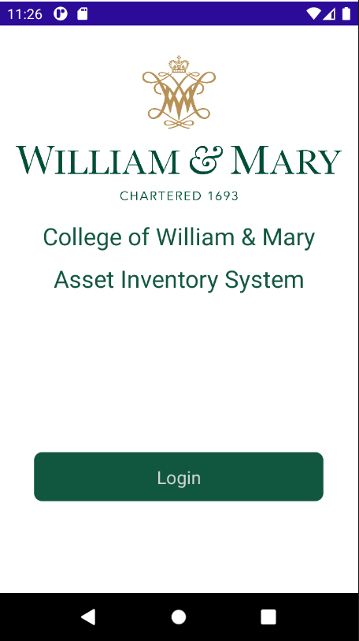

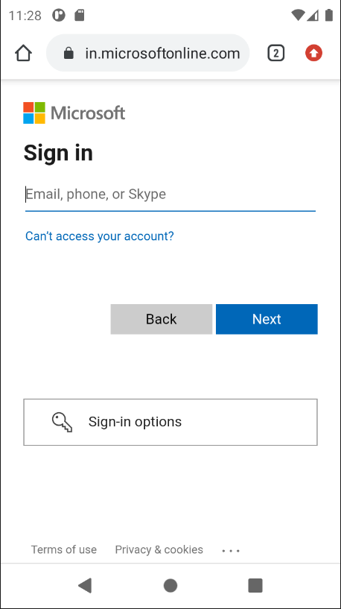

User: Enters user name and password.

Software: Uses Microsoft Entra ID single sign-on(SSO) to authenticate the login.

If the user is authenticated the user continues to the Select Department process otherwise an invalid user/password is displayed.

**Select Department**

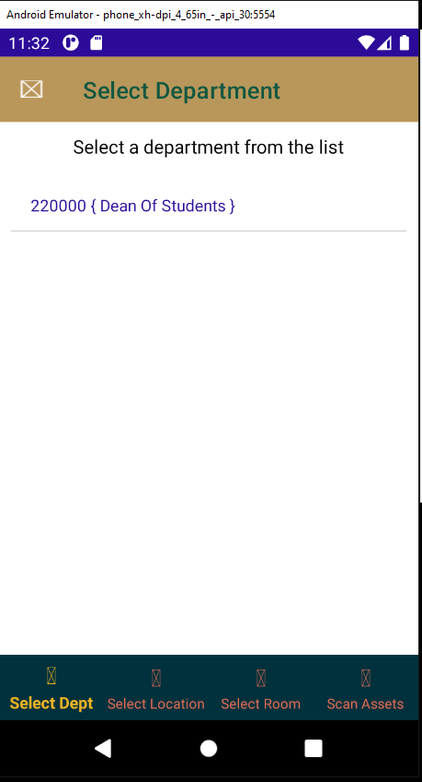 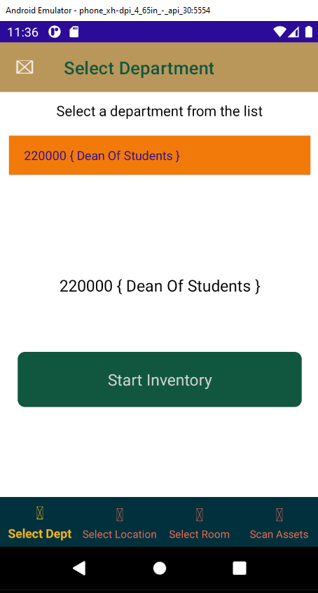

* The software displays the departments that the user has been assigned if more than one department.
* The user selects the department by tapping the department.
* The user taps start inventory to begin the inventory.

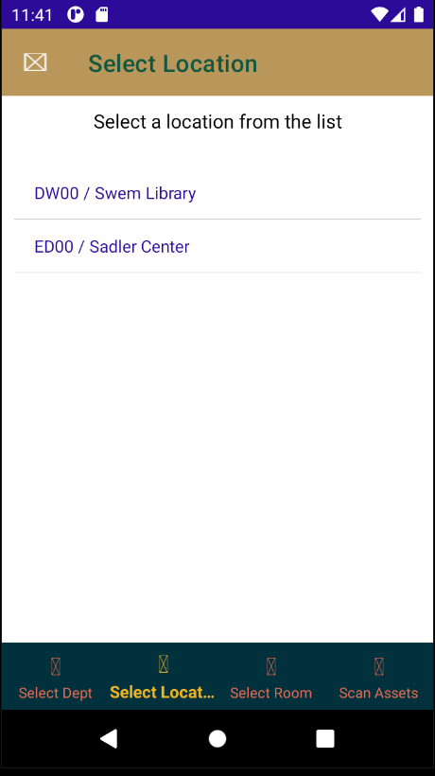 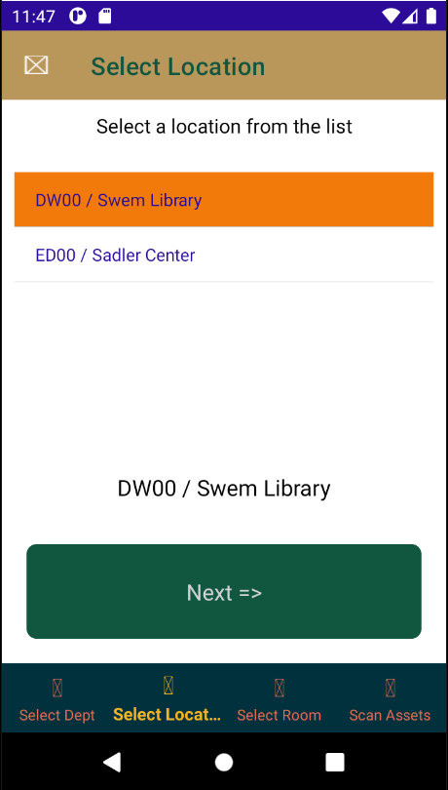

The software displays all locations that have not been inventoried.

The user selects the location they are going to inventory and then taps Next.

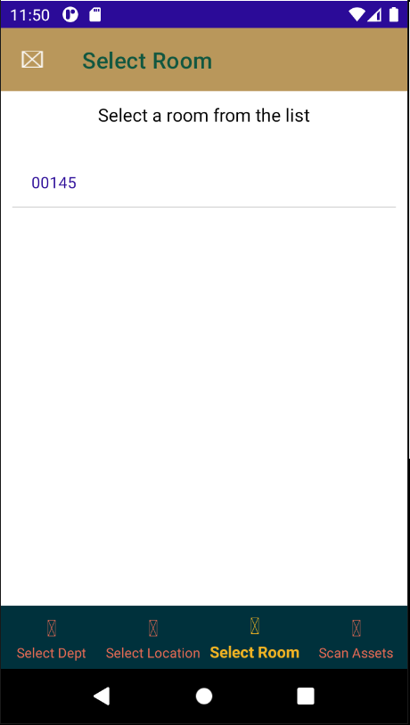 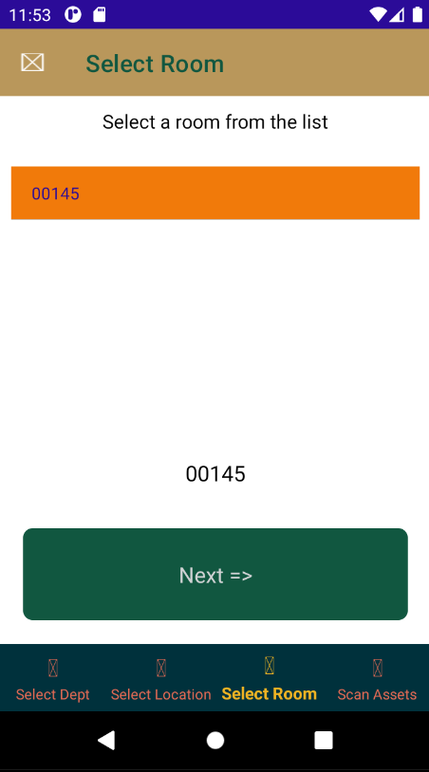

* The software displays all rooms in the selected loacation with assets that have not been inventoried.
* The user selects the room and taps next.

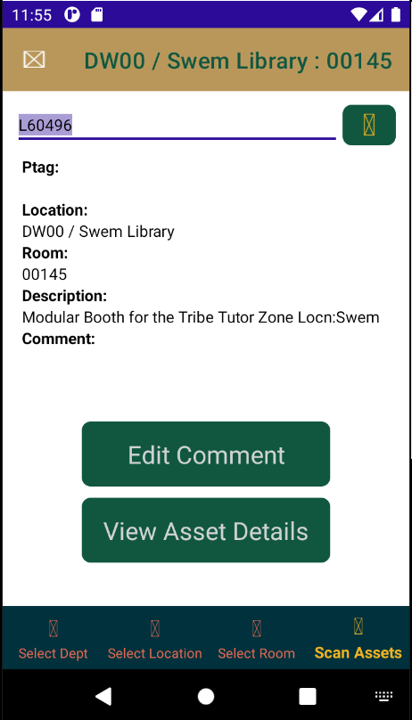

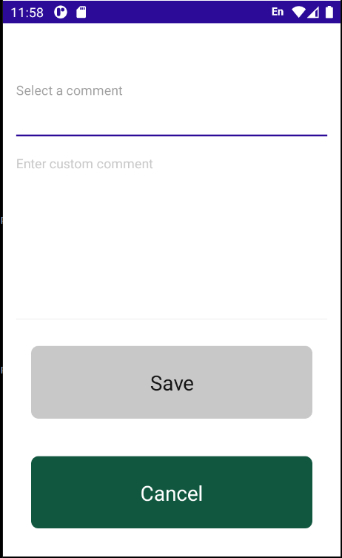 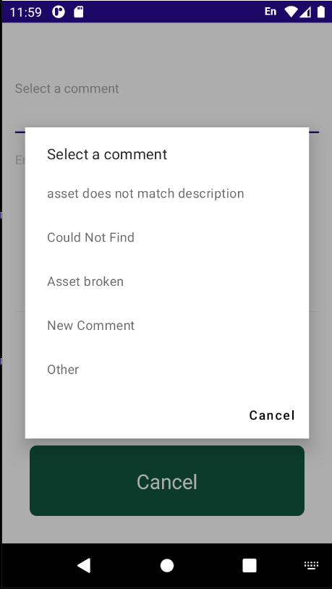 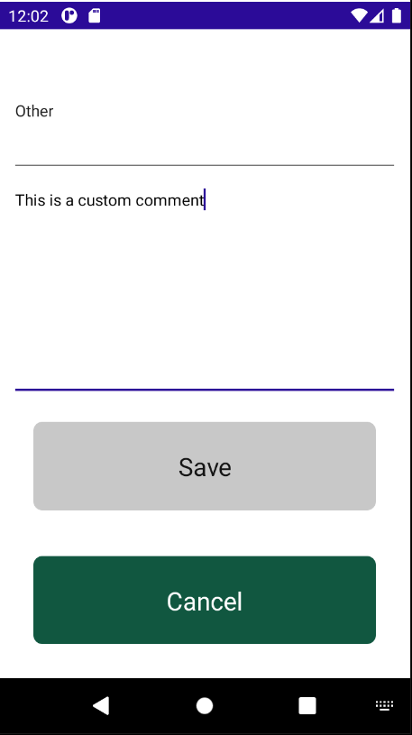

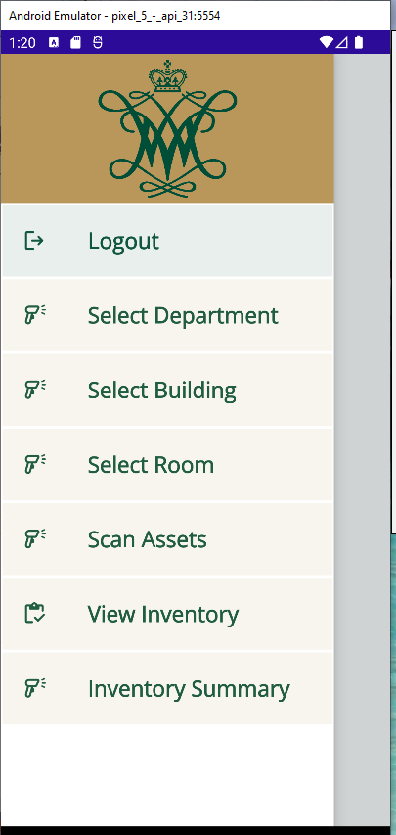

**Select Department Process**

User: Selects the department from a list of departments and continues to Select Building.

Software: Populates a list by selecting Departments from Department Schedule table in the PostgreSQL WM database that have not been completed and the current date is between selected department scheduled start and end date. When user selects the department the Current Inventory table is populated with items from the Master Inventory Table. If the Actual Startdate has a date and the Completed date is Null then the inventory is in progress and the Current Inventory table is not updated.

**Department Schedule Table**

Department

Scheduled Startdate

Scheduled Enddate

Actual Startdate

CompletedDate

**Select Building Process**

User: Selects the building from a list of buildings with inventory of the selected department.

Software: Populates a list by selecting buildings from the Current Inventory table in the PostgreSQL WM database with buildings with inventory of the department

**Select Room Process**

User: Selects the room from a list of rooms in the building with inventory of the selected department.

Software: Populates a list from the Current Inventory table in the PostgreSQL WM database with rooms in the selected building with the department inventory. List also displays Item counts next to room

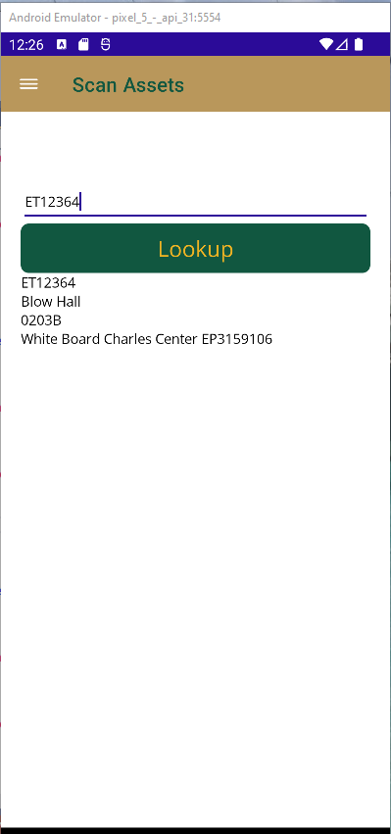

**Scan Asset Process**

User: Goes to the room in the selected building and scans an asset barcode.

Software:

Selects the asset with that barcode that matches the scanned barcode from the Current Inventory table and displays the description, mfg, model, serial number.

If the barcode is not found in the Current Inventory table then the software selects from the Master Inventory table.

If the barcode is not found in the Master Inventory table then an invalid asset message is displayed.

If the department, building, or room does not match the selected department or building or room the discrepancy is displayed and the user must add a comment before they can scan again.

The discrepancy is inserted in the discrepancy table along with the comment, inventory date, and user name. If department, building, or room is different the actual building, or actual room is updated in the current inventory table

If there is no discrepancy the Current Inventory table is updated with the inventory date, user name and comment if added.

**View Inventory Process**

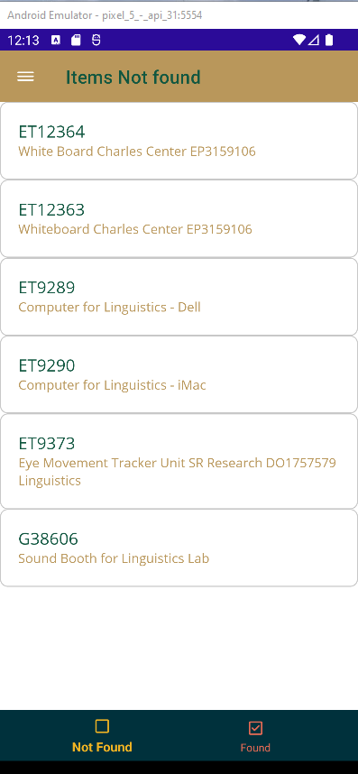 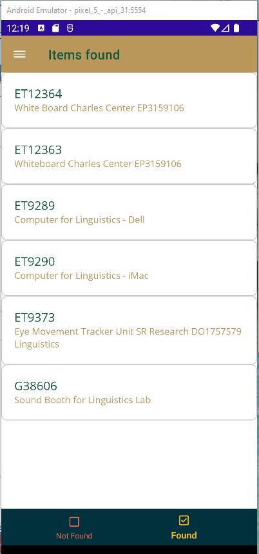

User: Selects View Inventory and can display items found or items not found in current room.

Software:

For Items found the software displays all assets scanned in the current room including discrepancy.

For Items not found the software displays all assets that were currently listed in the department, building, and room that have not been scanned.

The user selects an asset from the Not found list and adds comments. The comments can be selected from a list of common comments such as Not in room, In room but barcode damaged etc.

**View Inventory Summary Process**

User: Selects View Inventory Summary

Software:

Displays building, and room counts of items found and not found:

Building Room Items Found Items Not Found

208 23 125 12

54 45 0

345 12 200 8

**Inventory Complete**

This is handled by the FAM Desktop Application. Discuss today