Robert F. Hiatt
March 9, 2021
IT FDN 110 B
Assignment08
GitHub URL
Working with Classes
1. Introduction
This program dives further into the concept of separation of concerns and has add code according to Randal’s pseudocode to complete the exercise. There is a lot of new terminology in this assignment: constructor, decorator, and objects. And there is also a deeper dive into attributes, methods, and functions. The most fundamental component to the exercise, though, is using classes.
2. Program Review
As always, let’s start with the script header. Since Randal supplied the script’s skeleton, I made some aesthetic adjustments and updated the ChangeLog.
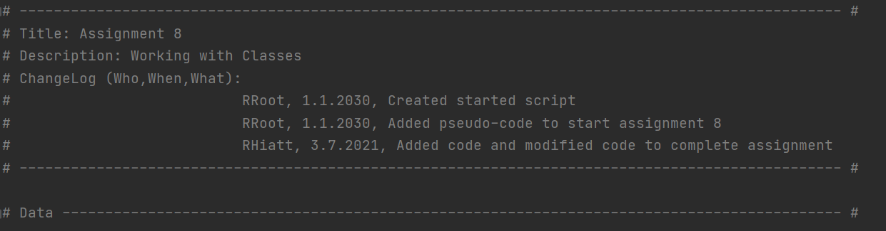
Script header with updated ChangeLog.
Michael Dawson refers to classes as “blueprints,” because a class “isn’t an object, it’s a design for one” (219). Important to note the Pythonic convention of capitalizing the first letter of your class (Dawson 221).
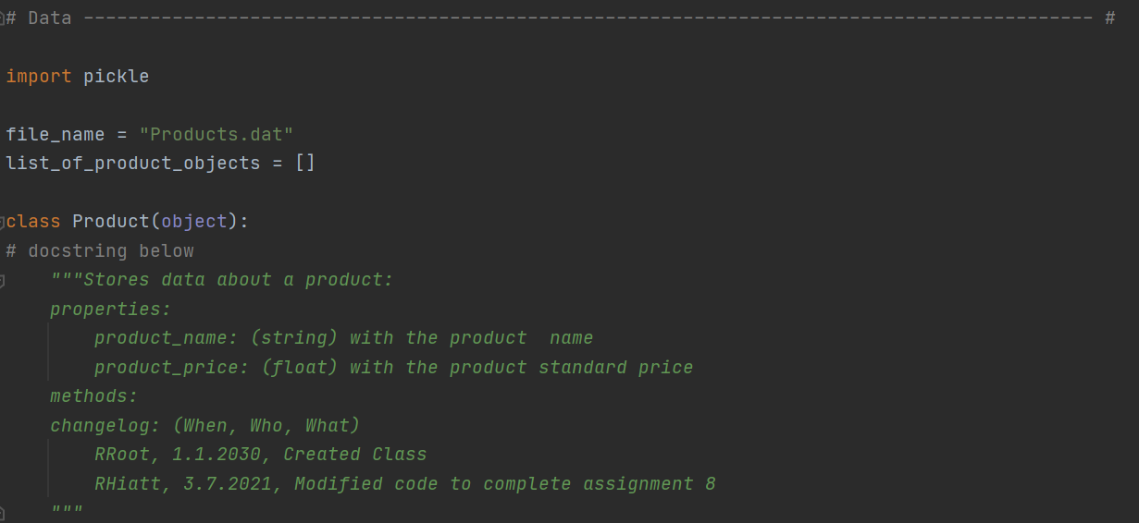
The class Product is capitalized, per convention.
In the image above, the class Product is created and we base the class on the “fundamental, built-in type” known as object (Dawson 221). As Randal requests, docstrings are included in the script. You’ll see that we’ve imported the pickle module because we’re writing a list that we wish to preserve.
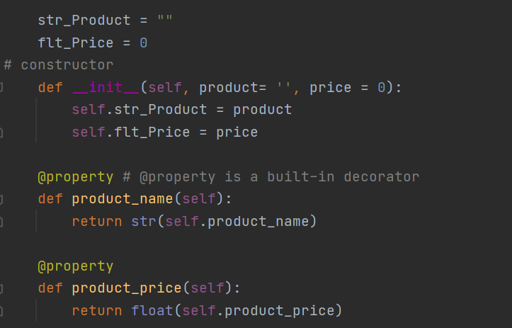Initialize your variables, greet the user, and tell the user your program’s purpose.
The next portion of our script employs special methods known as constructors. Constructors are “automatically invoked right after a new object is created” (Dawson 222). And there is a “specific method name recognized by Python,” also called the initialization method (Dawson 224). This method, __init__, is automatically called. Note, too, the use of the built-in decorator called @property. The utility is to make the implementation backward compatible following the initialization. In addition, there is a mandatory parameter in the image above known as self—as Dawson puts it, this “parameter provides a way for a method to refer to the object itself” (221). Further, appended to self are various attributes. Both self and attributes are conveniences in Python to make for efficient code.
What follows is the next portion of our separation of concerns. With the data setup implemented, we now create a new class called FileProcessor. The docstring clarifies what this script section accomplishes—namely, it processes data to and from a file and a list of product objects. Recalling the previous assignment, we implement structured error handling to allow the program to run smoothly with or without a pre-existing file.
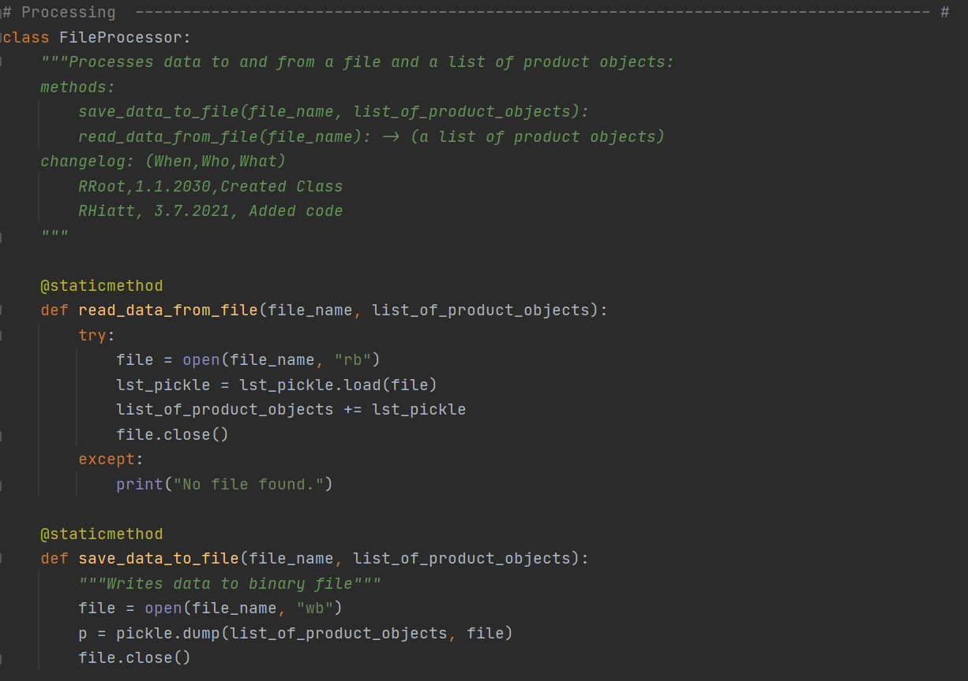
New class along with example of try statement and except clause.
Our next concern is user input. We create a new class called IO, and we create a user menu along with features to choose a menu option and enter inventory into the program. A distinction worth noting at this point is the lack of self in the definition’s parameter list. As Dawson puts it, “like all static methods, it’s designed to be invoked through a class and not an object. So, the method won’t be passed a reference to an object and therefore won’t need a parameter, like self, to receive such a reference” (231). The next decorator, @staticmethod, is used.
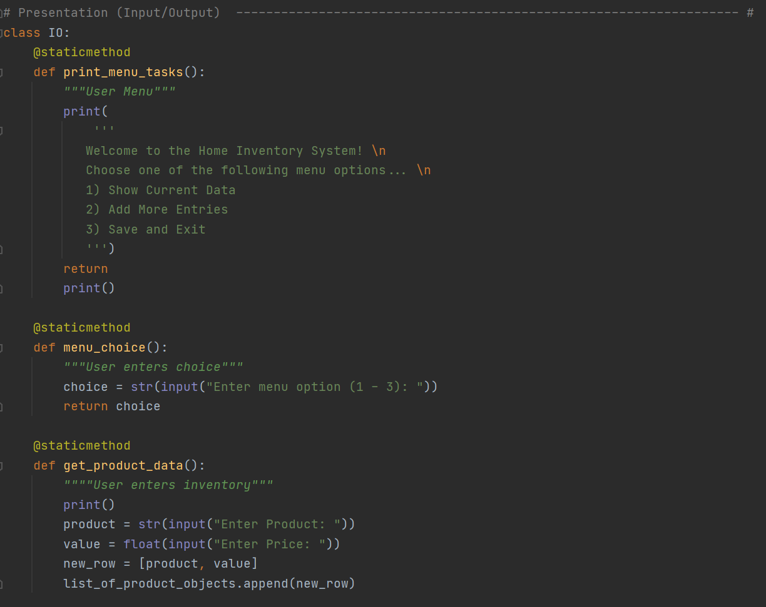
Presentation section with the class IO.
The next section displays the benefit to creating classes in that the references to said classes creates an efficient shorthand to execute the program. We also move into familiar territory, leveraging a while loop to keep up with the user’s choice entry.
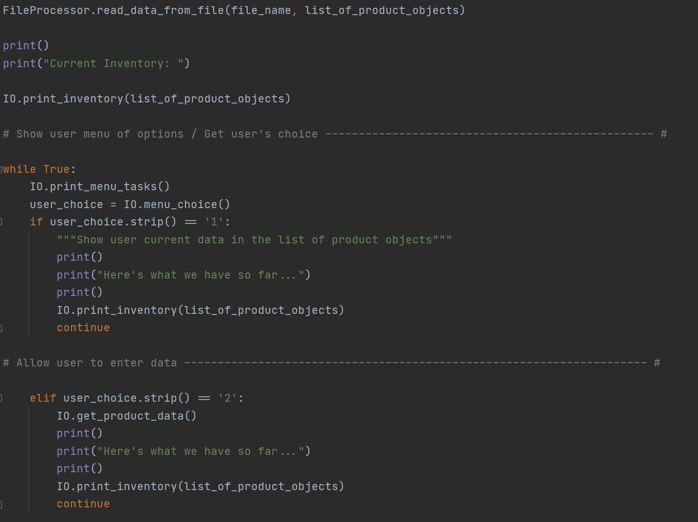
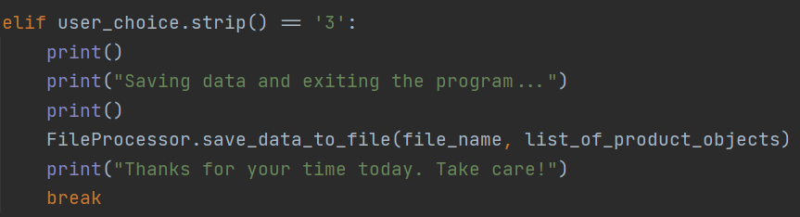
Moving to the payoff of creating classes.
3. Running the Program
With the new lessons explained for Assignment 08, let’s run the script in both PyCharm and the Command Line to ensure that the program is working properly.
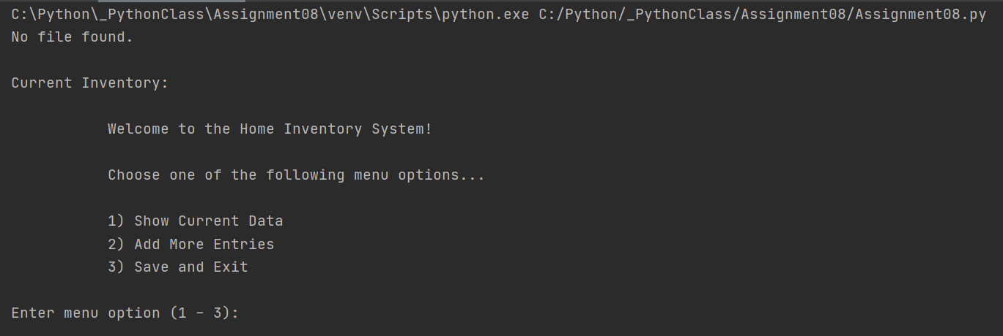
PyCharm: Welcoming the user and displaying the program.
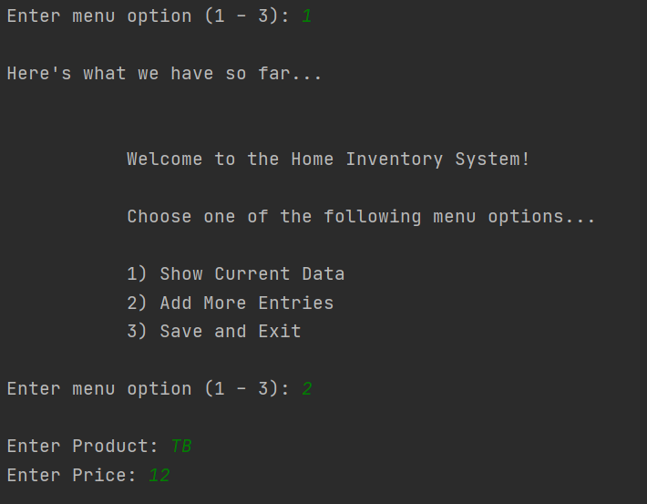
PyCharm: Option 1, no entries yet, so let’s move to Option 2!
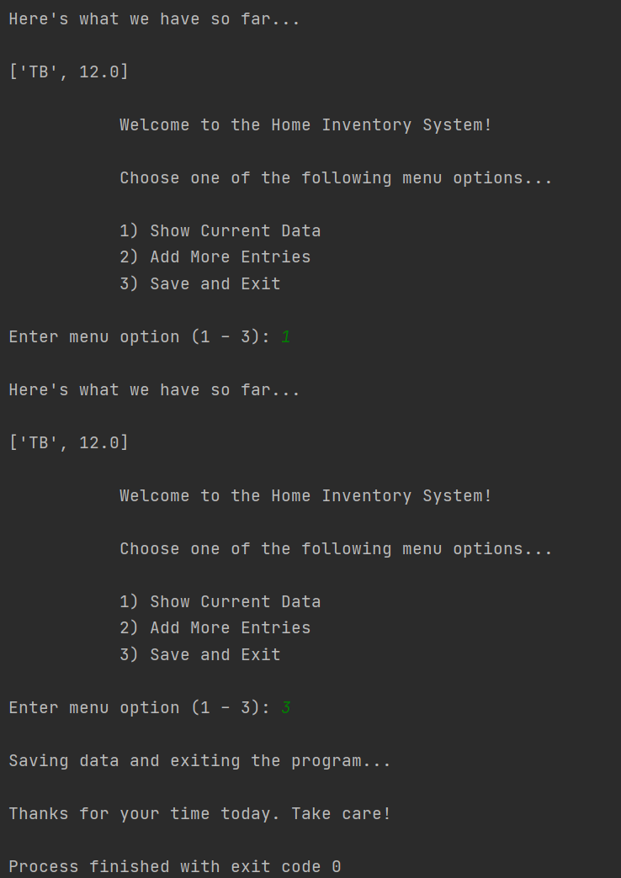
PyCharm: Moving through the menu options. No roadblocks.
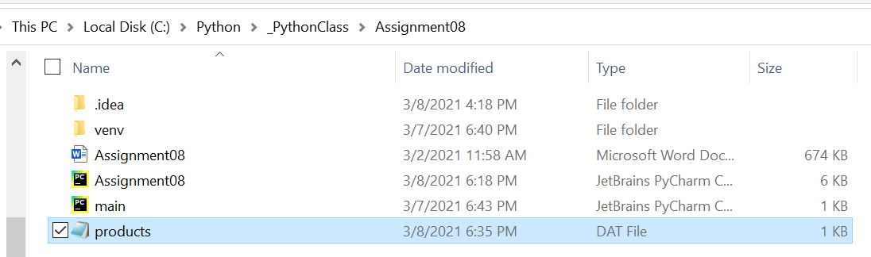
Confirmation of Assignment08 DAT file created.
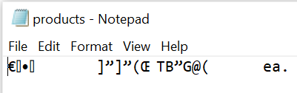
Confirmation that the data stored into the DAT file, and it’s binary!

Now let’s have a go on the Command Line:
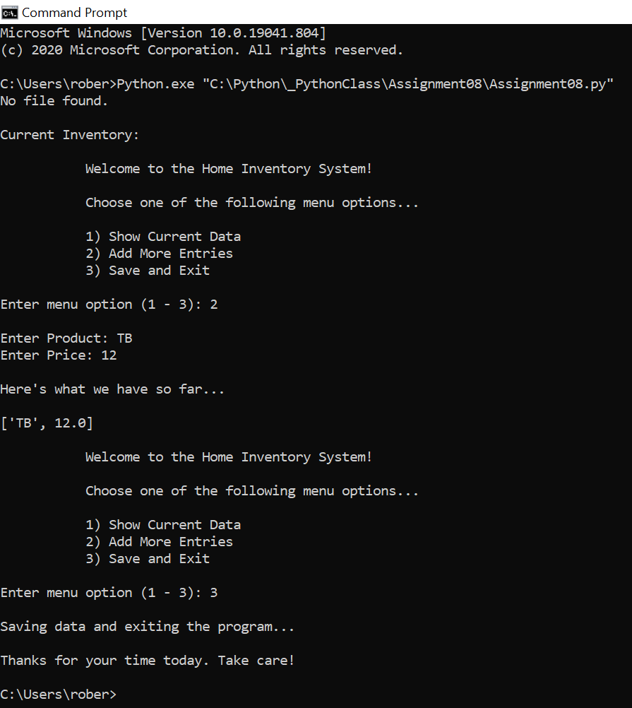
Command Line: The program ran successfully on the Command Line!
5. Summary
By this exercise’s completion you’ve created classes, constructors, decorators, and you’ve demonstrated the efficiency in using classes. By now writing menus and loops are very familiar, and structured error handling is further concretized into your repertoire. This assignment usefully demonstrated separation of concerns, and, while classes and object-oriented programming are still new concepts, they clearly are useful and important.
Works Cited
Dawson, Michael. Python Programming for the Absolute Beginner, Third Edition. Course Technology, 2010.

