How to get python from the windows store

Step 1: Open Microsoft Store
- Press Windows and type Microsoft Store in the search bar.
- Open the app and make sure you’re logged in with your Microsoft account.
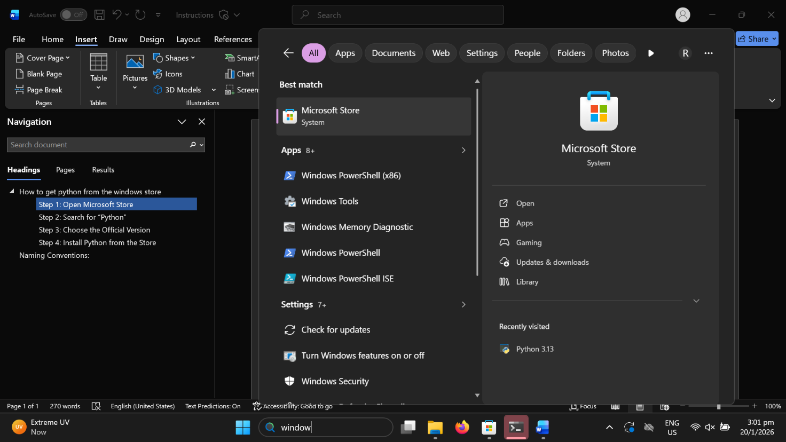

Step 2: Search for “Python”
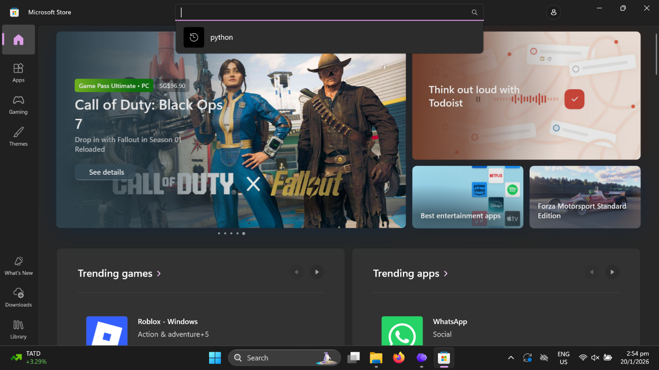
Once the Store is open, type Python in the search box at the top.
You’ll see several versions such as Python 3.10, Python 3.11, Python 3.12, Python 3.13.

Step 3: Choose the Official Version
Before installing, make sure the publisher is listed as: Python Software Foundation.
This is the official and verified version of Python. Avoid third-party uploads that might contain modified or unofficial builds.
Click on your preferred version — for example, Python 3.12 — to open the details page.

Step 4: Install Python from the Store

Once on the Python app page:
- Click the Get or Install button.
- The download will begin automatically, and installation usually takes less than a minute.
- Once installed, you’ll see an Open button on the same screen. 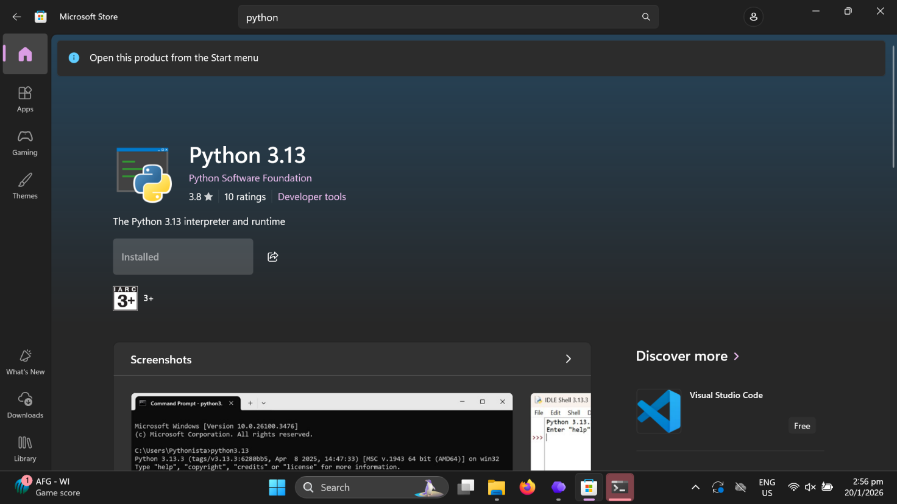
Python is now successfully installed on your Windows 11 system through the Microsoft Store!

Step 5: double click ‘installation script’ windows batch file in the pipeline folder from the zip file. This will install the necessary python libraries for the script to work.
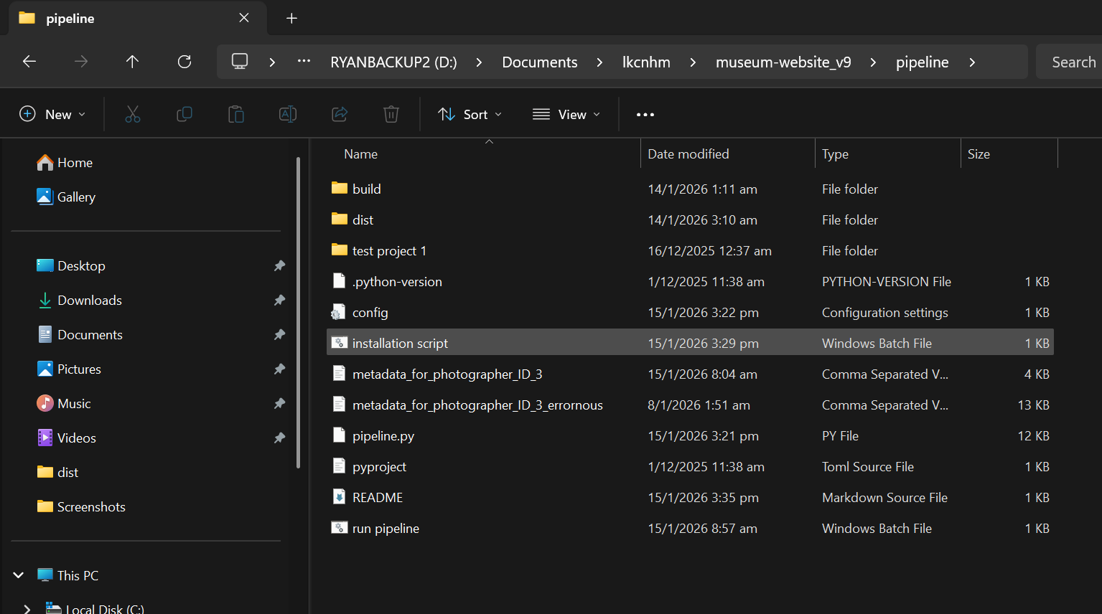

Step 6: Running the script

Click on ‘run pipeline’ batch file
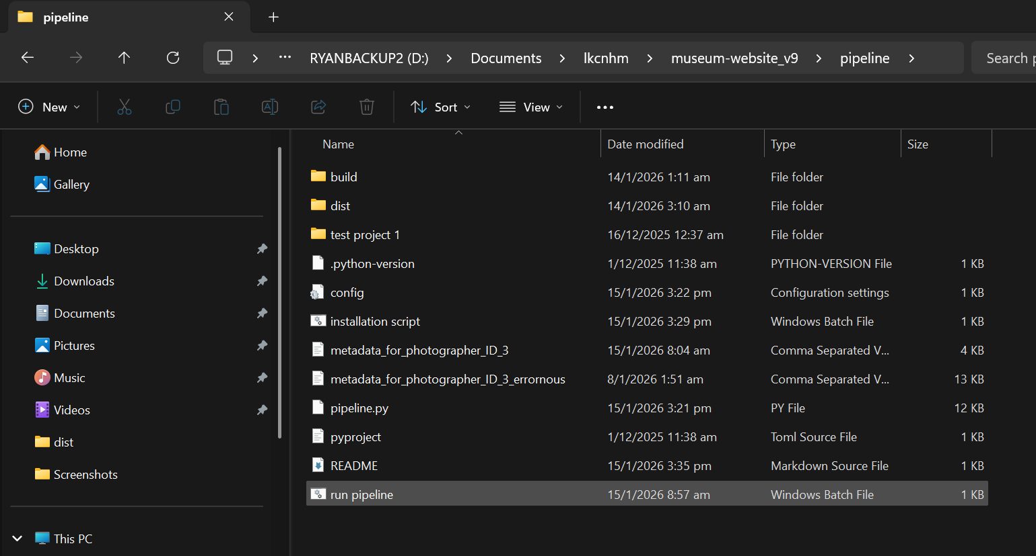
This UI will appear:

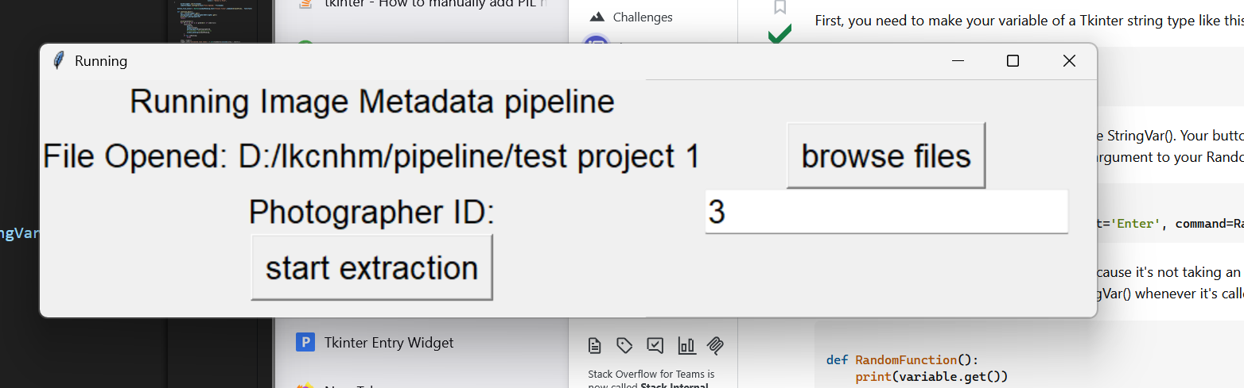

Make sure that the directory is selected and the photographer ID is written correctly

Please wait for the pipeline script to complete, it can take awhile when there are many image’s metadata to go through.

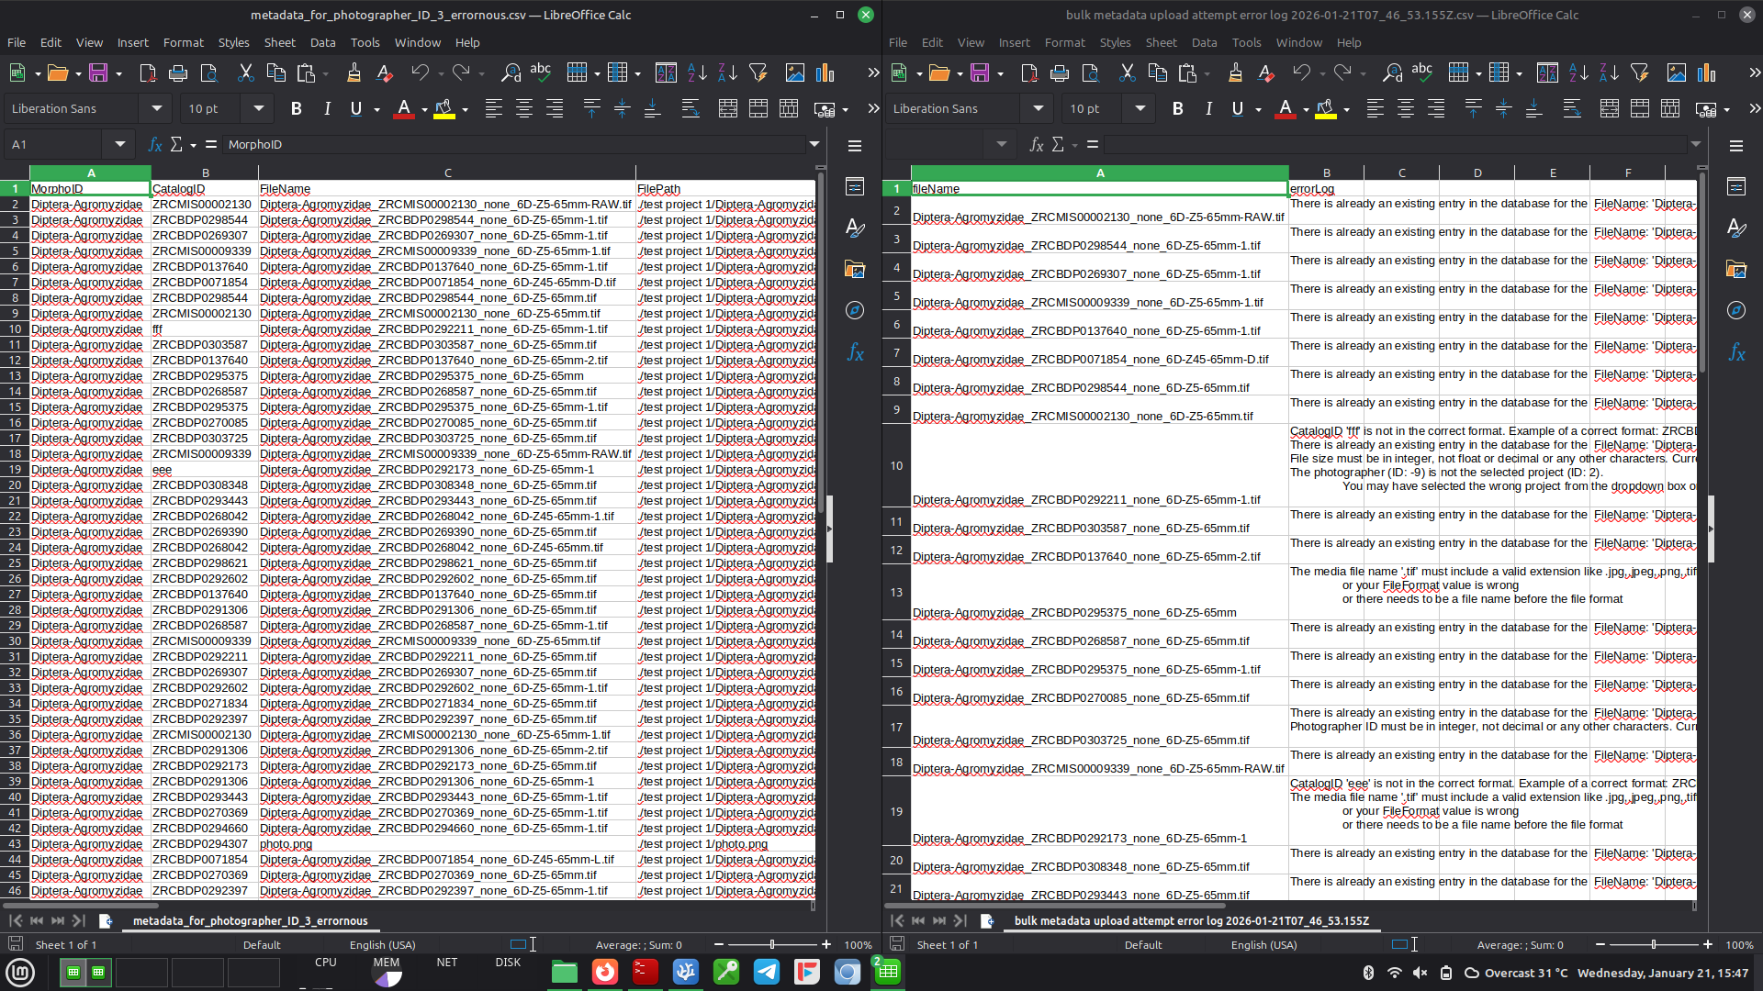
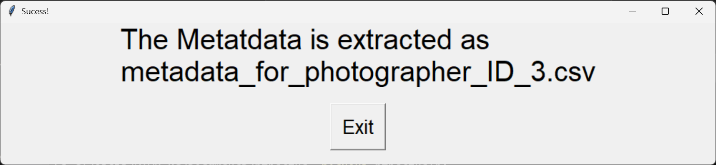

The extracted metadata will be saved in the same ‘pipeline’ folder.

If you faced errors, you can compare the error log and the csv file side by side like this where the row indices correspond to the indices of the other file:

Naming Conventions:

TaxonName_CatalogNumber_photoID_additionalinfoifany.fileformat
If any of the information is missing, put ‘none’ instead.
CatalogID will be need to have this convention: ZRCBDP0012345. 6 capital letters and then 7 numbers if not an error will be raised
TaxonName is MorphoID in the Media db Table. TaxonName must have at least 5 characters and is not an integer if not an error will be raised.
Any images names with ‘thumb’ or ‘index’ will be ignored.

