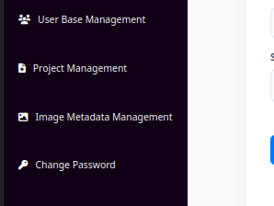
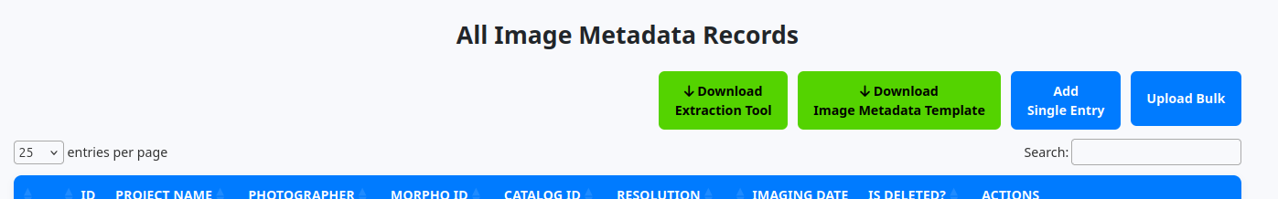
How to Download the mandatory Image Metadata Extraction Tool

Click on “Image Metadata Management” on the panel to the left of the screen.

Click on the “Download Extraction Tool” button

How to get python from the windows store (Required for Metadata Extraction Tool)

Step 1: Open Microsoft Store
- Press Windows and type Microsoft Store in the search bar.
- Open the app and make sure you’re logged in with your Microsoft account.
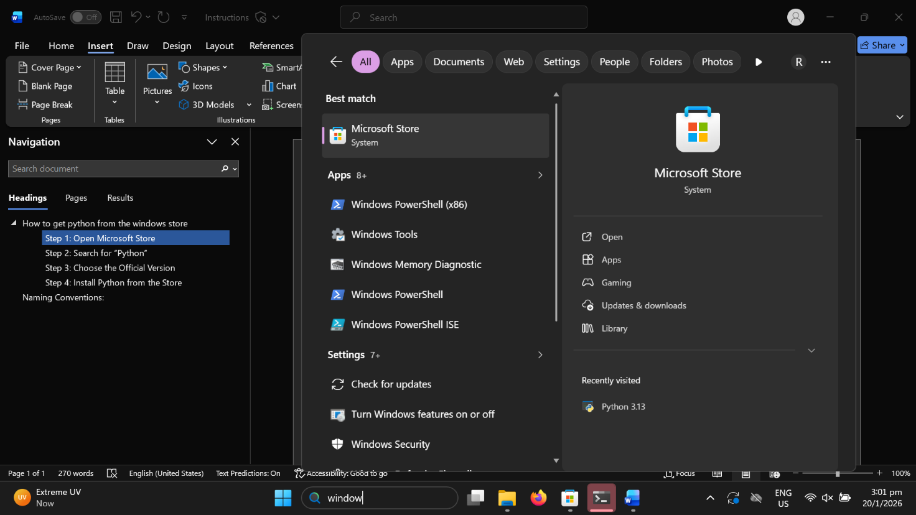

Step 2: Search for “Python”
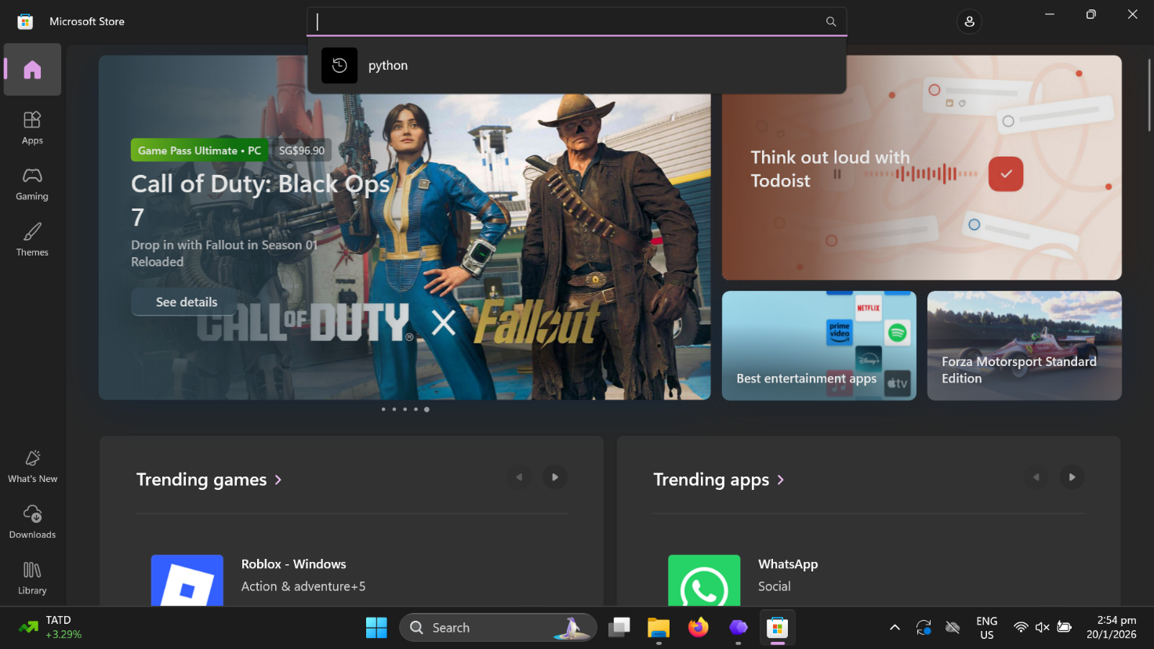
Once the Store is open, type Python in the search box at the top.
You’ll see several versions such as Python 3.10, Python 3.11, Python 3.12, Python 3.13.

Step 3: Choose the Official Version
Before installing, make sure the publisher is listed as: Python Software Foundation.
This is the official and verified version of Python. Avoid third-party uploads that might contain modified or unofficial builds.
Click on your preferred version — for example, Python 3.12 — to open the details page.

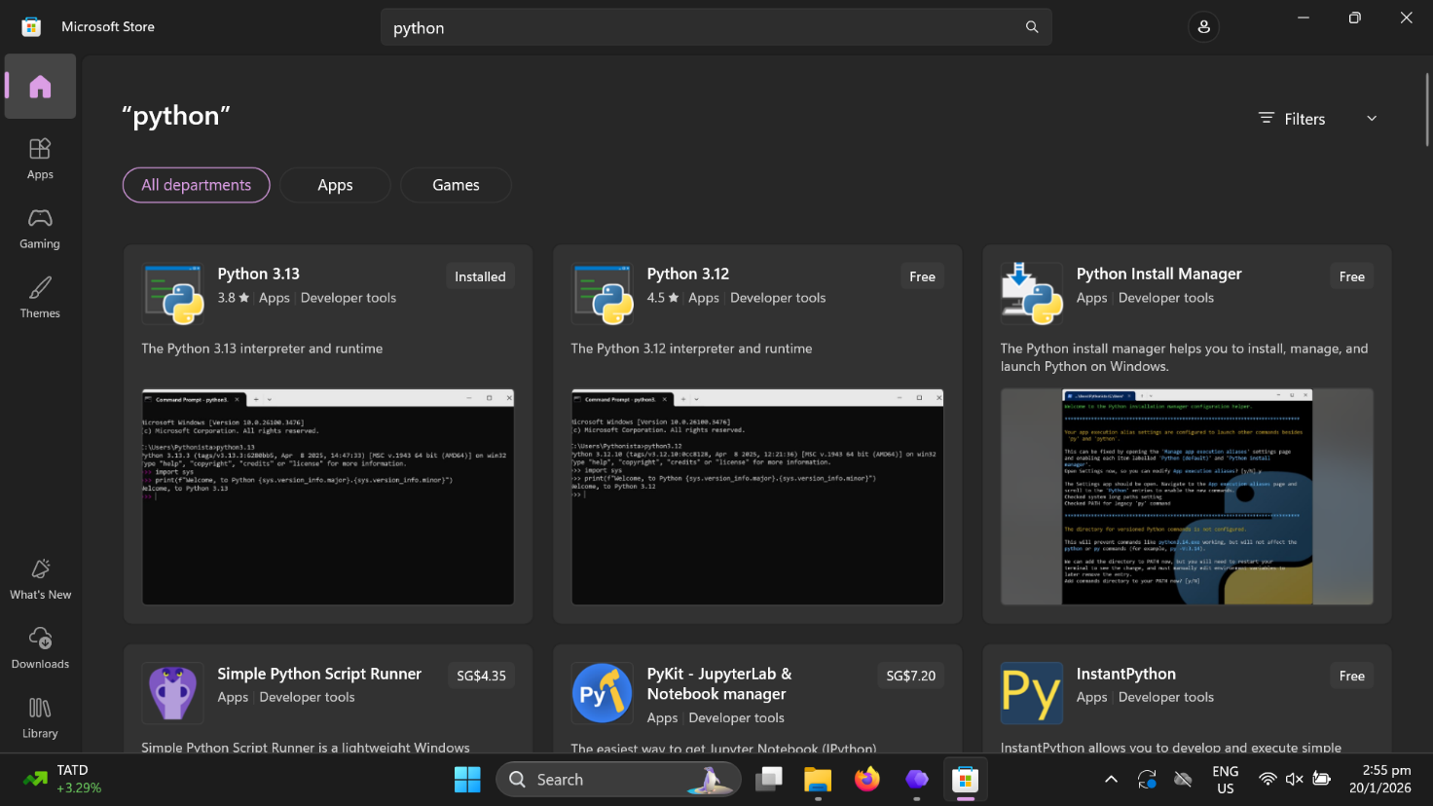Step 4: Install Python from the Store

Once on the Python app page:
- Click the Get or Install button.
- The download will begin automatically, and installation usually takes less than a minute.
- Once installed, you’ll see an Open button on the same screen. 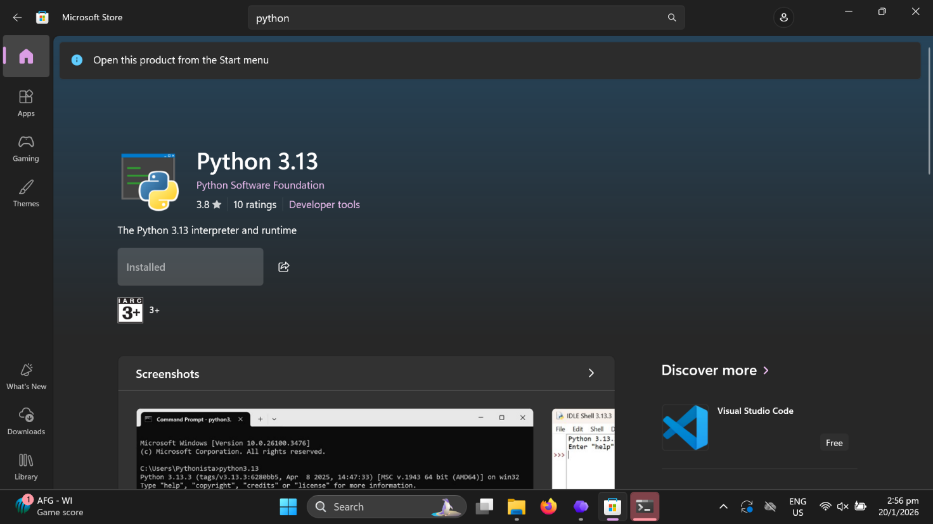
Python is now successfully installed on your Windows 11 system through the Microsoft Store!
Extract the zip file using the following steps:
- Locate the folder containing the extraction tool, to unzip (extract) files or folders from.
- To unzip all the contents of the zipped folder, press and hold (or right-click) the folder, select Extract All..., and then follow the instructions.

Step 5: double click ‘installation script’ windows batch file in the pipeline folder from the zip file. This will install the necessary python libraries for the script to work.
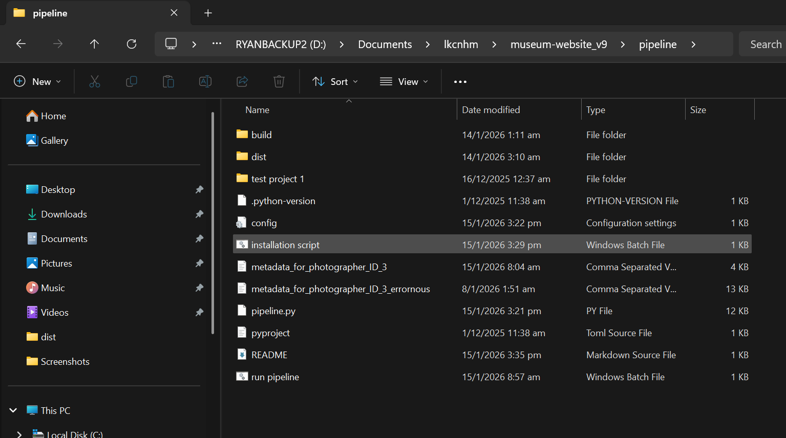

Step 6: Running the script

Click on ‘run pipeline’ batch file
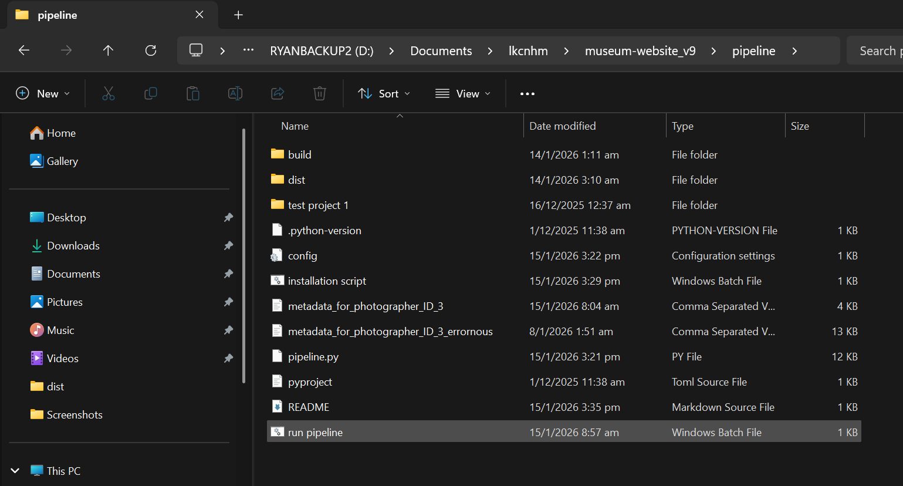

this security warning may appear:
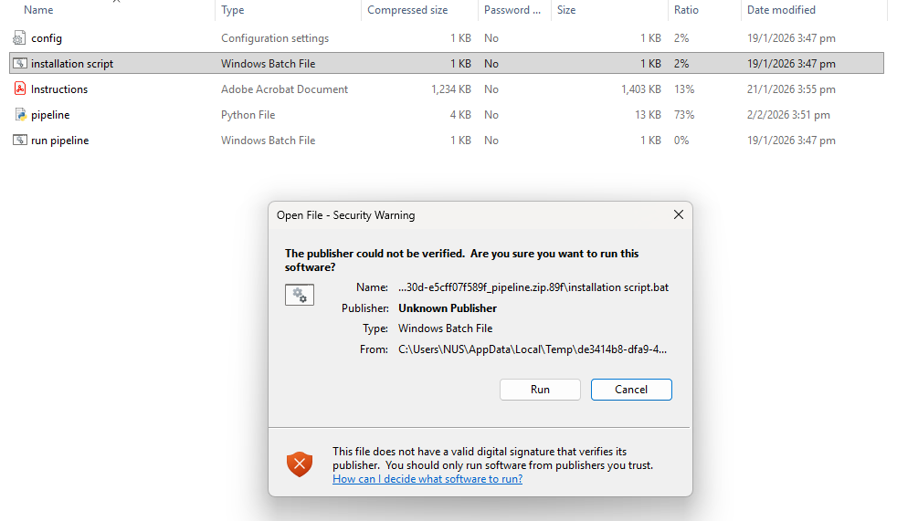
click on “Run”
This UI will appear:

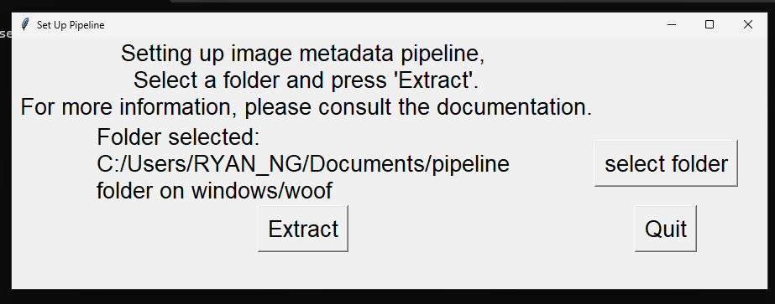

Make sure that the directory that the image files are in are selected.

Please wait for the pipeline script to complete, it can take awhile when there are many image’s metadata to go through.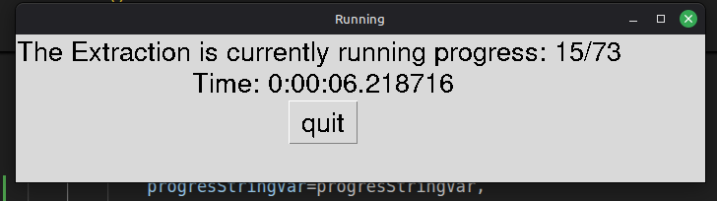

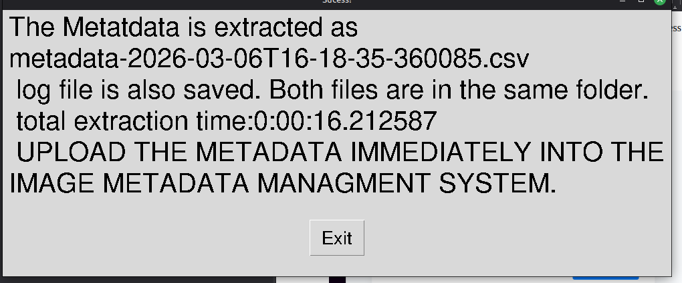

The extracted metadata will be saved in the same ‘pipeline’ folder.

Remember to upload the metadata csv file into the system immediately so that project and photographer will be tracked. You may fill in any additional information manually (e.g. imaging platform). You can also manually fill in the project and photographer IDs if you wish to have a different IDs for different rows. The IDs can be found in the Project Management Pages of the system via “View” button which will show the details of the project.

If you faced errors, you can compare the error log (In the same unzipped folder as the extraction tool) and the csv file side by side like this where the row indices correspond to the indices of the other file:
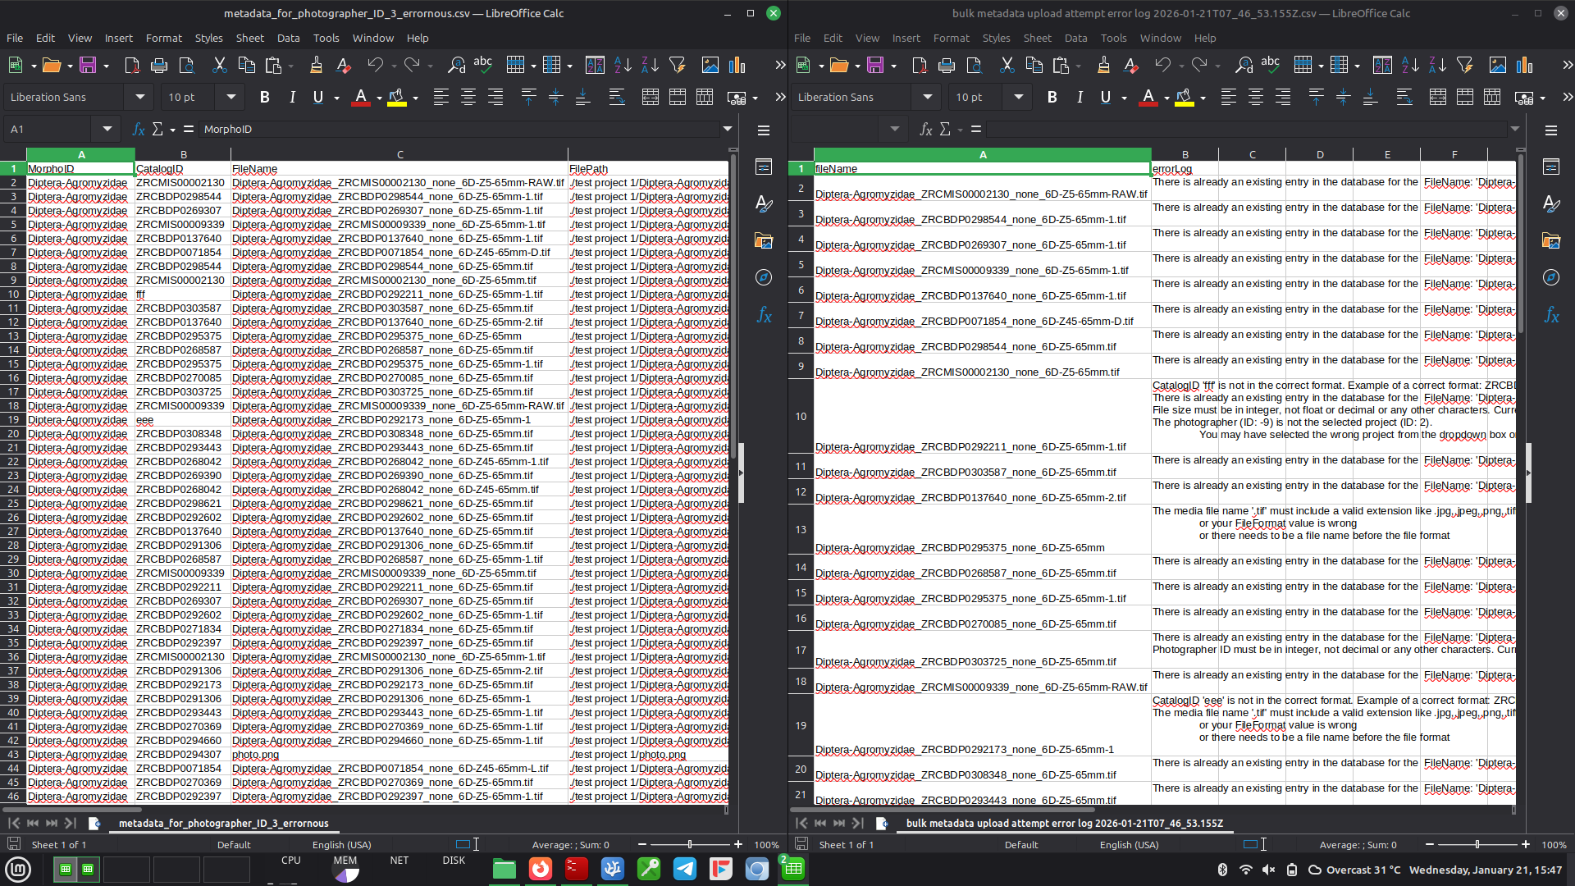
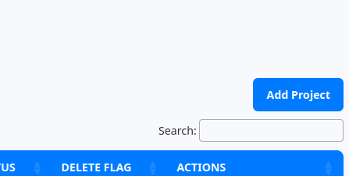

Creating a Project
All images are registered as being generated or belonging to a project. You will need to create a project first to upload any image metadata.
To start, click on “Project Management” on the sidebar, then you will see the all available projects which you have none.

click on “Add Project” from the right on the screen.

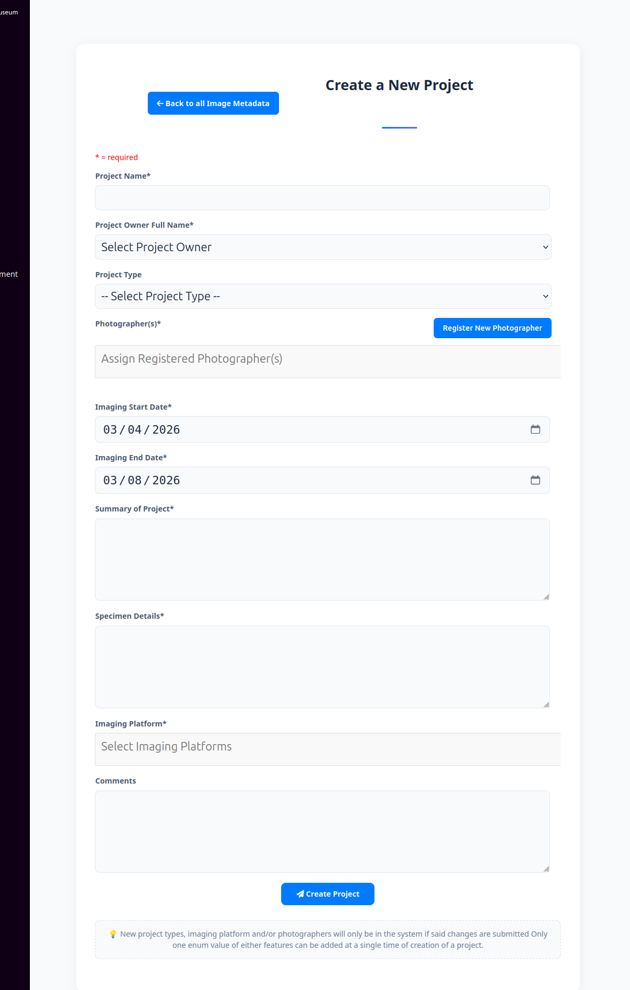

You will see a form to fill up in order to create a project. Fill up the form and press “Create Project”. You have now created a Project.

You can view details ,edit, delete projects.

Bulk Metadata Upload

Click on “Image Metadata Management”

Now, click on “Upload Bulk” from the left of the screen

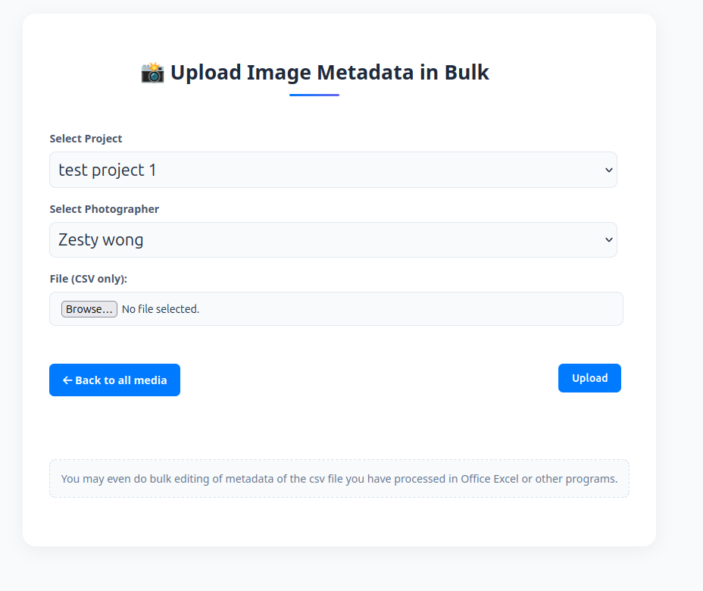
You will now see this page ,
- enter the project you want to assign your metadata,
- Afterwards Select Photographer that you want to assign your metadata to.
- Then select the metadata csv file to upload and then click upload
On success you will see all the uploaded metadata in the main page of “Image Metadata Management”

Naming Conventions:

TaxonName_CatalogNumber_photoID_additionalinfoifany.fileformat
If any of the information is missing, put ‘none’ instead.
CatalogID will be need to have this convention: ZRCBDP0012345. 6 capital letters and then 7 numbers if not an error will be raised
TaxonName is MorphoID in the Media db Table. TaxonName must have at least 5 characters and is not an integer if not an error will be raised.
Any images names with ‘thumb’ or ‘index’ will be ignored.

